Dependence of various SOL widths on plasma current and density in NSTX H-mode plasmas

J-W. Ahn¹, R. Maingi², J. A. Boedo¹, V. Soukhanovskii³

¹University of California – San Diego, San Diego, CA 92093, USA
²Oak Ridge National Laboratory, Oak Ridge, TN 37831, USA
³Lawrence Livermore National Laboratory, Livermore, CA 94551, USA

Abstract
The upstream plasma parameter profiles in the Scrape-off Layer (SOL) region and the heat flux ($q_{}$) profile at the divertor target were measured simultaneously by a mid-plane reciprocating probe and an IR camera, respectively, for the quiescent H-mode plasmas with Type-V ELMs in the National Spherical Torus Experiment (NSTX). The SOL plasma is strongly collisional within a few centimeters radially past the separatrix, where all the profiles are peaked at the separatrix and can be easily fitted to the exponential function with a baseline value, ie offset exponential, to define the SOL width. The dependences of various SOL widths on plasma operation parameters were thus readily investigated. In particular, the line averaged plasma density (${\overline{n}}_{e}$) and current (I_{p}) were varied to investigate effects on various SOL widths. It is found that the heat flux SOL width (λ_{q}) is virtually insensitive to ${\overline{n}}_{e}$ and has a strong negative dependence on I_{p}. λ_{q} stayed at ~0.9cm with the density increase from 4 to 6x10¹³cm⁻³, while increasing from ~0.5cm to ~1.0cm with the I_{p} decrease from 1MA to 700kA. This insensitivity of λ_{q} to ${\overline{n}}_{e}$ is consistent with the result from JET H-mode plasmas that shows a very weak dependence on the density. The electron temperature, ion saturation current, and the density decay lengths (λ_{Te}, λ_{jsat}, and λ_{ne}, respectively) measured by the probe showed that λ_{Te} and λ_{jsat} have strong negative dependence on I_{p}, whereas λ_{ne} revealed only a little or no dependence. The λ_{Te} result is consistent with the scaling law in the literature, whereas the λ_{ne} result is not consistent.

- Introduction

The lifetime of plasma facing components in the future fusion power plant is critically dependent on the peak heat flux that must be accommodated by the targets for a given power flowing into the Scrape-off Layer (SOL) region, P_{SOL}, which is governed by the radial heat flux width, λ_{q}. There have been a number of publications on the investigation of λ_{q} variation as a function of various operational parameters such as plasma current (I_{p}), plasma density (n_{e}), P_{SOL}, edge safety factor (q₉₅), and toroidal B-field (B_{t}). In the large aspect ratio geometry, multi-machine scaling laws on λ_{q} have been constructed both in L- and H-mode plasmas^{1, 2}, as well as the investigation of λ_{Te} and λ_{ne}³. In the spherical tokamak (ST) geometry, an L-mode λ_{q} scaling using the heat flux value from the target Langmuir probe measurement was constructed on MAST⁴ and investigations of H-mode λ_{q} dependence, based on the Infrared (IR) camera measurement, on I_{p} and P_{SOL} were also carried out^{5, 6}.
Heat flux to the divertor target can be calculated using electron temperature and radial particle flux density, by
$q_{}=γ_{s}{\text{kT}}_{e}Γ_{}=γ_{s}{\text{kT}}_{e}\frac{j_{\text{sat}}^{+}}{e}\text{sin}ξ$ (1)
where γ_{s} is the sheath heat transmission coefficient, $Γ_{}$is the particle flux incident on the surface, $j_{\text{sat}}^{+}$ is the ion saturation current density, and $ξ$ is the angle of incidence between the magnetic field lines and the surface. Relation between $j_{\text{sat}}^{+}$ and n_{e}, $j_{\text{sat}}^{+}∝\sqrt{T_{e}}n_{e}$, indicates that $q_{}$is also related to n_{e}, ie $q_{}∝T_{e^{3/2}}n_{e}$. Therefore, it is important to investigate the dependence of λ_{Te}, λ_{ne}, and λ_{jsat} on the operation parameters as well as the λ_{q} dependence on them in order to more efficiently approach an empirical extrapolation to the future machine. Currently there is only limited work previously on this subject in the literature, particularly in the ST geometry and H-mode plasmas. At the same time, one may hope to elucidate underlying physics via comparison between various scale lengths, such as λ_{q} and λ_{Te}⁷. In this paper, we report the first result of the four relevant SOL widths, λ_{Te}, λ_{ne}, λ_{jsat}, and λ_{q}, for the dependence on ${\overline{n}}_{e}$ and I_{p} in NSTX H-mode plasmas.

- Experimental Setup

Experiments were performed in the NSTX tokamak^{8, 9} (R = 0.85 m, a < 0.67 m, R/a > 1.27) in lower single null (LSN) discharges, with toroidal magnetic field, B_{T} = 0.38-0.55 T, plasma current, I_{p} = 0.7–1MA, line average electron density ${\bar{n}}_{e}=3\text{.}2−6\text{.}0×{\text{10}}^{\text{13}}$cm⁻³, and neutral beam (NBI) power of 1–2 MW. The plasmas had relatively lower elongation, κ=2.0, and triangularity, δ=0.45. Simultaneous measurements of the upstream T_{e}, n_{e}, and j_{sat} and the target $q_{}$ profiles were made using the fast reciprocating probe¹⁰ and infra-red (IR) camera⁵, respectively, in quiescent H-mode plasmas with type-V ELMs. The fast reciprocating probe measures upstream plasma parameters (17.3 cm below the mid-plane) across the SOL with spatial resolution of 1 – 2mm. The IR camera measures heat flux profile both on the inboard and outboard divertor tiles with temporal resolution of ~33ms and spatial resolution of ~6mm.
Fig. 1 shows the time evolution of a) plasma current, b) line averaged density, c) injected NBI power (P_{NBI}), and d) D_{α} signal for outer lower divertor, for a typical type-V ELM H-mode shot, 128341. The L-H transition is indicated by the D_{α} drop at ~130ms, and the plasma stays in H-mode until ~ 430ms. The small oscillations on D-alpha are signatures of the Type-V ELMs. Note the continuous rise of the line-averaged density during this time period, a common feature of NSTX H-modes. The reciprocating probe was plunged during the time window indicated by the dotted vertical lines, as the target line-average density for the reciprocating probe plunge was achieved. The measured profiles by the probe and IR camera are flux mapped to the midplane using the magnetic equilibrium reconstruction and are plotted as a function of R-R_{sep} (radial distance from the separatrix location).

- Dependence of various SOL widths on I_{p} and ${\overline{n}}_{e}$

The electron-electron collisionality (ν*_{ee} = L_{c}/λ_{ee}, where λ_{ee} is the e-e mean free path and L_{c} is the parallel connection length) in the upstream SOL region was calculated from the T_{e} and n_{e} profile data and L_{c} calculated by magnetic equilibrium reconstruction. It is found that the SOL plasma is strongly collisional near the separatrix, ν*_{ee}=30-40, and stays in the conduction-limited regime within a few centimeters from the separatrix. It is found that all the profiles investigated in the study of this paper are well peaked and are easy to fit to the exponential function. One can easily notice that the profiles have long tails in the far SOL region and the whole profile can be approximated as an offset exponential function, $a=a_{0}+a_{1}\text{exp}\left(−\frac{R−R_{\text{sep}}}{λ_{a}}\right)$, which was used to fit the T_{e}, $j_{\text{sat}}^{+}$, n_{e}, and q profiles in the data analysis of this paper.

3.1 I_{p} dependence

The I_{p} scan was conducted with approximately constant q₉₅ by varying B_{t} accordingly and with constant P_{NBI}=2MW and ${\overline{n}}_{e}$=3.8x10¹³cm⁻³ during the measurement, over a range of $0\text{.}7≤I_{P}≤1\text{.}0$MA. The reciprocating probe measurement was made simultaneously with the IR camera measurement.
The peak heat flux increased strongly with increasing I_{p} from 0.7 to 1.0MA, while λ_{q} decreased by a factor of ~2, as shown in Fig. 2. This is consistent with the previous result^{5, 6}. Also shown is that λ_{jsat} has a strong negative dependence on I_{p}, ie ~0.4cm for 1MA and ~0.9cm for 700kA. Note that ion saturation current profiles, as a function of R-R_{sep}, appear to be ‘shifted’ relative to each other. This is believed to be due to the uncertainty of the separatrix position from the magnetic equilibrium reconstruction, unlike the IR heat flux profiles where the separatrix position is well defined by the position of peak heat flux. However, T_{e} profiles in the dataset for the I_{p} scan in Fig. 2 seem to be missing data points near the separatrix, thus missing the steep gradient part of the profile which is necessary for λ_{Te} derivation from fitting the data to the exponential function. This means that the derived λ_{ne} would also be less reliable due to the contribution of T_{e} to the heat flux (see equation 1 and the following discussion). We therefore chose another dataset to investigate the dependence of λ_{Te} and λ_{ne} on I_{p}, of which the result is shown in Fig. 3. These discharges had lower beam power, P_{NBI}=1.4MW, and lower density, ${\overline{n}}_{e}$=3.2x10¹³cm⁻³. The two profiles are again radially shifted with respect to each other, which we believe is due to the uncertainty in the separatrix position generated by the magnetic equilibrium reconstruction. It is seen that λ_{Te} has a strong negative dependence on I_{p}, ie λ_{Te} decreased almost by a factor of 2, from 1.3cm to 0.7cm, with the I_{p} increase from 800kA to 1MA. This result is consistent with the H-mode λ_{Te} scaling result from AUG³.

$λ_{\text{Te}}∝n_{e}^{0\text{.}\text{92}±0\text{.}\text{18}}I_{p}^{−1\text{.}\text{79}±0\text{.}\text{27}}(P_{\text{tot}}−P_{\text{rad}})^{−0\text{.}\text{63}±0\text{.}\text{09}}$ (2)

On the other hand, little change in λ_{ne} is observed. It slightly increased, from 0.94cm to 1.1cm, with the I_{p} increase from 800kA to 1MA. However, this change could be within the error bar associated with the probe measurement and certainly the dependence of λ_{ne} on I_{p} appears much weaker than the other decay lengths such as λ_{Te}, λ_{jsat}, and λ_{q}. This result is not consistent with the H-mode λ_{ne} scaling result from AUG³, from which a significant λ_{ne} decrease is expected with the I_{p} increase from 800kA to 1MA.

$λ_{\text{ne}}∝n_{e}^{1\text{.}\text{11}±0\text{.}\text{13}}I_{p}^{−2\text{.}\text{25}±0\text{.}\text{16}}$ (3)

3.2 ${\overline{n}}_{e}$ dependence

The λ_{q} dependence on ${\overline{n}}_{e}$ in L-mode plasmas is found stronger in the ST geometry ($λ_{q}∝{\overline{n}}_{e}^{1\text{.}5}$)⁴ than in the conventional tokamaks ($λ_{q}∝{\overline{n}}_{e}^{0\text{.}\text{68}}$)¹. On the other hand, the multi-machine H-mode λ_{q} scaling in the conventional tokamak geometry¹ does not contain dependence on ${\overline{n}}_{e}$. A more recent result from JET ELMy H-mode plasmas² indicates that λ_{q} dependence on ${\overline{n}}_{e}$ is weakly positive. That is,

$λ_{q}∝B_{t}^{−0\text{.}9}q_{\text{95}}^{0\text{.}4}P_{\text{SOL}}^{−0\text{.}5}n_{e,u}^{0\text{.}\text{15}}$ (4)

Our investigation of λ_{q} dependence on ${\overline{n}}_{e}$ in H-mode plasmas is based on the dataset with density variation of about ~50% (from 4.0 to 6.0x10¹³cm⁻³). It is seen that λ_{q} stays almost the same over the whole range of density variation, at around λ_{q}=0.8-0.9cm. The result shown in Fig. 4 is for a discharge with I_{p} =900kA and P_{NBI}=2MW but investigations based on multi-shot datasets with different plasma conditions also show similar result. It is thus consistent with the prediction from equation 4. The λ_{Te}, λ_{jsat}, and λ_{ne} dependence on ${\overline{n}}_{e}$ could not be investigated due to the lack of measured data points.

- Discussions

Various SOL widths in the NSTX H-mode plasmas have been investigated in relation to the dependence on plasma operation parameters. The λ_{q} dependence on I_{p} confirms our previous result ^{5, 6} and the result of no dependence on ${\overline{n}}_{e}$ is consistent with the JET result (equation 4). The strong negative dependence of λ_{Te} on I_{p} is consistent with a scaling law from AUG database (equation 2). However, our result showing no dependence of λ_{ne} on I_{p}, is not consistent with the scaling law from the same database (equation 3). This result is to be validated with a bigger dataset in the future and the data analysis is currently underway. The λ_{Te} and λ_{ne} dependence on ${\overline{n}}_{e}$ will be also investigated and be compared with the existing scaling laws in the future work. In general, considering the limited size of our current database, there is a strong need for more work for a bigger dataset to further investigate dependences on I_{p} and ${\overline{n}}_{e}$ as well as to derive scaling laws and extrapolation to the future machine.

Acknowledgement
The authors are grateful to the NSTX research team for the excellent technical support. This work was supported by the US Department of Energy, contract numbers DE-FG02-03ER54731, DE-AC02-76CH03073, DE-AC05-00OR22725, and W-7405-ENG-48.

References
[1] A. Loarte et al., J. of Nucl. Mater. 266-269 (1999) 587
[2] W. Fundamenski and S. Sipila, Nucl. Fusion 44 (2004) 20
[3] K. McCormick et al., J. of Nucl. Mater. 266-269 (1999) 99
[4] J-W. Ahn, G. F. Counsell, and A. Kirk, Plasma Phys. Control. Fusion 48 (2006) 1077
[5] R. Maingi, et al., J. of Nucl. Mater. 363-365 (2007) 196
[6] R. Maingi, et al., Proc. of 34th EPS Conf., Warsaw, Poland, 2007
[7] J-W. Ahn, J. A. Boedo, R. Maingi, V. Soukhanovskii, submitted to Phys. Plasmas (2008)
[8] M. Ono, et al., Nucl. Fusion 40 (2000) 557
[9] S. M. Kaye, et al., Nucl. Fusion 45 (2005) S168
[10] J. A. Boedo, et al., submitted to Rev. Sci. Instrum. (2007)

FIG. 1. Time trace of various discharge parameters: a) plasma current, b) line averaged density, c) injected NBI power, and d) D_{α} signal for outer lower divertor. Data was taken during the quiescent H-mode phase with type-V ELMs. The window indicated by dotted vertical lines is the time period of reciprocating probe measurement.

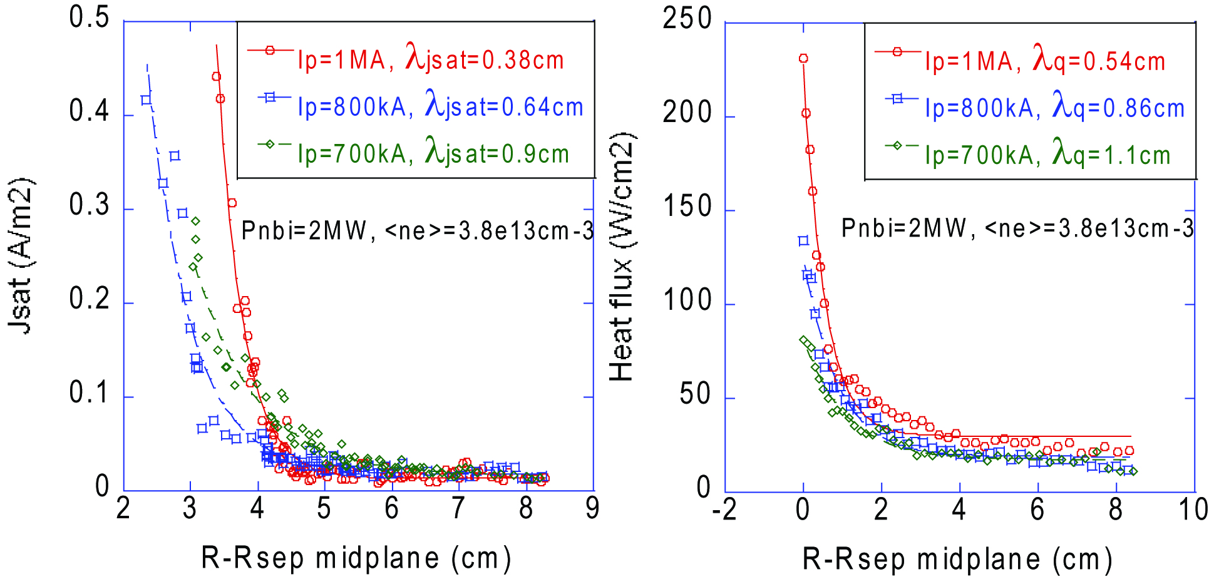

FIG. 2. Measured j_{sat} (by fast reciprocating probe at z = -17.3cm) and q_{target} (by IR camera at the lower divertor target) profiles, mapped to the midplane, as a function of R-R_{sep} in three I_{p} cases.

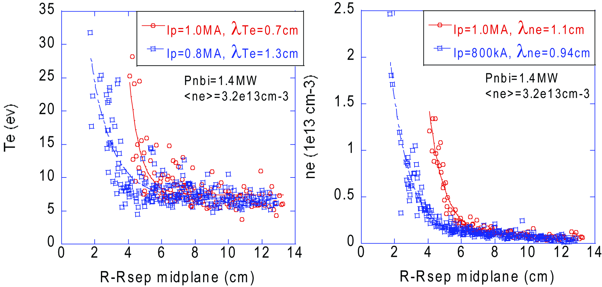

FIG. 3. Measured Te and ne profiles (by fast reciprocating probe at z = -17.3cm), mapped to the midplane, as a function of R-R_{sep} in two I_{p} cases.

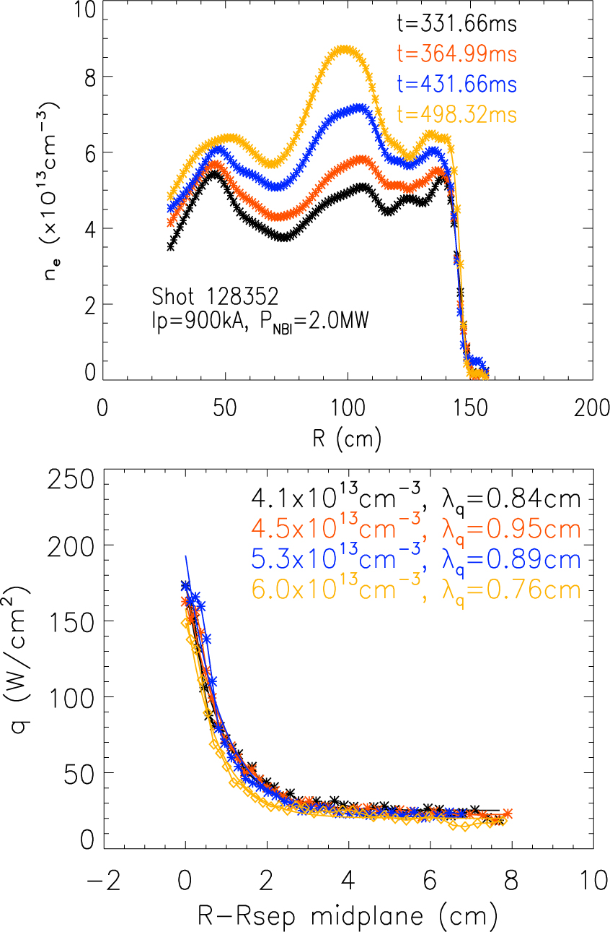

FIG. 4. Measured heat flux by IR camera (lower) and n_{e} by Thomson Scattering (upper) profiles in four line averaged density cases, corresponding to different time slices during the H-mode for shot 128352.

