P3-03
Biased electrodes for SOL control in NSTX

S.J. Zweben*, R.J. Maquedaª, L. Roquemore, C.E. Bush^{b}, R. Kaita,
R.J. Marsala, Y. Raitses, R.H. Cohen^{c}, D.D. Ryutov^{c}

Princeton Plasma Physics Laboratory, Princeton NJ USA
(a) Nova Photonics, Princeton NJ USA
(b) Oak Ridge National Laboratory, Oak Ridge TN USA
(c) Lawrence Livermore National Laboratory, Livermore, CA USA

Small electrodes were installed in the edge of NSTX to attempt to control the width of the scrape-off layer (SOL) by creating a locally outward E_{pol}xB flow. When the applied voltage between electrodes was ±90 volts, the density between these electrodes increased by a factor of 3-10 within a radial width of ~ 4 cm. Thus a local control of the far-SOL plasma density was obtained.

PSI18 keywords: Biasing, NSTX, Cross-Field Transport, Edge Plasma, Electric Field
JNM keywords: Plasma Properties (P0600), Plasma Materials Interaction (P0500)
PACS 52.40Hf, .Rk, 52.25.Fi, 52.40.Kh, F2.55.Fa

corresponding author: szweben@pppl.gov, P.O. Box 451, Princeton NJ 08540
presenting author: Ricardo Maqueda

1. Motivation and Previous Experiments

The present experiment was motivated by the theory that the scrape-off layer (SOL) width in a tokamak could be increased by toroidally non-axisymmetric electrical biasing of divertor plates [1-3]. Such biasing would create a local poloidal electric field and a radial E_{pol}xB drift larger than the normal radial flow velocity, thereby moving the local SOL strike region radially. This theory was developed for divertor plate biasing, but similar ideas were proposed for RF-sheath generated convective cells near the outer midplane [4].

These ideas have been tested in several previous experiments. In JFT-2M [5] an electrical bias of +120 volts was applied to an inner wall divertor plate and a poloidal electric field of ~1 kV/m was measured at the midplane where the magnetic field lines connected to the biased plate. In MAST [6] an electrical bias of +80 to +120 volts was applied to 6 toroidally separated divertor ‘ribs’, and a clear movement of the D_{α} emission in the expected ExB drift direction was seen at these ribs. In CASTOR [7] an electrode was biased +100 to +200 volts in the SOL, a poloidal electric field of up to 5 kV/m was created on flux surfaces connected to the electrode, and a strong poloidal modulation of the radial particle flux was measured. In related experiments, a positive DC plate bias in DITE changed the floating potential in a probe ~2.5 mm away along B [8], a positive DC and 30 kHz bias in TEXT were detected ~12 m away along B [9], and a 60 KHz probe bias in W7-AS was observed at a distance up to ~12 m away along B [10]. Thus several previous biasing experiments have created local poloidal electric fields in the SOL, which is encouraging for the development of control techniques.

2. NSTX Electrodes and probes

The electrode configuration used for this experiment is shown in Fig. 1. Four 3 cm x 3 cm stainless steel electrodes were flush-mounted in a boron nitride holder with a poloidal gap of ~1 cm between them. Each electrode could be independently biased up to ±100 volts with respect to the local vessel wall and could draw up to 30 amps per electrode for positive bias and 10 amps per electrode for negative bias. The electrode power supplies were modulated at 50 Hz for clearer comparison of electrode on and off states.

This electrode holder was mounted ~20º below the outer midplane and oriented so that the electrodes were spaced along the local poloidal direction and the total magnetic field was normal to the plane of the electrodes. The innermost radial edge of the electrode holder was ~1 cm behind the leading edge of an RF antenna limiter located just behind the electrode holder. Thus the electrodes were in contact with the SOL plasma in only one direction along B. The field lines in this direction extended a distance of from ~1 to ~8 meters along B before hitting any other object in the SOL, depending on the details of the plasma equilibrium.

The effect of the biasing was measured locally with a set of flush-mounted stainless steel Langmuir probes installed in the electrode holder, as shown in Fig. 1. The probes were 3 mm in diameter and probe voltages and currents (for 5 probes) were digitized at 200 kHz. The effect of the biasing was also measured ~1 meter downstream along the B field by the gas puff imaging (GPI) diagnostic. Further information concerning the hardware and diagnostics are described elsewhere [11].
3. Plasma conditions and biasing waveforms

The experiments described here were done using a standard NSTX deuterium plasma configuration with a current of I=0.8 MA, a toroidal field of B=4.5 kG, neutral beam heating power of P=2-4 MW, and a lower-single-null diverted geometry with a discharge duration of ~0.5 sec (#127046-054). These discharges had both H-mode and L-mode periods during biasing (the biasing itself did not affect this transition). The plasma density at the electrodes depended on the ‘outer gap’, i.e. the distance between the last closed flux surface and the outer midplane RF antenna limiter, which varied over the discharge from ~10 cm to 5 cm for these experiments. Since these electrodes and probes were at least ~1 cm behind the RF limiter, the measurements described in this paper were all made in the “far SOL” [12]. This electrode biasing never caused changes in the global plasma parameters in these experiments, in contrast to biasing experiments in which the electrode was inserted farther into the plasma [13].

An example of electrode voltage and currents waveforms for one of these discharges is shown in Fig. 2. For this and all other cases described in this paper, electrode E2 was biased at -90 volts, electrode E3 was biased at +90 volts, electrode E4 was biased at -90 volts, and electrode #1 was floating (the 3 biased electrodes were modulated in phase at 50 Hz). The E_{pol}xB drift direction between electrodes #2 and #3 was in the outward radial direction. The biased electrode currents in the L-mode period were typically ~4 amps in the positive electrode and ~0.5 amps in the negative electrode during L-mode, and ½ this during H-mode. The (I,V) characteristic of these electrodes was nearly flat above about ±50 volts, with a ratio of electron/ion saturation current of ~8.
Also shown in Fig. 2 is the signal from probe P3b (between electrodes #2 and #3), which was biased steadily at +45 volts for this case, i.e. near electron saturation current. This probe current signal, which is proportional to the local plasma density, increased significantly when the electrodes were biased, both during H-mode and L-mode. The electron temperature inferred from probe sweeps in probe P3a during a similar shot was T_{e} ~ 8±5 eV, and the approximate (lower limit) to the plasma density inferred from the electron current using I_{e} = ½nev_{e}A was n ~ 10¹¹ cm⁻³. The same qualitative behavior shown in Fig. 2 was seen in each of four similar discharges during this same series, and in several other plasma conditions including Ohmic and RF heated discharges.

4. Effects of biasing on radial profiles near the electrodes

The effect of this biasing on the radial profiles between electrodes #2 and #3 was measured by the four probes P3a-P3d. Fig. 3 shows the radial profiles of the probe current measured in (a) H-mode and (b) L-mode when the all probes were biased at +45 volts, i.e. near electron saturation (#127054). Each point represents the average over ~10-30 time periods of ~10 msec each with either bias “on” or “off” for four discharges similar to Fig. 1. The x-axis is the radial probe position with respect to the center of the electrodes. It is clear that the electrode biasing causes an increase in all of these probe currents, e.g. by a factor of x2-5 for L-mode (0.3-0.4 sec) and x3-10 for H-mode (0.2-0.27 sec) . These large changes were very likely due to electron density changes and not to electron temperature changes, which did not significantly change during biasing (within the measurement uncertainties).

Fig. 4 shows the effect of this biasing on the floating potential profile during (a) H-mode and (b) L-mode on a similar shot (#127052). In both cases the electrode bias caused a small (≤5 volt) increase in the floating potential for the two probes nearest the electrodes (P3a,P3b), but not for the probes farther out radially (P3c,P3d). Note that this small change in the floating potential had a negligible effect on the probe currents since the probes were operating near electron saturation.

No significant changes in either the electron current or the floating potential were seen in probe P2, which was between electrode #2 (-90 volts) and electrode #1 (floating). In general, a single negatively biased electrode had little or no effect on the local density or floating potential seen by probes on either side of it, while a single positively biased electrode caused an increase in the floating potential of both adjacent probes by about 5-20% of the positive electrode bias voltage.

5. Discussion

The main result of this experiment as shown in Fig. 3 was an increase in the plasma density between the biased electrodes by a factor of x3-10 during ±90 volt biasing. This result is at least qualitatively consistent with the theory that the SOL density will increase when the local plasma is driven outward by the E_{pol}xB drift created by biasing [1-3]. Thus a local control of the far-SOL plasma density was demonstrated in this experiment.

Another result as shown in Fig. 4 was that the floating potential increased by ≤5 volts adjacent to the electrodes, but not at ≥2 cm radially behind the electrodes. Thus the voltages between the electrodes are much less than those on the electrodes, and have a short range across the magnetic field. Similar results have been seen in previous experiments on SOL biasing [8-10]. It was also seen (but not shown here) that a single positively biased electrode affects the local potential much more than a single negatively biased electrode. These results are at least qualitatively consistent with the theory of the sheath effects on the plasma potential [2,3].

In order to quantitatively compare the observed effects of biasing with theory, we need to know how far the applied electric field penetrated along and across B. The applied (i.e. vacuum) field of ~180 volts/cm could have created a v_{rad} ~5x10⁶ cm/sec, i.e. ~50 times more than the normal radial flow speed in this region. However, the effects on the SOL density are integrated along and across a field line, and so depend on the electric field penetration into the plasma, which in turn depends on the cross-field mobility (e.g. viscosity, neutrals, turbulence), such as discussed in the context of probe theory [14].

Acknowledgments: We thank M. Bell, J. Boedo, R. Ellis, R. Maingi, and V. Soukhanovskii for help with the design and execution of these experiments. This work supported by U.S. DOE Contract # DE-AC02-76CH03073.

References

[1] Cohen, R.H. and Ryutov, D.D, Nucl. Fusion 37, 621 (1997)
[2] Ryutov,D.D et al, Plasma Phys. Cont. Fusion 43, 1399 (2001)
[3] Cohen, R.H. et al, Plasmas Phys. Cont. Fusion 49, 1 (2007)
[4] D’Ippolito, D. A. et al, Phys. Fluids B 5, 3603 (1993);
Myra, J.R. et al Phys. Plasmas 3, 699 (1996)
[5] Hara, J. et al, J. Nucl. Mat. 241-243, 338 (1997)
[6] Counsell G. et al, J. Nucl. Mat. 313-316, 804 (2003);
Counsell G. et al, 30th EPS Conference, Vol. 27A, P-3.202 (2003)
[7] Stockel, J. et al, Plasma Phys. Cont. Fusion 47, 635 (2005)
[8] Pitts, R.A. and Stangeby, P.C., Plasma Phys. Cont. Fusion 32, 1237 (1990)
[9] Winslow, D.L. et al, Phys. Plasmas 5, 752 (1998)
[10] Thomsen, H. et al, Plasma Phys. Cont. Fusion 47, 1401 (2005)
[11] Roquemore, A.L. et al, submitted to RSI (2008)
[12] Ahn, J.-W., et al submitted to Phys. Plasmas (2008)
[13] van Oost, G. et al, Plasma Phys. Cont. Fusion 54, 621 (2003)
[14 Rozhanski, V.A., et al, Nucl. Fusion 39, 613 (1999);
Carlson, A., Phys. Plasmas 8, 4732 (2001)

Figure Captions:
Fig. 1: Electrode and Langmuir probe configuration in this experiment. The four electrodes are 3x3 cm and flush-mounted into this boron nitride holding structure located just below the outer midplane of NSTX. The electrodes are separated in the poloidal direction and the local magnetic field was approximately normal to their surfaces. The 3 mm diameter probes are flush-mounted adjacent to each electrode and also arrayed in the radial direction between electrode #2 and #3.
Fig. 2: Waveforms of typical electrode voltages and currents vs. time for the discharges described in this paper (B=4.5 kG, I=0.8 MA). Electrodes #2 and #3 were biased at -90 volts and +90 volts and drew currents of ~0.5 Amps and ~4 Amps (respectively). All electrode voltages were modulated at 50 Hz. At the bottom is the current from probe #P3b which was biased steadily at +45 volts in this discharge. The probe current increased each time the electrodes were biased, both before and after the H-L transition at 0.275 sec. For clarity, all of these waveforms were smoothed to reduce the large turbulent fluctuations.
Fig. 3: Effects of electrode bias on the radial profiles of probe electron saturation current as measured by probes P3a-P3d (#127054). The x-axis is the radial probe position with respect to the center of the electrodes. The probe currents are increased during biasing at all radii for both L-mode and H-mode.
Fig. 4: Effects of electrode bias on the radial profiles of floating potential as measured by probes P3a-P3d (#127052). The x-axis is the radial probe position with respect to the center of the electrodes. The floating potentials increased during biasing in the probes nearest the electrodes (P3a,b), but not in the probes farther outward (P3c,d).

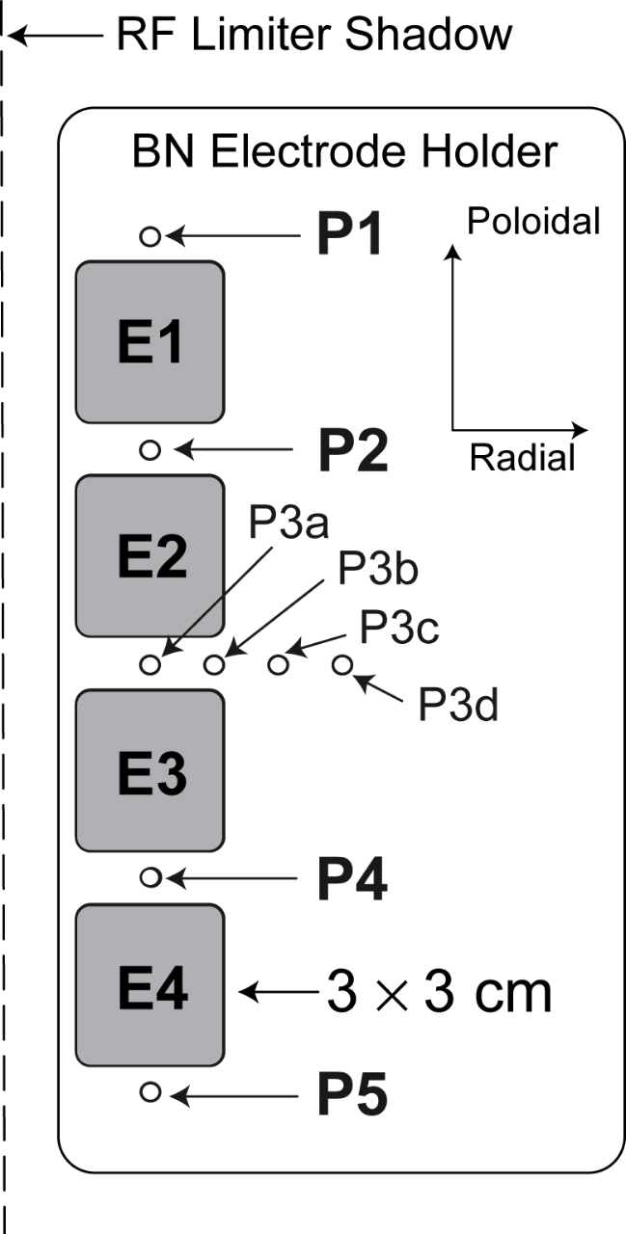

Fig. 1

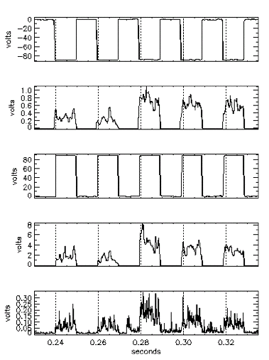
electrode #2 voltage (volts)
electrode #2 current (amps)
electrode #3 current (amps)
electrode #3 voltage (volts)
probe #3b current (amps)
H
L

Fig. 2

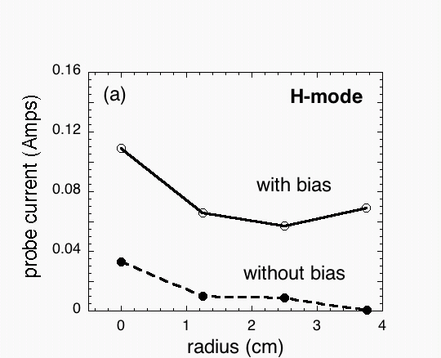
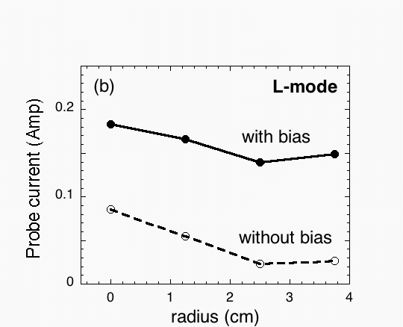

Fig. 3

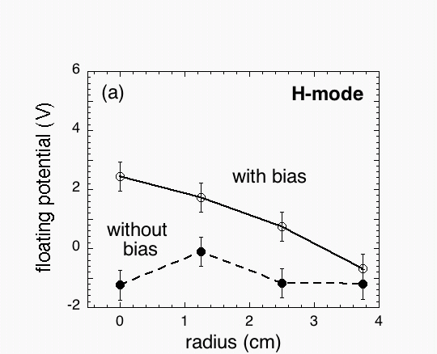
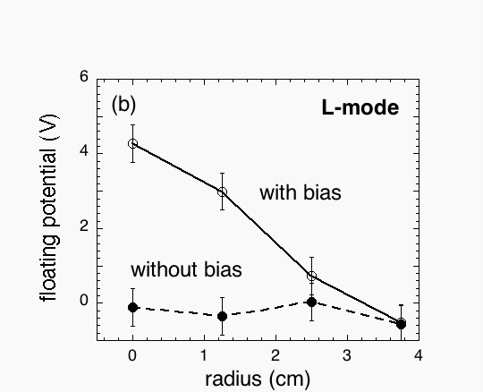

Fig. 4

