Progress in Developing the STFNSF Configuration*
T. Brown¹, J. Menard¹, P. Titus¹, A. Zolfaghari¹, L. El Guebaly², L. Mynsberge²
¹ Princeton Plasma Physics Laboratory, Princeton, NJ, USA
² University of Wisconsin, Madison, WI, USA
Author e-mail: tbrown@pppl.gov

Abstract— The design features developed for the Spherical Tokamak (ST) in the PPPL pilot plant study was used as the starting point in developing designs to meet the mission of a Fusion Nuclear Science Facility (FNSF) considering a range of machine sizes based on the influence of tritium consumption and maintenance strategies. The compact nature of a steady state operated ST device for this mission pushes operating conditions and places challenges in the design of components, device maintenance and the integration of supports and services.
This paper reviews the general arrangement, design details and maintenance strategy of the ST-FNSF device core for a 1.6-m and 1.0-m device; operating points which bracket the region between purchasing and breeding tritium.

Keywords—spherical tokamak; fusion; dpa

Introduction
One of the mission elements defined in the PPPL pilot plant study was to achieve Q_{eng} ≥ 1 which set the spherical tokamak option at 2.2-m major radius, if operated at a thermal efficiency (η_{th}) of 0.4 [1]. For a fusion nuclear science mission achieving Q_{eng} of 1 is not a necessary requirement. Defining a device size that provides sufficiently high wall loading with commensurate tritium breeding in a configuration designed to promote high operating availability are the characteristics needed to achieve the testing requirements of a fusion nuclear science mission.
*This work supported by the US DOE Contract No. DE-AC02-09CH11466
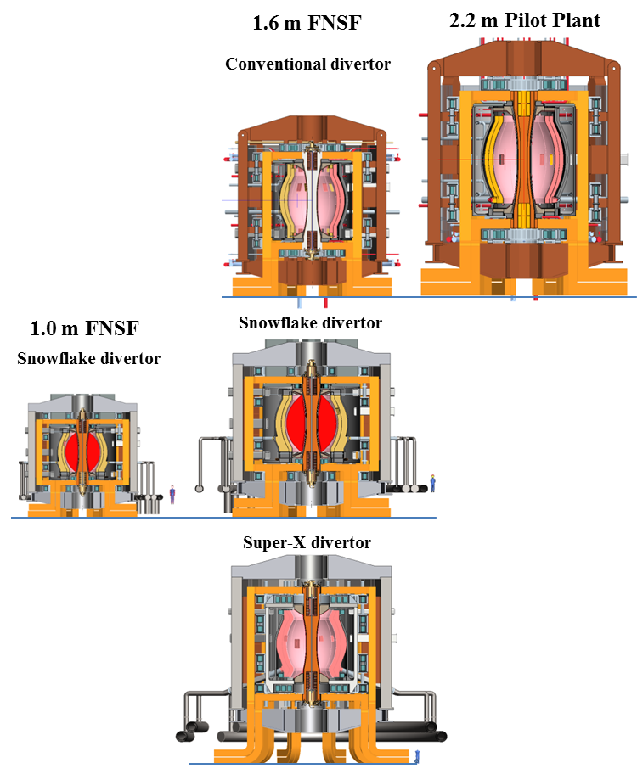
Fig 1. Configuration arrangement of evaluated ST options
The cost of tritium is expensive enough to enter the evaluation process in defining the machine mission and device size. With the elimination of the Q_{eng} requirement for the ST it is expected that a machine size could settle in the range of 1 to 1.6-m. A FNS mission with 1 MWy/m² would result in an annual cost of $0.3B to $0.9B for a 1-m major radius (R₀) and 1.6m device respectively and for a FNS component testing mission of 6 MWy/m² would result in an annual cost of $2.0B to $5.4B for the perspective 1-m and 1.6-m devices [2]. The implication here is that a tritium breeding ratio (TBR) of much less that 1 would be acceptable for the 1 MWy/m² FNS mission for a machine size on the order of 1-m major radius. For a 6 MWy/m² component testing mission a TBR approaching 1 would be required for all machine sizes considered. The compact nature of an ST device also warrants the evaluation of advanced divertor geometries (i.e. Snowflake and Super-X divertor geometries) to reduce divertor heat loads.
TBR and shielding analyses performed in support of the ST-FNSF study will be discussed in a paper by El-Guebaly [3] and details dealing with physics issues and poloidal field (PF) coil configurations to support different divertor geometries and a range of current profiles will be covered by Menard [4].
The evolution of different conceptual design configurations that support the proposed physics solutions will be presented in detail in this paper. As the initial pilot plant was reduced from 2.2-m to 1.6-m and eventually 1-m the device size and PF arrangements began to affect the configuration design choices and added restrictions on interfacing plasma components and external services.

Configuration design overview

The range of device sizes considered
The FNS configuration evolved through a sizing process and a selection of the divertor designs. Figure 1 provides a collection of scaled figures representing the different designs developed to support this effort starting with the 2.2-m pilot plant [5] [6], down to the 1.6-m devices and then to a 1.0-m FNS device. The 1.6-m size device was developed for each of three divertor options, a conventional divertor, a snowflake divertor and Super-X divertor.

Basic configuration features
The configuration developed for all options is driven by a collection of design choices that include: locating a vacuum vessel inside the TF coils, incorporating ten discrete TF coil legs that connect to a single turn hour-glass shaped TF center post, defining a robust PF coil arrangement to achieve plasma shaping and defining a concept that allows vertical access from above to remotely maintain the internal plasma core components. To minimize resistive losses for the water cooled copper TF system, the return legs were expanded in cross-section and superconducting PF coils are used where sufficient shielding is present. To keep within the criteria of using near term manufacturing techniques, a plate assembled design with MIT Alcator C-mod style sliding joints that include Felt metal electrical interfaces was adopted for the TF center post [5]. The plates of the center post incorporate vertical holes that run the length of the plate, an approach proposed in other ST neutron source concepts [7] and analyzed in an earlier study [5] showing acceptable thermal stress conditions. A radial coolant option is being evaluated as an alternate approach which may prove to be more space and operational efficient than the current design approach [8].
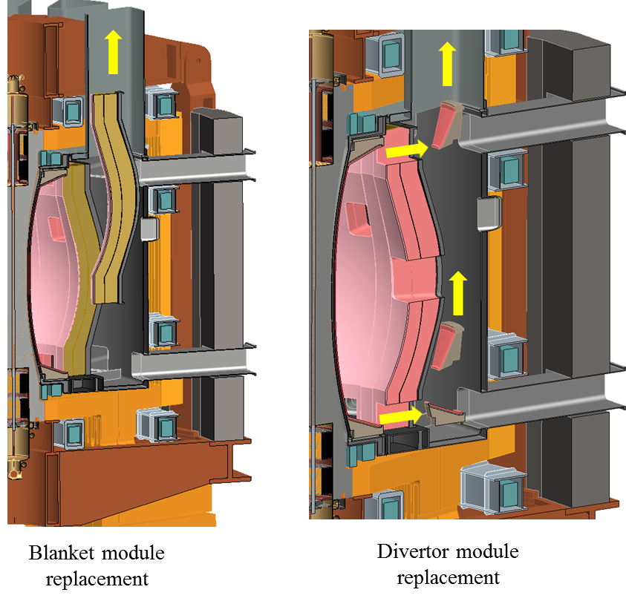
Fig 3. Internal segmentation allowing divertor and blanket module maintenance

A pair of Bitter plate PF coils is located inside the upper/lower region of the TF coil center post to help perform divertor shaping. Additional resistive copper coils located just outside the vacuum vessel, near the divertor are also added to help shape a snowflake divertor arrangement (discussed in further detail in this paper). The Bitter plate coils are canned in a copper alloy structure that contain matched drilled coolant holes which interface with holes emanating from the plates of the TF center post. A separate coolant supply is provided to the center post and to each PF center stack assembly with a common return system. The TF center post is Glidcop, a dispersion strengthened copper-alloy and a leak free system will be created by furnace brazing of the entire center post/PF containment structure. All outer PF coils are superconducting. The center-stack and Bitter plate design details are illustrated in Figure 2.
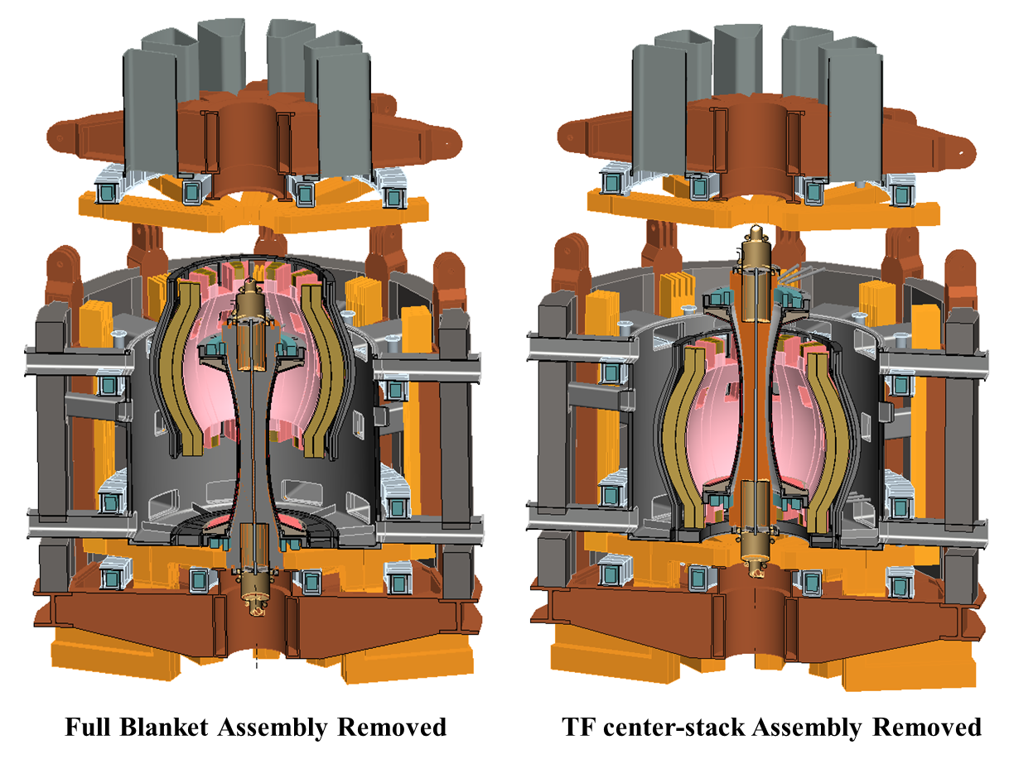

Fig 4. TF center-stack and full blanket assembly

In the larger pilot plant device and two of the FNS 1.6-m designs (options using conventional and a snowflake divertor) the TF coil outboard legs were positioned farther back to provide enough internal space to allow independent removal of divertor modules or individual blanket sub-modules through vertical vacuum vessel ports, eliminating the need to remove the full level of upper components to gain access to plasma area. This is illustrated in Figure 3. Given the large cross-section of the TF radial legs, increasing the radial extent did not adversely increase the overall circulating power. Horizontal ports are included at the divertor location to provide external service connections and diagnostic access. The configuration arrangement can support an ITER style divertor maintenance scheme but current plans are to provide horizontal remote maintenance assistance for a vertical maintenance approach. In addition to the removal of individual blanket and divertor segments the early pilot plant and 1.6-m FNS configurations allowed for the complete removal of a fully assembled blanket module or the complete TF center-stack if required, as illustrated in Figure 4.
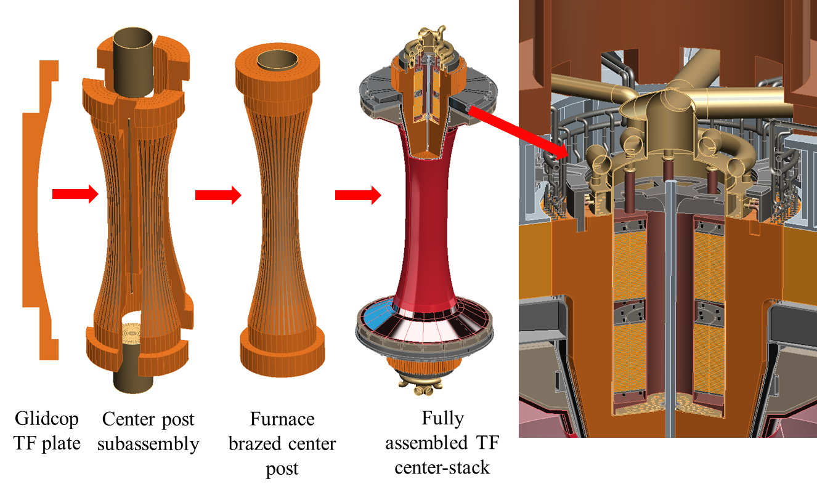
Fig 2. TF center-stack details
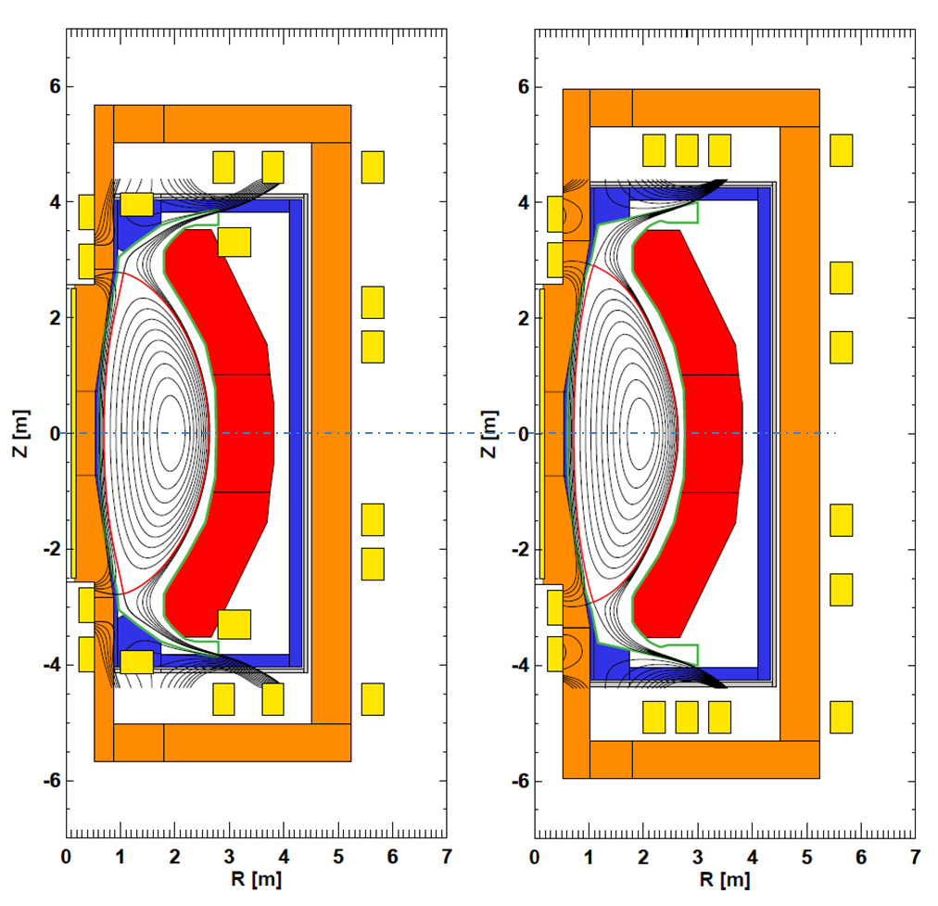
Fig 6. Super-X divertor PF arrangements
The structure support system for all ST-FNS designs developed use an external structure (shown in Figure 5) to support the magnetic loads, with vertical and out-of-plane TF loads transferred through local supports along the horizontal and outer vertical legs of the coil. The out-of-plane loads are equilibrated top-to-bottom by an external shell structure formed by the interconnection of outer panels and vertical support beams. In moving to the smaller 1.6-m and 1.0-m devices the upper dome structure was reduced in size and changed to a bolted connection to the outer structure using Superbolts with multi-jackbolt tensioners, instead of the multi-fingered pin connection developed for the larger (2.2-m) pilot plant device.
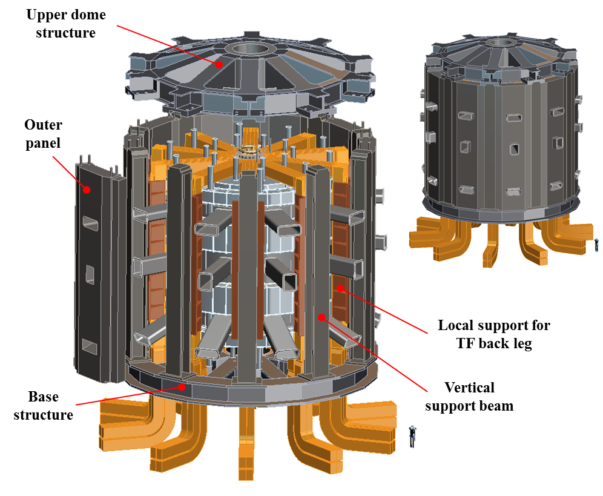
Fig 5. FNS structural arrangement

Impact of advanced divertors

The steady-state operation of an ST-FNS device has higher heating power and more severe divertor heat loads when compared with current experimental devices and ITER. After a basic definition of the ST-FNS configuration was established for a standard divertor scenario, snowflake and Super-X divertor configurations were developed by Menard [4] to reduce the divertor heat load with coil configurations and divertor geometry that was compatible with engineering and device maintenance requirements. A number of equilibrium studies were made with results of this effort illustrated in the two Super-X divertor cases shown in Figure 6. The PF arrangements define a self-consistent coil set that handles a respectable range of li values and plasma shapes.
With these advanced divertor shapes the divertor heat loads were reduced to the range of 3-5MW/m², which are acceptable values. Aside from small physics differences, the PF arrangement of the two options differs in the location of coils in the vicinity of the plasma sepatrix. External coils outside the vacuum vessel may be sufficiently shielded to allow some or all of them to be superconducting. The arrangement on the right has no coils near the sepatrix resulting in a solution with lower li and a drop in plasma elongation. These configurations also need to keep outboard PF coils closer to the plasma which eliminates the option of vertical maintenance of individual blanket segments. The divertor flux is moved out in major radius with reduced divertor heat loads and the space may allow an ITER style divertor maintenance scheme through horizontal ports located in the area.
The implications for locatig a coil near the sepatrix (as shown in left view of Figure 6) is that space is not available to provide sufficient shielding to allow coil windings to be made of standard organic insulation and space must be allocated to route coil leads and coolant services. Figure 7 shows the confined space for coils located in the divertor region. To allow instalation of the internal PF ring coil over the TF center post the position of the TF center post sliding joint was moved radially inward from the positoin established for the standard divertor machine design. This placed more restrictions on the center post services, torque restraint structure and space allocated to the sliding joint pressurized blader pack services. Although not enough shileding for organic insulation is available the level of shielding from the divertor and local shielding does allow the divertor shaping coils to be constructed using MgO insulated copper sandwished within a stainless steel tube. Design and analysis of a 1MA-turn winding was developed for steady state operating conditions. A concentric set of two three-trun pancake windings was designed with water flowing at 6 m/s and exiting after three turns of each layer; holding the water exit temperature at 72°C (see figure 8). Given the space available for a close-in divertor coil for the 1.6-m device arrangement the maximum current capacity is on the order of 1.5MA-turn with a water flow rate of 10 m/s. To develop the structural integraty of the magnet the full widing would be joined through a furnace braze process.

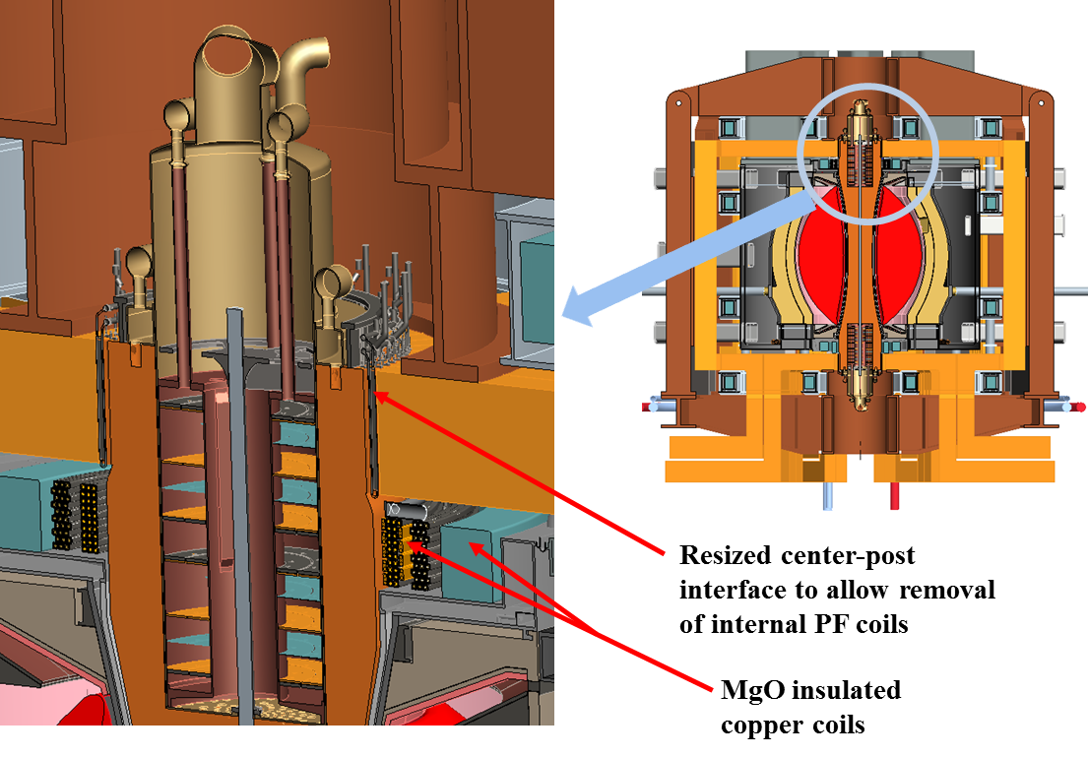
Fig. 7 Revisions made to the ST configuration with a standard divertor to accommodate close-in divertor shaping coils

1.6-m Super-X divertor configuraiton
Further evaluation proceeded with the ST-FNS design to accommodate the Super-X divertor arrangement depicted on the right hand side of Figure 6. Figure 9 defines the detail of the updated ST-FNS design with the exploded view of Figure 10 highlighting the assembly features of the device. From a device design standpoint there were both positive and negative developments with the change of the divertor magnetics. On a positive side, PF divertor shaping coils were moved away from the restricted space near the divertor to areas providing greater space for shielding. The requirement to keep all PF coils relative close to the plasma implies that access to all plasma components can only be accomplished with the removal of the upper vacuum vessel closure structure and all components above it (upper PF coils, TF horizontal legs, external support structure, test cell shield plug) along with the disconnection of any interfacing leads and services.
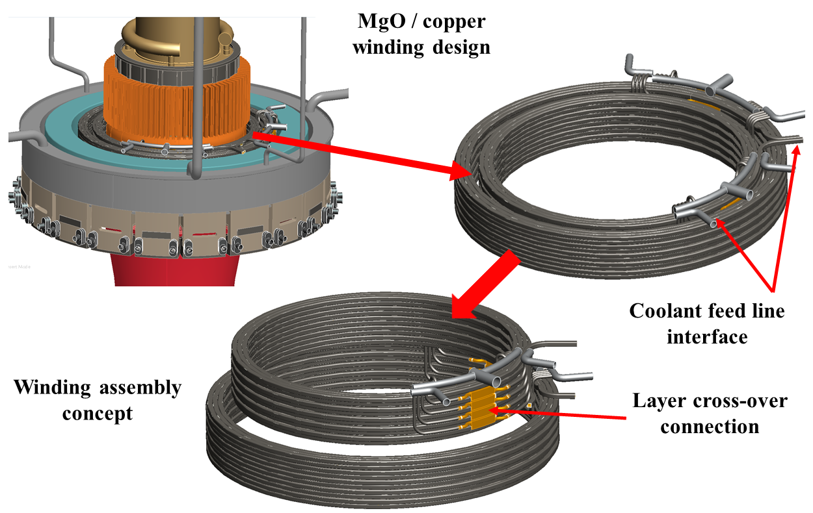

Fig. 8 MgO insulated copper winding
All external superconducting PF coils are contained in vacuum enclosures with space allocated for super-insulation, structural connections to adjacent superconducting magnets and connections to the external magnet beam structure. Space to interface with exterior components and services became more restrictive on the outer vertical section of the device. With the close proximity between some of the outer PF coils, a common cryostat was defined to house two coils. A DCLL blanket system was assumed in developing the blanket design. In conforming to the open space of this latest configuration the Pb-Li concentric piping arrangement was placed at an angle between two lower sets of PF coils and routed to the basement. All blanket piping must be disconnected to remove the blanket modules. With the concentric piping arrangement of the DCLL design only the outer pipe has a weld connection at the blanket interface. A separate weld joint connection was located outside the external magnet structure, just inside the test cell cylindrical bioshield wall. Sufficient space is needed between these surfaces to allow cutting of the outer pipe at the second interface as well as installation space in the first floor above the Pb-Li pipe manifold system located in the basement. Installation space will also be required to remove all local manifold piping as well as space to insert and retract all angled Pb-Li pipes interfacing with the blanket modules. It is assumed that an internal pipe welder/cutter system will be incorporated with access from the basement. Coolant services have not been defined for the center-stack or outer VV which also serves as a shield system with shield material located between the double walls. The main open issue is resolving expected conflicts that will occur between the blanket system services and the TF power supply systems that also will be located in the basement.
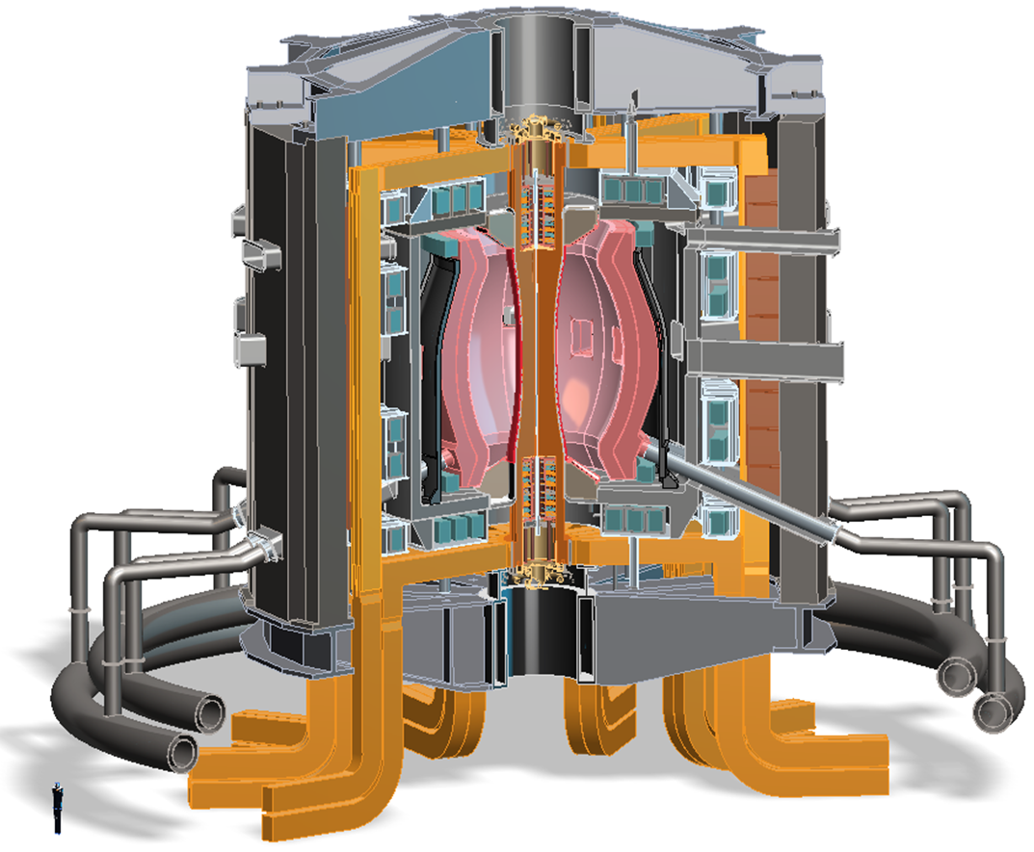
Fig. 9 1.6-m Super-X device configuration
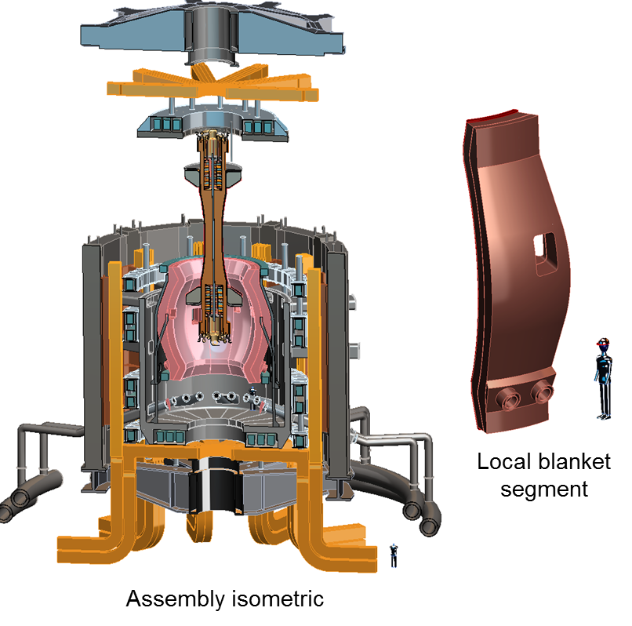

Fig. 10 Exploded view of the 1.6-m Super-X device and a view of a local blanket segment
An observed difference between the PF divertor coil arrangement of Figure 6 and the detailed configuration drawing of Figure 9 is in swapping the position of the TF outboard vertical leg with the PF coils that were located on the outboard side of the vacuum vessel. This change was done because it was easier to support the TF vertical legs to the outer structure, it provided more space to the vacuum vessel for shielding and it brought the PF coils closer to the plasma without adversely increasing the TF circulating power. A small internal MgO-copper coil was also included inside the vacuum vessel (top and bottom) to see if a reasonable design could be developed that might allow improved plasma characteristics – equilibrium studies need to be performed to determine the merit of the added internal coils.
Figure 11 shows a general arrangement of the 1.6-m Super-X device in a speculative test cell. Six JT-60SA NNBI’s which are well suited for the 1.6-m device are shown interfacing with the vacuum vessel just off the midplane, limited by restrictions placed on it by location of the outer PF coils. There is space to tilt the beams if this would augment plasma heating or current drive. In order to minimize Joule losses in the TF leads, the power supplies need to be located as close to the TF coils as possible. Given the vertical maintenance scheme at the top and heating systems surrounding the device mid-section - power supply systems were located in the basement at the bottom of the device. A hypothetical set of power supplies scaled from ARIES-ST was added to the ST-FNS facility layout. The ITER building was used as an initial starting point in defining the facility layout. To accommodate space for six NNI beams and their power supplies the ITER building was lengthened in the direction of the bridge crane to. No attempt was made to add local shielding or beam maintenance features. The TF power supplies currently are equally spaced outside the basement biological shield. A readjustment in spacing will be needed to allow room to bring out the lower PF coil superconducting leads and center-stack services along with the necessary space to support maintenance activities that will occur beneath the device. Considered but not developed at this time are the remote maintenance equipment, maintenance facility and tritium containment systems needed to handle/transport a complete blanket system and center-stack and the containment of a contaminated upper vacuum vessel lid.
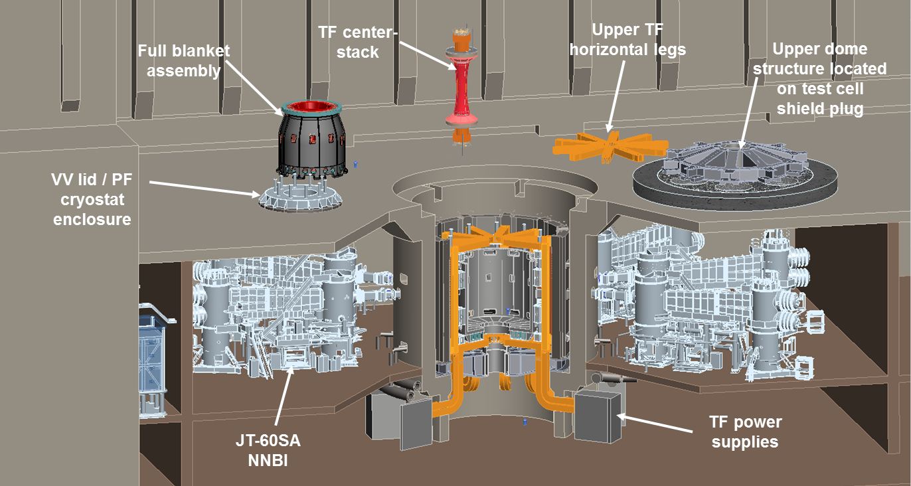

Fig. 11 1.6-m Super-X FNS device and test cell arrangement

1.0-m Super-X configuration

The 1.6-m device was downsized to 1.0-m, keeping the 1MW/m² fixed to keep the dpa the same for all configurations investigated. Developing the 1.0-m device for the ST-FNSF study is in the early phase so details are not complete. With this smaller device defining adequate shielding to protect the TF center-stack will not be possible, therefore the need to replace it more frequently than the case of the 1.6-m device will be required. The smaller size of the 1.0-m device may allow positive NBI to be used which may be smaller, both items leading to a reduced size test cell. More analysis and design effort is needed to fully evaluate this option.

CONCLUSIONS

The mission of a FNSF is to provide the operating environment to perform the material testing and plasma material interaction (PMI) necessary to establish the material science base and technology for a viable fusion energy program. The ST-FNSF study reported here primarily covers a medium-scale 1.6-m ST design with a goal of component testing, tritium self-sufficiency and performance level to achieve a minimum 6MW-y/m² neutron fluence. Greater clarity has been reached in defining the physics, plasma shaping and engineering details for the ST in striving to meet this mission. Further work is needed to fully understand the physics, design conditions and FNS mission level presented in moving to a smaller 1.0-m device. There are design and technology issues outside the plasma chamber that need to be addressed in perusing the ST option. Research and development is needed to define an insulation scheme for a Bitter plate magnet design located within the TF center post that precludes arcing through water when acting under chemistry changes due to radiation; the development of a technically viable close-in TF power system that can be located in the basement which will effectively co-exist with expected Pb-Li manifold lines, lower PF leads, TF center-stack services and lower maintenance requirements is needed and further development of the overall maintenance scheme and required tritium containment cask system also must be defined. To complete the study an assessment dealing with the feasibility of using high temperature superconducting TF coils for the ST option should be made and finally a candid evaluation of performing the FNS component testing mission using a superconducting advanced tokamak design operating without Q_{eng} requirements must be made.

References

- J.E. Manard et al., “Prospects for pilot plants based on the tokamak, spherical tokamak and stellarator,” 2011 Nucl. Fusion, Vol. 51 103014
- J.E. Manard et al., “Studies of ST-FNSF mission and performance dependence on device size,” 1st IAEA DEMO Programme Workshop, UCLA, Los Angeles, CA U.S.A, 15-18 October 2012
- L. El-Guebaly et al., “TBR and shielding analyses in support of ST-FNSF study,” 25th Symposium on Fusion Energy, San Francisco, CA, June 2013.
- J.E. Manard et al., “ST-FNSF mission and performance dependence on device size,” 25th Symposium on Fusion Energy, San Francisco, CA, June 2013
[5] T. Brown et.al, Progress in Developing a High-Availability Advanced Tokamak Pilot Plant, 24th Fusion Energy conference, San Diego, Calif., 8 October 2012.
[6] T. Brown et.al, Comparison of Options for a Pilot Plant Fusion Nuclear Mission, ANS 20th Topical Meeting on the Technology of Fusion Energy, Nashville, Tn., August 2012.
[7] V.A. Belyakov et al., The center post alternate design version for volumetric neutron source based on spherical torus, Fusion Engineering and Design 45 (1999) 317-331.
[8] R. Wolley., “Radial Cooling of a Spherical Torus (ST) TF Centerpost,” 25th Symposium on Fusion Energy, San Francisco, CA, June 2013

