Princeton Plasma Physics Laboratory
NSTX-U Experimental Proposal
Title: ELM pacing via multi-species granule injection and 3D field application for main ion control
OP-XP-1527 | Revision: | Effective Date:  (Approval date unless otherwise stipulated)  Expiration Date:  (2 yrs. unless otherwise stipulated)
PROPOSAL APPROVALS
Responsible Author: R. Lunsford |  |  | Date 5/13/2015
SG, TSG or TF Leader (assigned by RC): |  |  | Date
Run Coordinator (RC): |  |  | Date
Responsible Division: Experimental Research Operations
RESTRICTIONS or MINOR MODIFICATIONS
(Approved by Experimental Research Operations)

NSTX- EXPERIMENTAL PROPOSAL
TITLE: ELM pacing via multi-species granule injection and 3D field application for main ion control | No. OP-XP-1527
AUTHORS: R. Lunsford (PPPL), J.D. Lore (ORNL) | DATE:

1. Overview of planned experiment
This XP aims to demonstrate main plasma ion control during the boronization wall-conditioning operational phase of NSTX-U. Two techniques will be explored: 1) the injection of non-fueling solid granules of various species, and 2) the application of 3D field pulse trains. Granule injection is an extension of the “ELM control by pellet pacing” joint experiment (ITPA PEP #30) which has demonstrated a reduction in stimulated ELM intensity through high frequency pellet injection and also shown a corresponding clamping of core impurity accumulation. Similarly, pulse trains of applied 3D magnetic fields were used on NSTX to pace ELMs and control the ramp of the electron density and radiated power in otherwise ELM-free discharges with lithium coated walls. In this experiment both techniques will be attempted in discharges with a low natural ELM frequency (~10Hz). The granule species and size; 3D field pulse frequency, amplitude, and waveform; and plasma shape will be varied to determine the effect on ELM frequency and size, divertor heat flux, and main plasma ion and impurity control, with the goal of producing a discharge with reliable triggering and stationary conditions.

2. Theoretical/ empirical justification
The mitigation of peak heat flux due to edge localized modes is critical to preventing material erosion in plasma facing components. As there is evidence[1] for an inverse relation between ELM frequency and the energy contained within the mode, rapid small ELMs can be used as a method for managing this heat flux. ELM pacing has been demonstrated via several methods, including the application of 3D magnetic fields and edge density perturbations as a result of granule injection. The empirical relation between ELM energy loss (ΔW_{ELM}) and ELM frequency (f_{ELM}) as a function of P_{SOL} , the scrape off layer power input has been shown[1] to be
f_{ELM} x (ΔW_{ELM}) = (0.2 0.4) x P_{SOL}
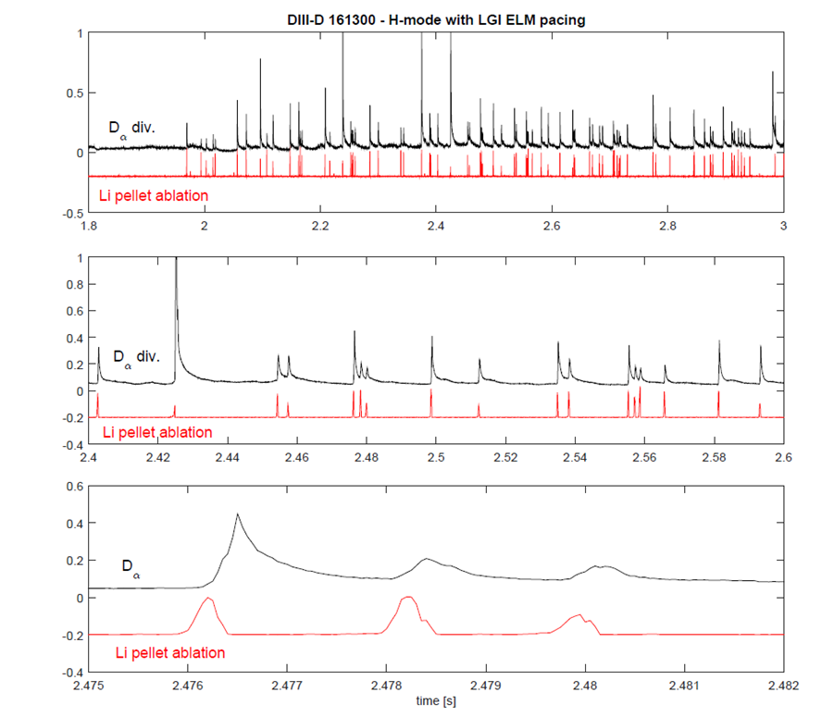
As was demonstrated on DIII-D[2] the rapid (60Hz) injection of deuterium pellets generated reliable, on demand ELM triggering at 12x the natural discharge ELM frequency. This led to a drop in the ELM energy content by a commensurate amount. While the utilization of deuterium pellets for fueling and ELM pacing has been extensively studied[3], triggering ELMs with small impurity granules is a more recent development. The use of lithium granules to trigger and pace ELMs has been successfully demonstrated on EAST [4] and more recently on DIII-D[5]. In the latter experiment lithium granules were injected at controlled velocities ranging from 50-100 m/s and were found to increase the natural ELM frequency of the discharge from 20-25 Hz to 50-100 Hz. Expanding the time base for the D_{α} traces shown in figure 1 in the second and then again in the third graph it becomes increasingly apparent that there is a causal link between the light recorded by the pellet ablation (red trace) and a resulting ELM event as evidenced by the D_{α} transient (black trace). This increased ELM frequency led to a reduction of the peak ELM heat flux and an clamping of the intrinsic Ni impurity content as measured in the plasma core.
Figure 1: ELM pacing by Li granule injection on DIII-D (A. Bortolon)

This XP expands these experiments to additional species of non-fueling impurity granules for experiments in ELM pacing, ablation physics and impurity transport. The utilization of materials similar to the wall components in ITER, specifically boron carbide and vitreous carbon, make an attractive injection species choice as these exhibit a similarity in density and sublimation energy to beryllium.

The pacing of ELMs via the application of 3D field pulse trains of various frequency and waveform has been demonstrated on NSTX [6,7] on discharges that were otherwise ELM-free due to the use of lithium wall conditioning. The paced ELMs were successful in controlling the impurity concentration and radiated power increase; however work remains in developing integrated scenarios to account for deleterious effects such as core confinement degradation and the triggering of tearing modes that can occur at high pacing frequencies. These effects may be mitigated by combining 3D field triggering synergistically with other pacing techniques. With boronized walls, where the discharge length is limited by main ion accumulation, 3D field ELM pacing has not been attempted. As plasma stability is clearly affected by the wall conditions, the 3D field perturbation amplitude required for triggering is yet to be determined.

[1] Loarte A., et al., 2014 Nucl. Fusion 54 033077
[2] Baylor L. R., et al., 2013 Phys. Rev. Lett. 110 245001
[3] Pégourié B., 2007 Plasma Phys. Control. Fusion 49 R87
[4] Mansfield D.K., et al., 2013 Nucl. Fusion 53 113023
[5] Bortolon A., et al., 2015 FESCPW Transients Workshop June 8-10
[6] Canik JM, et al., 2010 Phys. Rev. Lett. 104, 045001
[7] Canik JM et al 2010 Nucl. Fusion 50 064016

3. Experimental run plan

I_{P}

LGI
3D Fields

t₀
t₁
t₂
t₃
t_{F}

Figure 2:Subdivided experimental discharge template

The fiducial shot for this run plan will be a discharge with a natural ELM frequency of approximately 10 Hertz. Utilizing the earlier shots from the initial operations of NSTX-U as well as NSTX shot #112502 as guidance to determine the appropriate machine settings we will attempt to extend the plasma duration to approximately 2 seconds. As displayed on figure 2, the experimental operations during the discharge will be subdivided into two sections. After initial ramp up, the first approximately 500 milliseconds will be utilized for LGI operation, after which the LGI will be stopped and the 3D fields activated. As the operation of the LGI and 3D fields are uncoupled we will discuss them separately.

Granule Injector shot plan

1) Following the shot plan displayed in table 1 and using the injector assembly shown in figure 3 we will initially inject granules of boron carbide into the discharge at a range of granule frequencies and velocities. Impeller frequency will be monitored by a photodiode on the rear of the injector and impeller impact will be recorded by a fast camera viewing tangentially to the final trajectory. These impacts will then be correlated to the ablation flashes as viewed by a second camera. (5-7 shots)

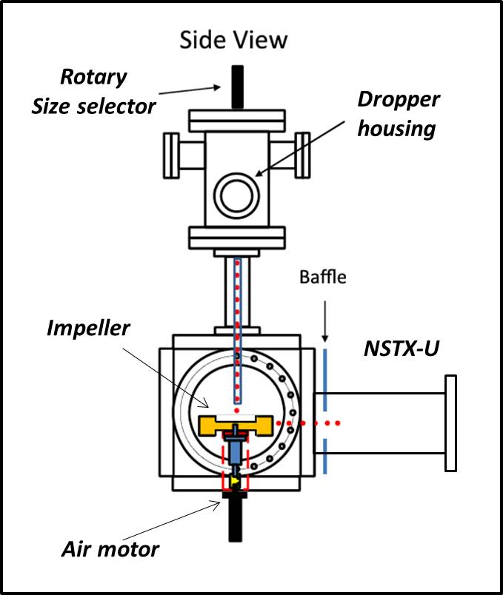
After the boron carbide experiments a controlled access to the test cell will be required in order to change granule species. The dropper housing is subdivided into a manually rotated set of 4 chambers to allow a change of granule size or type while still under vacuum. Three of these four chambers will be filled for this operation. Chamber 1 will be filled with 600 micron boron carbide granules. Chamber 2 will be left empty to facilitate the change in granule species. Chamber 3 will be filled with 600 micron carbon granules and chamber 4 will be filled with 900 micron carbon granules. During the first controlled access the dropper will be rotated from position 1 to position 2 (Empty) and run for a duration of not less than 1 minute to clear the crystal face of boron carbide particles. This duration can be extended if there is still visible particle throughput. After this the dropper will be rotated from position 2 to position 3 to fill the crystal face and then returned to position 2 and the piezo run again to further flush the crystal face. After this the dropper will be returned to position 3 and operation of the dropper will be observed to ensure a steady and regular flow of carbon granules.
Figure 3 : NSTX-U Granule Injector

2) The carbon granules will be injected into the plasma in an identical manner to the boron carbide granules. The only difference of note is the adjusted piezo voltage which has been reduced to maintain constant particle throughput (5-7 shots).

3) After the 600 micron carbon granule experiments are concluded an additional controlled access will be required to switch from the smaller to the larger carbon granules. In this instance there is no empty chamber separating sections 3 and 4 so an effort will need to be made to position the dropper opening between at the wall between the two sections in order to clear the granule inventory. After this has been accomplished the dropper can be moved to position 4 and operation verified with the cameras. Experiments are then repeated again with the final set of carbon granules (5-7 shots).

3D field ELM pacing shot plan
- Achieve baseline plasma with ramping main ion density and low (~10Hz) natural ELM frequency (1-3 shots).
- Determine the triggering threshold. Apply square wave n=3 binary pulse trains, 50% duty cycle, 10-80ms period with the amplitude increasing each pulse (anticipate 1-2kA). Apply pulse train on top of Error Field Coils if there is sufficient headroom in current (max 3.3kA). Reduce pulse length and amplitude if confinement degradation is strong or tearing modes triggered. Monitor effect on main ion and impurity diagnostics. (1-3 shots)
- Demonstrate reliable triggering, possibly several ELMs per 3D field pulse at this stage. Choose field level above threshold determined in step 1. Start with long pulses (50% duty cycle, ~30-60 ms period) to see if ELMs triggered each pulse and determine what natural ELMs do in between pulses. Decrease duty cycle as justified by time between 3D field application and first ELM. NSTX results showed decay time of internal fields on the order of 10ms, set by eddy currents in vessel and passive plates, limiting frequency to <50Hz. Vary amplitude as necessary to improve triggering. Monitor effect on main ion and impurity diagnostics. (2-5 shots)
- Decrease duty cycle and increase 3D pulse frequency to increase triggered ELM frequency. Push for single ELM triggering without natural ELMs. Monitor effect on main ion and impurity diagnostics. (2-5 shots).

Granule Injector and 3D field decision points
- Contingency shots may be used to reverse order of 3D field pulses and granule injection to determine effect (if any) of granule injection prior to 3D field application based on effectiveness of each technique. Priority given to granule injection as it will presumably be less disruptive to other experiments than 3D fields and it is a new technique.
- Impeller frequency and piezo voltage values are guidelines; these values may need to be adjusted if the particle load adversely affects plasma performance.
- Inability to generate reliable pacing with a particular species may adjust the timing of the controlled access points depending upon the discharge characteristics.
- It is anticipated based on NSTX results that square waves will be used for 3D field pulse trains; however it is possible that some tailoring of the waveform may lead to better performance. For example a large amplitude of short duration that is then reduced to an intermediate level, or (if approved by engineering) a short pulse of the opposite amplitude to reduce the impact of the fields on the plasma after the ELM is triggered.
- If n=3 pulses are ineffective, n=1 or 2 pulses may be attempted.
- If results warrant, ensure that a shot or set of shots is taken with a single pacing method per shot to determine maximum pulse length achievable and to have clean comparison for presentation and/or publication.
- Synergistic application of granule injection and 3D field pulses may be explored if both methods have been optimized quickly. It is possible that combining techniques may allow for reliable triggering with reduced perturbation from either method individually.

Shot Number | Granule Species | Granule Size | Impeller frequency | Piezo Voltage | Drop Duration*
1 (fiducial) | None
2 | B₄C | 600 μm | 125 Hz | 3 V | 500 ms
3 | B₄C | 600 μm | 125 Hz | 8 V | 500 ms
4 | B₄C | 600 μm | 250 Hz | 3 V | 500 ms
5 | B₄C | 600 μm | 250 Hz | 8 V | 500 ms
6 (Contingency) | B₄C | 600 μm | TBD | TBD | 500 ms
7 (Contingency) | B₄C | 600 μm | TBD | TBD | 500 ms
Controlled Access
8 (fiducial) | None
9 | C | 600 μm | 125 Hz | 1 V | 500 ms
10 | C | 600 μm | 125 Hz | 4 V | 500 ms
11 | C | 600 μm | 250 Hz | 1 V | 500 ms
12 | C | 600 μm | 250 Hz | 4 V | 500 ms
13 (Contingency) | C | 600 μm | TBD | TBD | 500 ms
14 (Contingency) | C | 600 μm | TBD | TBD | 500 ms
Controlled Access
15 (fiducial) | None
16 | C | 900 μm | 125 Hz | 1 V | 500 ms
17 | C | 900 μm | 125 Hz | 4 V | 500 ms
18 | C | 900 μm | 250 Hz | 1 V | 500 ms
19 | C | 900 μm | 250 Hz | 4 V | 500 ms
20 (Contingency) | C | 900 μm | TBD | TBD | 500 ms
Additional Shots | C | 900 μm | Single pacing method exemplar shots
Table 1 : Shot Plan
(* - Minimum drop duration, to be extended if flattop greater than 1 sec)

4. Required machine, NBI, RF, CHI and diagnostic capabilities
Granule Injector to be installed and operational, XMP to be completed prior to the start of the experiment.
Long duration (~2sec) relatively stable H-mode discharges with low natural ELM frequency should be demonstrated or have at least a reasonable chance of being achieved.

5. Planned analysis
EFIT and TRANSP as appropriate, comparisons to Nonlinear MHD code JOREK if possible, NGS pellet ablation model (for applicability to hard granule ablation), impurity transport analysis.

6. Planned publication of results
Results to be presented at 2015 APS-DPP meeting, 2016 IAEA and published in e.g. Nucl Fusion.

7. Estimated Neutron Production
Based on the number of shots, plasma current levels, and expected durations, estimate the maximum neutron production of this experiment. See calculator in Appendix #2 for this calculation.
# of Shots used in Estimate:___20___ Estimated Total Neutron Production:_ 1.2 x 10¹⁶___

PHYSICS OPERATIONS REQUEST
TITLE: ELM pacing via multi-species granule injection and 3D field application for main ion control | No. OP-XP-1527
AUTHORS: R. Lunsford (PPPL), J.D. Lore (ORNL) | DATE:
(use additional sheets and attach waveform diagrams if necessary)
Brief description of the most important operational plasma conditions required and any special hardware requirement:
A stable H-mode discharge with a low natural ELM frequency (~10-20 Hz) is required for this experiment. These conditions were achieved on NSTX shot # 112502 with I_{P} = 0.8 MA and P_{NBI} = 5 MW.
Previous shot(s) which can be repeated:
Previous shot(s) which can be modified: NSTX # 112502 extended to 2 sec
Machine conditions (specify ranges as appropriate, strike out inapplicable cases)
B_{T} Range (T): Flattop Duration (s):
I_{P} Range (MA): Flattop Duration (s):
Configuration: LSN
Equilibrium Control: Outer gap / Isoflux (rtEFIT) / Strike-point control (rtEFIT)
Outer gap (m): Inner gap (m): Z position (m):
Elongation: Triangularity (U/L): OSP radius (m):
Gas Species: Injector(s):
NBI Species: D Heating Duration (s):
Voltage (kV) 50 cm (1C): 60 cm (1B): 70 cm (1A):
Voltage (kV) 110 cm (2C): 120 cm (2B): 130 cm (2A):
ICRF Power (MW): Phase between straps (°): Duration (s):
CHI: Off / On Bank capacitance (mF):
LITERs: Off / On Total deposition rate (mg/min) or dose per discharge (mg):
EFC coils: Off/On

DIAGNOSTIC CHECKLIST [1]
TITLE: ELM pacing via multi-species granule injection and 3D field application for main ion control | No. OP-XP-1527
AUTHORS: R. Lunsford (PPPL), J.D. Lore (ORNL) | DATE:

Note special diagnostic requirements in Sec. 4
Diagnostic | Need | Want
Beam Emission Spectroscopy
Bolometer – midplane array | X
CHERS – poloidal | X
CHERS – toroidal | X
Divertor Bolometer (LADA) | X
Divertor visible cameras | X
Dust detector
Edge deposition monitors [2]
Edge neutral density diag.
Edge MIGs [2]
Penning Gauges [2]
Edge rotation diagnostic
Fast cameras – divertor [2] | X
Fast ion D_alpha - poloidal |  | X
Fast ion D_alpha - toroidal |  | X
Fast lost ion probes - IFLIP
Fast lost ion probes - SFLIP
Filterscopes [2] | X
FIReTIP
Gas puff imaging – divertor
Gas puff imaging – midplane
Hα cameras - 1D [2] | X
Infrared cameras [2] | X
Langmuir probes – divertor |  | X
Langmuir probes – RF
Langmuir probes – RF ant.
Magnetics – Diamagnetism | X
Magnetics – Halo currents
Magnetics – RWM sensors | X

Note special diagnostic requirements in Sec. 4
Diagnostic | Need | Want
MAPP
Mirnov coils – high f. | X
Mirnov coils – toroidal array | X
MSE-CIF | X
MSE-LIF
Neutron detectors [2] | X
Plasma TV | X
Reflectometer – 65GHz
Reflectometer – correlation
Reflectometer – FM/CW
Reflectometer – fixed f
Reflectometer – SOL
SSNPA [2]
RF edge probes
Spectrometer – divertor | X
Spectrometer – MonaLisa | X
Spectrometer – VIPS | X
Spectrometer – LOWEUS | X
Spectrometer – XEUS | X
TAE Antenna
Thomson scattering | X
USXR – pol. Arrays |  | X
USXR – multi-energy |  | X
USXR – TG spectr. |  | X
Visible Brems. det. [2] | X

Notes:

[1] Check marks in this table do not guarantee diagnostic availability. Check with diagnostic physicists or research operations management to ensure diagnostic coverage.

[2] In some cases, a given line represents multiple diagnostics. For instance, there are multiple SSNPAs, multiple IR cameras, multiple neutron detectors, and multiple Langmuir probe arrays.

Appendix #1: Allowed Neutral Beam Power vs. Pulse Duration

Heating of the primary energy ion dump limits the beam duration to that given in the following table:
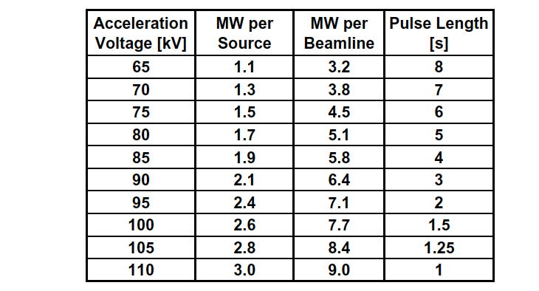
Table A1: Beam power and pulse length as a function of acceleration voltage

Appendix #2: Table for neutron rate estimations:

Table A2: Neutron Emission Rate Calculator. Double click to open in excel for automatic calculation. Change only the blue cells.

J.E. Menard, et al., Nuclear Fusion 52, 2012 (83015)

