Princeton Plasma Physics Laboratory
NSTX-U Experimental Proposal
Title: Characterize plasma near planned plenum entrance position
OP-XP-1528 | Revision: 0 | Effective Date:  (Approval date unless otherwise stipulated)  Expiration Date:  (2 yrs. unless otherwise stipulated)
PROPOSAL APPROVALS
Responsible Author: |  |  | Date
SG, TSG or TF Leader (assigned by RC): |  |  | Date
Run Coordinator (RC): |  |  | Date
Responsible Division: Experimental Research Operations
RESTRICTIONS or MINOR MODIFICATIONS
(Approved by Experimental Research Operations)

NSTX-U EXPERIMENTAL PROPOSAL
TITLE: | No. OP-XP-
AUTHORS: | DATE:

1. Overview of planned experiment
The goal of this experiment is to gather the divertor measurements that form the basis for the physics design of the cryo-pumping system. This includes divertor particle flux and electron temperature data from Langmuir probes, as well as heat flux measurements from the IRTV system. These will be measured under Boronized wall conditions early in the run, and under plasma conditions that are unlikely to be produced outside this experiment. In particular, the outer strike point will be swept across the planned cryo entrance to test the role of pump proximity in projected performance of the system. This data will be used to confirm the physics design, and to inform minor changes to the plenum geometry as part of the final engineering design.

2. Theoretical/ empirical justification
A physics design of the NSTX-U cryo pumping system has been performed using projections of the divertor plasma parameters based on SOL heat flux width scaling experiments and SOL T_{e} measurements from NSTX. While the semi-analytic pumping model forming the basis for the design has been validated against DIII-D experiments, this requires the divertor plasma to be known and so the weakest part of this effort has been the required projection of these for NSTX-U. In particular, the divertor Te was simply assumed to be 15 eV, based on the very weak dependences measured in NSTX. This is a questionable assumption, especially at higher current and power where the heat flux is anticipated to be much higher than in NSTX. With direct measurements of the plasma flux, density, and temperature in NSTX-U, the pumping calculations can be repeated with much more confidence in the results in order to confirm and finalize the design.
A key feature of the predictions and measurements at DIII-D to be tested is the sensitivity of pumping to proximity of the strike point to the plenum entrance. While projections for NSTX-U suggest that this dependence is weaker than DIII-D due to the strong flux expansion, this relies of projections of the full divertor profile which are very uncertain. This will be tested directly by sweeping the strike point across the planned plenum entrance and using the resulting data to predict the plenum pressure as a function of strike point proximity.

3. Experimental run plan
The overall plan for the experiment is to first establish a plasma scenario in which the outer strike point is swept across the planned pumping entrance, roughly from R_{OSP}~0.6 to ~0.8 m. This will be first done with NSTX-like parameters (I_{p}, B_{t}, P_{NBI}). The plasma current will then be increased as much as possible to make the SOL narrow and enhance the anticipated sensitivity of pumping to R_{OSP}. Finally, this will be repeated with input power increased as much as possible to vary the heat flux as much as possible and test its role both on the far SOL T_{e} and on pumping performance.
- Step 0: create shape with OSP on bullnose tile (3 shots)
  - Most parameters NSTX-like
    - Kappa~2-2.2, delta~0.6, drsep~-1 cm
    - B_{t}=0.45 T, I_{p}=1MA, P=4MW
- Scan 1: R_{OSP} (2 shots)
  - Sweep OSP from R~0.6 of R~0.8 over 200 ms
    - And back to check consistency
    - Need strike point control
- Scan 2: ROSP sweep at I_{p}=max (1.5 MA?) (3 shots)
    - Narrow SOL and test role of pump proximity
- Scan 3: Repeat at P=max (2 shots)
- If all goes well, next scan would be fexp
  - Make new shape with lower kappa, higher X-point (reduce fexp)
  - Repeat R_{OSP} scan

4. Required machine, NBI, RF, CHI and diagnostic capabilities
Strike point control needed. X-point even better.
NBI power of at least 4 MW needed.

5. Planned analysis
Analysis of the LP and IRTV data will be required to extract divertor heat and particle flux, and temperature and density. This will be then be analyzed first with the Maingi semi-analytic pumping model, then later with SOLPS to predict pumping performance of planned cryo system.

6. Planned publication of results

7. Estimated Neutron Production
Based on the number of shots, plasma current levels, and expected durations, estimate the maximum neutron production of this experiment. See calculator in Appendix #2 for this calculation.
# of Shots used in Estimate:________ Estimated Total Neutron Production:________________
PHYSICS OPERATIONS REQUEST
TITLE: | No. OP-XP-
AUTHORS: | DATE:
(use additional sheets and attach waveform diagrams if necessary)
Brief description of the most important operational plasma conditions required and any special hardware requirement:
Previous shot(s) which can be repeated:
Previous shot(s) which can be modified:
Machine conditions (specify ranges as appropriate, strike out inapplicable cases)
B_{T} Range (T): Flattop Duration (s):
I_{P} Range (MA): Flattop Duration (s):
Configuration: Limiter / DN / LSN / USN
Equilibrium Control: Outer gap / Isoflux (rtEFIT) / Strike-point control (rtEFIT)
Outer gap (m): Inner gap (m): Z position (m):
Elongation: Triangularity (U/L): OSP radius (m):
Gas Species: Injector(s):
NBI Species: D Heating Duration (s):
Voltage (kV) 50 cm (1C): 60 cm (1B): 70 cm (1A):
Voltage (kV) 110 cm (2C): 120 cm (2B): 130 cm (2A):
ICRF Power (MW): Phase between straps (°): Duration (s):
CHI: Off / On Bank capacitance (mF):
LITERs: Off / On Total deposition rate (mg/min) or dose per discharge (mg):
EFC coils: Off/On

DIAGNOSTIC CHECKLIST [1]
TITLE: | No. OP-XP-
AUTHORS: | DATE:

Note special diagnostic requirements in Sec. 4
Diagnostic | Need | Want
Beam Emission Spectroscopy
Bolometer – midplane array
CHERS – poloidal
CHERS – toroidal
Divertor Bolometer (LADA)
Divertor visible cameras
Dust detector
Edge deposition monitors [2]
Edge neutral density diag.
Edge MIGs [2]
Penning Gauges [2]
Edge rotation diagnostic
Fast cameras – divertor [2]
Fast ion D_alpha - poloidal
Fast ion D_alpha - toroidal
Fast lost ion probes - IFLIP
Fast lost ion probes - SFLIP
Filterscopes [2]
FIReTIP
Gas puff imaging – divertor
Gas puff imaging – midplane
Hα cameras - 1D [2]
Infrared cameras [2]
Langmuir probes – divertor
Langmuir probes – RF
Langmuir probes – RF ant.
Magnetics – Diamagnetism
Magnetics – Halo currents
Magnetics – RWM sensors

Note special diagnostic requirements in Sec. 4
Diagnostic | Need | Want
MAPP
Mirnov coils – high f.
Mirnov coils – toroidal array
MSE-CIF
MSE-LIF
Neutron detectors [2]
Plasma TV
Reflectometer – 65GHz
Reflectometer – correlation
Reflectometer – FM/CW
Reflectometer – fixed f
Reflectometer – SOL
SSNPA [2]
RF edge probes
Spectrometer – divertor
Spectrometer – MonaLisa
Spectrometer – VIPS
Spectrometer – LOWEUS
Spectrometer – XEUS
TAE Antenna
Thomson scattering
USXR – pol. Arrays
USXR – multi-energy
USXR – TG spectr.
Visible Brems. det. [2]

Notes:

[1] Check marks in this table do not guarantee diagnostic availability. Check with diagnostic physicists or research operations management to ensure diagnostic coverage.

[2] In some cases, a given line represents multiple diagnostics. For instance, there are multiple SSNPAs, multiple IR cameras, multiple neutron detectors, and multiple Langmuir probe arrays.

Appendix #1: Allowed Neutral Beam Power vs. Pulse Duration

Heating of the primary energy ion dump limits the beam duration to that given in the following table:
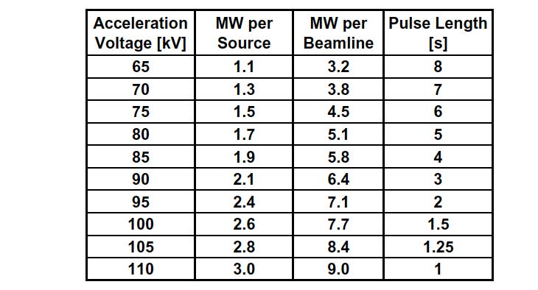
Table A1: Beam power and pulse length as a function of acceleration voltage

Appendix #2: Table for neutron rate estimations:

Table A2: Neutron Emission Rate Calculator. Double click to open in excel for automatic calculation. Change only the blue cells.

J.E. Menard, et al., Nuclear Fusion 52, 2012 (83015)

