Princeton Plasma Physics Laboratory
NSTX Experimental Proposal
Title: Effect of Fueling Location on H-mode Access and Quality
OP-XP-305 | Revision: | Effective Date: 1/20/03  (Ref. OP-AD-97)  Expiration Date:  (2 yrs. unless otherwise stipulated)
PROPOSAL APPROVALS
Author: R. Maingi |  |  | Date
ATI - Task Force Leader: B. LeBlanc |  |  | Date
RLM - Run Coordinator: S. Kaye |  |  | Date
Responsible Division: Experimental Research Operations
Chit Review Board (designated by Run Coordinator)

MINOR MODIFICATIONS (Approved by Experimental Research Operations)

Effect of Fueling Location on H-mode Access and Quality

R. Maingi, T. Biewer, R. Bell, D. Mueller, V. Soukhanovskii

1. Overview of planned experiment
The physics goal of this experiment is to compare the characteristics of H-mode discharges fueled with gas puffing from the high field side injector, the shoulder injector, the lower dome injector, and a low field side injector. The center stack midplane and shoulder injectors and also the lower dome injector are lock-and-load systems which have different temporal characteristics; these time characteristics will be matched by programming the low-field side injector to have identical flow rates to the other three.

This XP also has the programmatic development goal of re-establishing H-mode access after the CY2002 opening, and testing the impact of the shoulder injector which has a different time characteristic than the midplane injector.

2. Theoretical/ empirical justification

Recent theoretical work[] has shown that the poloidal location of neutral density introduced by a localized gas source can affect the magnitude of the charge exchange momentum loss. In particular, the charge exchange momentum loss rate can dominate the neoclassical damping rate if n₀/n_{i} exceeds 10⁻⁴. The charge exchange loss rate is stronger for a neutral source at the outer midplane than at the inner midplane, suggesting that the edge toroidal rotation would be higher for fueling from the inner midplane for comparable plasma parameters. Although this study was done for ohmic discharges, an extension to neutral beam heated discharges is in progress and this mechanism should lead to a lower power threshold for H-mode access when comparing center stack fueling with outboard side fueling[]. Research from DIII-D confirmed[] that the charge exchange rate could indeed be comparable to the neoclassical viscous damping rate in certain low density conditions, corroborated by the observation of a higher power threshold. However in those studies, the effect of poloidal variation of the gas input was not examined.

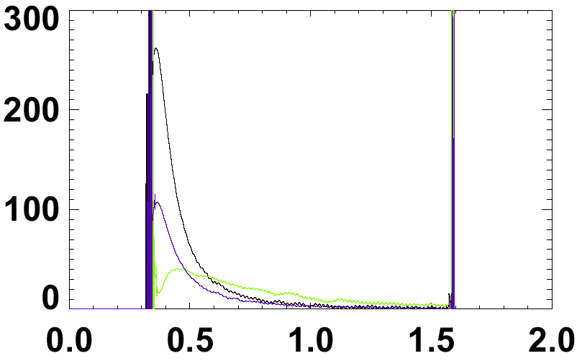
NSTX made significant improvements in H-mode access[,] by using the midplane center stack gas injector in CY 2002. However the center stack injector has a very rapid initial gas dump followed by a long dribble, due to its long tube. During the opening, an additional tube to the upper midplane center stack shoulder was installed. This tube allows for a more rapid dump (without the strong initial pop) followed by a shorter tail on the gas dribble. Finally the lower dome injector has been characterized and it has an even faster initial dump and almost no dribble.
Fuel Rate [Torr-l.s]

Time [sec]

Shoulder @ 1000 Torr

Shoulder @ 500 Torr

Midplane @ 1000 Torr

3. Experimental run plan
We will re-establish H-modes with inboard gas puffing, and compare with H-modes fueled with the shoulder injector, lower dome injector, and the low-field side injector. We also request 8 minutes HeGDC between discharges.

- Re-establish H-mode discharge with inboard puffing in LSN
- Use 0.8 MA, B_{t}=0.45 T (reference was 0.5 T), 2 srcs, LSN shot like 108741 (2-6 shots)
- repeat with lower fill pressures to vary neutral density (2 shots)
- repeat with single source, to localize power threshold (2 shots)
- Controlled access to change over to shoulder injector, at latest by 1 PM
- Test access w/shoulder injector (similar line density) to part 1, fill~300-600 torr (4–10 shots)
----- decision point – move onto LFS injection below if time running out ------
- Reproduce 1 and 3 above with low-field side injector (8-12 shots)
- Test access with lower dome gas injector at 100-200 torr fill pressure (3 shots)
- Establish H-mode discharge with inboard shoulder puffing in DND, time permitting
- Use 1.0 MA, B_{t}=0.4 T , 2 srcs, LSN shot like 108450 (2-4 shots)
- repeat with single source (2 shots)
- repeat with lower fill pressure (2 shots)

4. Required machine, NBI, RF, CHI and diagnostic capabilities
This XP requires an operational NBI system, as well as the capability of generating lower-single null an double-null diverted discharges with the plasma control system. No RF or CHI will be used during this experiment. The gas injectors must have been calibrated.

5. Planned analysis
Confinement analysis requires EFIT and TRANSP. Estimation of the neutral density will require UEDGE and DEGAS-2 modeling.

6. Planned publication of results
The results will be presented at the H-mode workshop and/or in APS talks.

PHYSICS OPERATIONS REQUEST
Effect of Fueling Location on H-mode Access and Quality XP #305
Machine conditions (specify ranges as appropriate)
I_{TF} (kA): 24-52 Flattop start/stop (s): _____/_____
I_{P} (MA): 0.8-1.0 Flattop start/stop (s):0.15/0.8
Configuration: Lower Single Null and double-null Diverted
Outer gap (m): __5-10cm_ Inner gap (m): _~2-3cm__
Elongation κ: _1.8_ Triangularity δ: __~0.3___
Z position (m): 0.00
Gas Species: D₂, Injector: CS midplane, Shoulder, Outer Midplane, Lower Dome
NBI - Species: D, Sources: A/B/C, Voltage (kV): 80, Duration (s):<0.6s
ICRF – Power (MW): 0, Phasing: N/A Duration (s): _____
CHI: Off
Either: List previous shot numbers for setup: 108741 (LSN), 108450 (DN)
Or: Sketch the desired time profiles, including inner and outer gaps, κ, δ, heating, fuelling, etc. as appropriate. Accurately label the sketch with times and values.

DIAGNOSTIC CHECKLIST
Title: Effect of Fueling Location on H-mode Access and Quality No. 305

Diagnostic system | Need | Desire | Requirements (timing, view, etc.)
Magnetics | 
Fast visible camera |  |  | (D_{α} filter)
VIPS-1 |  | 
VIPS-2 |  | 
SPRED | 
GRITS |  | 
Visible filterscopes | 
VB detector |  | 
Midplane bolometer |  | 
Diamagnetic flux | 
Density interferometer (1mm) |  | 
FIReTIP interf'r/polarimeter |  | 
Thomson scattering | 
CHERS | 
NPA |  | 
X-ray crystal spectrometer |  | 
X-ray PHA |  | 
EBW radiometer |  | 
Mirnov arrays | 
Locked-mode detectors | 
USXR arrays |  | 
2-D x-ray detector (GEM) |  | 
X-ray tangential camera |  | 
Reflectometer (4 ch.) |  | 
Neutron detectors |  | 
Neutron fluctuations |  | 
Fast ion loss probe |  | 
Reciprocating edge probe
Tile Langmuir probes |  | 
Edge fluctuation imaging |  | 
H-alpha cameras (1-D) | 
Divertor fast camera (2-D) |  |  | (D_{α} filter)
Divertor bolometer (4 ch.) |  | 
IR cameras (2) |  | 
Tile thermocouples
SOL reflectometer |  | 
Poloidal and toroidal rotation | 

References:

T. Fulop, et. al., 19th IAEA Fusion Energy Conference paper TH/P3-03, submitted to Nucl. Fusion.
K.C. Shaing, private communication, Oct. 2002.
B.A. Carreras, et. al., Phys. Plasmas 5 (1998) 2623.
R. Maingi, et. al., 19th IAEA Fusion Energy Conference paper EX/C2-5, submitted to Nucl. Fusion
C.E. Bush, et. al., 44th APS Meeting Invited talk, submitted to Phys. Plasma.

