Princeton Plasma Physics Laboratory
NSTX Experimental Proposal
Title: Divertor heat flux reduction and detachment in highly shaped plasmas
OP-XP-708 | Revision: | Effective Date:  (Ref. OP-AD-97)  Expiration Date:  (2 yrs. unless otherwise stipulated)
PROPOSAL APPROVALS
Author: V. A. Soukhanovskii |  |  | Date 02/08/2007
ATI – ET Group Leader: V. A. Soukhanovskii (H. W. Kugel) |  |  | Date
RLM - Run Coordinator: D. Gates (M. G. Bell) |  |  | Date
Responsible Division: Experimental Research Operations
Chit Review Board (designated by Run Coordinator)
MINOR MODIFICATIONS (Approved by Experimental Research Operations)

NSTX EXPERIMENTAL PROPOSAL
Divertor heat flux reduction and detachment in highly shaped plasmas OP-XP-708

1. Overview of planned experiment

The goal of this experiment is to determine conditions of the steady-state outer divertor target heat flux reduction and detachment in the NBI-heated H-mode plasma operational space in a higher-end elongation / triangularity LSN shape with κ=2.2−2.5 and δ=0.5-0.7, referred hereforth as the PF1A/PF1B shape. Two techniques will be used to achieve the outer target detachment: raising scrape-off layer density by means of D₂ injections, and raising edge radiated power by injecting an extrinsic impurity (CD₄ or N₂). In the first part of the experiment deuterium will be injected in the lower divertor region. In the second part of the experiment deuterated methane or nitrogen will be injected in increased quantities to yield P_{rad}/P_{in} up to 0.5 to obtain the outer target detachment. Divertor measurements, such as the D_{α}, D_{β}, D_{γ} brightnesses, heat flux (from IR cameras), radiated power, divertor Langmuir probe I_{sat} and neutral pressure will be measured and analyzed for signs of heat flux reduction, detachment, and an X-point MARFE formation. The goal is to determine the injected gas quantity necessary to establish radiative and/or detached (partially detached) divertor conditions, simultaneously retaining good core plasma quantities (MHD, confinement, impurity level).

2. Theoretical/ empirical justification

Previous divertor experiments in NSTX [1, 2, 3] with deuterium and neon puffing demonstrated that the outer divertor peak heat flux can be reduced by 50-80 % and simultaneously H-mode confinement can be maintained. These experiments have been conducted using the PF2L shape. The experiments revealed a strong dependence of the plasma performance and divertor heat flux reduction on a gas puffing location. When deuterium is puffed in the midplane or private flux region locations at rates 20-160 Torr l /s, radiative divertor conditions are apparently attained. When deuterium is puffed in the divertor at 200 - 450 Torr l /s, a partially detached divertor state can be achieved. Midplane neon injections apparently lead to the radiative mantle type heat exhaust since NSTX divertor temperature in the heat flux limited regime was too low for neon to radiate effectively. This experiment will study divertor heat reduction and detachment in high elongation/triangularity LSN shape (κ<2.5 and δ~0.7). This shape has shown great promise toward achieving CTF-like parameters (β_{t}, β_{n}, bootstrap and non-inductive current fraction) [4]. Because of large poloidal magnetic flux expansion, divertor peak heat flux is reduced in this shape by a factor 2-3 in comparison with the low triangularity/elongation shape. The Branch 5 and the LDGIS injectors will be used to puff deuterium in the lower divertor region in a steady-state fashion to further study the radiative and partially detached divertor regimes. Midplane CD₄ or N₂ injection will be used to increase divertor radiated power and to attempt the OSP detachment through divertor radiation simultaneously maintaining H-mode confinement.

3. Experimental run plan

Part 1. Heat flux reduction and detachment in high elongation / triangularity (PF1A/PF1B) LSN plasmas with D₂ injection (up to 25 shots)

- Setup an LSN HFS-fueled plasma with elongation κ = 2.2 − 2.5 and triangularity δ < 0.75 (3 - 4 shots)
    - Wall conditions should permit reproducible H-mode access.
    - (Optional) Run a helium discharge to de-saturate walls if necessary
    - Use 2 NBI sources at full energy (80 kV). Start with A, B and add C as needed
    - HFS plenum pressure is 1200-1300 Torr
    - Example shots: 120339 (0.7 A), 119622, 119645, 120640 (0.8 A)
    - Greenwald density for I_{p}=0.8 MA is n_{G} = 5.5 x 10¹⁹ m⁻³

- Perform a gas injection rate and location scan (up to 25 shots). Use Branch 5 injector and the PZV4/4a valve to inject gas in the outer SOL close to outer strike point. Use lower dome gas injection system (LDGIS) fast valves to inject high-rate gas pulses in the private flux region. Use LDGIS and PZV4/4a valve to inject gas in flow mode in the private flux region (Figures 1, 2).

- Use Branch 5 gas injector (Bay K bottom, CHI gap) in flow mode at several plenum pressures to obtain injection rates 50 - 160 Torr l /s as shown in Table 1 (~ 10 shots)

Number | Flow rate in PCS  (Torr l /s) | Injection time wrt t0  in PCS (s) | Gas pulse duration (s)
1 | 70 | 0.300 | 0.100
2 | 80 | 0.300 | 0.100
3 | 50-60 | 0.300 | 0.100
Table 1. Branch 5 gas injector parameter scan
  - Use valve PZV4/4a to control gas flow. Plenum fill pressure 2500 Torr. Delay between valve waveform and gas appearance inside NSTX VV is 80-100 ms.
  - A flow rate value set in PCS corresponds to one half of the actual flow rate, since there are two piezoelectric valves PZV 4 and PZV4a mounted in parallel.
  - Adjust flow rate, timing, and duration of PZV4/4a gas pulse to optimize

- Use LDGIS fas valve injectors in series at several plenum pressures to obtain injection rates 50 - 600 Torr l /s as shown in Table 2 (~ 10 shots). The LDGIS valves are: AV119 (Bay L), AV120 (Bay C), AV121 (Bay I), AV122 (Bay F).

Number | Plenum Pressure (Torr) | Injection time wrt t0 (s) | Comment
1 | 400 | 0.400 | Gas pulses 40 ms apart
2 | 500 | 0.400 | Gas pulses 40 ms apart
3 | 600 | 0.400 | Gas pulses 40 ms apart
4 | Optimal | 0.400 | Gas pulses 80 ms apart
5 | Optimal | 0.40 | Gas pulses 20 ms apart
Table 2. LDGIS gas injector parameter scan
  - Adjust plenum pressure, timing, and time between gas pulses to optimize
  - Use LDGIS valves in the following order: AV120, AV122, AV119, AV121

- Use LDGIS injectors with PZV4/4a valves to inject gas in the private flux region in flow mode (up to 5 shots) as shown in Table 3.

Number | Flow rate in PCS  (Torr l /s) | Injection time wrt t0  in PCS (s) | Gas pulse duration (s)
1 | 40 | 0.300 | 0.100
2 | 80 | 0.300 | 0.100
3 | 30-60 | 0.300 | 0.100
Table 3. LDGIS gas injector parameter scan

  - In one high density discharge, turn off NBI at the time when n_{e} is high (> 5 x 10¹⁹ m⁻³) to obtain high density low input power condition for 50 - 100 ms
  - Use GPI diagnostic and edge reciprocating probe in 3-5 shots with divertor gas puffing to obtain edge turbulence data
  - (Conditional) Use Supersonic gas injector (SGI) instead of divertor gas puffers to obtain radiative / detached divertor conditions
  - Optional, time permitting: Use a target with 3 NBI sources at full energy (80 kV) and best gas injection scenario. Example shots: 119622 (0.8 MA), 121120 (0.7 MA)

- Optional -- Heat flux reduction and detachment in high elongation / triangularity LSN plasmas with CD₄ or N₂ injection (up to 10 shots, conditional, time-permitting)
  - Perform CD₄ injections in increasing quantities (from 1 to 20 Torr l / s ) into intermediate density two NBI source shot from 1. Monitor radiated power (10 shots)
  - Wall conditions should permit reproducible H-mode access
  - Use Injector 3 for CD₄ or N₂. The gas pulse start time is 0.30-0.35 s, pulse duration 0.05 – 0.300 s
  - Start with a impurity gas pulse at the rate of 1 Torr l / s, pulse duration 50 ms
  - Increase impurity gas injection rate to 20 Torr l / s in steps of 1-2 Torr l / s, increase the pulse duration from 50 ms to 200 ms, in accordance with plasma behavior and the flat-top length obtained (expect shortening due to increased plasma resistivity (Z_{eff}) and higher ohmic flux consumption). Monitor plasma radiated power
  - Conditional, time permitting - perform an impurity gas injection at established in 3 rates into a high density two NBI source shot from 1. Monitor radiated power
  - A 10 liter bottle of CD₄ has been reserved for this experiment. The quantity of methane in the bottle is 10 liter x (350 psi x 51.71 Torr/psi) = 181000 Torr l. A modification of gas handling setup may be developed to reduce the loss of methane to pipe and plenum pressure cycling and pumpout
  - Run a standard fiducial as a last shot of the day to evaluate post-CD₄ wall conditions

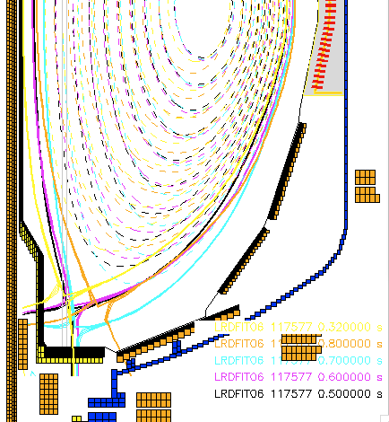
Figure 1. Divertor strike point locations in reference to gas injector locations, shot 117577. Gas willl be injected either from Branch 5 injector (CHI gap) or from LDGIS ports (shown by thin gray lines).

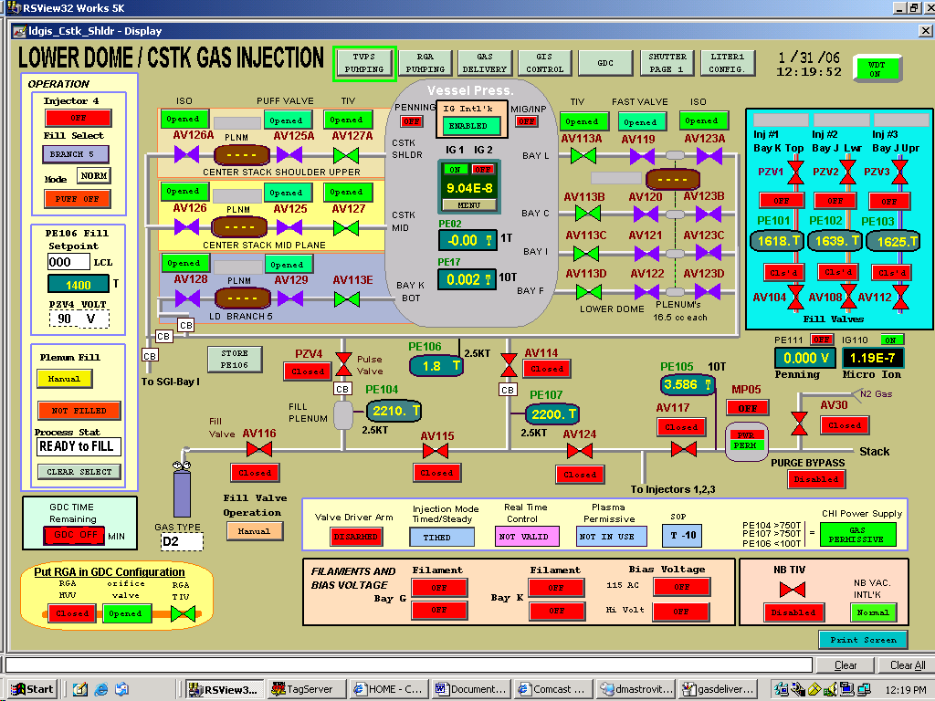

Figure 2. Lower dome and Branch 5 gas delivery systems schematic.

4. Required machine, NBI, RF, CHI and diagnostic capabilities
Physics Operations Request and Diagnostic Checklist are attached.
Diagnostic capabilities: Tile Langmuir probes, IR cameras, main plasma and divertor bolometers, and the D_{α}, D_{γ} cameras should be operational. Lower divertor Langmuir probe locations are (major radii, m): 0.2775, 0.4952, 0.7970, 0.9110, 1.0170.
Branch 5 Injector in FLO mode must be tested prior to the execution of this experiment.

5. Planned analysis
The following numerical tools will be used for data analysis: LRDFIT, UEDGE, ADAS, DEGAS 2, TRANSP, analytic two point divertor model.

6. Planned publication of results
Results will be presented at the upcoming EPS, APS meetings, and will be published in a refereed journal as appropriate.

References

[1] V. A. Soukhanovskii, R. Maingi, R. Raman, R. E. Bell, C. Bush, R. Kaita, H. W. Kugel, C. J. Lasnier, B. P. LeBlanc, J. E. Menard, S. F. Paul , A. L. Roquemore, and the NSTX Team, “Divertor Heat Flux Reduction and Detachment in NSTX”, IAEA FEC 2006 (Chengdu, China 2006), to be submitted to Nuc. Fusion, 2007

[2] V. A. Soukhanovskii, R. Maingi, R. Raman, R. E. Bell, C. Bush, R. Kaita, H. W. Kugel, C. J. Lasnier, B. P. LeBlanc, J. Menard, S. F. Paul, A. L. Roquemore, and the NSTX Research Team, "Divertor heat flux reduction and detachment experiments in NSTX", J. Nucl. Mater., to appear, 2007.

[3] Soukhanovskii, VA; Johnson, DW; Kaita, R; Roquemore, AL, "Electron density measurements in the National Spherical Torus Experiment detached divertor region using Stark broadening of deuterium infrared Paschen emission lines", Rev. Sci. Instrum., 77, 10F127, (2006).

[4] J. E. Menard et. al., “Recent physics results from NSTX”, IAEA FEC 2006 (Chengdu, China 2006), submitted to Nuc. Fusion, 2007

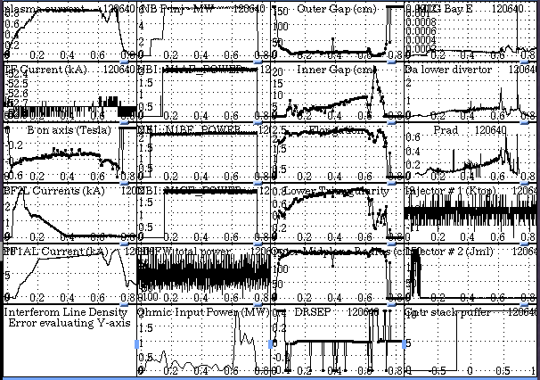

Figure 3 Waveforms of example shot 120640 (0.8 A)
PHYSICS OPERATIONS REQUEST
Divertor heat flux reduction and detachment in highly shaped plasmas OP-XP-708
Machine conditions (specify ranges as appropriate)
I_{TF} (kA): -53 Flattop start/stop (s): -0.02/1.2
I_{P} (MA): 0.7-0.8 Flattop start/stop (s): 0.12/0.9
Configuration: Lower Single Null
Outer gap (m): 0.10-0.13, Inner gap (m): 0.05-0.0.08
Elongation κ: 2.2-2.3, Triangularity δ: 0.72-0.74
Z position (m): 0.00
Gas Species: D / He / CD4,
Gas Injector: Midplane / Inner wall / Lower Dome/Branch 5
NBI - Species: D, Sources: A/B/C, Voltage (kV): 80, Duration (s): 0.8-1.0
ICRF – Power (MW): 0, Phasing: Heating / CD, Duration (s): _____
CHI: Off
Either: List previous shot numbers for setup: 120640, 120339

Gas setup: CS Injector – D₂ at 1300 Torr, LDGIS - D₂, Injector 1 – He, Injector 2 – D₂, Injector 3 - CD₄,
Injector Bay B High Flow - D₂ or He for GPI

DIAGNOSTIC CHECKLIST
Divertor heat flux reduction and detachment in highly shaped plasmas OP-XP-708
Diagnostic | Need | Desire | Instructions
Bolometer - tangential array | ✓
Bolometer array - divertor | ✓
CHERS | ✓
Divertor fast camera | ✓ |  | View the X-point region with Dα filter
Dust detector
EBW radiometers
Edge deposition monitor
Edge pressure gauges | ✓
Edge rotation spectroscopy | ✓
Fast lost ion probes – IFLIP
Fast lost ion probes – SFLIP
Filtered 1D cameras | ✓ |  | CIII, Dα, Dγ filters
Filterscopes | ✓
FIReTIP | ✓
Gas puff imaging | ✓ |  | Measure turbulence during detachment
High-k scattering
Infrared cameras | ✓ |  | Divertor & CS
Interferometer – 1 mm
Langmuir probes - PFC tiles | ✓
Langmuir probes - RF antenna
Magnetics – Diamagnetism
Magnetics – Flux loops | ✓
Magnetics – Locked modes
Magnetics – Pickup coils | ✓
Magnetics - Rogowski coils | ✓
Magnetics - RWM sensors
Mirnov coils – high frequency
Mirnov coils – poloidal array
Mirnov coils – toroidal array
MSE
Neutral particle analyzer
Neutron Rate (2 fission, 4 scint)
Neutron collimator
Plasma TV | ✓ |  | Dα filter when requested, no filter otherwise
Reciprocating probe | ✓ |  | Operate on several shots when requested
Reflectometer - FM/CW
Reflectometer - fixed frequency homodyne quadrature
Reflectometer - homodyne correlation
Reflectometer - HHFW/SOL
RF antenna camera
RF antenna probe

Solid State NPA
SPRED | ✓
Thomson scattering - 20 channel | ✓
Thomson scattering - 30 channel | ✓
Ultrasoft X-ray arrays | ✓
Ultrasoft X-ray arrays - 2 color |  | ✓
Visible bremsstrahlung det. | ✓
Visible spectrometers (VIPS) | ✓ |  | Chords: Bay C fibers U-V; J-K; F-G-H
X-ray crystal spectrometer - H |  | ✓
X-ray crystal spectrometer - V |  | ✓
X-ray PIXCS (GEM) camera
X-ray pinhole camera
X-ray TG spectrometer

