Princeton Plasma Physics Laboratory
NSTX Experimental Proposal
Title: Beta Scaling of Confinement in Weakly Shaped Plasmas
OP-XP-713 | Revision: | Effective Date:  (Ref. OP-AD-97)  Expiration Date:  (2 yrs. unless otherwise stipulated)
PROPOSAL APPROVALS
Author: S. Kaye |  |  | Date
ATI – ET Group Leader: K. Tritz |  |  | Date
RLM - Run Coordinator: D. Gates |  |  | Date
Responsible Division: Experimental Research Operations
Chit Review Board (designated by Run Coordinator)

MINOR MODIFICATIONS (Approved by Experimental Research Operations)

NSTX EXPERIMENTAL PROPOSAL
Beta Scaling of Confinement in Weakly Shaped Plasmas OP-XP-713

1. Overview of planned experiment
This XP follows up on last year’s confinement scaling XP in which the degradation of energy confinement with beta was found to be negligible. That scan was done in a strongly shaped plasma (κ~2.1, δ~0.8). This result supported results found in other strongly shaped tokamak devices, while experiments in more weakly shaped plasmas indicated a strong degradation of confinement with beta. This XP will address the shape issue by redoing the power scan but in an ITER-shaped plasma.

2. Theoretical/ empirical justification
The results from last year’s XP showed very little degradation of confinement with beta. This conclusion was obtained from a scan in which B_{T}, I_{p} and line-averaged density were the same, and in which the beam power was varied from one to three sources. Over this beam power range, the effective collisionality and electron gyroradius were constant to within 20%, while beta varied by a factor of 2.5 to 3. The results are shown below.

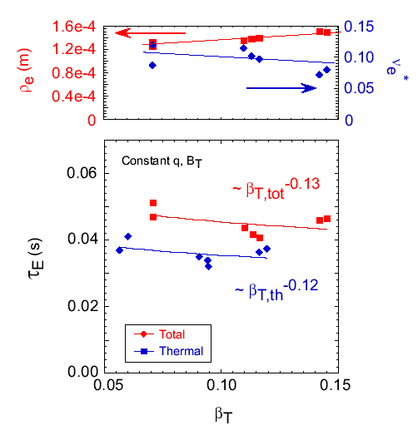

These results supported the lack of beta scaling on other devices (DIII-D and JET) with strongly shaped plasmas, but differed from those on AUG and JT60-U, which showed a strong degradation of confinement with beta. In these latter two experiments, the plasma shaping was weaker. It has been hypothesized that the difference in the beta degradation results is due to the differences in plasma shaping. NSTX will test this hypothesis by redoing the beta scan in an ITER-shaped plasma with κ~1.7 and δ~0.4

3. Experimental run plan
Redo beta scan with κ~1.7 and δ~0.4. Either shot 122574 or 122591, developed for the small ELM experiment, or a later developed shot, will be used as a baseline. This is a ½ day experiment, and the shot list is given below.

Case | Previous Shot | Power
Low-β | 121020 | Source A
Med-β | 120967 | Source A,B
High-β | 121016 | All sources
If there is time, the medium β case will be rerun with sources A&C. Two shots per condition will be taken, with 2 to 3 setup shots anticipated.

If the high-β case disrupts with all three sources, the voltage on source C will be lowered.

4. Required machine, NBI, RF, CHI and diagnostic capabilities
None

5. Planned analysis
EFIT, TRANSP, etc.

6. Planned publication of results
APS, journal article, ITPA
PHYSICS OPERATIONS REQUEST
Beta Scaling of Confinement in Weakly Shaped Plasmas OP-XP-713
Machine conditions (specify ranges as appropriate)
I_{TF} (kA): 42 kA (0.35 T) Flattop start/stop (s): _____/_____
I_{P} (MA): 0.7 MA Flattop start/stop (s): _____/_____
Configuration: Lower Single Null
Outer gap (m): _____, Inner gap (m): _____
Elongation κ: 1.7, Triangularity δ: 0.4 (lower)
Z position (m): 0.00
Gas Species: D , Injector: Midplane
NBI - Species: D, Sources: A/B/C, Voltage (kV): 90 keV, Duration (s): _____
ICRF – Power (MW): , Phasing: Heating / CD, Duration (s): _____
CHI: Off
Either: List previous shot numbers for setup: 120769 or one that has been developed more recently for 2007 small ELM experiment.
Or: Sketch the desired time profiles, including inner and outer gaps, κ, δ, heating, fuelling, etc. as appropriate. Accurately label the sketch with times and values.
DIAGNOSTIC CHECKLIST
Beta Scaling of Confinement in Weakly Shaped Plasmas OP-XP-713
Diagnostic | Need | Desire | Instructions
Bolometer - tangential array | ✓
Bolometer array - divertor
CHERS | ✓
Divertor fast camera
Dust detector
EBW radiometers
Edge deposition monitor
Edge pressure gauges
Edge rotation spectroscopy |  | ✓
Fast lost ion probes – IFLIP
Fast lost ion probes – SFLIP
Filtered 1D cameras
Filterscopes | ✓
FIReTIP |  | ✓
Gas puff imaging |  | ✓
High-k scattering |  | ✓
Infrared cameras
Interferometer – 1 mm
Langmuir probes - PFC tiles
Langmuir probes - RF antenna
Magnetics – Diamagnetism |  | ✓
Magnetics – Flux loops | ✓
Magnetics – Locked modes | ✓
Magnetics – Pickup coils | ✓
Magnetics - Rogowski coils | ✓
Magnetics - RWM sensors |  | ✓
Mirnov coils – high frequency |  | ✓
Mirnov coils – poloidal array |  | ✓
Mirnov coils – toroidal array |  | ✓
MSE | ✓
Neutral particle analyzer |  | ✓
Neutron Rate (2 fission, 4 scint)
Neutron collimator
Plasma TV | ✓
Reciprocating probe
Reflectometer - FM/CW
Reflectometer - fixed frequency homodyne quadrature
Reflectometer - homodyne correlation
Reflectometer - HHFW/SOL
RF antenna camera
RF antenna probe

Solid State NPA
SPRED
Thomson scattering - 20 channel
Thomson scattering - 30 channel | ✓
Ultrasoft X-ray arrays |  | ✓
Ultrasoft X-ray arrays - 2 color
Visible bremsstrahlung det.
Visible spectrometers (VIPS)
X-ray crystal spectrometer - H
X-ray crystal spectrometer - V
X-ray pinhole camera

