Princeton Plasma Physics Laboratory
NSTX Experimental Proposal
Title: Scaling of impurity transport in beam heated NSTX H-mode discharges
OP-XP-716 | Revision: | Effective Date:  (Ref. OP-AD-97)  Expiration Date:  (2 yrs. unless otherwise stipulated)
PROPOSAL APPROVALS
Authors: L. F. Delgado-Aparicio et al. |  |  | Date: March 29, 2007
ATI – ET Group Leaders: K. Tritz & S. Kaye |  |  | Date:
RLM - Run Coordinator: D. Gates |  |  | Date:
Responsible Division: Experimental Research Operations
Chit Review Board (designated by Run Coordinator)

MINOR MODIFICATIONS
(Approved by Experimental Research Operations)
Scaling of impurity transport in beam heated NSTX H-mode discharges

L. F. Delgado-Aparicio, D. Stutman, K. Tritz and M. Finkenthal (The Johns Hopkins University)
R. E. Bell, R. Kaita, S. Kaye, B. P. LeBlanc, S. Paul, L. Roquemore and D. Smith (Princeton Plasma Physics Laboratory)
F. Levinton, H. Yuh and R. Maqueda (Nova Photonics)
R. Maingi, C. Bush (ORNL)
V. Soukhanovski (LLNL)
J. Lepson (University of California – Berkeley)
P. Beiersdorfer (Lawrence Livermore National Laboratory)

1. Proposed experiment and background
We propose to perform a dedicated study of the scaling of impurity transport in NSTX H-modes by using neon and argon gas puffs. We will attempt injection into ELM-free (quiescent) H-modes by applying brief (50 ms) gas puffs at the edge, as has been done during the last NSTX 2006 campaign. The time evolution of the added impurity should give us information about the average magnitude of the particle diffusion coefficient as well as the Z-scaling of the convective velocity for ranges of time in the order of few hundred milliseconds. The dependence of particle diffusivity with the q-profile, toroidal filed (B_{φ}), and plasma current (Ip) will also be assessed by independent scaling experiments.

In order to follow the evolution of the perturbed profiles, the poloidal USXR arrays and the new tangential optical array developed at The Johns Hopkins University will be used in a “multi-color” mode. For the neon injections for instance, the He- & H-like neon (Ne8+ & Ne9+) ions emit resonances lines between 0.9-1.0 keV which will be observed by the detector filtered with the thin Beryllium 10 μm foil. The fully stripped ions (Ne10+) on the other hand, emit strong recombination continuum radiation above the 1.4 keV so they will mainly be detected through the Be 100 & 300 μm foils. Some of the first results regarding the Neon injection and its build-up at the edge, including the edge diffusivities, are illustrated in Figure 1. The normalized SXR emissivity contour plots corresponding to the first 16 channels filtered with a Be 10 μm foil, are shown for three different conditions of plasma current and toroidal field during fixed q-profile ρ* scaling experiment: a) 0.9 MA - 4.0 kG, b) 1.0 MA - 4.5 kG, and c) 1.2 MA - 5.5 kG. A first qualitative estimate of the particle transport using the Neon buildup in NSTX edge indicates low impurity diffusivities in very good agreement with the D_{Z}~ρ²q²ν_{Z,i}∝q²B² scaling of the neoclassical transport coefficients. The normalized contours also indicate the strong effect of the magnetic field in the early penetration of the Ne8+ and Ne9+ charge states.
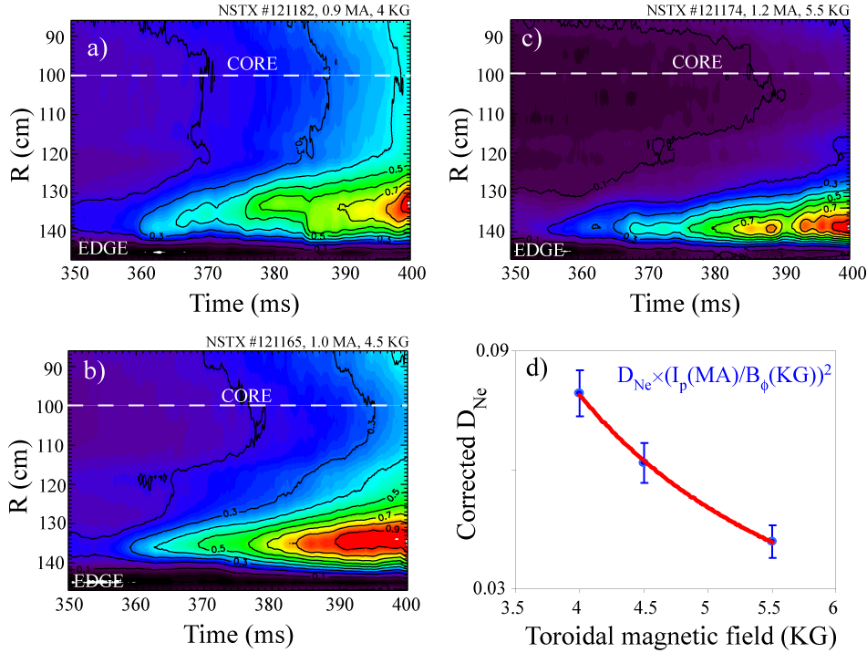
Figure 1.- Reconstructed SXR emissivities during a ρ* scaling experiment at fixed q-profile. The neon diffusivity has a 1/B² dependence.
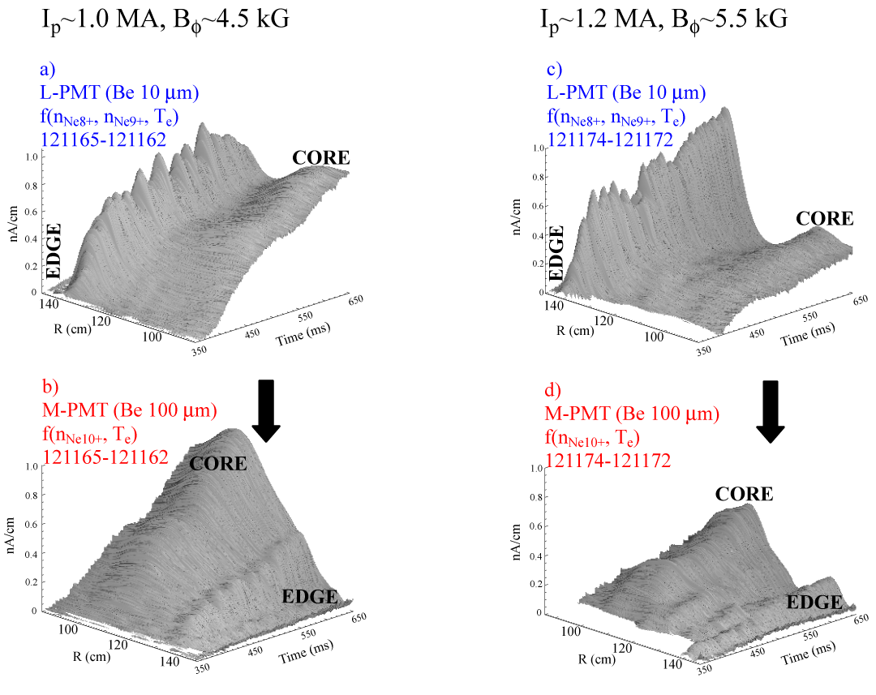
Figure 2.- Reconstructed SXR emissivities profiles during Neon injection in plasmas with 1.0 MA & 4.5 kG, and 1.2 MA & 5.5 kG.

A convective velocity study can also be performed but on long time-scales in comparison to the injection duration. Figure 2 depicts the solely contribution of the neon SXR emission in a 300 ms time window, obtained by subtracting the intrinsic background from reference reproducible discharges. The two plasma conditions considered were part of the fixed q-profile ρ* scaling experiment: a) 1.0 MA - 4.5 kG, and b) 1.2 MA - 5.5 kG. A comparison between the edge and core signals in Figures 2 suggests that at higher plasma current and toroidal magnetic fields, the penetration of the impurities is dramatically reduced. An independent scaling of the plasma current and the toroidal magnetic field is necessary to decouple their effects from the fixed-q profile experiments.

Overview of the planned experiment.
Three basic single-parameter scans are proposed for the experiment using a developed H-mode baseline shot (NSTX: 121154,121162), at 1.0MA, 4.5 kG, long pulse DND, CS gas at 1000 Torr. The three (A, B & C) NBI sources should be timed at 60ms, 80ms and 145ms at voltages of 90, 90 and, 70 kV respectively. At approximately 300 ms source C should be turned OFF to avoid ELMs. For an assessment of the neon and argon gas penetration in NSTX H-modes, we will perform gas injections with plenum pressures at 760 Torr, Ne and Ar gas flows of 1.5 and 0.5 Torr·l/s, and a common gas pulse length of Δt ~ 50 ms. The gas puff will begin at 350 ms when the plasma electron density, ~ 5×10¹⁹ m⁻³, and temperature, ~ 800 eV, are constant, with a central carbon density ~ 1.6×10¹⁸ m⁻³ and ion temperature and 1.2 keV. Because we need to subtract the background in the SXR data, a baseline shot should precede every gas injection shot. A total of ten shots per gas (see Tables 1 and 2) will be needed to complete the three-scaling experiment. The ρ*-scaling at fixed q-profile, as well as the plasma current and toroidal magnetic filed scans will be done using the same optimized injection technique.

4. Required machine, NBI, RF, CHI and diagnostic capabilities
(1) Neutral beams sources operational at A=90 kV, B=90 kV and C=70 kV.
(2) Gas Injection System #3 (PVZ3, Bay J midplane/lower, both neon and argon available on LFS).
(3) Three-color tangential optical SXR array (Be 10, Be 100, Be 300 filters).
(4) USXR arrays in two-color configuration: Hor. Up – Be100, Hor. Down - Be10, Re-entrant Be-100.
(5) Filter-scopes.
To measure the evolution of the impurity profiles we will use the tangential “optical” (scintillator-based) SXR array and the poloidal (diode-based) USXR diode arrays filtered for edge and core charge states, the tangential bolometer array, as well as the CHERS carbon system.

5. Planned analysis
The impurity density profiles will be inferred from analysis of USXR and OSXR data. Fast EFIT for equilibrium changes. Use of MIST simulations to map the contributions from the neon, argon and carbon spectrum to the USXR & OSXR detectors. Use of multi-color ratios to address possible variations on the electron temperature during gas injections. Fast TRANSP analysis, using USXR & OSXR T_{e} profiles and assuming T_{i} profiles measured by CHERS could be possible. NCLASS will be used to assess neoclassical transport. Correlation with GS2 linear stability analysis before and after gas injection are of interest.

6. Planned publication of results
TTF 07-08, EPS 07-08, APS/DPP 2007, publications in a refereed journal.

Dial 2006 baseline + Ne @ 350 ms (Δt~50 ms)  (121154/121162 but at 5.5 kG & 1.0 MA) | I_{p} scaling | 2 shots
Baseline + Ne @ 350 ms (Δt~50 ms)  (5.5 kG & 1.2 MA) | I_{p} scaling | 2 shots
Baseline + Ne @ 350 ms (Δt~50 ms)  (5.5 kG & 0.8 MA) | I_{p} scaling  B_{φ} scaling | 2 shots
Baseline + Ne @ 350 ms (Δt~50 ms)  (4.5 kG & 0.8 MA) | B_{φ} scaling | 2 shots
Baseline + Ne @ 350 ms (Δt~50 ms)  (4.0 kG & 0.8 MA) | B_{φ} scaling | 2 shots
Total (tentative/time permitting) |  | 10
Table 1. Shot matrix for neon (Z=10) injections. Neon flow=1.5 Torr·l/s

Dial 2006 baseline + Ar @ 350 ms (Δt~50 ms)  (121154/121162 at 4.5 kG & 1.0 MA) | Fixed q-profile | 2 shots
Baseline + Ar @ 350 ms (Δt~50 ms)  (4.0 kG & 0.9 MA) | Fixed q-profile  (priority 2) | 2 shots
Baseline + Ar @ 350 ms (Δt~50 ms)  (5.5 kG & 1.2 MA) | Fixed q-profile  I_{p} scaling | 2 shots
Baseline + Ar @ 350 ms (Δt~50 ms)  (5.5 kG & 0.8 MA) | I_{p} scaling  B_{φ} scaling | 2 shots
Baseline + Ar @ 350 ms (Δt~50 ms)  (4.0 kG & 0.8 MA) | B_{φ} scaling  (priority 1) | 2 shots
Total (tentative/time permitting) |  | 10
Table 1. Shot matrix for argon (Z=18) injections. Argon flow=0.5 Torr·l/s
PHYSICS OPERATIONS REQUEST
Machine conditions (specify ranges as appropriate)
I_{TF} (kA): -53, (-65) Flattop start/stop (s): -0.02 / 1.4 (0.8)
I_{P} (MA): 1.0 Flattop start/stop (s): 0.2 / 1.2
Configuration: DND
Outer gap (m): 0.10, Inner gap (m): 0.06
Elongation κ: 2.25, Triangularity δ: 0.7 – 0.8
Z position (m): 0.00
Gas Species: D, Ne, Ar, Injector: CS Midplane, PZV#3
NBI - Species: D, Sources: A/B/C, Voltage (kV): 90/90/70 kV, Duration (s): 1s
ICRF – Power (MW): Off
CHI: Off
Shot numbers for setup: 121154/121162

DIAGNOSTIC CHECKLIST
Scaling of impurity transport XP-716
Diagnostic | Need | Desire | Instructions
Bolometer - tangential array | ✓
Bolometer array - divertor
CHERS | ✓ |  | Synchronize to pellet timing
Divertor fast camera |  | ✓
Dust detector
EBW radiometers
Edge deposition monitor
Edge pressure gauges |  | ✓
Edge rotation spectroscopy
Fast lost ion probes – IFLIP |  | ✓
Fast lost ion probes – SFLIP |  | ✓
Filtered 1D cameras
Filterscopes |  | ✓ | C, Ne, Ar filters
FIReTIP |  | ✓ | Pellet density perturbation
Gas puff imaging
High-k scattering | ✓
Infrared cameras
Interferometer – 1 mm |  | ✓
Langmuir probes - PFC tiles |  | ✓
Langmuir probes - RF antenna |  | ✓
Magnetics – Diamagnetism | ✓
Magnetics – Flux loops | ✓
Magnetics – Locked modes |  | ✓
Magnetics – Pickup coils | ✓
Magnetics - Rogowski coils | ✓
Magnetics - RWM sensors |  | ✓
Mirnov coils – high frequency | ✓
Mirnov coils – poloidal array |  | ✓
Mirnov coils – toroidal array | ✓
MSE | ✓ |  | Synchronize to pellet
Neutral particle analyzer |  | ✓ | Fast Ti mode
Neutron Rate (2 fission, 4 scint) | ✓
Neutron collimator
Plasma TV | ✓ |  | C, Ne filters
Reciprocating probe
Reflectometer - FM/CW
Reflectometer - fixed freq. homodyne quadrature |  | ✓
Reflectometer - homodyne correlation |  | ✓
Reflectometer - HHFW/SOL
RF antenna camera
RF antenna probe
Solid State NPA
SPRED |  | ✓
Thomson scattering - 20 channel | ✓ |  | 6ms laser separation around pellet
Thomson scattering - 30 channel |  | ✓
Ultrasoft X-ray arrays poloidal -2 color | ✓
Visible bremsstrahlung det. | ✓
Visible spectrometers (VIPS) |  | ✓
X-ray crystal spectrometer - H
X-ray crystal spectrometer - V
X-ray pinhole camera |  | ✓
Tangential Optical SXR Array (OSXR)_ | ✓
Fiber optics with beam splitters for D_{α} and C II |  | ✓

