Princeton Plasma Physics Laboratory
NSTX Experimental Proposal
Title: ELMs versus Resonant Magnetic Perturbations
OP-XP-730 | Revision: May 22, 2007 | Effective Date:  (Ref. OP-AD-97)  Expiration Date:  (2 yrs. unless otherwise stipulated)
PROPOSAL APPROVALS
Author: T. Evans, S. Kaye, R. Maingi |  |  | Date April 20, 2007
ATI – ET Group Leader: R. Maingi |  |  | Date
RLM - Run Coordinator: D. Gates (M. Bell) |  |  | Date
Responsible Division: Experimental Research Operations
Chit Review Board (designated by Run Coordinator)

MINOR MODIFICATIONS (Approved by Experimental Research Operations)

NSTX EXPERIMENTAL PROPOSAL
ELMs versus Resonant Magnetic Perturbations OP-XP-730

1. Overview of planned experiment
The goal of this experiment is to significantly reduce the amplitude of large periodic drops in the pedestal pressure and associated divertor heat pulses caused by Type I ELM instabilities. The approach to be used is based on replacing impulsive transport bursts due to ELMs with a lower level of continuous transport provided by an edge stochastic magnetic field. The level of stochasticity will be adjusted to obtain stable pedestal pressure profiles without significantly impacting the core confinement. The width of the edge stochastic layer will be adjusted by controlling currents in the EF/RWM coils which will be configured for n=3 magnetic field perturbations in order to minimize resonant effects on core MHD modes. The toroidal phase of the EF/RWM coil perturbations will be rotated by π/3 radians under some conditions to assess the impact of intrinsic field-errors on the stochastic layer and to compare the toroidal structure the radial heat flux distribution on the divertor targets with theoretical models. This experiment follows up on some promising results from XP 525 in 2005.

2. Theoretical/ empirical justification
Edge localized modes have been suppressed in both moderate ν_{e}^{ped} ~1 [1] and low ν_{e}^{ped} < 0.1 [2] collisionality DIII-D plasmas with n=3 RMP fields from an internal non-axisymmetric coil (the DIII-D I-coil). In both cases, it is found there is a resonant q₉₅ window where the effect on the ELMs is maximized. The existence of this resonant window combined with numerical field line modeling in the vicinity of the pedestal plasma suggests that magnetic islands and an associated stochastic layer are essential for the suppression of large Type-I ELMs. Based on field line modeling with the TRIP3D code, we expect the width of the q₉₅ resonant ELM suppression window to be relatively broad in NSTX with n=3 field perturbations produced by the EF/RWM coil. In this experiment we will vary both q₉₅ and the current in the EF/RWM coil to determine the location and width of the resonant q₉₅ window in NSTX. Establishing the properties of the ELM suppression resonant window in NSTX, with the EF/RWM coil geometry, is important for validating the field line model and for defining a generalized poloidal mode spectrum criteria that can be used to design ELM suppression coils for ITER.
Since routine density control is not yet available on NSTX, this experiment will done in plasmas with moderate collisionalities. At ν_{e}^{ped} ~1, DIII-D ELM suppression results are especially sensitive to wall conditions. In particular, DIII-D attempts to reproduce discharges without ELMs after a fresh boronization have shown limited success, often suffering from a lack of reproducibility. Additionally, once wall conditions conducive to good ELM suppression are obtained in these discharges, it is found that the application of an RMP pulse in one discharge can change the early evolution of a subsequent discharge causing a delay in the H-mode transition timing. Similar effects wee seen in moderate collisionality NSTX experiments using the EF/RWM coil during the execution of XP525 in July 2005. Here, the L-H transition was delayed from 180 ms to 235 ms, possibly due to an increase the upper divertor recycling, and the gas fueling rate had to be reduced from 1400 TL/s to 1300 TL/s to recover the earlier L-H transition.
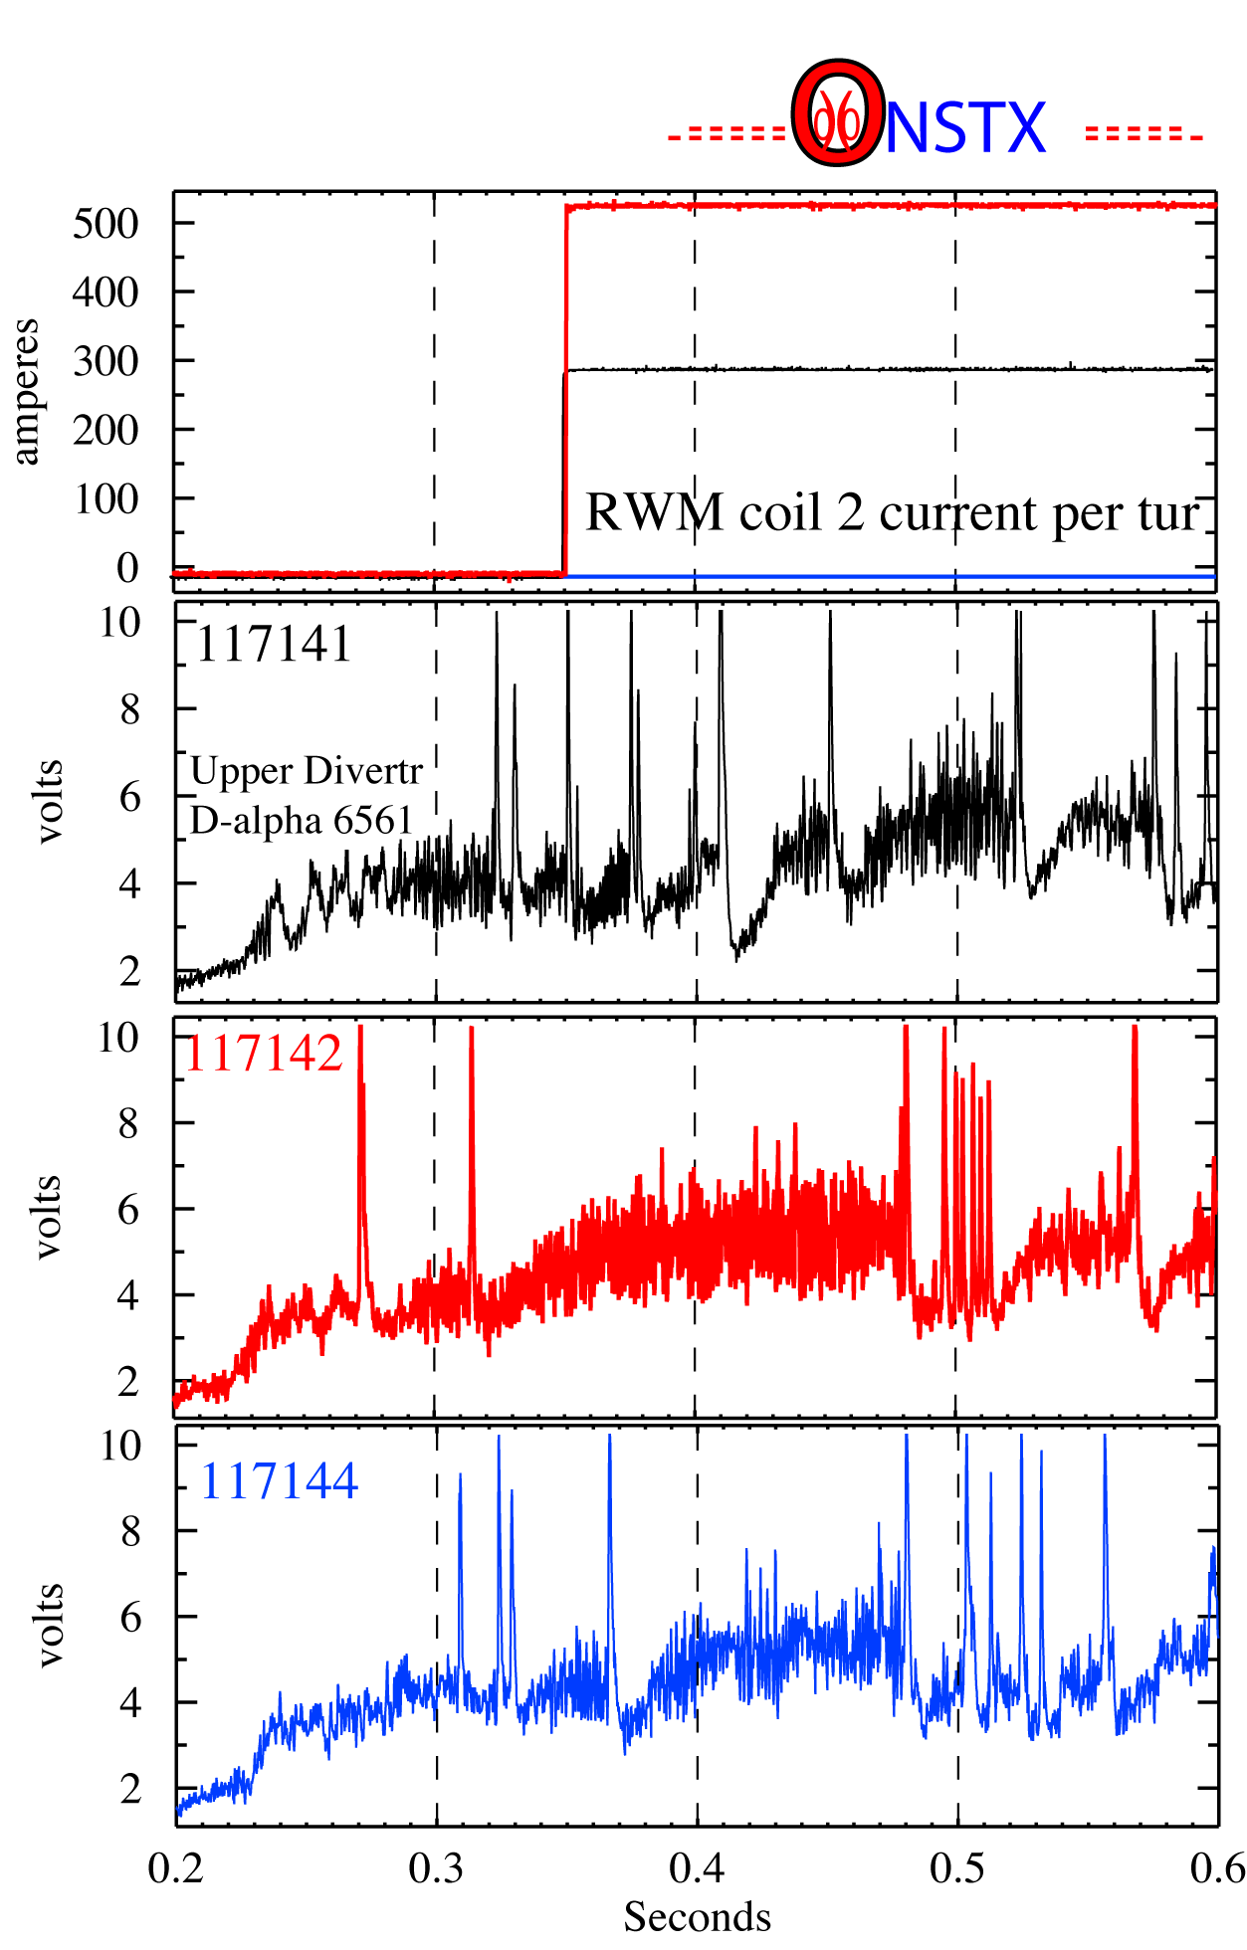
As shown in the figure on the right, a shot-to-shot evolution of wall conditions and recycling complicates the interpretation of the ELM suppression in these NSTX discharges. In this series of discharges, a 300 A EF/RWM coil current was initially used with no significant effect on the ELMs (the black traces in the figure during discharge 117141). In the next discharge (117142 shown in red), the EF/RWM current was increased to 500 A and a period ELM suppression was observed between 0.35 and 0.48 s. At 0.48 s an n=1 core instability enters the plasma causing ELM-like D_{α} bursts. The following discharge (117143 not shown), with an RMP current of 800 A, suffered from an early core instability which significantly enhanced ELM-like bursts seen on the D_{α} signals. In the next discharge (117144 shown in blue), the RMP was turned off and only a single ELM returned prior to the n=1 core instability at 0.48 s. This behavior suggests the possibility of a lag in the wall recovery time following an RMP pulse and implies that several discharges may be needed to recover reproducible ELMs following the application of the RMP in these moderate collisionality plasmas. To assess these affects we will repeat discharges without RMP fields until regular Type-I ELMs return once a discharge with good RMP ELM suppression has been obtained. This will allow us to determine how long it takes the wall to recover following an RMP ELM suppressed discharge.

3. Experimental run plan (1 day, prioritized list below)
Discharges with large Type-I ELMs and frequencies of ~ 50 Hz provide a good starting point for this experiment. In NSTX balanced or slightly upward biased DN plasmas often have long periods of regular ELMs (c.f., NSTX discharge 117425). The first step in this experiment is to determine how small changes in dRsep affect the recycling and divertor heat flux in a discharge similar to 117425 without RMP pulses. Once stable conditions, with reproducible ELMs, have been obtained the RMP will be pulsed using various levels of currents. Two toroidal phases of the n=3 perturbation field will be used with EF/RWM coil current level increments of 0.3 kA (starting at 0.35 sec and lasting until 0.75 sec). The stability of the core plasma my be affected by n=3 currents greater than 1 kA in which case several discharges will be needed to establish stable current profiles during the early H-mode phase. A total of 25 shots are requested (one experimental day).
- Reproduce reference discharge DN #117425 or newer version (e.g. 122655 except program drsep=0) with B_{t}=0.45 T, Ip = 1 MA, gapout = 10 cm, P_{NBI}= 6 MW and no RMP current. (1-2 shots)
Sequence # | Comment | Parameter | RMP Current/phase
I, 1-2 | Reference (117425) | dRsep = 0.0 | 0
- dRsep scan, B_{t}=0.45 T, Ip = 1 MA, gapout = 10 cm, P_{NBI}= 6 MW and no RMP current. If XP609 is completed prior to this run day the dRsep information needed may already be available which would make this sequence optional. (4 shots)
Sequence # | Comment | Parameter | RMP Current/phase
II, 1 | dRsep scan | dRsep = +0.2 cm | 0
II, 2 |  | dRsep = +0.4 cm | 0
II, 3 |  | dRsep = -0.2 cm | 0
II, 4 |  | dRsep = -0.4 cm | 0
- RMP current scan with B_{t}=0.45 T, Ip = 1 MA, gapout = 10 cm and P_{NBI}= 6 MW. If ELM suppression is obtained reproduce the discharge without RMP fields until regular Type-I ELMs seen in sequence I or II return. If core MHD or locked modes are triggered with the RMP adjust early current penetration to correct. (4-8 shots)
Sequence # | Comment | Parameter | RMP Current/phase
III, 1 | Best ELMing dRsep from sequence I or II | B_{t}=0.45 T, Ip = 1 MA | 0.3 kA / 0º
III, 2 |  |  | 0.6 kA / 0º
III, 3 |  |  | 0.9 kA / 0º
III, 4 |  |  | 1.2 kA / 0º
- RMP 0º current scan with higher q₉₅, B_{t}=0.55 T, Ip = 0.9 MA, gapout = 10 cm and P_{NBI}=10 MW. If ELM suppression is obtained reproduce discharge without RMP until regular Type-I ELMs seen in sequence I or II return. (4-6 shots)
Sequence # | Comment | Parameter | RMP Current/phase
IV, 1 | Best ELMing dRsep from sequence I or II | B_{t}=0.50 T, Ip = 1.0 MA | 0.3 kA / 0º
IV, 2 |  |  | 0.6 kA / 0º
IV, 3 |  |  | 0.9 kA / 0º
IV, 4 |  |  | 1.2 kA / 0º
- RMP 60º current scan with best q₉₅ from sequence III or IV, gapout = 10 cm and P_{NBI}= 6 MW. If ELM suppression is obtained reproduce discharge without RMP until regular Type-I ELMs seen in sequence 2 return. (4-6 shots)
Sequence # | Comment | Parameter | RMP Current/phase
V, 1 | Best ELMing dRsep from sequence I or II | Best q95 from sequence III or IV | 0.3 kA / 60º
V, 2 |  |  | 0.6 kA / 60º
V, 3 |  |  | 0.9 kA / 60º
V, 4 |  |  | 1.2 kA / 60º
- Outer gap scan with best q₉₅ from sequence III or IV and best RMP current/phase from sequence IV or V. (3 shots)
Sequence # | Comment | Parameter | RMP Current/phase
VI, 1 | Best ELMing dRsep from sequence II | Gapout = 14 cm | Best current/phase from sequence IV or V
VI, 2 |  | gapout = 16 cm
VI, 3 |  | gapout = 18 cm
If time remains go to lower density with best parameters from sequence VI.

4. Required machine, NBI, RF, CHI and diagnostic capabilities
This XP requires a fully operational NBI system. We desire HeGDC between shots of ~ 6.5 minutes for a 12.5 minute repetition rate.

5. Planned analysis
Changes in ELM dynamics will be correlated with RMP spectral modeling and stochastic layer widths (c.f. ref. 3). The effects of recycling on ELM behavior and reproducibility of RMP effects on ELM amplitude and frequency will be analyzed. We also plan to use the new python profile tools for the analysis pedestal and ELM stability changes with and without the RMP. RMP effects on divertor heat and particle flux profiles will be analyzed.

6. Planned publication of results
Results will be presented at various conferences and published in a refereed journal when the analysis is complete.
PHYSICS OPERATIONS REQUEST
ELMs versus Resonant Magnetic Perturbations OP-XP-730
Machine conditions (specify ranges as appropriate)
I_{TF} (kA):53 Flattop start/stop (s): 0/1
I_{P} (MA): 1.0-0.9 Flattop start/stop (s): 0.15/1.0 (max)
Configuration: Double Null
Outer gap (m): 10->15 cm Inner gap (m): 5-10 cm
Elongation κ: 2.2 Triangularity δ: 0.6->0.7
Z position (m): 0.00
Gas Species: D, Injector: Inner wall Midplane
NBI - Species: D, Sources: A/B/C, Voltage (kV): 90, 90, 90, Duration (s): <1 sec
ICRF – Power (MW): 0, Phasing: , Duration (s): _____
CHI: Off
Either: List previous shot numbers for setup: 117425, 122655 (DN); EF/RWM coil current on from 0.35 to 0.75 s (constant with time)
Or: Sketch the desired time profiles, including inner and outer gaps, κ, δ, heating, fuelling, etc. as appropriate. Accurately label the sketch with times and values.
DIAGNOSTIC CHECKLIST
ELMs versus Resonant Magnetic Perturbations OP-XP-730

Diagnostic | Need | Desire | Instructions
Bolometer - tangential array | ✓
Bolometer array - divertor |  | ✓
CHERS | ✓
Divertor fast cameras | ✓
Dust detector
EBW radiometers
Edge deposition monitor |  | ✓
Edge pressure gauges |  | ✓
Edge rotation spectroscopy | ✓
Fast lost ion probes – IFLIP
Fast lost ion probes – SFLIP
Filtered 1D cameras |  | ✓
Filterscopes | ✓
FIReTIP |  | ✓
Gas puff imaging |  | ✓
High-k scattering
Infrared cameras |  | ✓
Interferometer – 1 mm
Langmuir probes - PFC tiles |  | ✓
Langmuir probes - RF antenna |  | ✓
Magnetics – Diamagnetism | ✓
Magnetics – Flux loops | ✓
Magnetics – Locked modes | ✓
Magnetics – Pickup coils | ✓
Magnetics - Rogowski coils | ✓
Magnetics - RWM sensors | ✓
Mirnov coils – high frequency | ✓
Mirnov coils – poloidal array | ✓
Mirnov coils – toroidal array | ✓
MSE |  | ✓
Neutral particle analyzer |  | ✓
Neutron Rate (2 fission, 4 scint)
Neutron collimator
Plasma TV | ✓
Reciprocating probe |  | ✓
Reflectometer - FM/CW |  | ✓
Reflectometer - fixed frequency homodyne quadrature | ✓
Reflectometer - homodyne correlation |  | ✓
Reflectometer - HHFW/SOL |  | ✓
RF antenna camera
RF antenna probe

Solid State NPA
SPRED |  | ✓
Thomson scattering - 20 channel | ✓
Thomson scattering - 30 channel | ✓
Ultrasoft X-ray arrays | ✓
Ultrasoft X-ray arrays - 2 color |  | ✓
Visible bremsstrahlung det. |  | ✓
Visible spectrometers (VIPS) |  | ✓
X-ray crystal spectrometer - H
X-ray crystal spectrometer - V
X-ray PIXCS (GEM) camera
X-ray pinhole camera
[1] T. E. Evans, R. A. Moyer, P. R. Thomas, et al., Phys. Rev. Lett. 92 (2004) 235003-1.
[2] T. E. Evans, R. A. Moyer, K. H. Burrell, et al., Nature Physics 2 (2006) 419-23.
[3] Longwen Yan, T. E. Evans, S. M. Kaye and R. Maingi, Nucl. Fusion 46 (2006) 858.

