Princeton Plasma Physics Laboratory
NSTX Experimental Proposal
Title: Te gradient and magnetic shear effects on core transport
OP-XP-734 | Revision:  2007 | Effective Date:  (Ref. OP-AD-97)  Expiration Date:  (2 yrs. unless otherwise stipulated)
PROPOSAL APPROVALS
Author: H. Yuh |  |  | Date
ATI – ET Group Leader: K. Tritz |  |  | Date
RLM - Run Coordinator: D. Gates |  |  | Date
Responsible Division: Experimental Research Operations
Chit Review Board (designated by Run Coordinator)

MINOR MODIFICATIONS (Approved by Experimental Research Operations)

NSTX EXPERIMENTAL PROPOSAL
Te gradient and magnetic shear effects on core transport OP-XP-734

1. Overview of planned experiment
This experiment seeks to modify and diagnose core transport as a results varying the power input into reversed shear plasmas. Previous work (Levinton XP522 & XP610, Hosea, XP617, LeBlanc XP538) have explored, respectively, RS discharges, HHFW heating, and injection of HHFW into RS discharges. The goal of this experiment is to combine and continue these effort at high field (5.5 kG).
By changing the injected power using a combination of NBI and HHFW into RS high core confinement plasmas, we would either affect T_{e} gradients or transport amplitude (unless MHD is responsible for transport). Critical T_{e} gradients necessary to drive ETG/microtearing may or may not have been reached in prior experiments, and it is hoped that increasing levels of turbulence will be diagnosed with increasing ∇Te. MSE, high-k, reflectometers, and both poloidal and tangential two color soft X-ray arrays will be used to diagnose the fluctuations.

2. Theoretical/ empirical justification
The previous works had the discharge conditions (best shots) summarized as:

XP 610 | L-Mode | RS | D | 4.5kG | 1.0MA | 2MW SrcA | No RF | 4.0×10¹⁹ m⁻³ | 2.0 keV
XP 538 | L-Mode | RS | D | 4.5kG | 0.9MA | 2MW SrcA | 0.7 MW RF | 3.4×10¹⁹ m⁻³ | 2.2 keV
XP 617 | L-Mode | ?? | He | 5.5kG | 0.7MA | No NBI | 2 MW RF | 1.8×10¹⁹m⁻³ | 3.7 keV
XP 734 | L-Mode | RS | He | 5.5kG | 1.0MA | 2-4 MW NBI | 0-2 MW RF | 1.3×10¹⁹m⁻³ | ?

Although the high T_{e} discharges in XP 617 did not have MSE and could not be confirmed as reversed-shear, they are suspected to be RS due their high core confinement.
Previous experiments have confirmed the improvement of core electron transport for reversed-shear q-profile plasmas. High-k measurements were made more difficult due in part to MHD activity, particularly for the monotonic q-profile discharges. Heating power and timing will be varied to achieve various ∇T_{e} and q-profiles. Critical gradients in HHFW and NBI heated plasmas will be compared.

Results from XP 522 & 610 comparing reversed shear vs. flat core q-profiles. Note that beam timing was the primary input difference between the two discharges.

Comparison of profiles and peak trajectories for a good RS shot from XP 610 (RS) and a good shot from XP 617 (HHFW). While the RS shot achieved higher pressures due to density, the HHFW discharge reached higher T_{e} with sharper core T_{e} gradients with stationary n_{e} profiles. To diagnose fluctuations with correlation and profile reflectometers, the n_{e} profile must be monotonic (L-mode), with the peak lower than 2×10¹⁹ m⁻³.
Comparison between shots from B. LeBlanc’s XP 538 (RS with HHFW at 4.5kG) and its reference shot from XP 522 (RS). About 700kW of HHFW was injected (best shot). Locked modes were an issue and RF coupling was an issue. Nonetheless, somewhat higher temperatures than the reference shot were reached.
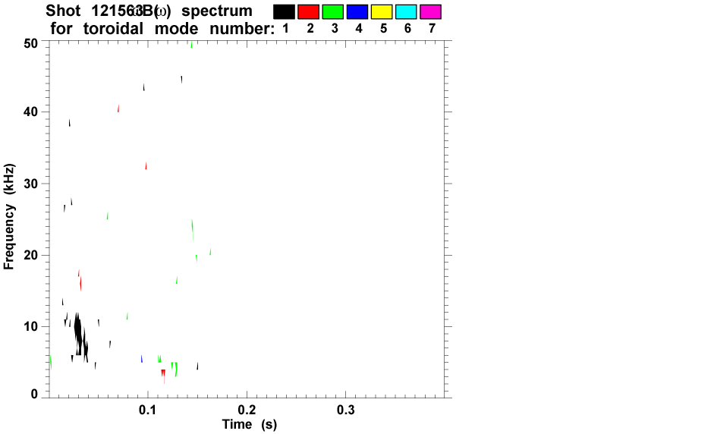
The HHFW shot 121563 appears to be relatively MHD quiescent.
3. Experimental run plan
- Establish 3 q-profiles at different shear using heating timing. Using 123574 but at 1MA as the reference shot.
  - Maximize kappa. Adjust squareness in steps of +0.02 to maximum stable value. Do this at 140ms NBI timing. Use Ip ramp from 116960.
  - Option: modify current ramp to be constant for entire ramp.
  - Maintain minimum density while avoiding locked modes and MHD.
  - High-k set to observe at R=115cm (cell access)

Shot Description | NBI | HHFW
5.5 kG NBI | 2MW (70ms, Src A) | None
5.5 kG NBI | 2MW (140ms, Src A) | None
5.5 kG NBI | 2MW (210ms, Src A) | None
SRC A (90kV)
0.00.070.140.210.280.35
Time
- Add additional power in RF and NBI
  - Scan gap in 2cm steps (4-8 cm) to optimize RF coupling.
  - Delay RF timing if coupling is poor.
  - Compare 14m⁻¹ to 7m⁻¹ current drive phasing
  - Try 4MW NBI only if RF coupling is poor

Shot Description | NBI | HHFW
5.5 kG NBI | 2MW (70ms, Src A) | 2MW (140ms)
5.5 kG NBI | 2MW (140ms, Src A) | 2MW (140ms)
5.5 kG NBI | 2MW (210ms, Src A) | 2MW (210ms)
5.5 kG NBI | 4MW (70ms, Srcs A,C) | 2MW (140ms)
5.5 kG NBI | 4MW (140ms, Srcs A,C) | 2MW (140ms)
5.5 kG NBI | 4MW (210ms, Srcs A,C) | 2MW (210ms)
0.00.070.140.210.280.35
Time
SRC A (90kV)
RF (14 cm⁻¹)
0.00.070.140.210.280.35

Time
SRC A (90kV)
RF (14 cm⁻¹)
SRC C (90kV)
Decision point. If neither A or B works. Stop to consider options.
C. Take most successful RS profile shot(s) from Part B and change RF phasing to co-current and observe effects on core q evolution.
Shot Description | NBI | HHFW
5.5 kG NBI | 2MW (Src A) | 2MW+ (100ms), Co
5.5 kG NBI | 4MW (Src A) | 2MW+ (100ms), Co
Cell access for high-k to switch to 130cm and repeat most successful shot set for high-k at R=130cm.
D. Switch to deuterium and run best shots from parts A,B,C.

4. Required machine, NBI, RF, CHI and diagnostic capabilities
The 2007 HHFW XPs or XP 735 should be run first. Out of the results from that day, we will have the closest reference to create the discharge needed in this XP.
Plasmas seem to hit β limits in the RS discharges. It is hoped that increasing B_{t} relative to XP610 and increasing I_{p} relative to XP617 will allow for somewhat higher β limits. A reduction in density would also serve to postpone reaching the β limit. Locked modes were a major issue in XP 538 at low densities, but does not seem to be an issue during XP617. A density even lower than that in XP 617 would be preferred (1.3-1.5 ×10⁻¹⁹).
We will be running He plasmas with a possibility of switching to deuterium for comparison. He plasmas exhibit better density control important to avoid the β limit and allow reflectometers to measure fluctuations. These plasmas should not dither into H-mode. However, a clean transition into H-mode while maintaining the improved core confinement would be very interesting and was Part C of XP 610.

5. Planned analysis
LRDFIT/EFIT will be used to reconstruct q-profile. TRANSP will be used to calculate transport coefficients. Relative turbulent fluctuation amplitudes measured with the reflectometer and high-k (possible growth rates) can be compared with analytic theory. Hopefully, turbulence simulation codes will have matured sufficiently to be able to compare trends in measured and simulated fluctuation amplitudes with varying shear and ∇Te.

6. Planned publication of results
Successful results will be submitted to a suitable journal such as PoP or PRL.
PHYSICS OPERATIONS REQUEST
Te gradient and magnetic shear effects on core transport OP-XP-734
Machine conditions (specify ranges as appropriate)
I_{TF} (kA): 5.5 kG Flattop start/stop (s):
I_{P} (MA): 1.0 MA Flattop start/stop (s): _____/_____
Configuration: Same as 123574, modified to 1MA
Outer gap (m): _____, Inner gap (m): _____
Elongation κ: _____, Triangularity δ: _____
Z position (m): 0.00
Gas Species: He, Injector: Midplane / Inner wall / Lower Dome
NBI - Species: D, Sources: A/B/C, Voltage (kV): 90(A),70-90(B,C) Duration (s):
ICRF – Power (MW): 2MW, Phasing: Heating / CD, Duration (s): _____
CHI: Off
Either: List previous shot numbers for setup: 123574
Or: Sketch the desired time profiles, including inner and outer gaps, κ, δ, heating, fuelling, etc. as appropriate. Accurately label the sketch with times and values.
DIAGNOSTIC CHECKLIST
Te gradient and magnetic shear effects on core transport OP-XP-734
Diagnostic | Need | Desire | Instructions
Bolometer - tangential array
Bolometer array - divertor
CHERS | ✓
Divertor fast camera
Dust detector
EBW radiometers
Edge deposition monitor
Edge pressure gauges
Edge rotation spectroscopy
Fast lost ion probes – IFLIP
Fast lost ion probes – SFLIP
Filtered 1D cameras
Filterscopes
FIReTIP | ✓
Gas puff imaging
High-k scattering | ✓
Infrared cameras
Interferometer – 1 mm
Langmuir probes - PFC tiles
Langmuir probes - RF antenna
Magnetics – Diamagnetism
Magnetics – Flux loops | ✓
Magnetics – Locked modes
Magnetics – Pickup coils | ✓
Magnetics - Rogowski coils | ✓
Magnetics - RWM sensors
Mirnov coils – high frequency | ✓
Mirnov coils – poloidal array
Mirnov coils – toroidal array
MSE | ✓
Neutral particle analyzer
Neutron Rate (2 fission, 4 scint)
Neutron collimator
Plasma TV
Reciprocating probe
Reflectometer - FM/CW | ✓
Reflectometer - fixed frequency homodyne quadrature | ✓
Reflectometer - homodyne correlation | ✓
Reflectometer - HHFW/SOL | ✓
RF antenna camera
RF antenna probe | ✓
Solid State NPA
SPRED
Thomson scattering - 20 channel
Thomson scattering - 30 channel | ✓
Ultrasoft X-ray arrays | ✓
Ultrasoft X-ray arrays - 2 color | ✓
Visible bremsstrahlung det.
Visible spectrometers (VIPS)
X-ray crystal spectrometer - H
X-ray crystal spectrometer - V
X-ray PIXCS (GEM) camera
X-ray pinhole camera
X-ray TG spectrometer

