Princeton Plasma Physics Laboratory
NSTX Experimental Proposal
Title: Investigation of Ion Transport with Beam Modulation
OP-XP-737 | Revision: | Effective Date:  Expiration Date:  (2 yrs. unless otherwise stipulated)
PROPOSAL APPROVALS
Responsible Author: P. Ross |  |  | Date
ATI – ET Group Leader: K. Tritz |  |  | Date
RLM - Run Coordinator: D. Gates |  |  | Date
Responsible Division: Experimental Research Operations
Chit Review Board (designated by Run Coordinator)

MINOR MODIFICATIONS (Approved by Experimental Research Operations)

NSTX EXPERIMENTAL PROPOSAL
TITLE: Investigation of Ion Transport with Beam Modulation No. OP-XP-737
AUTHOR: P. Ross DATE: 5-7-07

1. Overview of planned experiment
The goals of this Experimental Proposal are to investigate the ion power balance by determining effects of beam modulation on the fast ion distribution and then the effects of longer beam modulation on the thermal ion population. The fast ion population represents a source term in the ion power balance equation, so this will be studied first. To study the fast ion population, the beam power will be modulated under plasma conditions which have no large MHD modes. The fast ion distribution will be measured using the NPA, incorporating the Edge Neutral Diagnostic which will measure the neutral density profile in the edge of the plasma.
Beam modulation will also be used to affect the thermal ion population.
The beam will be varied over a range of modulation times. The beam modulation times will vary from 10 ms to 80 ms, covering the slowing down time of fast ions and the energy confinement time of the thermal ions.

2. Theoretical/ empirical justification
The fast ion distribution function has been shown to be anomalous during periods free of low amplitude MHD modes. (See, for example, Sid Medley’s analysis of shot 120001 in his recent PPPL report-4235) This anomaly may be due to high frequency MHD activity, which is ubiquitous in beam heated H-mode discharges. The amplitude of the high frequency modes can be reduced by decreasing the beam voltage. It is also hoped that the amplitude can be reduced by reducing the number of beams heating the plasma.
In shot 120001, q(0) remained high (q(0) ~ 1.3) well into the shot, when TRANSP calculations showed that q(0) should have dropped to approximately 1. (see figure 1) This remained true even when the low frequency modes disappeared at approximately 600 ms. One possibility is that the fast ions diffused, which would change the source term for the power balance. We therefore need to ascertain whether such an effect exists before proceeding to study the thermal ion confinement. A study of the fast particle effects on this diffusion is critical. This XP will study the effects of beam power modulations on the fast ion population distribution.
a.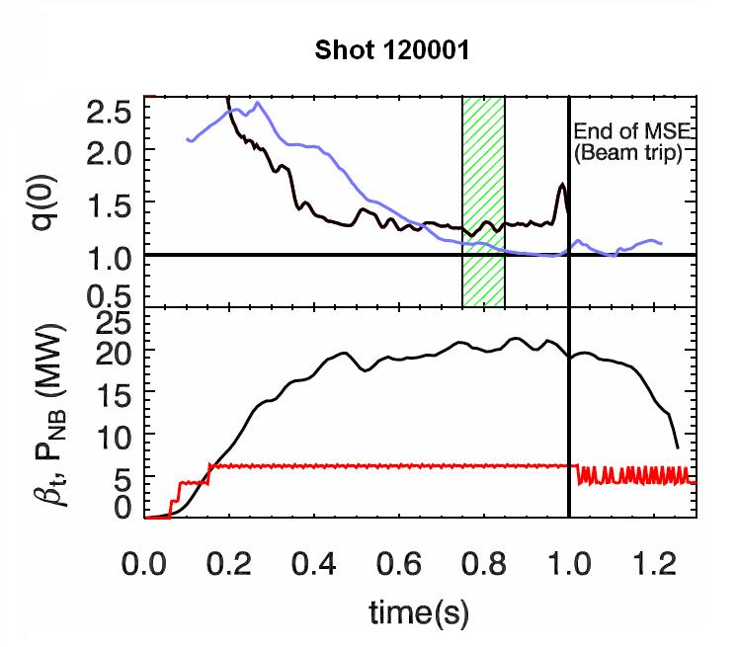b.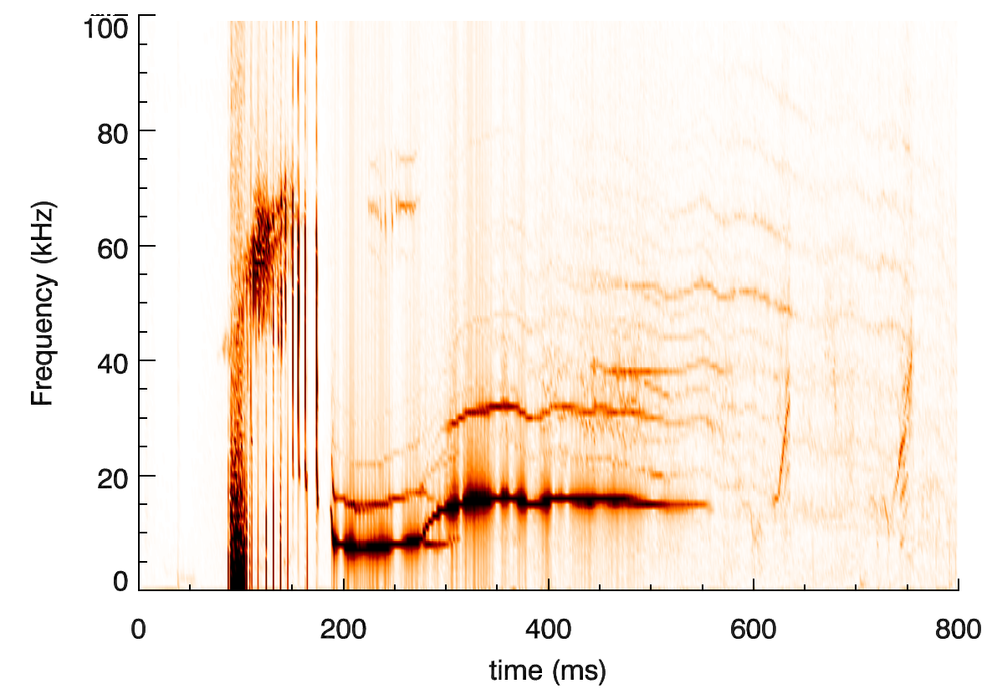
Figure 1. In shot 120001, q(0) stays higher than predicted by Transp (blue line). Q(0) reaches a stable value at about 0.6 seconds, which corresponds to the end of the low frequency MHD modes. Figure 1b shows the amplitudes of the various modes.

The NPA flux spectrum also shows a depletion. Part of this depletion may be due to an attenuation of the signal due to increased plasma density, and hence, increased charge exchange. However, the depletion corresponds with the onset of the high frequency MHD activity (GAE modes) in this shot. (see figure 2). The depletion also corresponds with the onset of very low frequency MHD modes. The depletion persists through the rest of the shot, even though the low frequency MHD modes disappear around 600 ms. This implies that the depletion was not caused by, or at least sustained by, the low frequency MHD, and that other factors such as the high frequency MHD are sustaining the depleted NPA signal.
Figure 2. Shot 120001. The NPA signal shows a depletion in the fast ion distribution that corresponds with the onset of both low and high frequency MHD activity. However, when the low frequency activity ends, the hole in the distribution function persists. Reproduced for PPPL-4235.
The goal of this XP is to observe changes in the fast ion distribution function due to changes in the neutral beam power. Source B will be modulated and the effects will be measured using the NPA and the FLIP probe to determine the effects on lost particles.
This XP will also look at the effects of the beam modulation on the thermal ions. D. Gates, et al, proposed a mechanism for direct transfer of energy from super-Alfvénic energetic ions directly to thermal ions, rather than by heating the electrons. (D.Gates, N. Gorelenkov, R. White, Phys Rev Lett 87, 205003, (2001).) Such a mechanism would explain why the thermal ion temperature is often greater than the electron temperature, even when $Q_{\text{ie}}[≡3/2{nυ}_{i}(T_{i}−T_{e})$, the collisional power transferring from the ions to the electrons, is greater than the total input power to the ions.
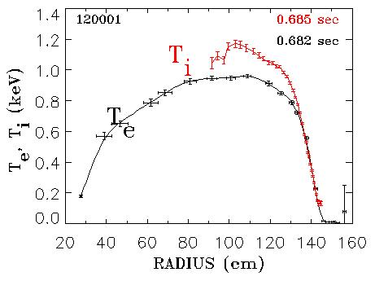
Figure 3. T_{i} is greater than T_{e} for much of the discharge, even though the beam is presumed to be primarily heating the electrons.
3. Experimental run plan

This experiment will be based on shot 120001. This was a long discharge, which achieved a period free from low frequency MHD activity. This shot will be repeated, adjusting the angle of the NPA. Also, the neutral beams will be modulated (3-2 beams) over a wide range of modulation times (10-80 ms, ~50% duty cycle). The beam modulation will begin at 650 ms, chosen to match the CHERS clock. It is expected that this modulation will cover the range of times necessary to view any changes in the fast ion population due to the beam power. (slowing down time: ~30 ms; energy confinement time: ~50 ms)
See Table 1 for a complete list of shots.
It would also be interesting to compare these H-mode shots with equivalent data from L-mode shots. This will be performed if time is available during this XP.

Shot list showing beam modulation
 | Rtan=110 cm | Rtan=80 cm | Rtan=50 cm
Z=0° | 10, 30 | 10, 30, 60, 80 | 10, 30
Z=4° | 30 | 30 | 30
Z=8° | 10, 30 | 10, 30, 60, 80 | 10, 30
Z=12° | 30 | 30 | 30
Z=18° | 30 | 30, (60, 80) | 30
Table 1. Beam modulation times at varying angles of the NPA.

Shot order:
On all shots, beam notches will begin at 650 ms (assuming replication of shot 120001)
Shot development: (~2 shots)
Set 1: NPA: Rtan 80 cm (11-13 shots)
Set 2: NPA: Rtan 110 cm (7 shots)
Set 3: NPA: Rtan 50 (7 shots)
Shot List: Repeat same shot varying beam modulation time, always modulating source B starting at 450 ms.

- 10 ms
- 30 ms
- 60 ms (60 off, 30 on)
- 80 ms (80 off, 30 on)
- 30 ms
- 10 ms
- 30 ms
- 60 ms (60 off, 30 on)
- 80 ms (80 off, 30 on)
- 30 ms
- 30 ms
- 10 ms
- 30 ms
- 30 ms
- 10 ms
- 30 ms
- 30 ms
- 30 ms
- 10 ms
- 30 ms
- 30 ms
- 10 ms
- 30 ms
- 30 ms
- 30 ms

4. Required machine, NBI, RF, CHI and diagnostic capabilities
Base shot: 120001
See attached Diagnostic Checklist

5. Planned analysis
Data analysis will largely focus on the NPA and CHERS data. These two diagnostics will be complimented by the addition of the Edge Neutral Diagnostic, which will measure the profile of the edge neutral particles.
The shots will be simulated in TRANSP to analyze the beam neutrals and study the ion power balance.
6. Planned publication of results
The results will be published in a PPPL report, as well as reported at the DPP07 conference. These results are also an integral part of P. Ross’s dissertation.
PHYSICS OPERATIONS REQUEST
Title Investigation of Ion Transport with Beam Modulation OP-XP-737
Machine conditions (specify ranges as appropriate)
I_{TF} (kA): 53 Flattop start/stop (s): 0.05
I_{P} (MA): 0.8 Flattop start/stop (s): 0.18
Configuration: Single null
Outer gap (m): 0.1 Inner gap (m): 0.06
Elongation κ: 2 Triangularity δ: 0.6
Z position (m): 0
Gas Species: D Injector(s): Midplane CS gas valve
NBI - Species: D Sources: A,B,C Voltage (kV): 90 Duration (s): 1.0
ICRF – Power (MW): None Phasing: 0 Duration (s): 0
CHI: None
Base Shot: 120001
Beam modulations of source B to begin at 0.450 s, with a duty cycle of 50%.
DIAGNOSTIC CHECKLIST
Title Investigation of Ion Transport with Beam Modulation OP-XP-737
Diagnostic | Need | Desire | Instructions
Bolometer – tangential array
Bolometer – divertor
CHERS – toroidal | x
CHERS – poloidal | x
Divertor fast camera
Dust detector
EBW radiometers
Edge deposition monitors
Edge pressure gauges
Edge rotation diagnostic
Fast ion D_alpha - FIDA
Fast lost ion probes - IFLIP | x
Fast lost ion probes - SFLIP | x
Filterscopes
FIReTIP
Gas puff imaging
Hα camera - 1D
High-k scattering
Infrared cameras
Interferometer - 1 mm |  | x
Langmuir probes - divertor
Langmuir probes – RF antenna
Magnetics – Diamagnetism
Magnetics - Flux loops
Magnetics - Locked modes
Magnetics - Pickup coils | x
Magnetics - Rogowski coils
Magnetics - RWM sensors
Mirnov coils – high frequency
Mirnov coils – poloidal array
Mirnov coils – toroidal array
MSE | x
NPA – ExB scanning | x
NPA – solid state | x
Neutron measurements | x
Plasma TV
Reciprocating probe
Reflectometer – 65GHz
Reflectometer – correlation
Reflectometer – FM/CW
Reflectometer – fixed f
Reflectometer – SOL
RF edge probes
Spectrometer – SPRED
Spectrometer – VIPS
SWIFT – 2D flow
Thomson scattering | x
Ultrasoft X-ray arrays | x
Ultrasoft X-ray arrays – bicolor | x
Ultrasoft X-rays – TG spectr. | x
Visible bremsstrahlung det.
X-ray crystal spectrometer - H
X-ray crystal spectrometer - V
X-ray fast pinhole camera

