Princeton Plasma Physics Laboratory
NSTX Experimental Proposal
Title: Beta-induced Alfven-acoustic modes (BAAE), three wave coupling, and HHFW stabilization of CAE/GAE chirping
OP-XP-741 | Revision: | Effective Date:  (Ref. OP-AD-97)  Expiration Date:  (2 yrs. unless otherwise stipulated)
PROPOSAL APPROVALS
Author: N. N. Gorelenkov |  |  | Date April 30, 2007
ATI – ET Group Leader: S. Sabbagh |  |  | Date
RLM - Run Coordinator: D. Gates |  |  | Date
Responsible Division: Experimental Research Operations
Chit Review Board (designated by Run Coordinator)
MINOR MODIFICATIONS (Approved by Experimental Research Operations)

NSTX EXPERIMENTAL PROPOSAL
Beta-induced Alfven-acoustic modes (BAAE), three wave coupling, and HHFW stabilization of CAE/GAE chirping
Goals: Characterize and assess 1) the effects of supra-Alfvénic fast ion driven BAAEs on their confinement and driven current in the plasma core; 2) three wave coupling of several MHD instabilities; 3) stabilization of high-f modes, GAE/CAE during HHFW.
OP-XP-741

1. Overview of planned experiment

The core of the proposed experiment is to investigate predicted, potentially new, MHD eigenmodes, which are due to coupling of two fundamental MHD branches Alfvénic and acoustic. Previously identified L-mode plasma conditions under which Beta-induced Alfvén-acoustic eigenmodes (BAAE) were observed will be reproduced as initial plasma condition. Measurements of the eigenmode structure will be performed with the 5-8 channels of the UCLA reflectometer so that the plasma density should be relatively low n=3.5x10¹³cm⁻³. At the same time, the evolution of the current profile will be measured with MSE and complete equilibrium diagnostic data will be collected. After BAAE modes will be identified, multiple, identical shots will be made to allow an NPA scan.
In previous observations plasma rotation was high, f_{rot}~40kHz in the center and played a negative role in unambiguous mode identification as the rotation and its shear were ramping during the discharge. We are planning to apply resonant-error-field braking to avoid or minimize the rotation effect.
As often in NSTX NBI heated plasmas three wave coupling is expected and will be explored in order to investigate several effects, such as beam ion loss and redistribution.
Early applied HHFW is desirable to heat electrons and increase their beta without heating ions to avoid high ion Landau damping of BAAEs. These conditions will be compared with later stages of the BAAE instabilities after electron and background ion betas will be comparable. At the same time if applied early HHFW will likely effect the chirping of high frequency modes, such as GAEs/CAEs, which are often seen at the beginning of the discharge. This is aimed at the goal of a third part of the proposal, which is to investigate the HHFW introduced velocity scattering of beam ions on GAE/CAE chirping rate.

2. Theoretical/ empirical justification
Discovery of new global BAAE modes on NSTX, and on JET could be of importance to ITER with finite plasma beta. These modes may be an ultimate explanation of some fishbone-like low-frequency instabilities, often observed with fast frequency chirps. BAAEs are correlated with fast ion losses, just like TAEs. Three-wave interactions were observed to correlate with fast ion losses, and have been recently observed between such low frequency modes and higher frequency Alfvén eigenmodes (see Figure 1). When three-wave interaction is weak, good agreement between measurement and theory is expected. When it is strong, comparison between theory and measurement may reveal the effects of the interaction.
The proposed experiment would measure eigenmode radial structure to validate identification of the mode with the ideal code NOVA. An important tool would be to minimize rotation shear to simplify interpretation of these modes. Since plasma beta in NSTX is rather high in comparison with JET beta, it can be considered complimentary to JET observations. Figure 2 shows the possible target magnetic signal frequency spectrum and results of its analysis using NOVA code, which used the q-profile (shown in subfigure c) from 8 channel MSE measurements. As one can see the modes at n=2 are located at the minimum of safety factor profile, which turns out to be at the strongest toroidal shear radial point. Note that obtained BAAE frequency corrected by the Doppler shift is about 90kHz in the lab frame, which is in good agreement with the data at t=0.26sec(see figure 2 (left)). However before that the simulated BAAE frequency is below the frequency of the observed activity. Removing uncertainty associated with the toroidal plasma rotation will help to identify the magnetic activity by measuring its mode structure, polarization and frequency.
Figure 3 shows previous NSTX shot with GAE/CAE chirp (Angel fish) observations and the effect of the HHFW on the repetition and frequency chirping rates. The blow-up figure 3b demonstrates the extent of chirping and how much it is reduced. However, just before the end of the heating there is the onset of another symmetric chirp signal, perhaps an indication that extra rf power allows a change of equilibrium parameters that lead to an altered character to the chirping pulses.
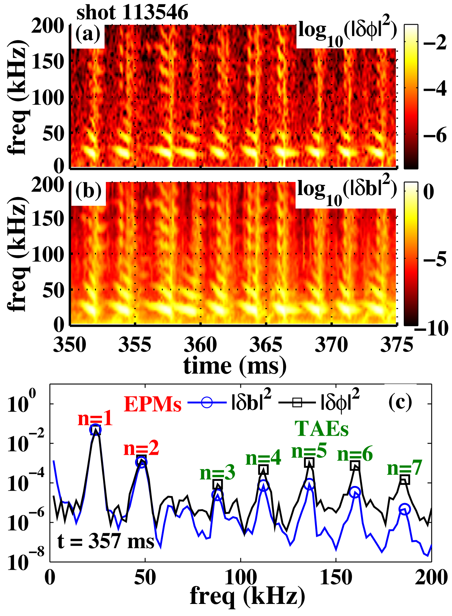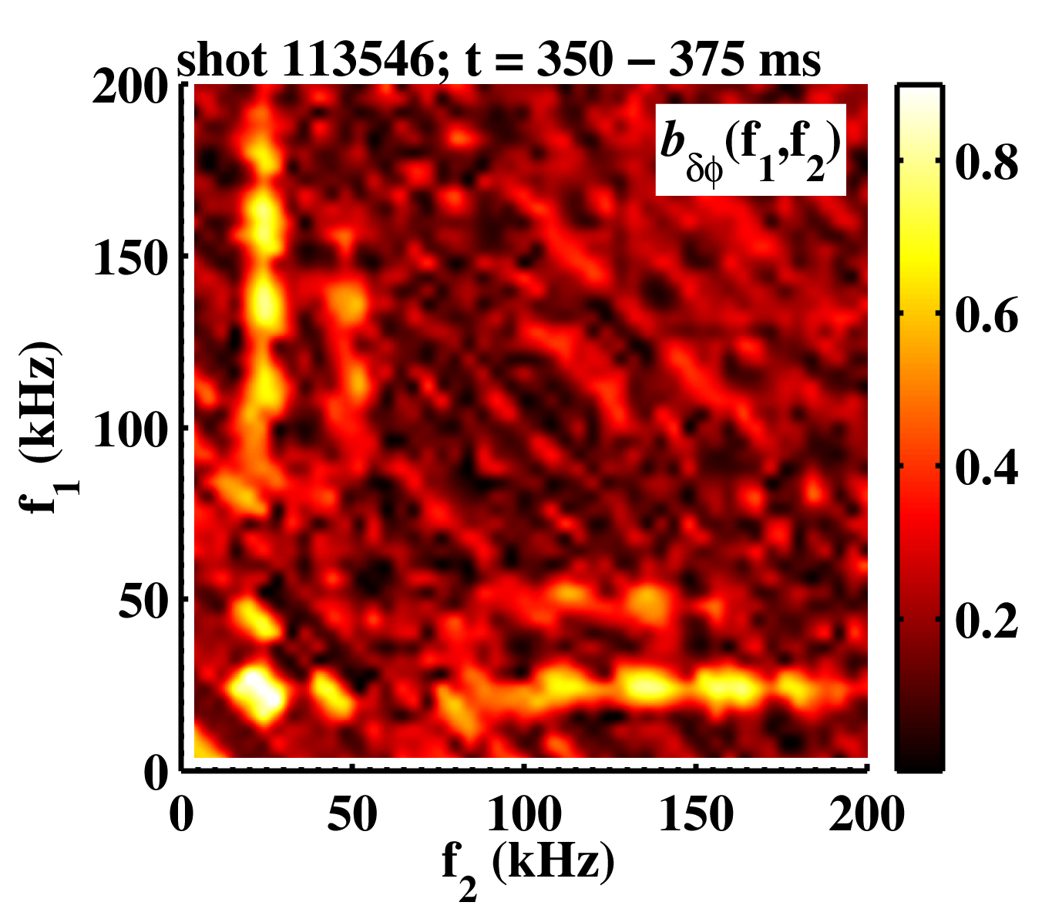

Figure 1: (Right) Spectrum vs. time of: a) 50 GHz reflectometer phase and b) edge magnetic fluctuations. c) Spectra for t = 357.0 – 357.5 ms with mode numbers as determined from edge magnetics. Fishbone-like modes (labled as EPMs) and Alfvén eigenmodes (labeld as TAEs) are indicated. (Left) Bicoherence of 50 GHz reflectometer for t = 350 – 375 ms. Maximum uncertainty is ~ 0.1.
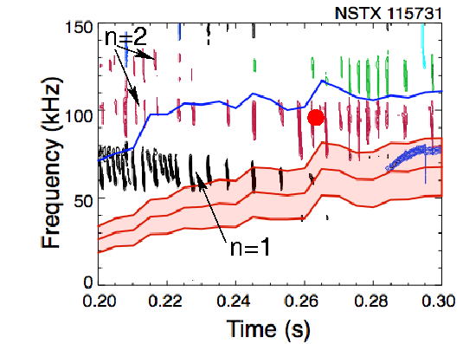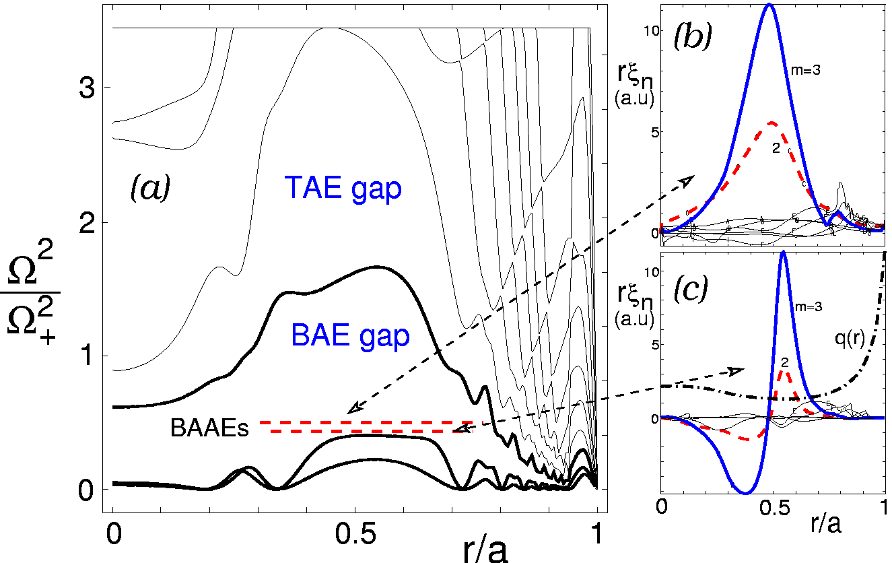
Figure 2: NSTX shot 115731 frequency spectrum, where BAAE activity was measured and identified (left figure). Figure on the right shows results of the NOVA analysis, which produced the Alfven-acoustic continuum gap (a, normalized to Omega_+=55kHz) and two BAAE radial mode structures with the first radial mode having (higher) frequency 35kHz.

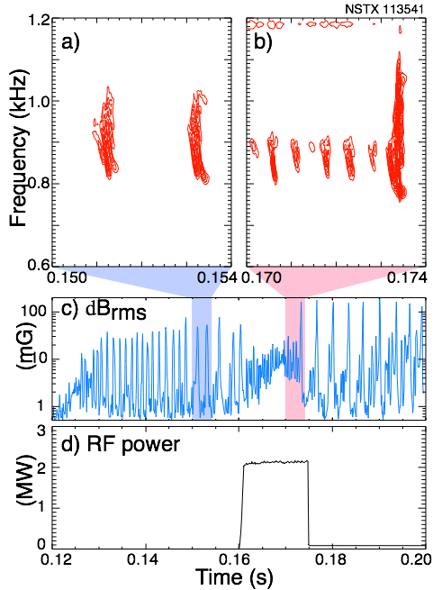
Figure 3: (a) Repetition of frequency sweeping pulses. (b) Spectral frequency content of a single pulse vs. time (c)Resonance regions of energetic particle distribution function, with sweeping signal
The chirping suppression was not always achieved and we would like to understand this by changing the applied HHFW power to up to 3MW. This will ultimately help to study the effect of electron heating (during HHFW) on BAAE frequency. We expect that the BAAE instability will change its character as well due to reduced damping from thermal ions at comparable total plasma pressure.

3. Experimental run plan
The experiment will target plasma conditions similar to shot 115731. Similar shots from more recent XP-734 (Yuh) exist and should be used as a target shot, such as 123599. We will start with 1 MA L-mode discharge (123599 like) where the peak density reached ≈ 3.5 x 10¹³/cm³ by 350 ms, but with lower field B=4.5kG. The main study will be focused on BAAE mode structure measurements with and without non-resonant rotation breaking. We will have three densities of the plasma with 3.2 x 10¹³/cm³, 3.5 x 10¹³/cm³, and 3.8 x 10¹³/cm³ to shift the reflectometer channels.
If time would allow we will lower the plasma current to create optimal conditions for the three wave coupling. Some small scan in the density evolution may be necessary to optimize the reflectometer diagnostic measurements. Shot 115731 had only source A with injection starting at 170 ms, but for three wave coupling sources B and C are desirable.
The logic of the XP is the following:
- Start XP with only source A conditioned to 90 keV and at B=4.5kG, n_{e}=3.5x10¹³cm³.
  - If BAAEs are not seen (below RSAE/TAEs) take following actions:
    - increase field to B=5.5kG,
    - apply source C at t=0.2sec with increased outer plasma/wall gap up to 6-10cm,
    - if no BAAEs are present, go to 115731 shot conditions.
  - If BAAEs are seen proceed to non-resonant breaking.
- At established conditions (1 above) apply n=3 nonresonant rotation breaking with coil current at I_{RWM}=1kA from t=0.25 (earlier BAAE activity time) with the PCS setup of the shot 123184.
  - If RWM develops apply lower current in steps from 1 to 0.7 to 0.5 kA and proceed to step 3.
  - If BAAE activity persist lower coil current to I_{RWM}=0.7kA at later time t=0.5sec.
- Adjust density to optimize reflectometer data at time of BAAE modes with n_{e}=3.1x10¹³cm³ and n_{e}=3.8x10¹³cm³. Repeat 2 shots without and 2 shots with resonance breaking for each of those two densities.
- NPA will be applied at different tangential radii for each plasma density for horizontal scan: R_{tan}=100cm for n_{e}=3.1x10¹³cm³, R_{tan}=75cm for n_{e}=3.5x10¹³cm³, and R_{tan}=50cm for n_{e}=3.8x10¹³cm³.
- At the end of this part of the XP apply small Argon doping for SXR rays BAAE diagnostic – 2 shots in n_{e}=3.5x10¹³cm³ plasma.
- The following is for the possible extension of the XP, that is if more time will be allocated.
  - To accommodate three-wave coupling we will start with source A again and switch to B and C (1 MW each) at t=250msec. Again two shots with and two shots without rotation breaking. Switch back to source A at the end of the shot for MSE measurements.
    - If three-wave coupling is not observed we move toward conditions of the shot 120124 with lower plasma current Ip=800kA and earlier start of B and C sources.
  - To accommodate the study of HHFW effect on angel fish behavior we will apply RF at those times when angel fish is seen, typically at the beginning of the discharge. RF effects on BAAE is of interest as well. Thus we will need to apply it at times when BAAEs are seen.

4. Required machine, NBI, RF, CHI and diagnostic capabilities
Describe any prerequisite conditions, development, XPs or XMPs needed.
Attach completed Physics Operations Request and Diagnostic Checklist

Toroidal field of 4.5 kG. MSE, multi-channel reflectometer, NPA are required. High-k and FIReTIP diagnostics are needed to complement the reflectometer data.

5. Planned analysis
What analysis of the data will be required: EFIT, TRANSP, etc.

Extensive TRANSP analysis to calculate fast ion distribution. As much useful data as possible will be used to benchmark M3D-k and NOVA simulations. NOVA-KN, nonperturbative code analysis maybe be required to identify the fishbone and BAAEs as two possible candidates in explanations of such rather low frequency activity in presence of strong damping and drives from background plasma and fast ions.

6. Planned publication of results
What will be the final disposition of the results; where will results be published and when?

Results of BAAE observations would be reported in the invited talk at the EPS meeting 2007 and in the subsequent publication after the meeting.
PHYSICS OPERATIONS REQUEST
Beta-induced Alfven-acoustic modes (BAAE), three wave coupling, and HHFW stabilization of CAE/GAE chirping OP-XP-741
Machine conditions (specify ranges as appropriate)
I_{TF} (kA): 34-52 Flattop start/stop (s): 0.0/1.0
I_{P} (MA): 0.8-1.0 Flattop start/stop (s): 0.2/0.9
Configuration: 123599
Outer gap (m): _____, Inner gap (m): _____
Elongation κ: _____, Triangularity δ: _____
Z position (m): 0.00
Gas Species: D , Injector: Midplane / Inner wall / Lower Dome
NBI - Species: D, Sources: A/B/C, Voltage (kV): 90/-/90, Duration (s): 0.90
ICRF – Power (MW): -/2 Phasing: Heating / CD, Duration (s): 0.2
CHI: Off
Either: List previous shot numbers for setup: 123599
Or: Sketch the desired time profiles, including inner and outer gaps, κ, δ, heating, fuelling, etc. as appropriate. Accurately label the sketch with times and values.
DIAGNOSTIC CHECKLIST
Beta-induced Alfven-acoustic modes (BAAE), three wave coupling, and HHFW stabilization of CAE/GAE chirping OP-XP-741
Diagnostic | Need | Desire | Instructions
Bolometer – tangential array
Bolometer array - divertor
CHERS | 
Divertor fast camera
Dust detector
EBW radiometers
Edge deposition monitor
Edge pressure gauges
Edge rotation spectroscopy
Fast lost ion probes - IFLIP |  | 
Fast lost ion probes - SFLIP | 
Filtered 1D cameras
Filterscopes
FIReTIP | 
Gas puff imaging
Infrared cameras
Interferometer - 1 mm | 
Langmuir probe array
Magnetics - Diamagnetism | 
Magnetics - Flux loops | 
Magnetics - Locked modes | 
Magnetics - Pickup coils | 
Magnetics - Rogowski coils | 
Magnetics - RWM sensors
Mirnov coils – high frequency | 
Mirnov coils – poloidal array | 
Mirnov coils – toroidal array | 
MSE | 
Neutral particle analyzer | 
Neutron measurements | 
Plasma TV | 
Reciprocating probe
Reflectometer – core | 
Reflectometer - SOL
RF antenna camera
RF antenna probe
SPRED
Thomson scattering | 
Ultrasoft X-ray arrays | 
Visible bremsstrahlung det.
Visible spectrometers (VIPS)
X-ray crystal spectrometer - H
X-ray crystal spectrometer - V
X-ray PIXCS (GEM) camera
X-ray pinhole camera
X-ray TG spectrometer

