Princeton Plasma Physics Laboratory
NSTX Experimental Proposal
Title: H-mode fueling optimization using Supersonic Gas Injector - Upgrade
OP-XP-742 | Revision: | Effective Date:  Expiration Date:  (2 yrs. unless otherwise stipulated)
PROPOSAL APPROVALS
  Responsible Author: V. A. Soukhanovskii |  |  | Date 05/04/2007
ATI – ET Group Leader: H. Kugel |  |  | Date 05/04/2007
RLM - Run Coordinator: D. Gates |  |  | Date 05/07/2007
Responsible Division: Experimental Research Operations
Chit Review Board (designated by Run Coordinator)

MINOR MODIFICATIONS (Approved by Experimental Research Operations)

NSTX EXPERIMENTAL PROPOSAL
TITLE: H-mode fueling optimization using Supersonic Gas Injector - Upgrade
No. OP-XP-742
AUTHOR: V. A. Soukhanovskii DATE: 05/04/2007

1. Overview of planned experiment
The goal of the experiment is to optimize H-mode fueling using the supersonic gas injector (SGI). A typical H-mode discharge in NSTX is fueled from a high field side (HFS) gas injector, a system that injects gas through a small orifice located at z=0 along the center stack. This enables reliable H-mode access. A drawback of this fueling technique is the uncontrollable gas feed at a decreasing rate from about 50 to 10 Torr l / s throughout the discharge duration and an uncontrollable density rise as a result. The goal of SGI fueling experiments is to replace or significantly reduce the HFS fueling to gain gas fueling control, without impact on H-mode access and plasma properties. Experiments in FY 2004-2006 have demonstrated that the SGI can be successfully used for H-mode fueling. This experiment will use an upgraded SGI capabilities - a higher gas flow rate (up to 130 Torr l /s), a higher plenum pressure (up to 5000 Torr), and a multipulse capability - to optimize H-mode fueling. In parallel, data will be obtained on fueling efficiency and other characteristics of the SGI.

2. Theoretical/ empirical justification

Recent theory and modeling results [Rozhansky et. al, NF 46 (2006) 367] suggest that the radial propagation of a high-pressure jet through the edge plasma is determined to first order by the fluid pressure balance, mainly by the relative magnitude of the plasma magnetic and kinetic pressure vs the gas jet impact pressure. Deep penetration appears to be inhibited by a high-density ionizing plasmoid that forms in front of the jet, blocking it from further penetration. Increasing the supersonic jet pressure would promote its penetration through the SOL and separatrix. Off-line SGI testing demonstrated that the highest available plenum pressure of 0.33 MPa (2500 Torr) limits the flow rate to 4.6x10²¹ s⁻¹ (~ 65 Torr l / s) and the jet impact pressure to 30 kPa at the exit nozzle exit and to about 0.02 kPa at a distance of 10 cm from the nozzle exit. The corresponding plasma pressure at the separatrix is 0.01 – 0.07 kPa (75 - 500 mTorr) suggesting that a higher SGI plenum and jet impact pressures are required for deeper penetration.

3. Experimental run plan
The experiment is comprised of two parts which can be executed separately and on different dates. Part one addresses H-mode access and fueling optimization with high pressure SGI. The second part addresses the SGI fueling efficiency in the plasma start-up phase.

3.1 H-mode access with SGI (up to 10 shots)
- Obtain a reference H-mode discharge with HFS fueling (up to 3 shots)
- Use 0.8 - 1.0 MA 2 NBI source LSN target plasma with HFS fueling
- Template shots 122738, 122747 - HFS gas 1100 Torr, NBI sources A, B (start 60 ms, 80 ms)
- Replace the HFS injector gas with an SGI gas pulses and optimize (up to 12 shots)
- Start with the following SGI setup: R=1.56 - 1.58 m, Plenum pressure 5000 Torr
- Start with HFS pressure of 500 Torr and reduce to 0 Torr in shot-increments (500, 300, 200, 100 Torr), adding a first SGI pulse of duration 50-200 ms at or around 100 ms
- Adjust SGI timing to optimize H-mode access as necessary
- Adjust SGI plenum pressure between 5000 Torr and 2500 Torr as necessary
- (Optional, time permitting) Use an SGI-fueled template shot but replace SGI with Injector 2 at similar pressure to compare fueling efficiency of a conventional gas injector with SGI.
- (Optional, time permitting) In one or two long H-mode shots, turn off SGI early in the flat-top (0.400-0.800 s) to see if density rate of rise changes.

3.2 Use of SGI in discharge front-end (up to 5 shots)
- Use a suitable 1-2 source NBI LSN target plasma. Use LFS Injector # 1, 2 or 3 for initial density ramp-up (front-end) for a reference case. Replace the LFS injector with an identical or as similar as possible SGI pulse. Note the density ramp rate.
- The SGI will be parked at R=1.56 - 1.58 m.
- SGI setup: plenum pressure P₀=2000-5000 Torr.
- Adjust SGI pulse duration or pressure as needed

4. Required machine, NBI, RF, CHI and diagnostic capabilities
- SGI plenum pressure up to 5000 Torr
- Wall / impurity conditions to allow reliable H-mode access
Completed Physics Operations Request and Diagnostic Checklist are attached.

5. Planned analysis
We plan to use DEGAS 2, UEDGE and TRANSP for fueling efficiency and jet penetration analysis.

6. Planned publication of results
Results will be presented at the SOFE 2007 conference and / or published in a refereed journal as appropriate.
PHYSICS OPERATIONS REQUEST
Title: H-mode fueling optimization using Supersonic Gas Injector - Upgrade OP-XP-742
Machine conditions (specify ranges as appropriate)
I_{TF} (kA): -53 kA Flattop start/stop (s): 0.180
I_{P} (MA): 0.80 Flattop start/stop (s): 0.800
Configuration:
Outer gap (m): 0.08-0.09 Inner gap (m): 0.06-0.07
Elongation κ: 2.15 Triangularity δ: 0.7
Z position (m): 0.0
Gas Species: D₂ Injector(s): SGI, Injectors 2, HFS
NBI - Species: D Sources: A, C Voltage (kV): 90 Duration (s): 0.8 s
ICRF – Power (MW): Phasing: Duration (s):
CHI:
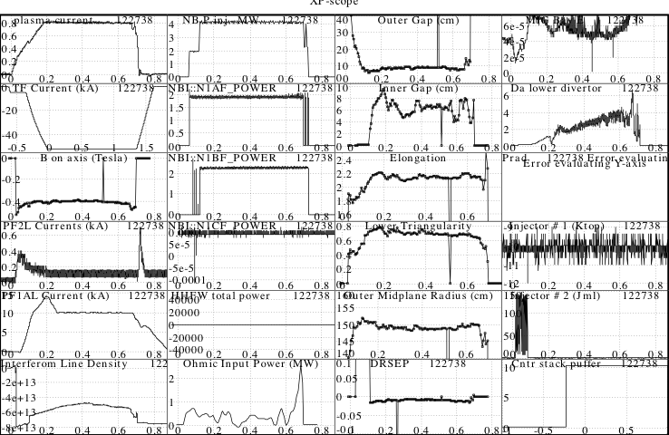
Either: List previous shot numbers for setup: 122738

DIAGNOSTIC CHECKLIST
Title OP-XP-
Diagnostic | Need | Desire | Instructions
Bolometer – tangential array | x
Bolometer – divertor | x
CHERS – toroidal | x
CHERS – poloidal
Divertor fast camera |  | x
Dust detector
EBW radiometers
Edge deposition monitors
Edge pressure gauges | x
Edge rotation diagnostic | x
Fast ion D_alpha - FIDA
Fast lost ion probes - IFLIP
Fast lost ion probes - SFLIP
Filterscopes | x
FIReTIP | x
Gas puff imaging |  | x
Hα camera - 1D | x
High-k scattering |  | x
Infrared cameras |  | x
Interferometer - 1 mm
Langmuir probes - divertor |  | x
Langmuir probes – RF antenna |  | x
Magnetics – Diamagnetism |  | x
Magnetics - Flux loops |  | x
Magnetics - Locked modes |  | x
Magnetics - Pickup coils |  | x
Magnetics - Rogowski coils |  | x
Magnetics - RWM sensors
Mirnov coils – high frequency
Mirnov coils – poloidal array |  | x
Mirnov coils – toroidal array |  | x
MSE |  | x
NPA – ExB scanning
NPA – solid state
Neutron measurements
Plasma TV | x
Reciprocating probe
Reflectometer – 65GHz
Reflectometer – correlation
Reflectometer – FM/CW
Reflectometer – fixed f
Reflectometer – SOL |  | x
RF edge probes |  | x
Spectrometer – SPRED | x
Spectrometer – VIPS | x
SWIFT – 2D flow
Thomson scattering | x
Ultrasoft X-ray arrays |  | x
Ultrasoft X-ray arrays – bicolor |  | x
Ultrasoft X-rays – TG spectr. |  | x
Visible bremsstrahlung det. |  | x
X-ray crystal spectrometer - H
X-ray crystal spectrometer - V
X-ray fast pinhole camera

