Princeton Plasma Physics Laboratory
NSTX Experimental Proposal
Title: Error Field Threshold Study in high-β Plasmas with Reduced Input Torques
OP-XP-1018 | Revision: 0 | Effective Date:  (Approval date unless otherwise stipulated)  Expiration Date:  (2 yrs. unless otherwise stipulated)
PROPOSAL APPROVALS
Responsible Author: J.-K. Park, J. E. Menard, S. P. Gerhardt, R. J. Buttery, S. A. Sabbagh |  |  | Date
ATI – ET Group Leader: S. Sabbagh |  |  | Date
RLM - Run Coordinator: E. Fredrickson |  |  | Date
Responsible Division: Experimental Research Operations
RESTRICTIONS or MINOR MODIFICATIONS
(Approved by Experimental Research Operations)

NSTX EXPERIMENTAL PROPOSAL
TITLE: Error Field Threshold Study in High-β | No. OP-XP-1018
AUTHORS: Park, et al. | DATE:

1. Overview of planned experiment
The purpose of this experiment is to continue the error field threshold study in high-β NSTX plasmas as done in XP903 or XP915, but to investigate different regimes with lower rotations. The input torques will be reduced by replacing NBI heating by HHFW heating, although NBI can be used to assist plasmas to reach sufficiently high-β regime. For each target with different levels of input torques, the RWM/EF coils will be used to produce n=1 field. The field will be applied increasingly until a critical point where a locking is expected.

2. Theoretical/ empirical justification
Tokamak plasmas become more sensitive to error fields for higher β, or in H-mode, due to the amplifications by plasma response as has been demonstrated in NSTX and DIII-D. The results imply that the control or correction of error field can be more important in H-mode plasmas, and that more systematic study of error field effects on H-mode is required to establish reliable threshold and scaling for ITER. In the last year’s NSTX campaign, XP903 and XP915 studied error field thresholds in H-mode in different plasma β, and also different rotations using n=3 magnetic braking, and showed the sensitivity increases when plasma β increases and rotation decreases. The rotation is the key parameter to shield error fields, although perhaps it can be ignored in L-mode study since the rotation in L-mode is self-generated. Apparently more investigations are required to sort out the rotation effects on thresholds in H-mode. The study can be done by changing rotations with n=3 magnetic braking, but also can be done with reduced input torques. The input torques will be modified using HHFW heating instead of NBI heating, and measured thresholds in those plasmas will give new useful data for global error field threshold scaling and will be added to present database (Fig. 1)
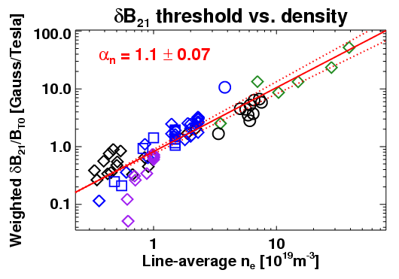
Figure 1. Error field threshold vs. density based on present database, including NSTX, DIII-D, CMOD L and H-mode plasmas

3. Experimental run plan
3.1 Baseline case with NBI 2MW
3.1.1 The reference is #132623 or #132624 dischages, which had I_{P}=800 kA, P_{inj}=2MW, with high-κ and high-δ shape. Target plasmas can be changed if recent shots are recommended to maximize coupling with HHFW. Source (A,B) or (A,C) can be tweaked to obtain lower rotation. The use of LITER must be decided before XPs. (2 shots)
Shot Numbers ______ ______ ______ ______
3.1.2 RWM/EF currents will be applied, with the increasing rate of 2kA/200ms (Fig. 2). The SPA1 is negative and SPA2 is positive to approximately align the applied field with the intrinsic OH/TF error fields. (2 shots)
Shot Numbers ______ ______ ______ ______

3.2 HHFW on NBI 2MW
3.2.1: HHFW ~1.5MW and ~3MW will be added during the flat-top of previous baseline cases. It is expected that HHFW doesn’t change rotation, but change other parameters as should be checked in this target developments. (3 shots)
Shot Numbers ______ ______ ______ ______

3.2.2: The Fig. 2 waveform of RWM/EF currents will be applied at 50ms after HHFW heating. (3 shots)

Shot Numbers ______ ______ ______ ______

3.3 Only HHFW
3.3.1: Only HHFW will be applied with 1.5MW and 3MW power. The H-mode transition should be checked. (3 shots)
Shot Numbers ______ ______ ______ ______

3.3.2: The Fig. 2 waveform of RWM/EF currents will be applied. (3 shots)
Shot Numbers ______ ______ ______ ______

3.3.3: NBI (source A) will be added at the end of HHFW heating. (2 shots)
Shot Numbers ______ ______ ______ ______

Shot # | NBI | HHFW | SPA (t0,t1) | β_{N}, Ω, etc | Comment

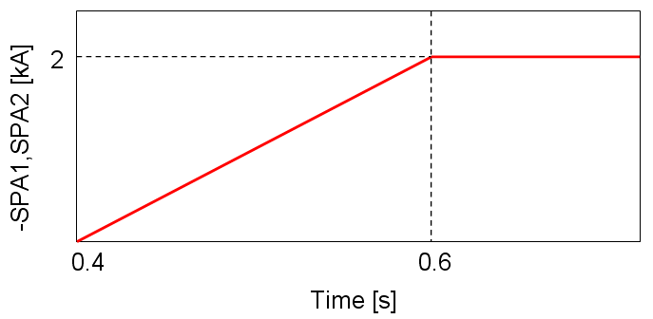
Figure 2. Desired SPA waveform. The initial time will be changed.

4. Required machine, NBI, RF, CHI and diagnostic capabilities
NBI (A,B) or (A,C) up to 2MW, HHFW up to 3MW, but CHI is not required.
All magnetic, profile diagnostics are required: MSE, CHERS, MPTS.
Fast camera is also strongly recommended

5. Planned analysis
Equilibrium reconstruction with EFIT and LRDFIT, and error field analysis using VAC3D and IPEC. All other kinetic parameters will be mapped on magnetic surfaces.

6. Planned publication of results
Successful results would make a nice Nuclear Fusion paper.
PHYSICS OPERATIONS REQUEST
TITLE: Error Field Threshold Study in High-β | No. OP-XP-1018
AUTHORS: Park, et al. | DATE:

Brief description of the most important operational plasma conditions required:
1: NBI and HHFW are both required
2: SPAs are required
Previous shot(s) which can be repeated: This XP will likely use #132623-24
Machine conditions (specify ranges as appropriate, strike out inapplicable cases)
I_{TF} (kA): 0.4-0.45 T Flattop start/stop (s): 0.2s/0.6s.
I_{P} (MA): 800-900 kA Flattop start/stop (s):
Configuration: DN (maybe slightly biased down)
Equilibrium Control: Isoflux (rtEFIT)
Outer gap (m): ~10 cm Inner gap (m): Z position (m):
Elongation: Triangularity (U/L): OSP radius (m):
Gas Species: Injector(s):
NBI Species: D Voltage (kV) A: 90 B: 90 C: 90 Duration (s): ~1.3
ICRF Power (MW): 3MW Phase between straps (°): N. A. Duration (s): 0
CHI: Off Bank capacitance (mF):
LITERs: On Total deposition rate (mg/min): TBD, likely 100 mg/shot
LLD: Probably no. Temperature (°C):
EFC coils: On Configuration: Odd

DIAGNOSTIC CHECKLIST
TITLE: Error Field Threshold Study in High-β | No. OP-XP-1018
AUTHORS: Park, et al. | DATE:

Note special diagnostic requirements in Sec. 4
Diagnostic | Need | Want
Beam Emission Spectroscopy
Bolometer – divertor
Bolometer – midplane array
CHERS – poloidal | √
CHERS – toroidal | √
Dust detector
Edge deposition monitors
Edge neutral density diag.
Edge pressure gauges
Edge rotation diagnostic | √
Fast cameras – divertor/LLD | √
Fast ion D_alpha - FIDA
Fast lost ion probes - IFLIP
Fast lost ion probes - SFLIP
Filterscopes
FIReTIP | √
Gas puff imaging – divertor
Gas puff imaging – midplane
Hα camera - 1D
High-k scattering
Infrared cameras
Interferometer - 1 mm | √
Langmuir probes – divertor
Langmuir probes – LLD
Langmuir probes – bias tile
Langmuir probes – RF ant. | √
Magnetics – B coils | √
Magnetics – Diamagnetism | √
Magnetics – Flux loops | √
Magnetics – Locked modes | √
Magnetics – Rogowski coils | √
Magnetics – Halo currents
Magnetics – RWM sensors | √
Mirnov coils – high f. | √
Mirnov coils – poloidal array
Mirnov coils – toroidal array
Mirnov coils – 3-axis proto.

Note special diagnostic requirements in Sec. 4
Diagnostic | Need | Want
MSE | √
NPA – E||B scanning
NPA – solid state
Neutron detectors
Plasma TV
Reflectometer – 65GHz
Reflectometer – correlation
Reflectometer – FM/CW
Reflectometer – fixed f
Reflectometer – SOL
RF edge probes | √
Spectrometer – divertor
Spectrometer – SPRED
Spectrometer – VIPS
Spectrometer – LOWEUS
Spectrometer – XEUS
SWIFT – 2D flow
Thomson scattering | √
Ultrasoft X-ray – pol. arrays
Ultrasoft X-rays – bicolor
Ultrasoft X-rays – TG spectr.
Visible bremsstrahlung det.
X-ray crystal spectrom. - H
X-ray crystal spectrom. - V
X-ray tang. pinhole camera

