Princeton Plasma Physics Laboratory
NSTX Experimental Proposal
Title: Characterization Of Intrinsic Rotation Drive Using Neutral Beam
Torque Steps
OP-XP-1042 | Revision: 2 | Effective Date:  (Approval date unless otherwise stipulated)  Expiration Date:  (2 yrs. unless otherwise stipulated)
PROPOSAL APPROVALS
Responsible Author: Wayne Solomon |  |  | Date 7/2/10
ATI – ET Group Leader: H. Yuh |  |  | Date
RLM - Run Coordinator: E. Fredrickson |  |  | Date
Responsible Division: Experimental Research Operations
RESTRICTIONS or MINOR MODIFICATIONS
(Approved by Experimental Research Operations)

NSTX EXPERIMENTAL PROPOSAL
TITLE: Characterization Of Intrinsic Rotation Drive Using Neutral Beam Torque Steps | No. OP-XP-1042
AUTHORS: W.M. Solomon, S.M. Kaye, … | DATE: 6/9/10

1. Overview of planned experiment
This experiment aims to infer the effective torque associated with the drive of intrinsic rotation on NSTX. The idea is to essentially use steps in the neutral beam torque to infer the momentum characteristics of the plasma, and then deduce the missing "torque" in the plasma (if any) required to account for the steady state rotation. A secondary goal is to see if there is any interplay between the intrinsic rotation drive and the torque exerted by non-resonant magnetic fields via neoclassical toroidal viscosity. Finally, if possible, we would like to look for any possible modification of the intrinsic drive in the presence of high-harmonic fast wave heating (HHFW), which may be related to previous observations of an edge rotation “clamping”.

2. Theoretical/ empirical justification
An international database has been constructed for scaling the so-called intrinsic rotation, the rotation observed in the absence of any direct external momentum input. Some extrapolations of this database have suggested very large levels of intrinsic rotation for ITER, potentially sufficient to stabilize resistive wall modes and be provide increased neoclassical tearing mode stability. However, a fundamental understanding for the generation of intrinsic rotation is clearly required in order to validate these projections, and increase the confidence of the rotation level expected in future devices.
In the past, the effective torque associated with the intrinsic rotation has been inferred by determining the amount of neutral beam torque required to oppose the intrinsic drive and bring the plasma rotation to rest [1]. While this has the advantage of providing a relatively clear demonstration and measurement of the “intrinsic torque”, the technique cannot be directly used on plasmas with finite rotation, thereby limiting the range of conditions that the intrinsic torque can be measured. This has made it problematic to assess the role and magnitude of the intrinsic rotation drive in NSTX plasmas, where the co-current neutral beam injection results in rapidly rotating plasmas.
Recently, a new technique has been developed on DIII-D to infer the intrinsic torque, by making use of a transient step in the applied torque. By looking at the transient relaxation of the angular momentum, one can infer a momentum confinement time, which can then be used during the steady state portion of the discharge to infer any missing effective torque associated with the intrinsic rotation. While it is not a-priori clear that such an approach captures the full physics of the angular momentum balance equation adequately, this technique has been benchmarked with the standard method of determining the torque required to zero out the rotation. The inferred intrinsic torque profiles from these complementary techniques are found to be quantitatively similar [2]. Therefore, this XP seeks to exploit this new technique to make the first measurements of the intrinsic torque on NSTX.
Even still, there are some subtleties for how best to make this measurement on NSTX. Ideally, one would like to make the torque step at constant power or β_{N} so as to minimize the likelihood of modifying the intrinsic drive. Applying an NBI torque perturbation also applies a significant power perturbation. The analysis is still relatively robust to this, since we track confinement changes through the thermal channel (ie energy confinement), and can fold in these changes in the analysis if necessary.
One can also envision compensated power steps, using the high harmonic fast wave (HHFW) heating to substitute for the beams. However, the addition of HHFW itself adds complexity to the experiment. Firstly, there has been evidence that the HHFW itself may modify the rotation (perhaps through modifications to the intrinsic drive). Moreover, the HHFW is known to affect the fast ions, but it is not clear whether this can be adequately modeled. This may, for example, compromise the calculation of the NBI torque in TRANSP. Finally, while NBI can be considered a standard operating tool, the use of HHFW still likely requires experimental development. Hence, this XP will focus primarily on torque steps with uncompensated power, but will also attempt compensated power at the end of the day (lower priority) to try to isolate the different effects. As a backup if we are unsuccessful coupling HHFW power to the plasma, we can instead try compensated power from beams alone, switching between source B and C.
If time permits, we would also like to attempt torque perturbations using n=3 fields, in place of the NBI. The inferred intrinsic torque should not depend on the technique used to make the perturbation, so this will offer a check. The n=3 torque will need to be calculated in IPEC, although we can also estimate its profile from the prompt change in the rotation at the n=3 turn-on.

3. Experimental run plan
A key requirement for success of this XP is to obtain reproducible long MHD quiescent phases of the discharge. We have had good success at achieving this in previous momentum transport experiments, including XP908 and XP 813, using Li evaporation, coupled with optimal EF correction and n=1 mode control (earlier attempts before Li evaporation proved much more problematic). As such, this experiment requires Li evaporation and static and dynamic error field control. Ideally, the plasma needs to be relatively robust against changes in the NBI torque and/or rotation. The baseline reference discharge will be #134750 (a comparable reference is #134119). If HHFW power is expected to be reliably available (eg recently run successfully in a previous XP), then steps 5 and 6 should be considered moved higher in priority.

- Reproduce #134750, Bt=0.45 T, Ip=0.9 MA
  - Apply error field correction as early as possible in the discharge 1 shot
# shots: 1 + 2 contingency
Decision: If unsuccessful at producing suitable MHD quiescent discharge, reevaluate and consider deferring.
- Perform power scan, with torque perturbation from NBI (uncompensated power). In all cases, the torque perturbation will come from source B. Derate source B as far as practical while still providing measurable change to rotation. Ideally, the torque step will occur from 400-700 ms, but there needs to be at least 100 ms of steady conditions before the step for the measurement to be successful. If necessary, delay the torque step appropriately.
  - 1 source level (source A). Try nominal voltage for B first, and adjust
as appropriate. 2 shots
  - 2 source level (sources A+C) 1 shot
  - 3 source level (produce torque steps by turning off B) 1 shot
# shots: 4 + 2 contingency
Decision: If highest power level results in significant MHD that compromises the measurement, then we can try a finer scan by adjusting beam voltages.
- Investigate interaction of intrinsic drive with NTV from n=3 fields. Repeat best condition with varying n=3 field strength. Apply n=3 field at least 100 ms (preferably 200 ms) before the NBI torque pulse.
  - 400 A 1 shot
  - 800 A 1 shot
  - 600 A 1 shot
# shots: 3 + 2 contingency
Decision: If low levels of n=3 field causes MHD and/or mode locking, then obviously there is no value in going to higher fields. In that case, we would attempt to complete a three-point scan by moving down in current as appropriate.
- Repeat Step 2, and perform I_{p} scan
  - 1.0 MA 3 shots
  - 0.8 MA 3 shots
# shots: 6 + 2 contingency
- Repeat Step 2, with addition of 2 MW of HHFW heating (configuration similar to eg #128663).
# shots: 3 + 3 contingency
Decision: If we are struggling to couple the HHFW power to the plasma, then we should abandon this step and Step 6 involving the HHFW and move to the alternate step 6 option.
- Repeat Step 2, but attempt to run with constant power using HHFW during torque perturbation. Specifically, apply HHFW power throughout (power to match source B), starting around 200 ms, and step off when source B is turned on (invert the HHFW waveform for part c).
# shots: 3 + 2 contingency
- (alternative) Attempt a moderate power scan with torque step at constant power by switching between sources B and C (ie begin with lower torque source, and switch to higher torque source B). In order that the torque switch between B and C be likely to be measurable, the steady torque from A must be reduced. Therefore, source A should be run at minimum voltage (65 kV ideally) while still maintaining acceptable CHERs signal level.
  - Source B and C at 80 kV 1 shot
  - Source B and C at 65 kV [midway between voltages of (a) and (b)] 1 shot
# shots: 2 + 2 contingency
- Repeat Step 2a, but use an n=3 perturbation (approximately 400 A) in place of source B. Obtain a rotation scan by applying this 400 A step on top of a DC perturbation.
  - 0 → 400 A 1 shot
  - 200 → 600 A 1 shot
  - 400 → 800 A 1 shot
# shots: 3 + 0 contingency

TOTAL: 22 good shots + 13 contingency

4. Required machine, NBI, RF, CHI and diagnostic capabilities
All 3 NBI sources are required. Source B will likely be run at reduced voltage. Approximately 2-4 MW of HHFW is requested. Standard profile diagnostics are required, and all fluctuation diagnostics would make highly desirable complements to the experiment, since a strong candidate for the intrinsic drive is the turbulent Reynolds stress.

5. Planned analysis
This data will be analyzed using EFIT/LRDFIT, with follow up analysis in TRANSP for computation of the torque sources and transport quantities. The TRANSP output will be post-processed using analysis codes already developed for DIII-D discharges, requiring minimal adaptation for NSTX.

6. Planned publication of results
The data obtained from this XP will represent the first measurements of the intrinsic drive on NSTX, and should warrant a PoP or other publication.

References
[1] W.M. Solomon, K.H. Burrell, J.S. DeGrassie, et al., Plasma Phys. Control. Fusion, 49, B313 (2007).
[2] W.M. Solomon et al, accepted Phys Plasmas (2010).

PHYSICS OPERATIONS REQUEST
TITLE: Characterization Of Intrinsic Rotation Drive Using Neutral Beam Torque Steps | No. OP-XP-1042
AUTHORS: W.M. Solomon, S.M. Kaye, … | DATE: 6/9/10
Brief description of the most important operational plasma conditions required:
Discharge reproducibility, with significant periods of MHD quiescence (ideally between times 300-800 ms).

Previous shot(s) which can be repeated:
Previous shot(s) which can be modified: #134750, primary changes to beam program and/or additions of HHFW
Machine conditions (specify ranges as appropriate, strike out inapplicable cases)
I_{TF} (kA): 41 – 64 (3.5 – 5.5 kG) Flattop start/stop (s):<0.2/0.8 (longer if reasonable)
I_{P} (MA): 0.8-1.0 Flattop start/stop (s): 0.2/0.9
Configuration: LSN
Equilibrium Control: Outer gap / Isoflux (rtEFIT) / Strike-point control (rtEFIT)
Outer gap (m): ~0.11 Inner gap (m): ~0.07 Z position (m):
Elongation: 2.3 Triangularity (U/L): 0.4/0.8 OSP radius (m):
Gas Species: D Injector(s): conventional
NBI Species: D Voltage (kV) A: 90 B: <=80 C: 80 Duration (s): 0.9
ICRF Power (MW): 4 Phase between straps (°): as per #128663 Duration (s): 0.9
CHI: Off Bank capacitance (mF):
LITERs: On Total deposition rate (mg/min): 15
LLD: Temperature (°C):
EFC coils: On Configuration: Odd (n=1 correction with feedback) + n=3 correction if possible
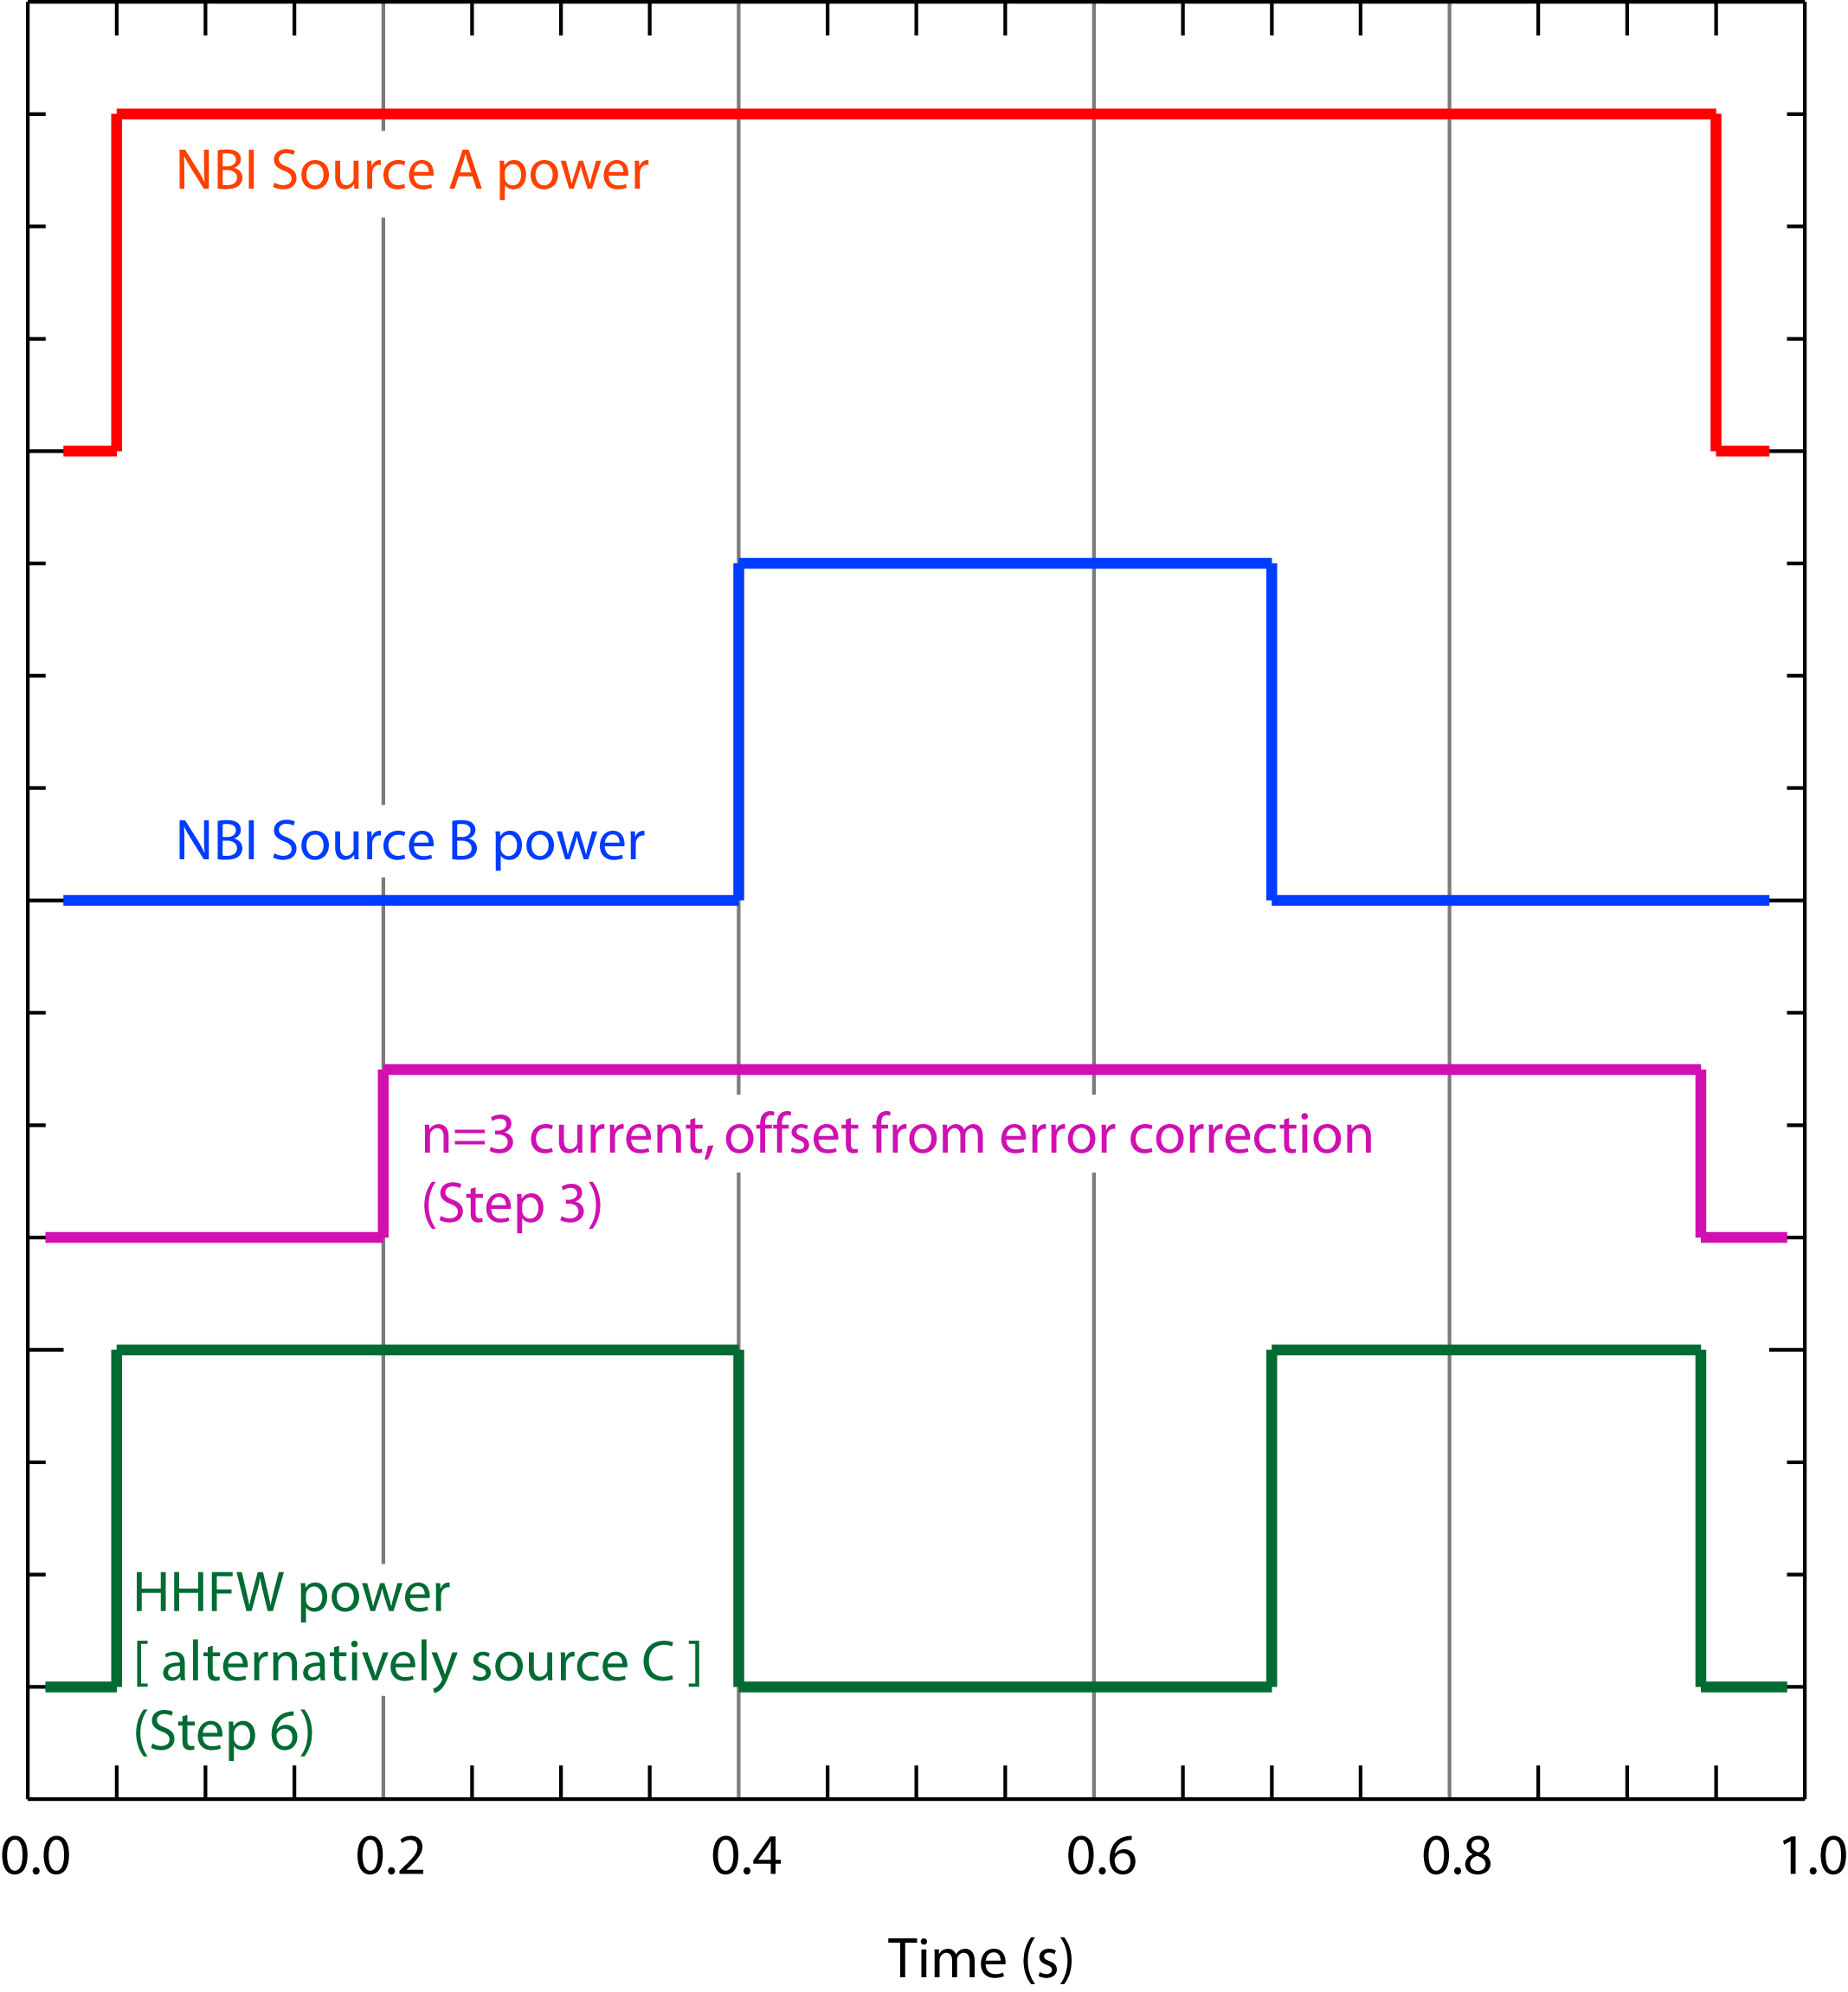
DIAGNOSTIC CHECKLIST
TITLE: Characterization Of Intrinsic Rotation Drive Using Neutral Beam Torque Steps | No. OP-XP-1042
AUTHORS: W.M. Solomon, S.M. Kaye, … | DATE: 6/9/10

Note special diagnostic requirements in Sec. 4
Diagnostic | Need | Want
Beam Emission Spectroscopy |  | √
Bolometer – divertor |  | √
Bolometer – midplane array | √
CHERS – poloidal | √
CHERS – toroidal | √
Dust detector
Edge deposition monitors
Edge neutral density diag. |  | √
Edge pressure gauges |  | √
Edge rotation diagnostic | √
Fast cameras – divertor/LLD
Fast ion D_alpha - FIDA | √
Fast lost ion probes - IFLIP |  | √
Fast lost ion probes - SFLIP |  | √
Filterscopes | √
FIReTIP |  | √
Gas puff imaging – divertor |  | √
Gas puff imaging – midplane |  | √
Hα camera - 1D |  | √
High-k scattering |  | √
Infrared cameras
Interferometer - 1 mm |  | √
Langmuir probes – divertor
Langmuir probes – LLD
Langmuir probes – bias tile
Langmuir probes – RF ant.
Magnetics – B coils | √
Magnetics – Diamagnetism | √
Magnetics – Flux loops | √
Magnetics – Locked modes | √
Magnetics – Rogowski coils | √
Magnetics – Halo currents |  | √
Magnetics – RWM sensors | √
Mirnov coils – high f. | √
Mirnov coils – poloidal array | √
Mirnov coils – toroidal array | √
Mirnov coils – 3-axis proto.

Note special diagnostic requirements in Sec. 4
Diagnostic | Need | Want
MSE | √
NPA – E||B scanning
NPA – solid state |  | √
Neutron detectors | √
Plasma TV |  | √
Reflectometer – 65GHz |  | √
Reflectometer – correlation |  | √
Reflectometer – FM/CW |  | √
Reflectometer – fixed f |  | √
Reflectometer – SOL |  | √
RF edge probes
Spectrometer – divertor
Spectrometer – SPRED | √
Spectrometer – VIPS
Spectrometer – LOWEUS
Spectrometer – XEUS
SWIFT – 2D flow |  | √
Thomson scattering | √
Ultrasoft X-ray – pol. arrays |  | √
Ultrasoft X-rays – bicolor |  | √
Ultrasoft X-rays – TG spectr. |  | √
Visible bremsstrahlung det. | √
X-ray crystal spectrom. - H |  | √
X-ray crystal spectrom. - V |  | √
X-ray tang. pinhole camera

