Princeton Plasma Physics Laboratory
NSTX Experimental Proposal
Title: Dependence of Pedestal Structure on Ip and Bt
OP-XP- | Revision: | Effective Date:  (Approval date unless otherwise stipulated)  Expiration Date:  (2 yrs. unless otherwise stipulated)
PROPOSAL APPROVALS
Responsible Author: Ahmed Diallo |  |  | Date
ATI – ET Group Leader: V. Soukhanovskii |  |  | Date
RLM - Run Coordinator: E. Frederickson |  |  | Date
Responsible Division: Experimental Research Operations
Chit Review Board (designated by Run Coordinator)

MINOR MODIFICATIONS (Approved by Experimental Research Operations)

NSTX EXPERIMENTAL PROPOSAL
TITLE: Dependence of Pedestal Structure on Ip and Bt | No. OP-XP-1044
AUTHORS: A. Diallo, R. Maingi, S. Zweben, B. Leblanc, B. Stratton, and J. Menard, J. Canick, A. Maclean, S. Kubota et al | DATE:

1. Overview of planned experiment
This experiment is designed to obtain detailed measurements of the pedestal structure (height, width and gradient) in a low aspect ratio tokamak as a function of plasma current Ip, and toroidal field. This systematic dataset will be used to analyze the effects of the pressure gradient and pedestal width in setting the pedestal height. In addition, we plan on testing the applicability on NSTX of pedestal models, e.g. EPED or EPED2. Finally, initial fluctuations measurements will be carried out to assess the impact of turbulence on the pedestal.

2. Theoretical/ empirical justification
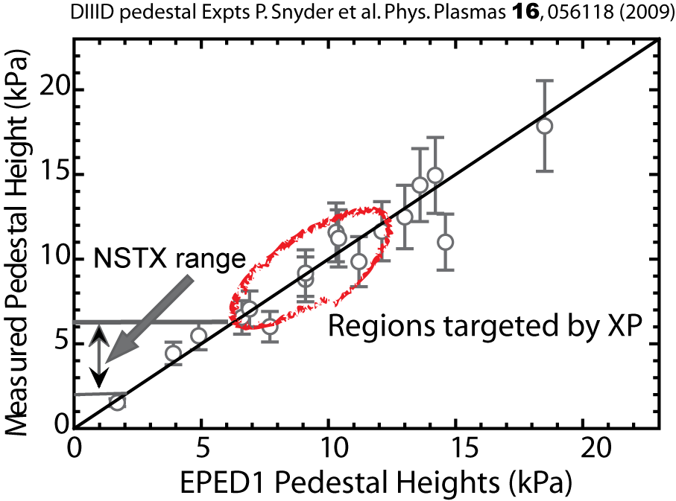
Two critical issues in the design of the future tokamak devices are the predictability of the edge pedestal height and the control of the divertor heat load in H-mode discharges. The control of the divertor heat load can easily be associated with the width of the pedestal. Both height and width of the pedestal are influenced by edge stability. In H-mode discharges, edge instabilities (ELM) are often driven by a large pedestal height, which is associated with improved edge confinement and associated large bootstrap current. It has been hypothesized that the peeling ballooning stability sets the critical pressure gradient and the kinetic ballooning mode turbulence sets the pedestal width. The combination of both constraints yields the pedestal height.

In this experiment, we plan to generate a large range of pedestal heights and associated widths (up to one order of magnitude) in order to access/probe the boundary of the stability limits. The present range of achieved pedestal height on NSTX is limited to a narrow range (factor ~3) as shown in figure 1.
Figure 1: Comparison between EPD1 and observed pedestal values in DIII-D. Also indicated are the present achieved pedestal heights in NTSX. The range of heights we plan to access is shown in the ellipse.

We plan on achieving large pedestal heights by systematically varying the toroidal field and current in high triangularity discharges. Data obtained from these discharges will set the scene for the investigation of potential height-width relationship of the pedestal and will attempt to differentiate between the ρ* and β_{pol} scalings, and assess the impact of turbulence in the pedestal region.

3. Experimental run plan
This XP will target discharges with triangularity ranging between 0.7 and 0.8, and with drsep kept between -0.5 cm and -1cm. For all cases, we will require MHD quiescent phases of the discharge and perform a fine scan in plasma current, and then a variation of the toroidal field (e.g., 0.45 T, 0.5T, and 0.55T) at select plasma currents. Some of the data points will lie along a constant q₉₅ scan. We will start from a recent fiducial discharge, with discharges with medium range toroidal field as it follows
- Starting with toroidal field of 0.5 T, we will perform a fine scan of the toroidal current from 700kA, 1.3 MA, 1.2 MA 9 Shots
- Repeat for 0.55 T for 0.7 MA, 0.9 MA, and 1.0 MA 9 Shots
- Repeat for 0.45T for 0.7 MA, 1.2 MA, and 0.9 MA 9 Shots
- Fill in shots as needed for good pedestal profile analysis
The combination of current and toroidal field scan will generate ~ 27 shots. One decision to be made is whether to run with cold or warm LLD, with the default being cold LLD with ~ 100mg LITER deposition between shots. Profile analysis will be performed by team members between discharges, and the outer gap will be maintained at ~ 10cm for optimum MPTS profiles.

4. Required machine, NBI, RF, CHI and diagnostic capabilities
Obtain H-mode ELMy discharges and all beams are required. Beam A kicks in at 60 ms, beam B at 80 ms, and beam C at 200 ms.

5. Planned analysis
I plan on using all the available tools for analyzing the data. These tools include EFIT, kinetic EFIT, and Osborne’s profile analysis tools, as well as stability analysis with ELITE and PEST. Thomson, CHERS and ERD are required.

6. Planned publication of results
The results will be reported in APS paper and Physics of Plasmas.
PHYSICS OPERATIONS REQUEST
TITLE: Dependence of Pedestal Structure on Ip and Bt | No. OP-XP-1044
AUTHORS: A. Diallo, R. Maingi, S. Zweben, B. Leblanc, B. Stratton, J. Menard, J. Canick, A. Maclean, S. Kubota et al | DATE:
(use additional sheets and attach waveform diagrams if necessary)
Describe briefly the most important plasma conditions required for the experiment:

Previous shot(s) which can be repeated:
Previous shot(s) which can be modified:
Machine conditions (specify ranges as appropriate, strike out inapplicable cases)
I_{TF} (kA): 54, 60, 66 Flattop start/stop (s):
I_{P} (MA): 0.7-1.3 or 1.4 Flattop start/stop (s):
Configuration: LSN (fiducal, with drsep ~ 5-10 mm)
Equilibrium Control: Outer gap / Isoflux (rtEFIT)
Outer gap (m): 0.1 Inner gap (m): 5-10cm Z position (m):
Elongation κ: 2.2-2.4 Upper/lower triangularity δ: 0.5-0.6/0.7-0.8
Gas Species: D Injector(s):
NBI Species: D Voltage (kV) A: √ B: √ C: √ Duration (s):
ICRF Power (MW): no Phase between straps (°): Duration (s):
CHI: Off Bank capacitance (mF):
LITERs: On Total deposition rate (mg/min): 5-10
EFC coils: On Configuration: Odd / Even / Other (attach detailed sheet

DIAGNOSTIC CHECKLIST
TITLE: Dependence of Pedestal Structure on Ip and Bt | No. OP-XP-1044
AUTHORS: | DATE:

Note special diagnostic requirements in Sec. 4
Diagnostic | Need | Want
Bolometer – tangential array | √
Bolometer – divertor |  | √
CHERS – toroidal | √
CHERS – poloidal | √
Divertor fast camera | √
Dust detector
EBW radiometers
Edge deposition monitors
Edge neutral density diag. |  | √
Edge pressure gauges |  | √
Edge rotation diagnostic | √
Fast ion D_alpha - FIDA
Fast lost ion probes - IFLIP
Fast lost ion probes - SFLIP
Filterscopes | √
FIReTIP |  | √
Gas puff imaging |  | √
Hα camera - 1D |  | √
High-k scattering | √
Infrared cameras |  | √
Interferometer - 1 mm
Langmuir probes – divertor
Langmuir probes – BEaP
Langmuir probes – RF ant.
Magnetics – Diamagnetism | √
Magnetics – Flux loops | √
Magnetics – Locked modes | √
Magnetics – Pickup coils | √
Magnetics – Rogowski coils | √
Magnetics – Halo currents |  | √
Magnetics – RWM sensors | √
Mirnov coils – high f. | √
Mirnov coils – poloidal array | √
Mirnov coils – toroidal array | √
Mirnov coils – 3-axis proto. |  | √

Note special diagnostic requirements in Sec. 4
Diagnostic | Need | Want
MSE | √
NPA – E||B scanning
NPA – solid state
Neutron measurements
Plasma TV
Reciprocating probe
Reflectometer – 65GHz |  | √
Reflectometer – correlation |  | √
Reflectometer – FM/CW |  | √
Reflectometer – fixed f |  | √
Reflectometer – SOL |  | √
RF edge probes
Spectrometer – SPRED |  | √
Spectrometer – VIPS |  | √
SWIFT – 2D flow
Thomson scattering | √
BES |  | √
Ultrasoft X-rays – bicolor |  | √
Ultrasoft X-rays – TG spectr.
Visible bremsstrahlung det. |  | √
X-ray crystal spectrom. - H
X-ray crystal spectrom. - V
X-ray fast pinhole camera
X-ray spectrometer - XEUS |  | √

