Princeton Plasma Physics Laboratory
NSTX Experimental Proposal
Title: Effect of divertor electrode biasing on local SOL transport
OP-XP-1051 | Revision: v. 1 - 2st DRAFT | Effective Date:  (Approval date unless otherwise stipulated)  Expiration Date:  (2 yrs. unless otherwise stipulated)
PROPOSAL APPROVALS
Responsible Author: Stewart Zweben |  |  | Date 8/16/10
ATI – ET Group Leader: Vlad Soukanovskii |  |  | Date
RLM - Run Coordinator: |  |  | Date
Responsible Division: Experimental Research Operations
RESTRICTIONS or MINOR MODIFICATIONS
(Approved by Experimental Research Operations)

NSTX EXPERIMENTAL PROPOSAL
TITLE: Effect of divertor plate electrode biasing on local SOL transport | No. OP-XP-1051
AUTHORS: S.J. Zweben, F. Scotti, M. Jaworski, I. Joseph,  R. Kaita, J. Kallman, H. Kugel, R. Maqueda, L. Roquemore,  H. Takahashi and the NSTX team | DATE: 8/16/10

1. Overview of planned experiment

The main goal of this experiment is to electrically bias the new LLD electrodes and determine whether they affect the local scrape-off layer transport. This will be diagnosed with the probes mounted near these electrodes and by vertically viewing cameras focused on these electrodes. A second goal is to determine whether this electrode biasing can either suppress or create ELMs, as has been proposed (independently) by H. Takahashi and I. Joseph (LLNL).

The experiment will start with a biasing the Bay E electrodes in a ~3 MW NBI plasma with the outer strike point sweeping from ~60-68 cm, i.e. well inboard of the electrode location at R=78±2 cm. For the template shot #139654 there were good probe signals on the Bay E probes near the Bay E electrode. After ~14 shots at with this probe configuration, the probes will be switched to Bay K for ~6 shots to see the effect of the differently-oriented Bay K electrodes. The possible effect of biasing on the ELMs will be determined from biasing both pairs of electrodes and looking at the usual D_{α} and edge diagnostics.

2. Theoretical/ empirical justification

The theoretical justification for this experiment comes from a series of papers by Ruytov and Cohen et al [1], which described an idea to control the heat and particle flux to the divertor plate of a tokamak. The mechanism for this control is the creation of convective cells (charged flux tubes), which can cause the plasma to flow radially at the local ExB speed. Since this flow can easily be larger than the usual (turbulent) radial transport, in principle the SOL profile can be significantly modified in space and time, at least nearby the electrodes.

Initial tests of this idea were made using biased electrodes and probes located near the outer midplane (BEaP). This resulted in a modification of the local particle flux to the probe by up to a factor-of-ten [2]. The local changes were qualitatively consistent with the expected changes due to ExB rotation, e.g. they changed in sign with a change in the direction of the bias. However, the magnitude and spatial extent of these changes could not be explained on the basis of existing modeling, most likely due to the uncertain effects of turbulence on the local fields. The physics of the local electric field generation may be significantly different at the divertor plate due to the different field line angle and flux tube geometry. Therefore the present experiment will be exploring a new regime for testing this idea.

The present BEaP electrodes were installed in the diagnostic tile sections of the LLD in 2009. Pictures of the new LLD biased electrodes and probes are shown below. There are two electrodes at Bay E (aligned toroidally) and two at Bay K (aligned radially). There are 5 small Langmuir probes next to each of these electrode pairs. Both electrodes can be viewed by an LLD camera from above using any one of several filters (D_{a}, Li I etc).

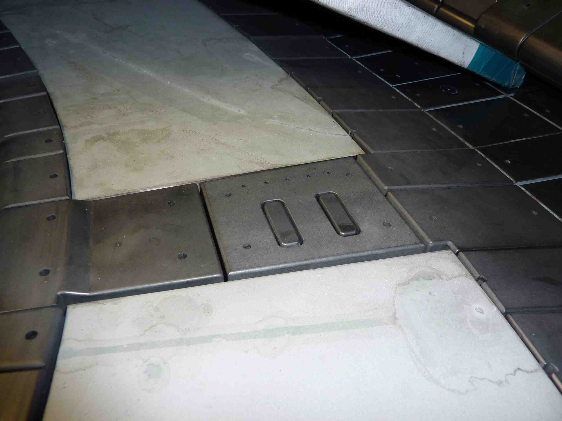
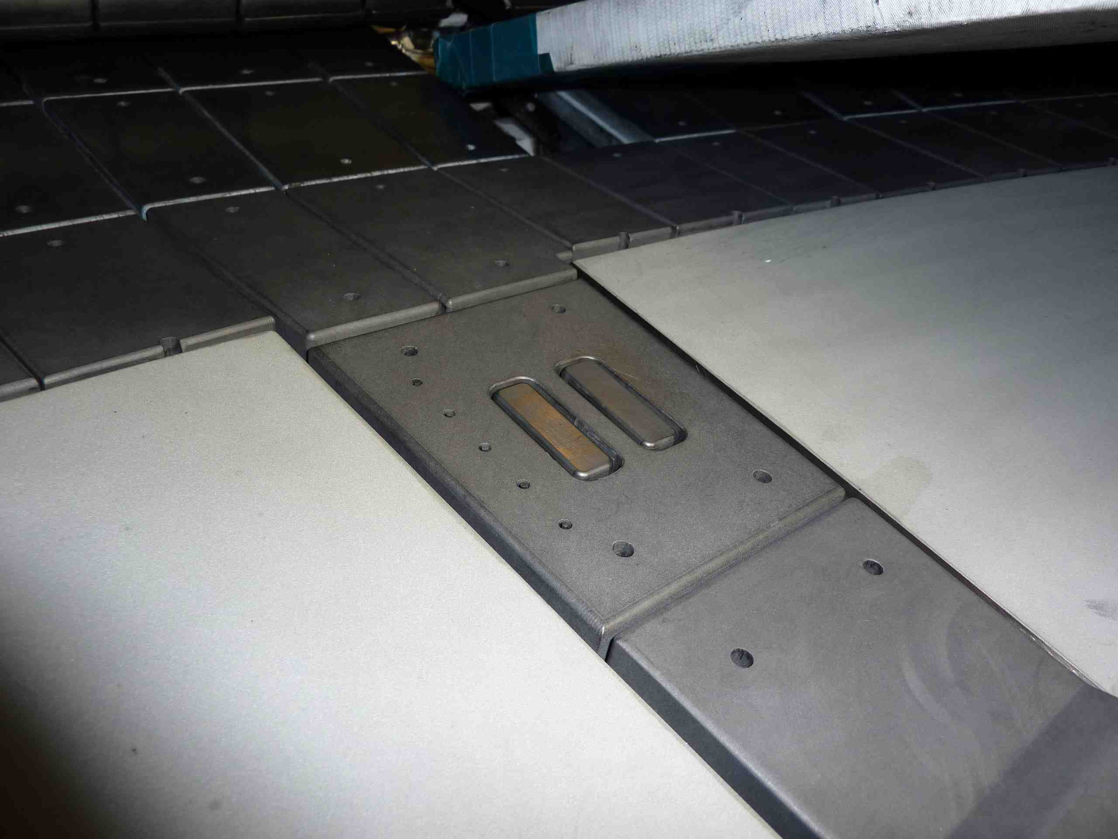
Bay K
Bay E
probes
electrodes
probes
electrodes
10 cm
10 cm

Recently it has been pointed out by H. Takahashi that SOL currents might have an important influence on ELMs [3]. Also, I. Joseph of LLNL has recently described an idea to actively control ELMs by generating SOL currents use biased electrodes in divertor plates [4]. Therefore this experiment will also look for effects of the divertor plate biasing on ELMs in NSTX.
[1] R.H. Cohen and D.D. Ryutov, Nucl. Fusion 37, 621 (1997); D.D. Ryutov, P. Helander, and R.H. Cohen, Plasma Phys. Control. Fusion 43, 1399 (2001).
[2] S.J. Zweben et al, PPCF 2009, 105012
[3] H. Takahashi et al, Phys. Rev. Lett. 100, 205001 (2008)
[4] I. Joseph, R.H. Cohen and D.D. Ryutov, Phys. Plasmas 16, 052510 (2009)

3. Experimental run plan

The first shots for this XP will be made using a standard discharge run previously for tests of the LLD operation in XP, e.g. shot #139654, with outer strike point (OSP) sweeping over R=60-68 cm. The figure below shows some waveforms from this shot, including the voltage and current signals from one of the BEaP Langmuir probes at Bay E. One electrode at Bay E will be biased positively, and the nearby one negatively at the same voltage for all these shots. The Bay E LLD camera will be operated with a ‘close-up’ lenses for this experiment, which should give a spatial resolution of ~ 1-2 mm at the electrodes.

On the first three shots the voltage to the pair of electrodes at Bay E will be increased from ±10 Volts to ±90 Volts, as shown in the Table. The effects of this biasing will be measured by the local Langmuir probes and by the LLD camera viewing the active electrodes with a Li I filter, but on one shot this will be switched to a D_{α} filter. On another shot the probes will be swept in order to estimate the local electron temperature near the electrodes. On another shot the negative bias will be removed from one of the electrodes to check its effect (expected to be small). This part of the XP should take 8 shots, including contingency.

The effect of adding bias to the Bay K electrodes will be assessed on the next two shots. This will be the condition in which the maximum effect of the electrodes on the plasma will be obtained, e.g. to make an effect on the ELMs. The electrode biasing will be at 50 Hz for ~400 msec so its effects should be easy to identify.

Next we will change the plasma to move the outer strike point outward so that it is nearer to the electrodes which are located at R=78±2 cm. The shot template for these cases will be chosen from among previous shots with OSP(EIFT) = 74 cm (#139393), OSP(EIFT) = 75 cm (#139402), OSP(EIFT) = 76 cm (#139395). Four shots will be taken at this larger OSP condition. Finally the effect of biasing the Bay K electrodes will be evaluated after switching the probe digitizers from Bay E to Bay K (this requires a brief controlled access). The Bay K electrodes extended in the radial direction instead of the toroidal direction as in Bay E.

This calls for a total of 20 shots, which should be done in ½ run day. Since a controlled access is required to do the last part involving the Bay K electrodes, this is best done on two days (3 hours on one day and one hour on a second day).

XP#1051 Shot List

Shot # | OSP R (cm) | E1 volts | E2 volts | K3 volts | K4 volts | Camera filters | Probe bias | Comment
1 | 60-68 | +10 | -10 | 0 | 0 | E,K - Li I | +50 VDC | E bias voltage scan
2 | 60-68 | +50 | -50 | 0 | 0 | E,K - Li I | +50 VDC | E bias voltage scan
3 | 60-68 | +90 | -90 | 0 | 0 | E,K - Li I | +50 VDC | E bias voltage scan
4 | 60-68 | +90 | -90 | 0 | 0 | E,K - Li I | +50 VDC | repeat shot
5 | 60-68 | +90 | -90 | 0 | 0 | E,K - Dα | sweep | repeat shot
6 | 60-68 | +90 | 0 | 0 | 0 | E,K - Dα | +50 VDC | zero negative voltage
7 | 60-68 | +90 |  |  |  |  |  | contingency repeat
8 | 60-68 | +90 |  |  |  |  |  | contingency repeat
9 | 60-68 | +90 | -90 | +90 | -90 | E,K - Li I | +50 VDC | add K bias to E bias
10 | 60-68 | +90 | -90 | +90 | -90 | E,K - Li I | +50 VDC | add K bias to E bias
11 | 74-76 | +90 | -90 | 0 | 0 | E,K - Li I | +50 VDC | increase OSP radius
12 | 74-76 | +90 | -90 | 0 | 0 | E,K - Li I | +50 VDC | repeat shot
13 | 74-76 | +90 | -90 | 0 | 0 | E,K - Dα | sweep | w/ Dα + sweep
14 | 74-76 | +90 |  |  |  |  |  | contingency repeat
switch probes from Bay E to Bay K (controlled access needed)
15 | 60-68 | 0 | 0 | +90 | -90 | E,K - Li I | +50 VDC | K bias w/K probes
16 | 60-68 | 0 | 0 | +90 | -90 | E,K - Li I | +50 VDC | K bias w/K probes
17 | 60-68 | 0 | 0 | +90 | -90 | E,K - Li I | +50 VDC | K bias w/K probes
18 | 60-68 | 0 | 0 | +90 | -90 | E,K - Dα | sweep | w/ Dα + sweep
19 | 60-68 | 0 | 0 | +90 | -90 | E,K - Li I | +50 VDC | increase OSP radius
20 | 60-68 | 0 | 0 | +90 |  |  |  | contingency repeat

Shot template for the first 10 shots

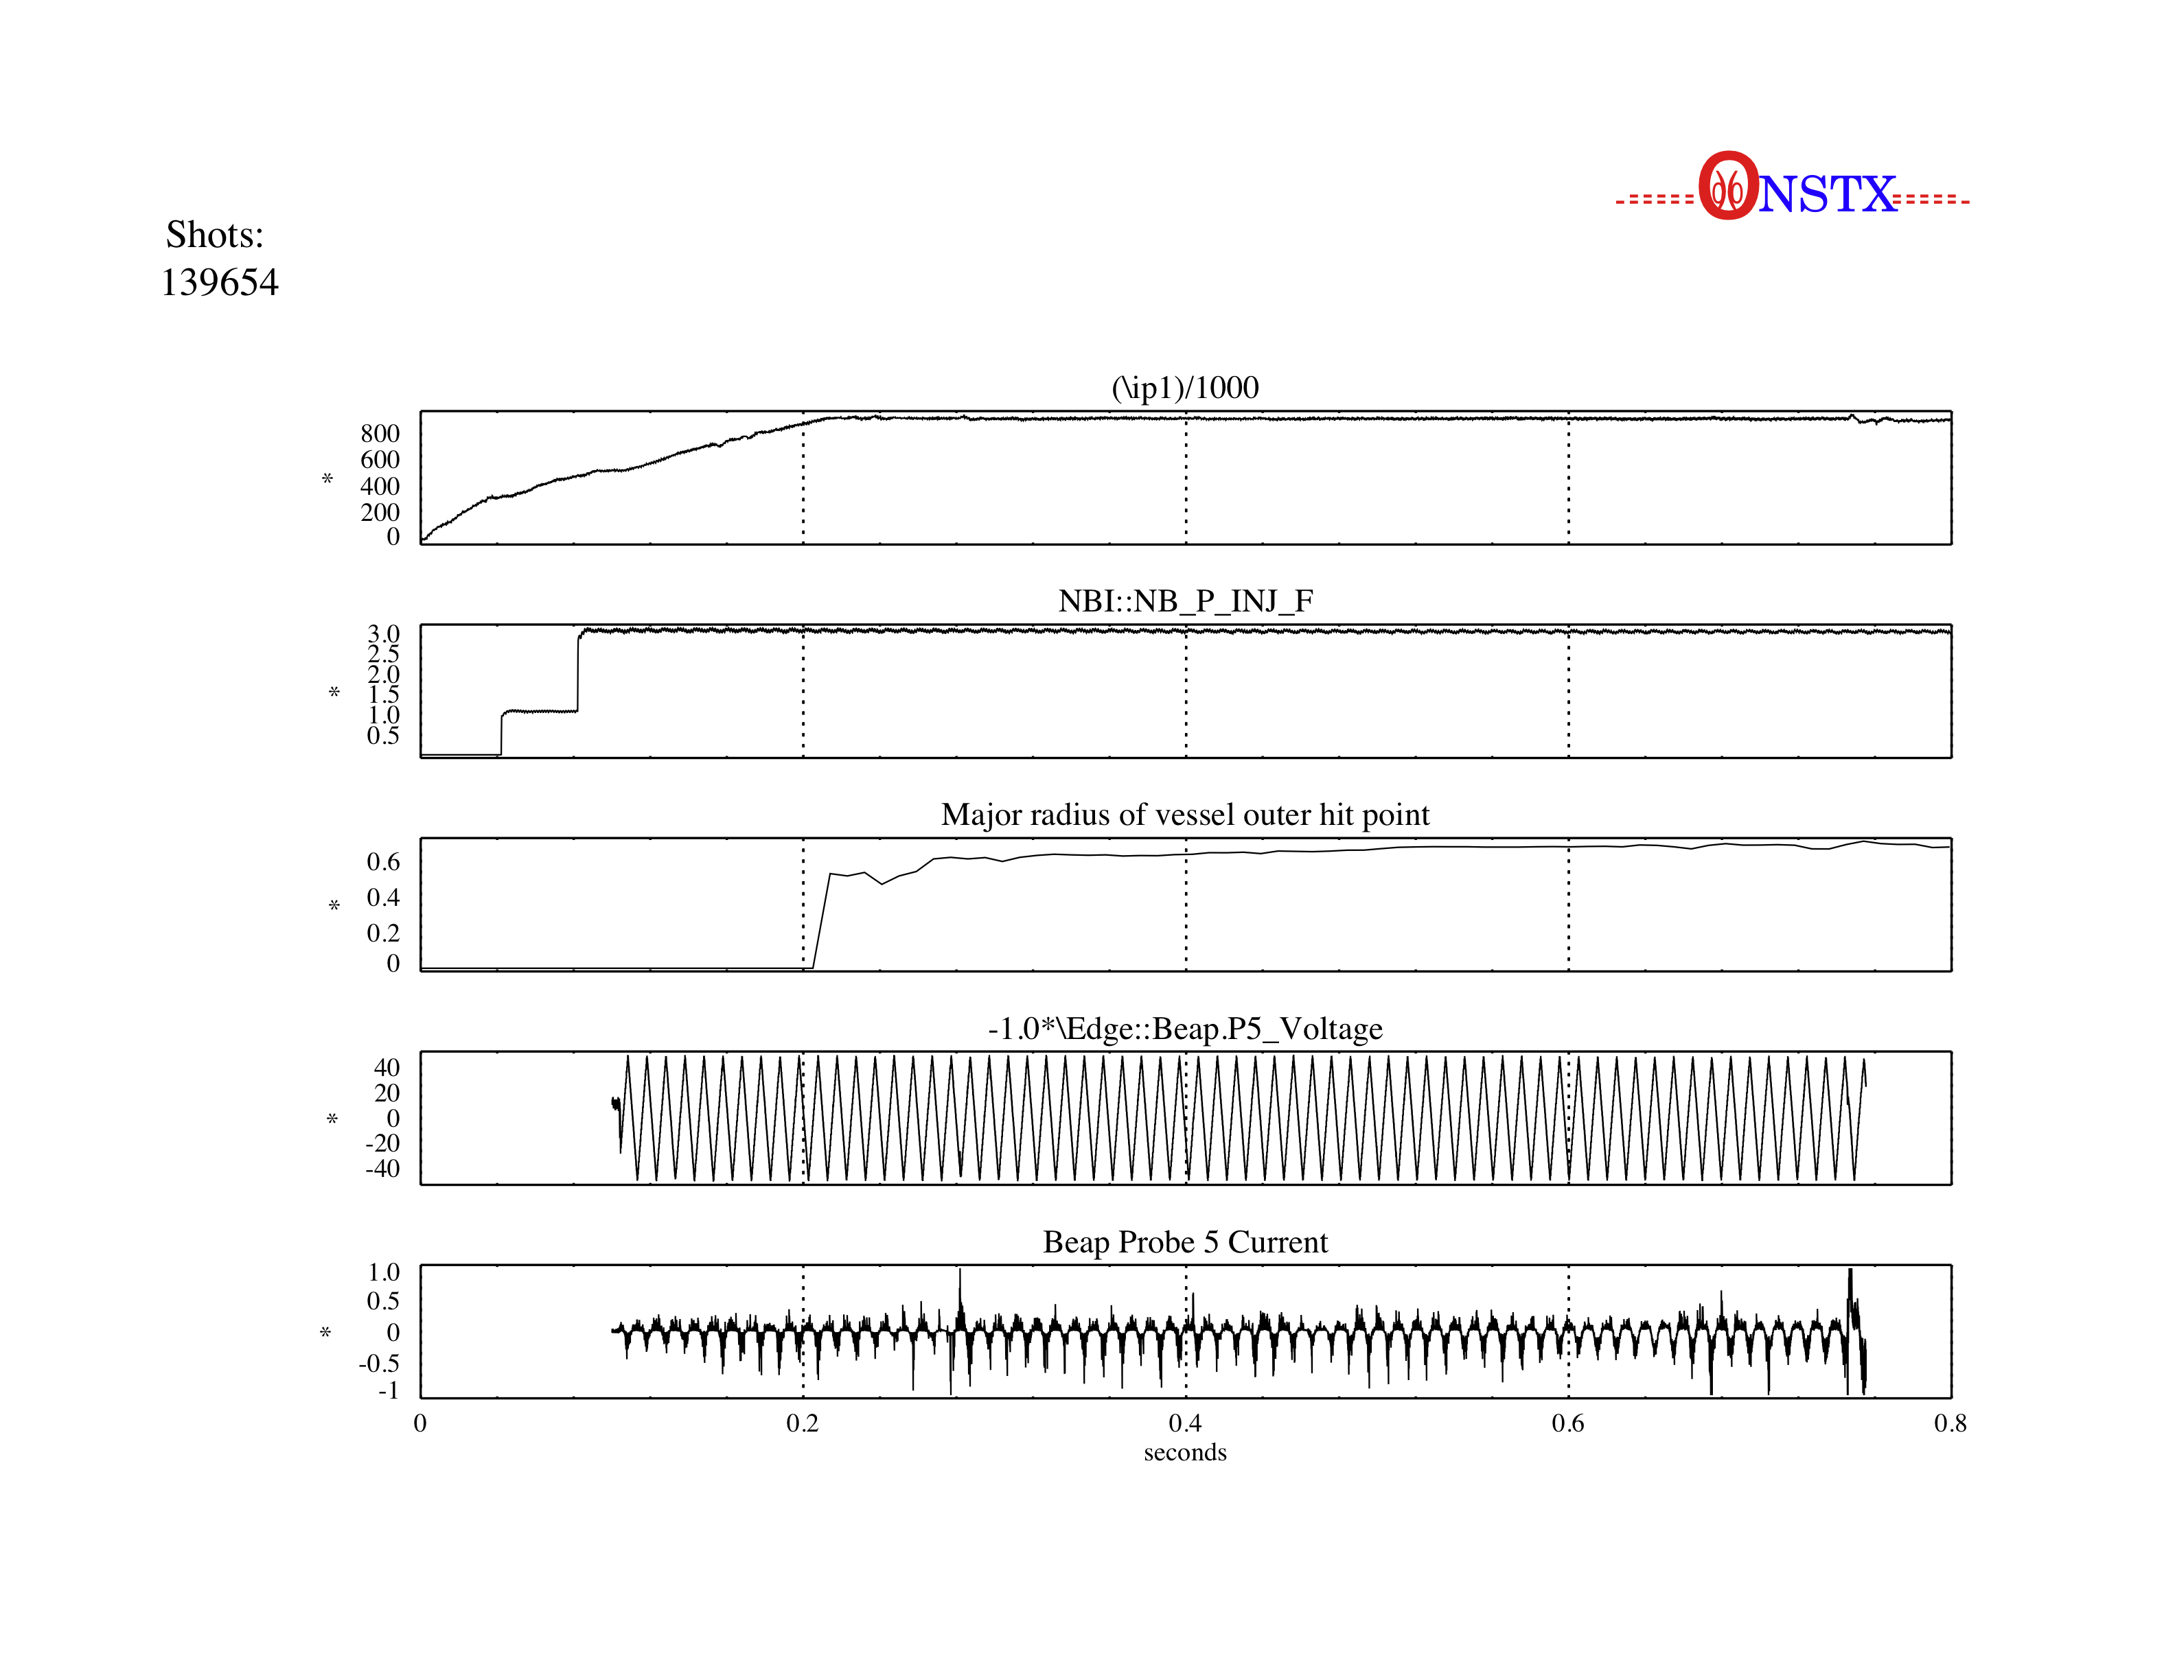

4. Required machine, NBI, RF, CHI and diagnostic capabilities

Baseline shot is repeat of #139652. No RF, no CHI.

Required diagnostics: LLD cameras Bay E and J, BEaP probes, TS.

The LLD cameras should be operated at the highest possible speed so that the interaction between the convective cells and the turbulence can be seen.

Normal diagnostics for ELMs should be monitored, e.g. D_{α}.

5. Planned analysis

The primary goal of the analysis will be to determine the spatial extent of the modification of the local SOL conditions by activation of the electrode biasing. This will be done by analysis of the images of Li I and D_{α} in the vicinity of the electrodes, and of the BEaP probe signals at Bays E and K. For example, the toroidal and radial extent of the perturbation of the light emission will be determined as a function of the applied bias voltage and OSP radius.

If a change in the local density or electron temperature is observed due to biasing, then the spatial extent of this change will most likely be determined by a balance between convection due to ExB flow around the electrode (convective cell). Some analysis of this situation can be probably done using the SOLT code of Lodestar, which can model a 2D SOL with a biased divertor plate segment along with the turbulence. If a change in ELM behavior is observed, the SOL current and magnetic field perturbation can be estimated from the electrode current, and the model of I. Joseph can be applied to try to explain the results. Any positive result in this direction would motivate a follow-up XP on this topic.

If a clear effect is seen due to biasing, it would be desirable to repeat this experiment under different plasma conditions to assess the sensitivity to q(a), NBI or RF power, distance of the electrodes into the SOL, etc. This will allow the design of a larger set of biased divertor plates which could be used to control the whole SOL of NSTX, including the high heat flux region near the OSP.

6. Planned publication of results

If good data is obtained the results will be written up for an article e.g. for Nucl. Fusion. The initial results will be presented in a contribution to 2010 IAEA paper of I. Joseph on SOL current effects.
PHYSICS OPERATIONS REQUEST
TITLE: Effect of divertor electrode biasing on local SOL transport | No. OP-XP-1051
AUTHORS: AUTHORS: S.J. Zweben, F. Scotti, M. Jaworski, I. Joseph, R. Kaita, J. Kallman, H. Kugel, R. Maqueda, L. Roquemore, H. Takahashi and the NSTX team | DATE: 8/16/10
(use additional sheets and attach waveform diagrams if necessary)
Brief description of the most important operational plasma conditions required:
Start with repeat of shot used for LLD operation XP, i.e. 139654.
For larger OSP, repeat shot 139393, 139395, or 139402.
Previous shot(s) which can be repeated: 139654
Previous shot(s) which can be modified:
Machine conditions (specify ranges as appropriate, strike out inapplicable cases)
I_{TF} (kA): 4.7 kG Flattop start/stop (s):
I_{P} (MA): 0.9 MA Flattop start/stop (s): 0.2 – 0.4
Configuration: LSN
Equilibrium Control: Outer gap / Isoflux (rtEFIT)
Outer gap (m): Inner gap (m): Z position (m):
Elongation: Triangularity (U/L): OSP radius (m):
Gas Species: D Injector(s):
NBI Species: D Voltage (kV) A: 90 B: C: Duration (s): 20 ms
ICRF Power (MW): Phase between straps (°): Duration (s):
CHI: Off Bank capacitance (mF):
LITERs: On Total deposition rate (mg/min): Established in XMP
LLD: Temperature (°C): cold
EFC coils: Off Configuration: Odd / Even / Other (attach detailed sheet)

DIAGNOSTIC CHECKLIST
TITLE: Effect of divertor electrode biasing on local SOL transport | No. OP-XP-1051
AUTHORS: AUTHORS: S.J. Zweben, F. Scotti, M. Jaworski, I. Joseph, R. Kaita, J. Kallman, H. Kugel, R. Maqueda, L. Roquemore, H. Takahashi and the NSTX team | DATE:

Note special diagnostic requirements in Sec. 4
Diagnostic | Need | Want
Beam Emission Spectroscopy |  | X
Bolometer – divertor |  | X
Bolometer – midplane array |  | X
CHERS – poloidal |  | X
CHERS – toroidal |  | X
Dust detector
Edge deposition monitors
Edge neutral density diag. |  | X
Edge pressure gauges |  | X
Edge rotation diagnostic |  | X
Fast cameras – divertor/LLD | X
Fast ion D_alpha - FIDA |  | X
Fast lost ion probes - IFLIP
Fast lost ion probes - SFLIP
Filterscopes |  | X
FIReTIP |  | X
Gas puff imaging – divertor |  | X
Gas puff imaging – midplane |  | X
Hα camera - 1D
High-k scattering
Infrared cameras |  | X
Interferometer - 1 mm |  | X
Langmuir probes – divertor |  | X
Langmuir probes – LLD | X
Langmuir probes – bias tile | X
Langmuir probes – RF ant. |  | X
Magnetics – B coils | X
Magnetics – Diamagnetism | X
Magnetics – Flux loops | X
Magnetics – Locked modes |  | X
Magnetics – Rogowski coils | X
Magnetics – Halo currents |  | X
Magnetics – RWM sensors |  | X
Mirnov coils – high f. |  | X
Mirnov coils – poloidal array |  | X
Mirnov coils – toroidal array |  | X
Mirnov coils – 3-axis proto. |  | X

Diagnostic | Need | Want
MSE |  | X
NPA – E||B scanning
NPA – solid state
Neutron detectors |  | X
Plasma TV |  | X
Reflectometer – 65GHz |  | X
Reflectometer – correlation |  | X
Reflectometer – FM/CW |  | X
Reflectometer – fixed f |  | X
Reflectometer – SOL |  | X
RF edge probes |  | X
Spectrometer – divertor |  | X
Spectrometer – SPRED |  | X
Spectrometer – VIPS
Spectrometer – LOWEUS
Spectrometer – XEUS |  | X
SWIFT – 2D flow |  | X
Thomson scattering | X
Ultrasoft X-ray – pol. arrays |  | X
Ultrasoft X-rays – bicolor |  | X
Ultrasoft X-rays – TG spectr. |  | X
Visible bremsstrahlung det. |  | X
X-ray crystal spectrom. - H |  | X
X-ray crystal spectrom. - V |  | X
X-ray tang. pinhole camera |  | X

