Princeton Plasma Physics Laboratory
NSTX Experimental Proposal
Title: Development of long pulse enhanced pedestal H-mode
OP-XP-1064 | Revision: | Effective Date:  (Approval date unless otherwise stipulated)  Expiration Date:  (2 yrs. unless otherwise stipulated)
PROPOSAL APPROVALS
Responsible Author: J.M. Canik |  |  | Date
ATI – ET Group Leader: |  |  | Date
RLM - Run Coordinator: |  |  | Date
Responsible Division: Experimental Research Operations
RESTRICTIONS or MINOR MODIFICATIONS
(Approved by Experimental Research Operations)

NSTX EXPERIMENTAL PROPOSAL
TITLE: Development of long pulse enhanced pedestal H-mode | No. OP-XP-1064
AUTHORS: J.M. Canik, R. Maingi, S.P. Gerhardt | DATE: 4/19/10

1. Overview of planned experiment
This goal of this experiment is to develop the Enhanced Pedestal H-mode (EPH) as a long pulse scenario. This will be accomplished in three parts: 1) demonstrate the ability to trigger the EPH using 3D-field-induced ELMs; 2) extend the duration of the EPH using beta feedback to avoid reaching beta limit; and 3) apply these techniques to use the EPH as a means to increase toroidal beta.

2. Theoretical/ empirical justification
The Enhanced Pedestal H-mode is a regime of improved confinement that has been observed in NSTX (Maingi, JNM 390-391 (2009) 440). This regime is characterized by a strong (factor of ~2) increase in the pedestal electron and ion temperatures, which is thought to be due to changes in radial electric field caused by local rotation braking, and a natural increase in the outer gap. These profile changes lead to a ~50% improvement in the normalized confinement time. The EPH typically occurs following a large ELM, and was originally identified and studies in plasmas that did not use lithium wall conditioning. In recent experiments where lithium has routinely been used, the occurrence of EPH modes appears to be more common. In particular, the triggering of ELMs using n=3 perturbations during lithium-conditioned plasmas has often been seen to lead to EPH modes. Examples of this are shown below. Both of these discharges are highly shaped (κ~2.4, δ~0.8), with plasma currents of 0.8 (left) and 1.0 MA (right). In the 1.0 MA case, the EPH is nearly fully developed as confirmed from edge profiles following the final triggered ELM; at 0.8 MA, the stored energy recovery phases after each ELM are indicative of EPH, but the period between ELMs is too short for the mode to develop enough to be confirmed in the edge profiles (we note that EPH has been clearly confirmed at 0.8 MA at a reduced elongation of κ~2.0, indicating that reduced I_{p} does not present a technical challenge). The increased occurrence following lithium conditioning suggests that fuelling plays a role; this idea is supported by the fact that the longest EPH seen to date used combined lithium and supersonic gas injection (SGI). The goal of the present experiment is to test if the EPH can be reliably triggered using ELMs induced by n=3 fields, as the data suggests is possible. If EPH-triggering is successful, this XP seeks to extend the duration of the EPH phase by adding beta feedback (beta limits are often hit following the transition to improved confinement in the EPH).
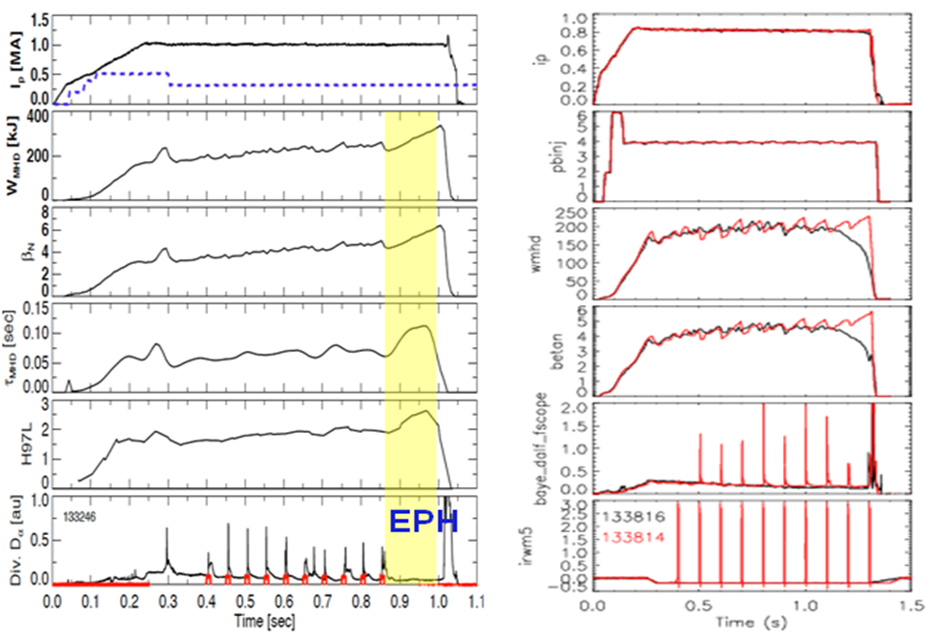

3. Experimental run plan
The starting point for the first ½ day experiment will be a fiducial-like discharge. Previous observations have shown EPH modes triggered by ELMs triggered by n=3 fields from the resistive wall mode coils at 0.8 and 1.0 MA with shaping similar to the fiducial. Rather than restore either of these cases, various aspects that could potentially be important to EPH access will be tested at the standard fiducial 900 kA plasma current. Three types of n=3 waveforms will be tested: slow lower amplitude pulses (1.2 kA, 50 ms) that trigger many ELMs; fast high amplitude pulses (2 kA, 10 ms) to trigger a single large ELM; and shorter duration pulses (shorter than ELM onset time) to test if EPH can be triggered by the n=3 field itself without the need for an ELM. If one of these waveforms is successful in triggering the EPH reliably, then the plasma current and toroidal magnetic field will be scanned (1.1 MA/0.45 T, 1.1/0.55). Otherwise, if EPH triggering is unreliable the role of outer gap will be explored by repeating these tests at 12-15 cm, and fuelling will be altered both by increasing the lithium evaporation rate and using SGI.
Part 1: Learning to trigger the EPH (1/2 day):
1.1. Produce reference discharge (no n=3 pulses) (2 shots)
Fiducial-like: I_{p}=0.9 MA, B_{t}=0.45 T, κ=2.4, δ=0.7, P_{NBI}=4 MW, outer gap 10 cm, LiTER at 250 mg/shot, 10 minute shot cycle
Adjust lithium evaporation rate to ensure ELM-free conditions
1.2. Apply n=3 fields using three SPA waveforms (4-6 shots)
If sufficient current flat-top (to t~0.8s) include two pulses per discharge, at 300 and 600 ms, else only at 300 ms
SPA waveform 1: 2.5 kA, 10 ms (trigger one large ELM)
SPA waveform 2: 1.2 kA, 50 ms (trigger several ELMs)
SPA waveform 3: reduce duration of pulse such that no ELMs are triggered (try to trigger EPH without ELM)
Start from whichever ELM-triggering waveform induced EPH
If neither triggered EPH modify waveform 1
If one waveform triggers EPH and others didn’t, repeat the “best”
1.3. Decision point: if the best waveform has triggered an EPH on 1/2 or more of the attempts, move on to current scan in 1.4, else
1.3.1 Increase outer gap to 12-15 cm and repeat three SPA waveforms (3 shots)
1.3.2. Go to 12.5 minute shot cycle, raise LiTER to 400 mg/shot and test best waveform (3 shots)
1.3.3. If still no EPH, replace CS with SGI, try again (3 shots)
1.4. Increase plasma current to 1.1 MA (6 shots)
Go to 12.5 minute shot cycle, adjust lithium evaporation until plasma is ELM-free
Test EPH triggering
If one waveform is clearly the best, test this several times
If multiple waveforms worked at 0.9 MA, test each
1.5. Time permitting, increase toroidal field to 0.55 T (6 shots)
Adjust lithium
Attempt to trigger EPH
1.6. Also time permitting, turn on beta feedback control to test during EPH
If possible, set Src B and C to 1 MW each during feedback discharges to reduce modulation

Part 2: Using EPH to achieve sustained high beta-toroidal (1/2 day)
Produce reference discharge: reload 1.1 MA, 0.45 T case from above, if that part of the shot list was completed, else reload 135119 (2 shots)
Demonstrate EPH mode triggering and feedback control (2 shots)
If necessary reduce proportional and integral gains during period after EPH transition
Details of feedback control will likely be addressed in XP1019
Toroidal field scan (4-5 shots at each field)
Set Bt to 0.45, 0.425, 0.4 T
At each value, reduce requested β_{N} to ~80% of previous case, then increase to maximum possible while avoiding disruption (start with increments of 0.7, then bracket)
Increase kappa as necessary to keep q* high

4. Required machine, NBI, RF, CHI and diagnostic capabilities
This XP requires a fully functioning NBI system, RWM coils configured as n=3, and LiTER.

5. Planned analysis
EFIT/LRDFIT needed. Pedestal profile analysis using Python tools. Transport analysis with TRANSP.

6. Planned publication of results
If successful, the results of this experiment will likely presented at APS, and published in a Nuclear Fusion paper.
PHYSICS OPERATIONS REQUEST
TITLE: Development of long pulse enhanced pedestal H-mode | No. OP-XP-1064
AUTHORS: J.M. Canik, R. Maingi, S.P. Gerhardt | DATE: 4/19/10
(use additional sheets and attach waveform diagrams if necessary)
Brief description of the most important operational plasma conditions required:
The reference discharge must be ELM-free, with at least 400 ms MHD-free flat-top (700 ms preferred)
RWM coils set configured for n=3 must be available
Beta- and RWM-feedback control are required for second and third parts of XP
Previous shot(s) which can be repeated: 2009 fiducial
Previous shot(s) which can be modified: 135182, 135119
Machine conditions (specify ranges as appropriate, strike out inapplicable cases)
I_{TF} (kA): 0.45-0.55 kG Flattop start/stop (s): 0/1
I_{P} (MA): 0.9-1.1 Flattop start/stop (s): 0.15/1.0, use full OH
Configuration: Limiter / DN / LSN / USN
Equilibrium Control: Outer gap / Isoflux (rtEFIT) / Strike-point control (rtEFIT)
Outer gap (m): 0.1 Inner gap (m): 0.05 Z position (m):
Elongation: 2.4 Triangularity (U/L): 0.7 OSP radius (m):
Gas Species: D Injector(s):
NBI Species: D Voltage (kV) A: 90 B: 90 C: 90 Duration (s):
ICRF Power (MW): Phase between straps (°): Duration (s):
CHI: Off / On Bank capacitance (mF):
LITERs: Off / On Total deposition rate (mg/min): 40
LLD: Temperature (°C):
EFC coils: Off/On Configuration: Odd / Even / Other (attach detailed sheet)

DIAGNOSTIC CHECKLIST
TITLE: Development of long pulse enhanced pedestal H-mode | No. OP-XP-1064
AUTHORS: J.M. Canik, R. Maingi, S.P. Gerhardt | DATE: 4/19/10

Note special diagnostic requirements in Sec. 4
Diagnostic | Need | Want
Beam Emission Spectroscopy |  | √
Bolometer – divertor |  | √
Bolometer – midplane array |  | √
CHERS – poloidal |  | √
CHERS – toroidal | √
Dust detector
Edge deposition monitors
Edge neutral density diag. |  | √
Edge pressure gauges |  | √
Edge rotation diagnostic |  | √
Fast cameras – divertor/LLD |  | √
Fast ion D_alpha - FIDA
Fast lost ion probes - IFLIP
Fast lost ion probes - SFLIP
Filterscopes | √
FIReTIP |  | √
Gas puff imaging – divertor |  | √
Gas puff imaging – midplane |  | √
Hα camera - 1D | √
High-k scattering
Infrared cameras |  | √
Interferometer - 1 mm
Langmuir probes – divertor |  | √
Langmuir probes – LLD |  | √
Langmuir probes – bias tile
Langmuir probes – RF ant.
Magnetics – B coils | √
Magnetics – Diamagnetism | √
Magnetics – Flux loops | √
Magnetics – Locked modes | √
Magnetics – Rogowski coils | √
Magnetics – Halo currents |  | √
Magnetics – RWM sensors | √
Mirnov coils – high f. |  | √
Mirnov coils – poloidal array |  | √
Mirnov coils – toroidal array |  | √
Mirnov coils – 3-axis proto.

Note special diagnostic requirements in Sec. 4
Diagnostic | Need | Want
MSE | √
NPA – E||B scanning
NPA – solid state
Neutron detectors |  | √
Plasma TV |  | √
Reflectometer – 65GHz |  | √
Reflectometer – correlation |  | √
Reflectometer – FM/CW
Reflectometer – fixed f
Reflectometer – SOL
RF edge probes
Spectrometer – divertor |  | √
Spectrometer – SPRED |  | √
Spectrometer – VIPS |  | √
Spectrometer – LOWEUS |  | √
Spectrometer – XEUS |  | √
SWIFT – 2D flow
Thomson scattering | √
Ultrasoft X-ray – pol. arrays | √
Ultrasoft X-rays – bicolor |  | √
Ultrasoft X-rays – TG spectr. |  | √
Visible bremsstrahlung det. | √
X-ray crystal spectrom. - H
X-ray crystal spectrom. - V
X-ray tang. pinhole camera
Reciprocating probe √

