Princeton Plasma Physics Laboratory
NSTX Experimental Proposal
Title: Merging Start-up
OP-XP-511 | Revision: 1 | Effective Date:  (Ref. OP-AD-97)  Expiration Date:  (2 yrs. unless otherwise stipulated)
PROPOSAL APPROVALS
Author: Y. Takase, Y. Ono, O. Mitarai, D. Gates, J. Menard,  R. Raman, J.R. Wilson, M. Yamada, S. Zweben |  |  | Date
ATI – ET Group Leader: R. Raman |  |  | Date
RLM - Run Coordinator: J. Menard |  |  | Date
Responsible Division: Experimental Research Operations
Chit Review Board (designated by Run Coordinator)

MINOR MODIFICATIONS (Approved by Experimental Research Operations)

NSTX EXPERIMENTAL PROPOSAL
Merging Start-up OP-XP-511

1. Overview of planned experiment
Briefly describe the scientific goals of the experiment.
The goal is to demonstrate plasma current start-up without the use of the central solenoid (OH coil). In this XP, plasma current start-up by merging of two ST plasmas, using only outboard PF coils, is proposed. The role of noninductive plasma production (EC preionization) and requirements for magnetic configuration will be evaluated..

2. Theoretical/ empirical justification
Brief justification of activity including supporting calculations as appropriate
Several start-up scenarios have been considered for NSTX: (1) pressure-driven start-up by ECH (CDX-U scenario), (2) RF ionization + PF induction (JT-60U scenario), and (3) plasma merging (TS-3/TS-4/START/MAST scenario). These scenarios have been modeled by LRDIAG, with the plasma modeled by a set of passive coils whose resistivities were chosen to reproduce I_{p} ramp-up of a 1 MA NSTX plasma.
JT-60U has demonstrated generation of 100 kA of plasma current by EC preionization and outboard PF coil induction only [Y. Takase, et al., IAEA Fusion Energy Conf. (Vilamoura, 2004), paper EX/P4-34]. A scenario similar to this, but with HHFW preionization, was attempted on NSTX in May 2004 (XP431). However, a convincing evidence of current channel formation was not observed. The most likely reason is the mismatch in the optimum range of neutral gas pressure between efficient delivery of RF power and plasma current start-up. A merging scenario was proposed in XP431 as scenario (3), but this was not attempted because of limited time allocated to the experiment.
In the merging start-up scenario, magnetic reconnection takes place, and part of the magnetic field energy is converted into the plasma kinetic energy. Because of the large heating power provided by reconnection, this scenario is suitable for forming a high-β ST plasma quickly. This technique was pioneered in TS-3 (Fig. 1), and was successfully applied to START, TS-4, and MAST. All of these experiments made use of either electrodes or coils located inside the vacuum vessel.
This XP proposes to demonstrate a merging start-up scenario which uses only outboard PF coils located outside the vacuum vessel. An example of LRDIAG simulation of such a scenario is shown in Fig. 2. Plasma currents of the order of 100 kA are predicted to be driven. PF1A, PF2 and PF4 coils are used to create X-points in the plasma formation regions at the top and bottom ends of the vacuum vessel. Inductive flux is provided mainly by PF2, PF3 and PF4 coils during the plasma formation phase, and further current ramp-up is accomplished by inductive flux provided mainly by PF3 and PF5 coils.
If successful plasma current start-up were accomplished, optimization of the merging process will be attempted to maximize ion heating due to reconnection.
Fig. 1. Merging formation of a high-β ST plasma on TS-3. High power heating due to magnetic reconnection helps create a high-β ST plasma quickly.

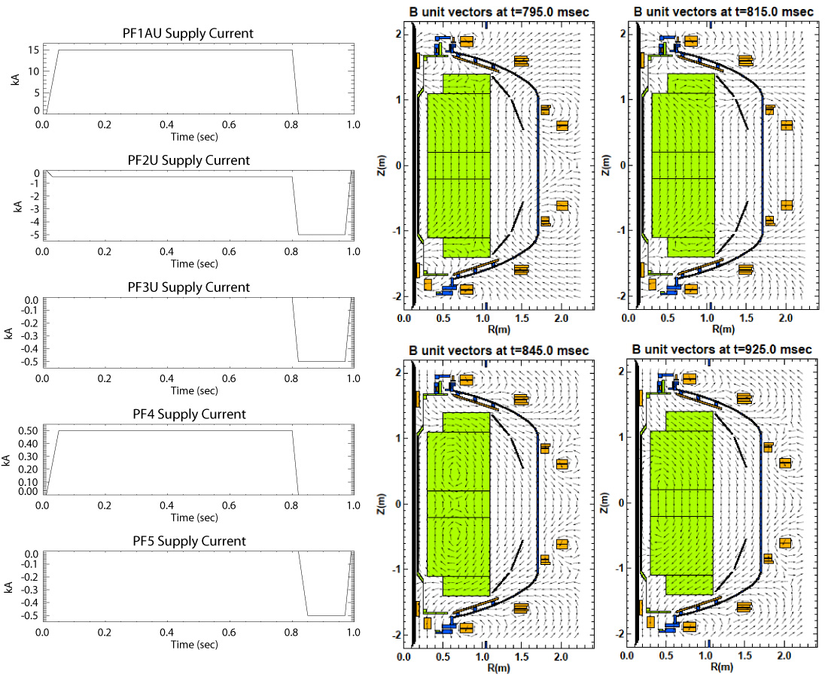
Fig. 2. A merging start-up scenario on NSTX. Plasmas are initially formed at the X-points created by PF1A, PF2 and PF4 coils at the top and the bottom of the vacuum vessel. The two plasmas merge near the midplane and form a single ST plasma.

3. Experimental run plan
Describe experiment in detail, including decision points and processes
Plasma initiation and plasma current formation at the X-points will be attempted first, starting with the PF coil waveforms shown in Fig. 2 (scenario 1). This places the X-points at R = 0.9 m and Z = ± 1.2 m, and a maximum loop voltage at the X-points of 3 V is predicted. Preionization ECH will be used at full power. The toroidal field should be 0.45 T, which places the preionization electron cyclotron (18 GHz) resonance layer at R = 0.6 m, to the high field side of the X-point. In this scenario PF1A, PF2, PF3 and PF4 coil currents are ramped simultaneously over 20 ms, while PF5 coil current is ramped over 30 ms after PF4 current reaches 0. Start the experiment with prefill pressure in the lower range of normal OH start-up. Proceed according to the following sequence.
- Scan down in pressure to find the optimum pressure for start-up, which is expected to be in the lower pressure range (5 shots).
- Vary the toroidal field: B_{t} = 0.3, 0.6 T ( 2 shots).
- Vary the X-point location in major radius from R_{X} = 0.75, 0.6 m (1A, 1B). In this sequence, B_{t} should be scaled to maintain the optimum relationship between the resonance layer and the X-point (2 shots).
- Vary PF coil current ramp rates: ramp time 10 ms (V_{l} = 4 V at X-point) and 50 ms (V_{l} = 1.7 V at X-point) to document the dependence on the applied loop voltage (2 shots).
- Reduce EC power until plasma current fails to start (4 shots).
- Using the optimized condition for plasma current initiation, optimization of further current rise is attempted by controlling the subsequent poloidal field evolution, including PF coil current ramp rates and timings, and relative magnitudes of PF2, PF3 and PF5 coil currents. Possible examples are shown in 2 ~ 6 below (~ 10 shots).
- After completion of this sequence, optimize merging to maximize ion heating due to reconnection. According to the experience on TS-3 and TS-4, initial separation of the two plasmas and subsequent control of the reconnection speed by PF coils are important (~ 5 shots).

Scenario | PF1A (kA) | PF2 (kA) | PF3 (kA) | PF4 (kA) | PF5 (kA) | comments
1 | 15→0 | −0.5→−5 | 0→−0.5 | 0.5→0 | 0→−0.5 | R_{X} = 0.9 m
1A | same as 1 | −1→−5 | same as 1 | 1→0 | same as 1 | R_{X} = 0.75 m
1B | same as 1 | −2→−5 | same as 1 | 2→0 | same as 1 | R_{X} = 0.6 m
2 | same as 1 | −0.5→−10 | same as 1 | same as 1 | same as 1
3 | same as 1 | same as 1 | 0→−5 | same as 1 | same as 1
4 | same as 1 | same as 1 | same as 1 | same as 1 | 0→−5
5 | same as 1 | same as 1 | 0→−2 | same as 1 | 0→−1
6 | same as 1 | same as 1 | 0→−5 | same as 1 | 0→−5
If successful start-up to 100 kA level were achieved, position feedback control will be implemented, and HHFW power (∼1 MW) will be applied to increase the electron temperature and drive current. NBI may be used in addition, or in stead.
The total number of shots required for this experiment is estimated to be about 30 shots. Adjustments to optimization steps may be made depending on the outcome of the experiment.

4. Required machine, NBI, RF, CHI and diagnostic capabilities
Describe any prerequisite conditions, development, XPs or XMPs needed.
Attach completed Physics Operations Request and Diagnostic Checklist
PF4 is needed in the polarity opposite to PF5. EC preionization at full power. If start-up is successful, HHFW electron heating/current drive (3 MW) will be attempted. NBI may be used in combination, if available. Diagnostics adjusted to study the low current start-up phase (higher gain, etc.) are needed. Magnetics and EFIT are essential. Kinetic measurements are highly desirable to constrain EFIT reconstruction and to evaluate plasma resistivity and bootstrap current. Fast visible camera is needed to identify the plasma boundary during the start-up phase. MSE and CHERS data would be very helpful, if available.

5. Planned analysis
What analysis of the data will be required: EFIT, TRANSP, etc.
EFIT reconstruction is essential. It is important to be able to reconstruct from as early as possible in time. It may be necessary to use filament reconstruction during early times. Time evolution will be modeled by TRANSP, LRDIAG, and eventually TSC, and compared with experimental results.

6. Planned publication of results
What will be the final disposition of the results; where will results be published and when?
Successful outcome of this experiment has a very large impact on tokamaks in general and STs in particular, and will be published in Phys. Rev. Lett. More comprehensive analyses will be published in Physics of Plasmas or Nuclear Fusion.

PHYSICS OPERATIONS REQUEST
Merging Start-up OP-XP-511
Machine conditions (specify ranges as appropriate)
I_{TF} (kA): __35-71__ Flattop start/stop (s): 0.0 / 0.2 _
I_{P} (MA): __NA_ Flattop start/stop (s): __NA _
Configuration: Inner Wall
Outer gap (m): NA , Inner gap (m): NA
Elongation κ: NA , Triangularity δ: NA
Z position (m): 0.00
Gas Species: D , Injector: Midplane / Inner wall
NBI - Species: D, Sources: A/B/C, Voltage (kV): 80 , Duration (s): 1s
ICRF – Power (MW): 1-3 MW, Phasing: Heating/CD, Duration (s): 1s
CHI: Off
Either: List previous shot numbers for setup: _____________________________
Or: Sketch the desired time profiles, including inner and outer gaps, κ, δ, heating, fuelling, etc. as appropriate. Accurately label the sketch with times and values.
DIAGNOSTIC CHECKLIST
Merging Start-up OP-XP-511
Diagnostic | Need | Desire | Instructions
Bolometer – tangential array |  | √
Bolometer array - divertor
CHERS |  | √
Divertor fast camera
Dust detector
EBW radiometers |  | √
Edge deposition monitor
Edge pressure gauges |  | √
Edge rotation spectroscopy |  | √
Fast lost ion probes - IFLIP
Fast lost ion probes - SFLIP
Filtered 1D cameras |  | √
Filterscopes |  | √
FIReTIP |  | √
Gas puff imaging
Infrared cameras |  | √
Interferometer - 1 mm |  | √
Langmuir probe array |  | √
Magnetics - Diamagnetism |  | √
Magnetics - Flux loops | √
Magnetics - Locked modes |  | √
Magnetics - Pickup coils | √
Magnetics - Rogowski coils | √
Magnetics - RWM sensors |  | √
Mirnov coils – high frequency |  | √
Mirnov coils – poloidal array |  | √
Mirnov coils – toroidal array |  | √
MSE |  | √
Neutral particle analyzer |  | √
Neutron measurements |  | √
Plasma TV | √
Reciprocating probe |  | √
Reflectometer – core |  | √
Reflectometer - SOL |  | √
RF antenna camera | √
RF antenna probe |  | √
SPRED |  | √
Thomson scattering |  | √

Visible bremsstrahlung det. |  | √
Visible spectrometers (VIPS) |  | √
X-ray crystal spectrometer - H |  | √
X-ray crystal spectrometer - V |  | √
X-ray PIXCS (GEM) camera |  | √
X-ray pinhole camera |  | √
X-ray TG spectrometer |  | √

