Princeton Plasma Physics Laboratory
NSTX Experimental Proposal
Title: Characterization of turbulence in the NSTX boundary
OP-XP-523 | Revision: 2 | Effective Date: 04/01/2005  (Ref. OP-AD-97)  Expiration Date:  (2 yrs. unless otherwise stipulated)
PROPOSAL APPROVALS
Author: J. Boedo, H. Kugel, S. Zweben, R. Maingi, R. Kaita |  |  | Date 04/01/2005
ATI - Task Force Leader: R. Kaita, deputy –- J. Boedo ET5 Boundary Physics Group |  |  | Date 04/01/2005
RLM - Run Coordinator: S. Kaye |  |  | Date 04/01/2005
Responsible Division: Experimental Research Operations
Chit Review Board (designated by Run Coordinator)

MINOR MODIFICATIONS (Approved by Experimental Research Operations)

NSTX EXPERIMENTAL PROPOSAL

TITLE: Characterization of turbulence in the NSTX boundary NUMBER: 523 Rev 1

AUTHORS: J. Boedo, H. Kugel, S. Zweben, R. Maingi, R. Kaita DATE: 04/01/2005

Overview of the Planned Experiments

A basic characterization of the properties of turbulence in the NSTX edge is required to develop an elementary knowledge of the cross-field transport, benchmark NSTX against other devices and eventually, advance basic understanding by comparing measurements to BOUT predictions. Further experiments will eventually allow a systematic survey of the dependence of turbulence on heating power, shape, and density. We will start with L-mode since the signal/noise ratio is higher. The GPI camera and the edge reciprocating probe were repositioned during the last vacuum opening and are now set for a 30-35° pitch angle. Consequently, the experiments should be performed at ~800-900 kA plasma current and a ~4.5 kG toroidal field, conditions that also have been shown to have long duration H-modes.

A density scan will be first priority since the edge turbulence is predicted to depend crucially on a combination of Ballooning/Resistive X-point interplay as can be seen in Fig. 1. The simulations indicate that as the density is increased (at constant pressure), the turbulence peaks more strongly on the LFS midplane and its intensity increase. Although NSTX does not have poloidally resolved turbulence diagnostics yet, the changes in turbulence intensity should be clearly observable. Further data will be obtained in H-mode, where the predictions hold, although at lower intensity levels due to the stabilization of turbulence by velocity shear. The key diagnostics for this XP will be:

- Fast Probe for edge fluctuations and profiles
- Reflectometers
- GPI edge camera for edge fluctuations
- H_{α}/D_{α} cameras and diodes particle inventory/transport analysis
- Divertor Langmuir probes for divertor electron density, temperature, and particle flux

The basic L-mode experiments should be performed with fairly low NBI power or strong gas puff to keep the plasma in L-mode. For true LSN, (800 kA, 0.45 T) the L-H transition power threshold should be ~650 kW unless LFS fueling is used. The plasma should be run so that ~4 density values ranging from 1.5 to ~4.5 × 10¹³ cm⁻³ (high density values may be too high for low power conditions) can be achieved. Particular attention will be paid to detecting MARFEs and the effects of plasma detachment. The diagnostics can take data at various times during the discharge to have the desired density.

The power levels will be obtained by using derated NBI sources if needed, instead of modulated, to avoid separatrix oscillations. The higher power discharges can be kept in L-mode if desired by strong outboard gas fueling:

- Run with higher power sources (de-rated ~ 60 kV if needed) or 750 kW per source and add sources for total power levels of 750, 1500 and 2250 kW.

The experiments can start with the lowest power set (~750 kW) and fuel the plasma on the LFS so that it is kept in L-mode and the lowest desired density is achieved. The density increase in NSTX will naturally provide higher densities. The gas puff can be increased to achieve higher densities if needed.

After the first density scan, the power should be increased to the next step and if possible, kept in L-mode by gas puffing and the density scan repeated. A third power point at (~2250 kW) will follow, obtaining H-mode, and a density scan will be performed. If short for time, sacrifice the mid power series.

The second data set concentrates on comparing the LSN configuration to a double null diverted (DND) plasma at two NBI power levels conducing to L and H-mode. The physics basis for this comparison is the addition of a second X-point and the corresponding resistive mode. The expectation is that a second X-point not only would increase the source but also pin down the existing mode and thus the fluctuation levels should increase on the LFS

2. Theoretical justification

A density scan will be first priority since the edge turbulence is predicted to depend crucially on a combination of Ballooning/Resistive X-point interplay as can be seen in Fig. 1. The simulations indicate that as the density is increased (at constant pressure), the turbulence peaks more strongly on the LFS midplane and its intensity increase. Although NSTX does not have poloidally resolved turbulence diagnostics yet, the changes in turbulence intensity should be clearly observable.
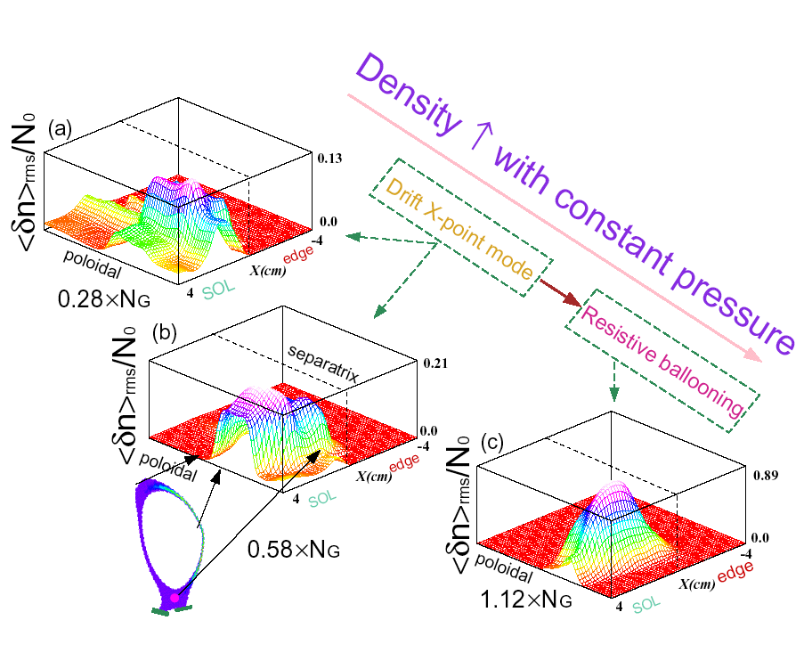
Figure 1. BOUT-predicted poloidal/radial variation of normalized density fluctuations with Greenwald factor (DIII-D simulation).

The second data set concentrates on comparing the LSN configuration to a double null diverted (DND) plasma at two NBI power levels conducing to L and H-mode. The physics basis for this comparison is the addition of a second X-point and the corresponding resistive mode. The expectation is that a second X-point not only would increase the source but also pin down the existing mode and thus the fluctuation levels should increase on the LFS. Another BOUT prediction is that the ExB velocity shear levels will change substantially when the configuration is shifted from LSN to DN. An example of changes induced by modifying the grad-B direction (or the location of the X-point) is shown in Fig. 2, where the turbulent radial particle flux varies by factors of ~2 inside the LCFS.

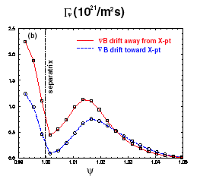
Figure 2. BOUT-predicted variation of the surfaced-averaged particle flux with change in the direction of the Grad-B drift. Factors of ~2 at the LCFS.

3. Experimental Run Plan

The main mode of operation is in lower single null divertor geometry, and later in DN for comparison. Operations are design to be a compromise between having enough flux-swing to maintain a 200-300 msec current flat-top and running in H-mode with I_{p}~ 800 kA and B_{t} = 4.5 kG reference shot is 112508 or a more recent 112819. Note that ELM free H-modes are to be avoided because they are transient in nature. H-modes with continuous ELM’s are acceptable, especially if shots with and without transitions can be taken for comparison. A shots such as 112819, 112823, etc or 110194, 111543, 111902 and 112508 are a good reference.

Figure 3. Configuration for reference shot 110194 (other references 111543 and 111902).

Figure 4. Timeline for reference shots 110194, 111543 and 111902. Proposed discharges have lower power levels. H-mode transition will be avoided by LFS gas puff. The probe will plunge at various times during the discharge to sample different densities.

Planning is for ~24 shots per day and He glow between discharges to maintain some density control. All shots are with deuterium prefill with deuterium beams. Helium GPI will be used in conjunction with the Edge TV system on every shot unless the gas puffing is found to be too perturbative. Typically each series requires at least one setup shot to verify the geometry for the scanning probe, no significant shape changes are expected by modifying the density unless instabilities are excited.

Detailed Experimental Run Plan (1 day)

Priorities are: SNL with L-mode and density scan, then LSN with H-mode, later DN with density scan. Optional: We will hunt for L-H transitions if time allows.

We start with SNL and L-mode with ~750 kW (de-rated beams if needed at 60 kV). Gas puff in the low field side to maintain discharge in L-mode. He glow will be required between discharges to keep the density under control but we will decide on the fly what the glow length should be to keep the discharge in L-mode (perhaps down to ~5-7 min). The density series will be stared at a medium value (~2.5 or 3.5 e 13) to avoid locked modes or density limit events related to too low or too high densities. Once we establish a good discharge, we sample it at two times with different densities. If all goes well, we increase the density until we reach the Greenwald limit. If the first series goes well, we move to ~150 kW. If we have problems we jump to 2.25 MW. Once finished the LSN, we move to DN (reference shot 112523) and repeat the L-mode density scan, moving on to H-mode later.

- Conditioning:

Perform 5 minutes of He GDC.

- L-mode, LSN low power (~750 kW) ne scan (1 good setup shot+ 4 good shots)

Establish discharges with I_{p}~ 800 kA with a 200-300 msec flat top, B_{t} = 4.5 kG. Scan sensity <n_{e}L> = 2 × 10¹⁵ cm⁻², 4 × 10¹⁵ cm⁻², and 5 × 10¹² cm⁻³, make sure to check for signs of plasma detachment. Use #112508 (a LSN with NBI but power will be different here) as a reference discharge. Lowest density is to be determined by locked mode limit, i.e. execute discharges with density high enough to avoid locked modes, nominally with n_{e}> = 2.5 × 10¹³ cm⁻³. Attempt to keep l_{p} as constant as possible during the flat top. If discharge goes into H-mode, puff vigorously in the LFS. If discharge still resists, reduce He glow to ~5 min.

- L-mode, LSN Threshold power (~1500 kW) ne scan (1 good setup shot+ 4 good shots)

Stack another NBI source into plasma (de-rated if needed) with above conditions (using shot #112823 as a reference discharge) so that the injected power is varied from 300 to 600 kW. Shots may have helium puffs for the edge camera. Avoid operations near disruption limit to prevent damage to edge probe. D cameras will be used to judge if there are transitions to H-mode. If discharge goes into H-mode, puff vigorously in the LFS. If discharge still resists, reduce He glow to ~5 min. If discharge resists L-mode, move on to next step.

- H-mode LSN (2.250 MW) ne scan (1 good setup shot+ 4+ 6 good shots)
Repeat ne scan in H-mode (4 shots)
(optional) Study L-H transition physics. Find transition time and place GPI and scanning probe on it. Fist 3 shots with GPI, then add the probe. (6 good shots)

- LSN to DN L and H mode
DN Configuration power and ne scan: (1 setup shot + 8 good shots)
Convert to DND configuration (reference 112523) with same operating conditions, injecting with NBI sources as detailed below. To the extent possible, keep δ, κ, q, l_{i} as similar as possible to the LSN case. Scan density <n_{e}L> = 2 × 10¹⁵ cm⁻², 4 × 10¹⁵ cm⁻², and 5 × 10¹² cm⁻³, make sure to check for signs of plasma detachment.

L-mode 750 kW (4 shots)
H-mode 1.5 or 2.250 MW (4 shots)

- DN H-mode 1.5 or 2.25 MW LCFS scan (4 shots)

TOTAL XP GOOD SHOTS: 28

TOTAL XP GOOD SHOTS w OPTIONAL: 34

- No RF is required.
- NBI is required throughout
- The following diagnostics are required: scanning probe, interferometer, magnetics, filterscopes, mid-plane bolometers, plasma TV, and VB emission, Thomson Scattering, divertor/wall probes, divertor bolometer, thermal helium injector/edge camera sytem, IRTV cameras.

5 Planned Analysis

- Characterize turbulence levels of density and potential in NSTX

- Calculate cross-field turbulent transport from turbulence levels

- Separate broadband and intermittent fluctuations

- Characterize intermittent fluctuations vs radius

- Scale all of the above with density and confinement (L or H mode)

- Provide enough data for UEDGE and BOUT

- UEDGE run needed

- BOUT run needed

- Compare data with BOUT results

- Calculate radial particle and heat transport (perpendicular and parallel flows)

- D emission from lower divertor will be used to calculate particle balance

- Electrostatic cross-field transport measurements will be obtained. Scaling of rms levels and intermittency levels with density will be calculated. Basic properties of intermittency will be deduced.

6. Planned publication of results

- Initial results will be included in the upcoming meeting abstracts such as APS and PSI.
- Final results will be published in PoP in late 2004, early 2005.
PHYSICS OPERATIONS REQUEST
Error: Reference source not found Error: Reference source not found
Machine conditions (specify ranges as appropriate)
I_{TF} (kA): 4.5 kG Flattop start/stop (s): throughout
I_{P} (MA): 0.9 Flattop start/stop (s): 0.15/0.5
Configuration: Inner Wall / Lower Single Null / Upper SN / Double Null
Outer gap (m): ~0.05 (see ref), Inner gap (m): ~0.06 (see ref.)
Elongation κ: _____, Triangularity δ: _____
Z position (m): 0.00
Gas Species: XD / He, Injector: X Midplane / Inner wall / Lower Dome
NBI - Species: D, Sources: A/B/C, Voltage (kV): 60, Duration (s): 0.5
ICRF – Power (MW): N/A, Phasing: Heating / CD, Duration (s): _____
CHI: Off
Either: List previous shot numbers for setup: 112508 LSN except for NBI. 112523 for DN except for NBI. Note, Strike points sweep intended and should be programmed.

DIAGNOSTIC CHECKLIST
Characterization of the Boundary Layer and Power Flow to the Divertor No. 217

Diagnostic system | Need | Desired | Requirements (timing, view, etc.)
Magnetics | 
Fast visible camera | 
VIPS-1 |  | 
VIPS-2 |  | 
SPRED | 
GRITS |  | 
Visible filterscopes | 
VB detector | 
Midplane bolometer | 
Diamagnetic flux |  | 
Density interferometer (1mm) |  | 
FIReTIP interf'r/polarimeter | 
Thomson scattering | 
CHERS | 
NPA |  | 
X-ray crystal spectrometer |  | 
X-ray PHA |  | 
EBW radiometer
Mirnov arrays | 
Locked-mode detectors |  | 
USXR arrays |  | 
2-D x-ray detector (GEM) |  | 
X-ray tangential camera |  | 
Reflectometer (4 ch.) |  |  | Scanning mode
Neutron detectors | 
Neutron fluctuations | 
Fast ion loss probe | 
Reciprocating edge probe | 
Tile Langmuir probes | 
Edge fluctuation imaging | 
H-alpha cameras (1-D) | 
Divertor camera (2-D) | 
Divertor bolometer (4 ch.) | 
IR cameras (2) | 
Tile thermocouples | 
ERD | 
ORNL Reflectometer | 
UCLA Reflectometer Kubota | 

