Princeton Plasma Physics Laboratory
NSTX Experimental Proposal
Title: Active control of rotation damping in RWM plasmas
OP-XP-524 | Revision: | Effective Date:  (Ref. OP-AD-97)  Expiration Date:  (2 yrs. unless otherwise stipulated)
PROPOSAL APPROVALS
Author: W. Zhu, et al. |  |  | Date
ATI – ET Group Leader: D. Gates |  |  | Date
RLM - Run Coordinator: J. Menard, S. Sabbagh (Deputy) |  |  | Date
Responsible Division: Experimental Research Operations
Chit Review Board (designated by Run Coordinator)
MINOR MODIFICATIONS (Approved by Experimental Research Operations)

NSTX EXPERIMENTAL PROPOSAL
Title: Active control of rotation damping in RWM plasmas OP-XP-524
Authors: W. Zhu, S. Sabbagh, A. Sontag, D. Gates, J. Menard

1. Overview of planned experiment
Briefly describe the scientific goals of the experiment.

The overall goal of the experiment is to use the new resistive wall mode (RWM) stabilization coils to control plasma toroidal rotation, and RWM growth and rotation, allowing a broader study of the physics of plasma rotation damping due to an applied resonant field and the RWM.

Understanding of plasma rotation damping mechanisms at high beta and low aspect ratio is important to optimize passive stabilization, and to scale results to future devices. Previous plasma rotation damping studies in NSTX demonstrated good agreement between a theoretical model of combined resonant (electromagnetic(EM)) and non-resonant (neoclassical toroidal viscosity (NTV)) effects and the experimentally observed rotation damping due to RWMs, 1/1 internal modes, and edge localized modes (ELM). The RWM causes fast global plasma rotation damping, which eliminates passive stabilization and has prevented a detailed investigation of rotation damping dynamics over periods spanning many CHERS integration periods. The utilization of the full RWM coil set can provide greater control over the plasma rotation, the onset of the RWM, and the RWM rotation. By rotating the RWM using pre-programmed applied fields, the mode growth can be slowed, saturated, or stabilized. This enhanced control will not only provide a longer sampling period, but will yield plasma rotation damping data in new instances that will further test the present theoretical model.

There are two specific goals:

1) Rotation damping physics due to applied field (plasma rotation alteration): RWM experiments in DIII-D have shown that resonant n=1-3 applied field perturbations can slow the rotation of toroidally rotating plasmas. This braking mechanism will be studied at low aspect ratio using n=1-3 applied perturbations both below and above the no-wall beta limit. NSTX experiments in CY2004 and early this year were proposed to study the physics of plasma rotation damping, critical rotation frequency, and resonant field amplification (RFA). The experiment proposed here will use the RWM coil to actively alter plasma rotation, test the present NTV theory, critical rotation frequency expectations, and rotation damping due to RFA.

2) Rotation damping during RWM activity (RWM rotation alteration): Using the RWM coil in pre-programmed mode, the RWM rotation will be altered by applying rotating applied field perturbations. In CY2004 experiments, we observed that the RWM has a real rotation frequency, , of order 100Hz, which is approximately the inverse of NSTX wall time, . By choosing a rotational frequency near the RWM rotation frequency, the goal is to have the RWM unlock and track the rotating applied field suppressing RWM growth and allowing a greater duration to study the plasma rotation damping during this phase.

2. Theoretical/ empirical justification
Brief justification of activity including supporting calculations as appropriate

1) Rotation damping physics due to applied field
CY2004 NSTX experiments show that the RWM is passively stabilized most of the time at the present level of the intrinsic error field when β_{N} / β_{N no-wall} > 1 by the high toroidal rotation generated by the neutral beam heating. Shots with β_{N} / β_{N no-wall} ~1.3 at the highest β_{N} last for much longer than the NSTX wall time. (Figure 1) This is in contrast to studies performed in DIII-D where an n=1 correction field must be applied to stabilize RWM when β_{N no-wall} is exceeded.
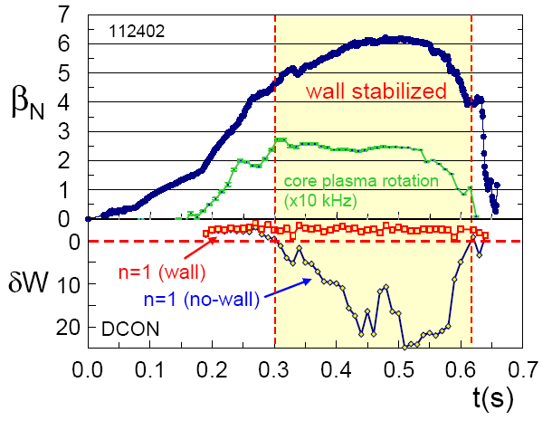
Figure 1 NSTX high β_{N} operation over the no-wall limit for several tens of wall times.

Since the RWM in NSTX is passively stabilized, n=1-3 field perturbations can be scanned to study their braking effects. This can yield three different but correlated studies: a) NTV damping, b) critical rotation frequency of RWM, and c) Plasma rotation damping due to RFA. DIII-D experiments show that with n=3 braking, rotation is promptly reduced across the outer profile, and the braking seems to be non-resonant. The applied field perturbations will penetrate a certain distance into the plasma, forming a profile. NTV damping theory based on this applied field profile can be compared to the experimentally measured damping of the plasma rotation profile. When plasma rotation slows to its critical value, RWM growth should be observed. By applying the resonant field in pulses, rotation damping due to RFA can be studied at different beta and field perturbation values before RWM growth.

The equation used to calculate NTV torque for a dominant m number is
The parameters are radial field perturbation (), toroidal mode number (), ion pressure and thermal velocity (, ), safety factor (), equilibrium toroidal field (), and the inverse of aspect ratio ().

The two key parameters investigated in this study are and. In past NSTX experiments, the dependence of on was examined, but the experiments were uncontrolled. Variation of was made by driving the RWM unstable. With the new RWM coil, we can precisely control the applied field perturbation and do a controlledscan. Nevertheless, the profile is not simply the applied field perturbation, but a function of plasma response. Therefore, the RFA gain needs to be accounted for, especially since it increases with (Figure 2). Consequently, a scan is necessary to study the effect of on the plasma rotation damping rate.
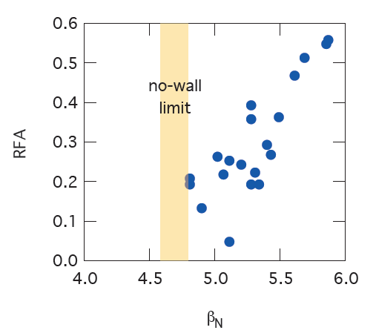
Figure 2 RFA by the stable RWM as a function of in NSTX
The toroidal mode number dependence of will be studied by an n=1- 3 scan of the applied field. However, it should be noticed that higher-n field is worse at penetrating the vessel and the plasma, and this “profile effect” will be examined.

, , and dependence are not planned to be studied in this XP due to time limitation. However, since precise profile will benefit this study, MSE is highly desired. Aspect ratio effects will be studied in XP-512: NSTX – DIII-D RWM Similarity Experiment by A. Sontag, et al.

2) Rotation damping during RWM activity

With the internal RWM sensors, we can measure the RWM amplitude, phase, and rotation frequency. Figure 3 (a) and (b) are the internal RWM sensor data and plasma rotation frequency measured by CHERS.
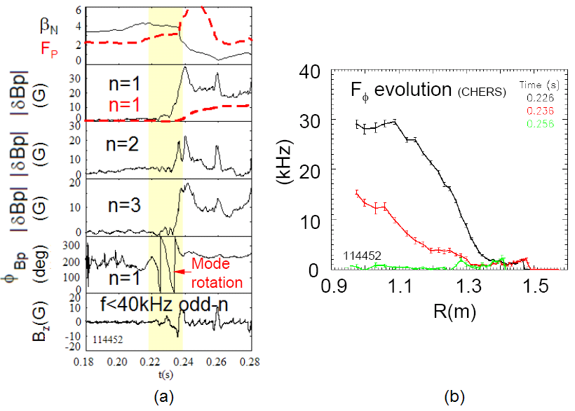
Figure 3 RWM rotation before exponential growth and corresponding plasma rotation damping

Previous experiments demonstrate that RWM growth is suppressed during mode rotation. If we apply pre-programmed (or active feedback) field perturbations near the observed RWM rotation frequency to slow down or prevent mode locking, RWM growth should be slowed, saturated or stabilized. A slowly growing or saturated RWM can give us more CHERS sampling times during the RWM activity, which will allow us to study the rotation damping dynamics due to RWM in greater detail.

Although we observed the real frequency of RWM in CY2004 experiments, the scaling of the “natural” RWM frequency is still under theoretical investigation. From Fitzpatrick-Aydemir theory (Phys. Plasmas 9, 3459, 2002), RWM has complex. And so the RWM is a naturally dissipative mode. NSTX results showed that rotating RWM locks to the lab frame after a couple of periods. By applying a rotating field, we may be able to unlock the RWM from lab frame indefinitely. However, we don’t know whether the RWM will lock to the applied rotating field or if there will be a frequency difference between them, and how large it might be. Any observed difference should not exceed. We will test above issue in this proposed XP.

In addition, RFA is dependent on field perturbation frequency. It peaks at the value around , and falls off at larger and smaller applied frequencies. An applied field frequency scan is therefore required to understand rotation damping due to RFA and the RWM rotation control.

3. Experimental run plan
Describe experiment in detail, including decision points and processes

The experiment will operate at both β_{N}/β_{N no-wall} < 1 and β_{N}/β_{N no-wall} > 1. Steady shape of is required, lower single null (LSN) plasmas will be used. If steady shape DND target is established before this XP, such a target can also be used. DC (steps and pulses) and AC (rotating) RWM coil currents will be applied. The experiment should be finished in 1.5 days. n=1, 3 field will be studied on the first day, another 0.5 days will be used to study n=2 field, which is desired since n=1 will cause the largest perturbation to the plasma and may induce n=1 tearing modes and n=3 field is weakest at penetrating into plasma.

A RWM coil current scan will be performed at roughly constant β_{N} above β_{N no-wall} by applying steps from zero up to the value causing RWM growth. n=1-3 will be tested respectively. We will naturally get some different β_{N} values in above test. Next, a β_{N} scan will be done by apply field pulses at the β_{N} values we don’t yet have.

A rotating field with a frequency near the RWM frequency will be applied first to attempt to unlock the RWM from lab frame. Applied current will be varied, followed by a frequency scan with the frequency range guided by the results of XP-501.

Task Number of Shots
n=1 and 3
1) Rotation damping physics due to applied field (plasma rotation alteration) 16
n=1, 3 vary applied current, zero rotation of applied field, attempt to avoid NTM to clearly distinguish RWM, β_{N}/β_{N no-wall} > 1, and β_{N}/β_{N no-wall} < 1
- 1-1.5 NBI sources (β_{N}/β_{N no-wall} < 1)
  - Control shot without tearing mode (no applied field) 1
  - Apply constant n=1 DC current to alter plasma rotation 2
3(or more)-step current scan
  - Apply constant n=3 DC current to alter plasma rotation 2
3(or more)-step current scan
- 2-3 NBI sources (β_{N}/β_{N no-wall} > 1)
  - Longest possible pulse (reference target in XP501) 1
no applied field
  - Apply n=1 DC current to alter plasma rotation 2
3(or more)-step current scan, 50ms each step, up to the field causing
RWM growth, anti-phase with static error field
  - Apply n=3 DC current to alter plasma rotation 2
3(or more)-step current scan, 50ms each step, up to the field causing
RWM growth, in/anti-phase with static error field
  - Apply n=1 DC field in pulses at different β_{N} to study plasma rotation 3
damping due to RFA
pre-programmed 100ms pulses at β_{N} values not acquired in above steps
  - Apply n=3 DC field in pulses at different β_{N} to study plasma rotation 3
damping due to RFA
pre-programmed 100ms pulses at β_{N} values not acquired in above steps
2) Rotation damping during RWM activity (RWM rotation alteration) 14
Preprogrammed n=1, 3 rotating applied field, β_{N}/β_{N no-wall} > 1
- n=1 rotating applied field
- Apply n=1 rotating field () when β_{N} exceeds β_{N no-wall} 2
try to unlock RWM, (or observed from part 1),
vary applied field current based on step 1)-A)
- Vary applied field frequency in steps 3
→ → (10 periods each)
→ → (10 periods each)
→ → (10 periods each)
(frequency ranges need to be revised based on the guidance of XP-501)
- Test low applied field frequency 2
(frequency need to be revised based on XP-501)
- n=3 rotating applied field
    - Apply n=3 rotating field () when β_{N} exceeds β_{N no-wall} 2
try to unlock RWM, (or observed from part 1)
    - Vary applied field frequency in steps 3
→ → (10 periods each)
→ → (10 periods each)
→ → (10 periods each)
(frequency ranges need to be revised based on the guidance of XP-501)
    - Test low applied field frequency 2
(frequency need to be revised based on XP-501)
n=2
Repeat the most successful trials above with n=2 applied field 15
Require overnight change to n=2 configuration

Total 45

4. Required machine, NBI, RF, CHI and diagnostic capabilities
Describe any prerequisite conditions, development, XPs or XMPs needed.
Attach completed Physics Operations Request and Diagnostic Checklist

Standard magnetic diagnostics are essential. Diamagnetic loop and Thomson scattering are required since partial kinetic EFIT reconstructions will be essential for this experiment. Standard CHERS measurements are required for toroidal rotation and ion temperature profile evolution and edge CHERS is desired. Internal RWM sensor set will be required for general RWM detection and measurement of RFA magnitude and phase. The RWM coil system must be operating with at least pre-programmed capability. Switching the applied field parity is desired. The first experiments will be conducted with odd parity. USXR data taken at two toroidal positions is very highly desired for this experiment as is MSE coverage.

5. Planned analysis
What analysis of the data will be required: EFIT, TRANSP, etc.

EFIT at all run levels will be important for this experiment, while partial kinetic EFIT will be crucial for this experiment, and will be run for each shot of interest. DCON stability analysis will be performed during the experiment as required. TRANSP will be useful to examine the evolution of the bootstrap current, fast ion pressure, and momentum input and diffusion.

6. Planned publication of results
What will be the final disposition of the results; where will results be published and when?

This experiment will provide critical data for the completion of the main author’s Ph. D thesis. Successful alteration of the plasma and RWM rotation and related analysis would warrant initial publication in Phys. Rev. Letters. Greater detail of the full experiment would be appropriate for publication in Physics of Plasmas.

PHYSICS OPERATIONS REQUEST
Active control of rotation damping in RWM plasmas OP-XP-524
Machine conditions (specify ranges as appropriate)
I_{TF} (kA): 3.5-4.5 kG Flattop start/stop (s): _____/_____
I_{P} (MA): 0.8-1.0 Flattop start/stop (s): _____/_____
Configuration: Inner Wall / Lower Single Null / Upper SN / Double Null
Outer gap (m): 5+/-3, Inner gap (m): 5+/-3
Elongation κ: 2.2+/-0.3, Triangularity δ: 0.5+/-0.1
Z position (m): 0.00
Gas Species: D, Injector: Midplane / Inner wall / Lower Dome
NBI - Species: D, Sources: A/B/C, Voltage (kV): max, Duration (s): _____
ICRF – Power (MW): ____, Phasing: Heating / CD, Duration (s): _____
CHI: On / Off
Either: List previous shot numbers for setup: _____________________________
Or: Sketch the desired time profiles, including inner and outer gaps, κ, δ, heating, fuelling, etc. as appropriate. Accurately label the sketch with times and values.
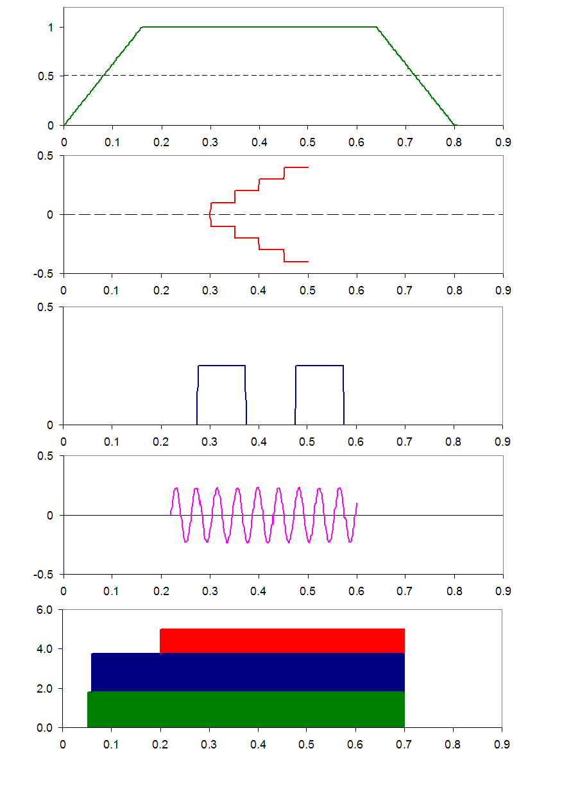
I_{p} (MA)
I_{RWM coil} (kA)
P_{NBI} (arb)
3
-3
3
3
-3
SCHEMATIC ONLY
Plasma current
Steps
Pulses
Rotating field
SCHEMATIC ONLY
Source B
Source A
Source C
SCHEMATIC ONLY
SCHEMATIC ONLY
SCHEMATIC ONLY
DIAGNOSTIC CHECKLIST
Active control of rotation damping in RWM plasmas OP-XP-524
Diagnostic | Need | Desire | Instructions
Bolometer – tangential array |  | ✓
Bolometer array - divertor
CHERS | ✓
Divertor fast camera
Dust detector
EBW radiometers
Edge deposition monitor
Edge pressure gauges
Edge rotation spectroscopy |  | ✓
Fast lost ion probes - IFLIP
Fast lost ion probes - SFLIP
Filtered 1D cameras
Filterscopes
FIReTIP |  | ✓
Gas puff imaging
Infrared cameras
Interferometer - 1 mm
Langmuir probe array
Magnetics - Diamagnetism | ✓
Magnetics - Flux loops | ✓
Magnetics - Locked modes | ✓
Magnetics - Pickup coils | ✓
Magnetics - Rogowski coils | ✓
Magnetics - RWM sensors | ✓
Mirnov coils – high frequency
Mirnov coils – poloidal array | ✓
Mirnov coils – toroidal array | ✓
MSE |  | ✓
Neutral particle analyzer
Neutron measurements |  | ✓
Plasma TV | ✓
Reciprocating probe
Reflectometer – core
Reflectometer - SOL
RF antenna camera
RF antenna probe
SPRED
Thomson scattering | ✓
Ultrasoft X-ray arrays |  | ✓
Visible bremsstrahlung det.
Visible spectrometers (VIPS)
X-ray crystal spectrometer - H
X-ray crystal spectrometer - V
X-ray PIXCS (GEM) camera
X-ray pinhole camera
X-ray TG spectrometer

