Princeton Plasma Physics Laboratory
NSTX Experimental Proposal
Title: Dependence of ELM Severity and Confinement on Boundary Shape
OP-XP-526 | Revision: | Effective Date:  (Ref. OP-AD-97)  Expiration Date:  (2 yrs. unless otherwise stipulated)
PROPOSAL APPROVALS
Author: S.M. Kaye, R. Maingi, D. Gates |  |  | Date 6/10/05
ATI – ET Group Leader: R. Maingi |  |  | Date
RLM - Run Coordinator: J. Menard (S. Sabbagh) |  |  | Date
Responsible Division: Experimental Research Operations
Chit Review Board (designated by Run Coordinator)

MINOR MODIFICATIONS (Approved by Experimental Research Operations)

NSTX EXPERIMENTAL PROPOSAL
Boundary Shape Dependences OP-XP-526

1. Overview of planned experiment
The goal of this experiment is to examine the severity of ELMs and dependence of energy confinement on plasma shape, most notably elongation and triangularity. Because of the scans involved in this XP, both topics can be addressed. Scans in both triangularity at fixed elongation, and the converse, will be performed. The experiment is planned to complete in 1 run day.

2. Theoretical/ empirical justification
ELM severity has been found to depend on plasma elongation. In experiments conducted in FY04, the plasma elongation and X-point height were varied simultaneously, but then independently, to determine that plasma elongation was the controlling factor, with ELM severity getting worse, and plasma stored energy decreasing, with increasing elongation (Fig. 1). In this set of discharges, neither triangularity or squareness was held fixed. Plasma confinement was also shown to be dependent on plasma boundary shape, with the confinement worsening with increased triangularity (Fig. 2). The source of this is not entirely ELMS, as this trend is observed even in ELM-free discharges, as can be seen in the figure.
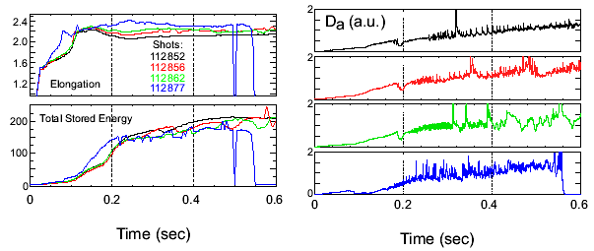
Fig. 1
Fig. 2

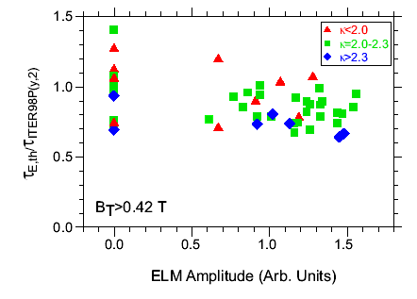
Fig. 2

3. Experimental run plan
In this experiment we will separate the effect of elongation and triangularity to address how ELM severity and plasma confinement varies with these parameters. Several scans at fixed elongation or triangularity are planned. The scan will start with a baseline shot of 115308/310 at an elongation of 2.1 and triangularity of 0.6 (800 kA). The first scan will be to increase kappa to the max (2.7) while keeping delta fixed. Then, delta will be scanned at fixed kappa, and finally, another kappa scan will be performed at lower delta. These scans can be done within the operating limits of the new PF1a coil. The run plan, in tabular form, is given below along with a schematic showing the shots in kappa-delta space.

CASE | Kappa | delta
1 | 2.1 | 0.6
2 | 2.3 | 0.6
3 | 2.5 | 0.6
4 | 2.7 | 0.6
5 | 2.5 | 0.7
6* | 2.5 | 0.8
7 | 2.5 | 0.5
8* | 2.5 | 0.4
9 | 2.3 | 0.4
10 | 2.1 | 0.4
11 | 1.9 | 0.4

* Power scan to be performed - First three sources, then 1 source (A or B, whichever is on earlier)

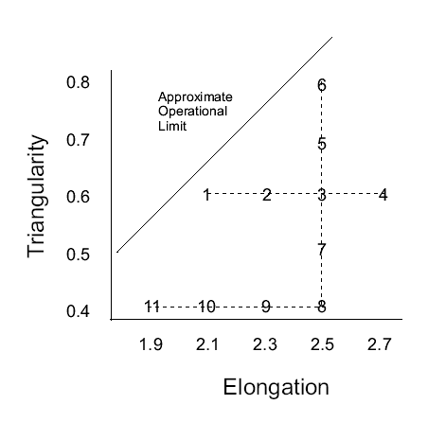
Several shots may need to be taken at given conditions in order to obtain enough data for good stability and transport analysis.

4. Required machine, NBI, RF, CHI and diagnostic capabilities
No special capabilities are needed. The edge stability analysis to be done in support of this XP would benefit from high resolution MPTS implementation, but it may be more important to get a first cut through the space before going back to diagnose specific conditions with this high resolution/edge capability.

5. Planned analysis
EFIT, TRANSP, Edge stability (ELITE)

6. Planned publication of results
Presented at meetings, and published in a refereed journal.
PHYSICS OPERATIONS REQUEST
Boundary Shape Dependences OP-XP-526
Machine conditions (specify ranges as appropriate)
I_{TF} (kA): 56 Flattop start/stop (s): usual
I_{P} (MA): 0.8 Flattop start/stop (s): usual
Configuration: Double Null
Outer gap (m): _____, Inner gap (m): _____
Elongation κ: _____, Triangularity δ: _____
Z position (m): 0.00
Gas Species: D, Injector: Midplane
NBI - Species: D, Sources: A/B/C, Voltage (kV): 90, Duration (s): _____
ICRF – Power (MW): ____, Phasing: Heating / CD, Duration (s): _____
CHI: Off
Either: List previous shot numbers for setup: 115308 with outer gap reduced by 2-3 cm for outer MPTS channels
Or: Sketch the desired time profiles, including inner and outer gaps, κ, δ, heating, fuelling, etc. as appropriate. Accurately label the sketch with times and values.
DIAGNOSTIC CHECKLIST
Boundary Dependences OP-XP-526
Diagnostic | Need | Desire | Instructions
Bolometer - tangential array | ♫
Bolometer array - divertor |  | ♪
CHERS | ♫
Divertor fast camera | ♫
Dust detector
EBW radiometers
Edge deposition monitor
Edge pressure gauges
Edge rotation spectroscopy |  | ♪ | Only available by special request of T. Biewer @ MIT
Fast lost ion probes – IFLIP
Fast lost ion probes – SFLIP
Filtered 1D cameras
Filterscopes | ♫
FIReTIP |  | ♪
Gas puff imaging |  | ♪
High-k scattering
Infrared cameras
Interferometer – 1 mm
Langmuir probes - PFC tiles
Langmuir probes - RF antenna
Magnetics – Diamagnetism | ♫
Magnetics – Flux loops | ♫
Magnetics – Locked modes |  | ♪
Magnetics – Pickup coils | ♫
Magnetics - Rogowski coils | ♫
Magnetics - RWM sensors |  | ♪
Mirnov coils – high frequency | ♫
Mirnov coils – poloidal array | ♫
Mirnov coils – toroidal array | ♫
MSE | ♫
Neutral particle analyzer
Neutron Rate (2 fission, 4 scint)
Neutron collimator
Plasma TV | ♫
Reciprocating probe
Reflectometer - FM/CW
Reflectometer - fixed frequency homodyne quadrature
Reflectometer - homodyne correlation
Reflectometer - HHFW/SOL
RF antenna camera
RF antenna probe

Solid State NPA
SPRED
Thomson scattering - 20 channel | ♫
Thomson scattering - 30 channel | ♫
Ultrasoft X-ray arrays | ♫
Ultrasoft X-ray arrays - 2 color |  | ♪
Visible bremsstrahlung det.
Visible spectrometers (VIPS)
X-ray crystal spectrometer - H
X-ray crystal spectrometer - V
X-ray pinhole camera

