Princeton Plasma Physics Laboratory
NSTX Experimental Proposal
Title: HHFW Heating into Reversed-shear Plasmas

OP-XP-538 | Revision: 0.1 | Effective Date:  (Ref. OP-AD-97)  Expiration Date:  (2 yrs. unless otherwise stipulated)
PROPOSAL APPROVALS
Author: B. LeBlanc, R.J. Wilson, J. Menard, F. Levinton, D. Stutman, R. Bell, D. Gates, J.C. Hosea |  |  | Date: 17-Aug-05
ATI – ET Group Leader: J.R. Wilson |  |  | Date
RLM - Run Coordinator: J. Menard (S. Sabbagh) |  |  | Date
Responsible Division: Experimental Research Operations
Chit Review Board (designated by Run Coordinator)
MINOR MODIFICATIONS (Approved by Experimental Research Operations)

NSTX EXPERIMENTAL PROPOSAL
Title: HHFW Heating into Reversed-shear Plasmas OP-XP-538

1. Overview of planned experiment
The goal of this experiment is to apply HHFW electron heating, some of it directed, to reversed-shear (RS) L-mode plasmas.

2. Theoretical/ empirical justification
The justification of this exercise resides in the experimental observation and theoretical expectation of better electron thermal confinement in RS plasmas. For example, analysis of HHFW heated plasma with very high T_{e} (i.e. 4 keV) suggested that q(R) was reversed. Also last year’s work by Stutman indicated that RS improved electron thermal confinement.

3. Experimental run plan
(a) Utilize RS scenario developed by Stutman and Levinton to establish a plasma target suitable for HHFW operation.
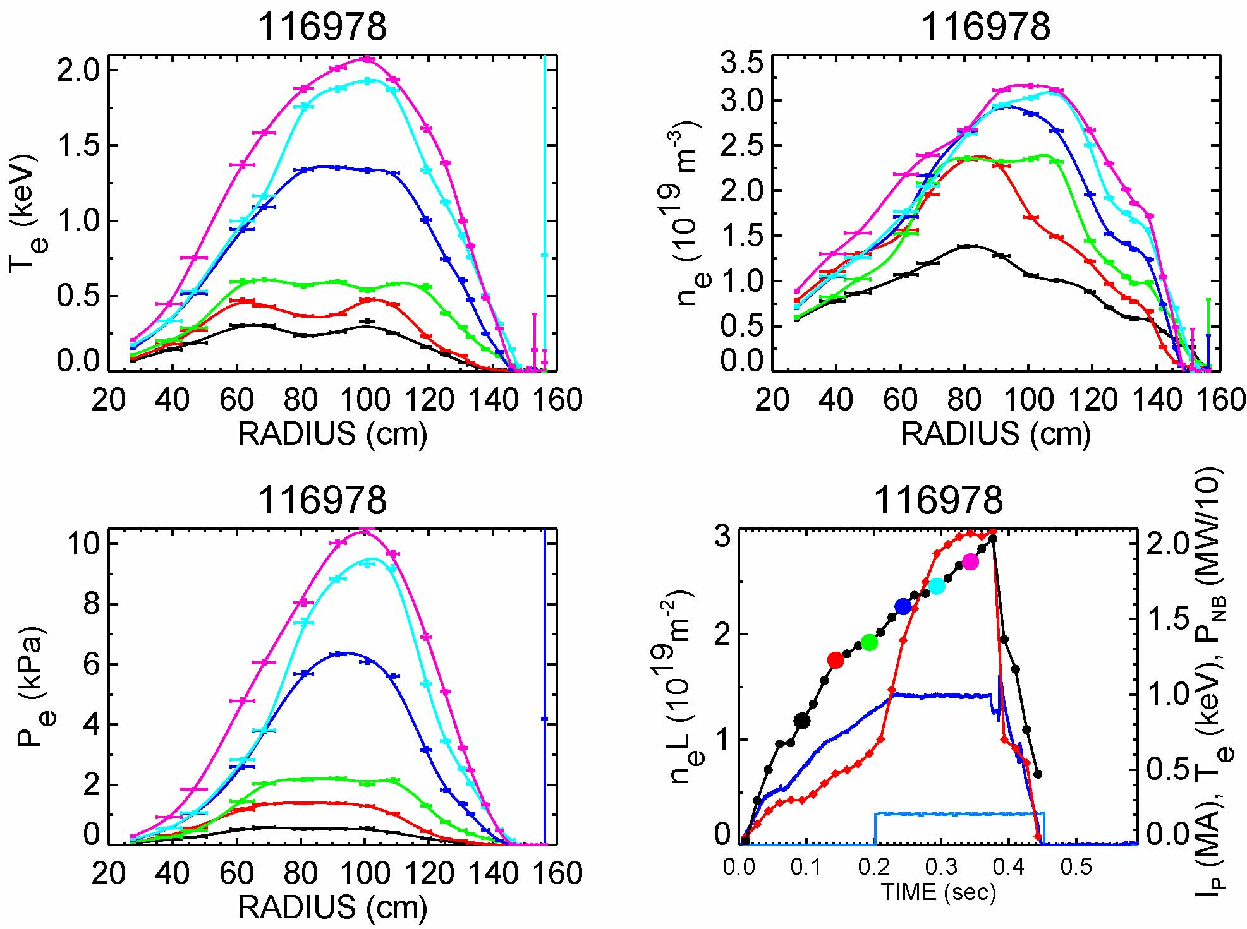
(b) Attempt to separate affects of fast-ion HHFW power absorption by delaying HHFW onset after NBI turnoff.

Shot Id | Description | NBI A(90 kV) | HHFW (≥ 2 MW) | N
Apply HHFW in presence of fast-ion population
0 | Target | 0.2-0.5 s | No | 1
1 | Add HHFW heating | 0.2-0.5 s | 0.2-0.5 s, k = 14 m⁻¹ | 1
2 | Add HHFW ctr-CD | 0.2-0.5 s | 0.2-0.5 s, k = 7 m⁻¹ | 1
3 | Add HHFW co-CD | 0.2-0.5 s | 0.2-0.5 s, k = -7 m⁻¹ | 1
Apply HFFW in “absence” of fast ions, i.e. wait 50 ms after NBI turnoff
4 | Target, but | 0.2-0.3, 0.4-0.5 s | No | 1
5 | Add HHFW heating | 0.2-0.3, 0.4-0.5 s | 0.35-0.5 s, k = 14 m⁻¹ | 1
6 | Add HHFW ctr-CD | 0.2-0.3, 0.4-0.5 s | 0.35-0.5 s, k = -7 m⁻¹ | 1
7 | Add HHFW co-CD | 0.2-0.3, 0.4-0.5 s | 0. 35-0.5 s, k = 7 m⁻¹ | 1

4. Required machine, NBI, RF, CHI and diagnostic capabilities
This XP will need NBI and RF system.
See attached Physics Operations Request and Diagnostic Checklist pages for details.

5. Planned analysis
EFIT, TRANSP, and specialized RF codes.

6. Planned publication of results
The data will analyzed by the lead author and depending on experimental success, publication will be made to PRL or POP, or equivalent.
PHYSICS OPERATIONS REQUEST
Title: HHFW Heating into Reversed-shear Plasmas OP-XP-538
Machine conditions (specify ranges as appropriate)
I_{TF} (kA): 4.5 kG Flattop start/stop (s): _____/_____
I_{P} (MA): ___1.0___ Flattop start/stop (s): _____/_____
Configuration: Double Null
Outer gap (m): 0.04 m, Inner gap (m): _____
Elongation κ: _____, Triangularity δ: _____
Z position (m): 0.00
Gas Species: D , Injector: Midplane / Inner wall / Lower Dome
NBI - Species: D, Sources: A, Voltage (kV): 90, Duration (s): _____
ICRF – Power (MW): > 2.0, Phasing: Heating / CD, Duration (s): _____
CHI: Off
Either: List previous shot numbers for setup: 116978 <<<<<<<<<<<<<<<<

Desired Heating patterns
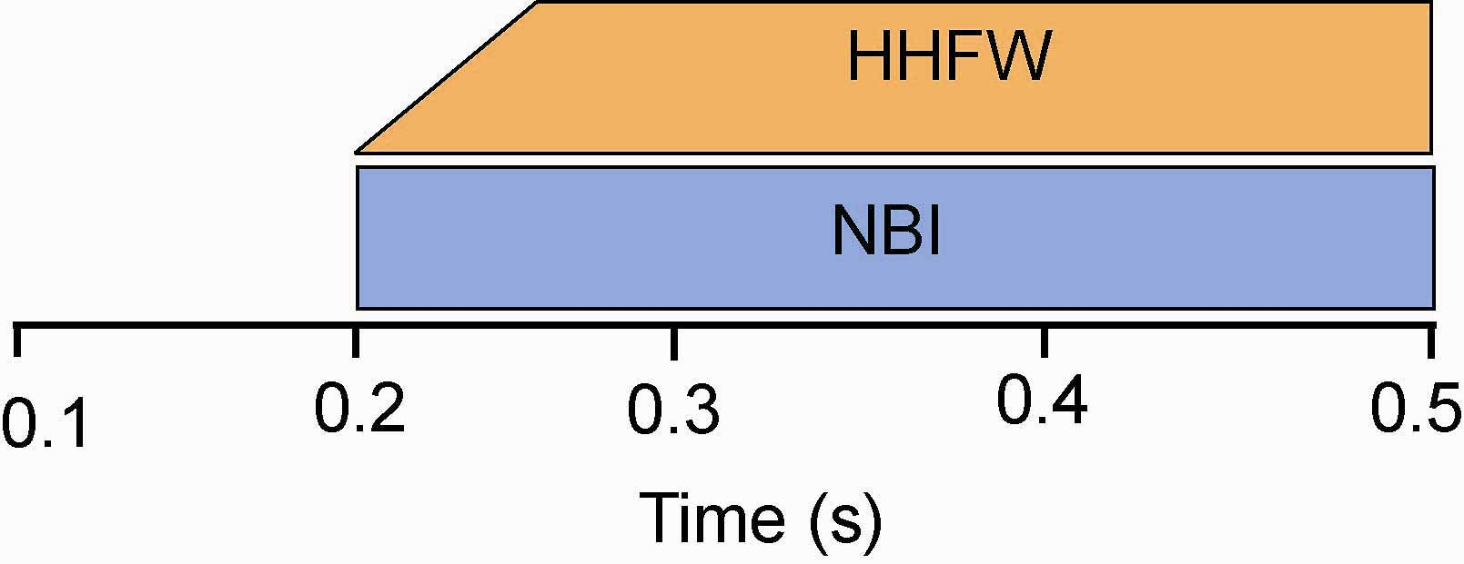
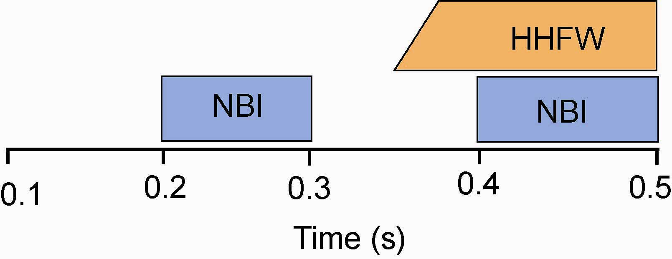
Shots 0-3
Shots 4-7
DIAGNOSTIC CHECKLIST
Title: HHFW Heating into Reversed-shear Plasmas OP-XP-538
Diagnostic | Need | Desire | Instructions
Bolometer - tangential array |  | ✓
Bolometer array - divertor
CHERS | ✓
Divertor fast camera
Dust detector
EBW radiometers
Edge deposition monitor
Edge pressure gauges
Edge rotation spectroscopy | ✓ |  | Only available by special request of T. Biewer @ MIT
Fast lost ion probes – IFLIP
Fast lost ion probes – SFLIP
Filtered 1D cameras
Filterscopes
FIReTIP | ✓
Gas puff imaging
High-k scattering
Infrared cameras
Interferometer – 1 mm
Langmuir probes - PFC tiles
Langmuir probes - RF antenna
Magnetics – Diamagnetism
Magnetics – Flux loops | ✓
Magnetics – Locked modes
Magnetics – Pickup coils | ✓
Magnetics - Rogowski coils | ✓
Magnetics - RWM sensors
Mirnov coils – high frequency
Mirnov coils – poloidal array
Mirnov coils – toroidal array
MSE | ✓
Neutral particle analyzer | ✓
Neutron Rate (2 fission, 4 scint) | ✓
Neutron collimator
Plasma TV
Reciprocating probe
Reflectometer - FM/CW
Reflectometer - fixed frequency homodyne quadrature
Reflectometer - homodyne correlation
Reflectometer - HHFW/SOL
RF antenna camera | ✓
RF antenna probe

Solid State NPA
SPRED
Thomson scattering - 20 channel | ✓
Thomson scattering - 30 channel
Ultrasoft X-ray arrays
Ultrasoft X-ray arrays - 2 color
Visible bremsstrahlung det.
Visible spectrometers (VIPS)
X-ray crystal spectrometer - H
X-ray crystal spectrometer - V
X-ray pinhole camera

