Princeton Plasma Physics Laboratory
NSTX Experimental Proposal
Title: HHFW Power Balance vs B at Constant q
OP-XP-617 | Revision: | Effective Date: Feb 14, 2006  (Ref. OP-AD-97)  Expiration Date: Feb 14, 2008  (2 yrs. unless otherwise stipulated)
PROPOSAL APPROVALS
Author: J. Hosea, R. Bell, S. Bernabei, B. LeBlanc, C.K. Phillips, P. Ryan, D. Stutman, J. Wilgen, J.R. Wilson, et al. |  |  | Date
ATI – ET Group Leader: Gary Taylor |  |  | Date
RLM - Run Coordinator: Roger Raman |  |  | Date
Responsible Division: Experimental Research Operations
Chit Review Board (designated by Run Coordinator)

MINOR MODIFICATIONS (Approved by Experimental Research Operations)

NSTX EXPERIMENTAL PROPOSAL
Title: HHFW Power Balance vs B at Constant q OP-XP-617

1. Overview of planned experiment
Goal: Measure RF power loss properties as a function of magnetic field constant q to elucidate:
• RF power loss scaling with B under similar stability conditions
• PDI ion heating loss vs B
• Fast wave propagation characteristic effects on surface wave propagation and damping

2. Theoretical/ empirical justification
A summary of the justification of this experiment is that it should provide data that can be analyzed to support the hypothesis that higher magnetic field should give higher efficiency of heating/current drive for a given wave-number launched by the antenna. Primarily:
• PDI instability should be weaker at higher field
• Onset density for propagation of HHFW is approximately proportional to B at a given k|| -
waves are propagating farther from plasma edge at higher B
• V Alfven scales with B - radial group velocity should increase with B so that wave
propagation into core (away from surface) is faster - surface fields should decrease with B
• Higher field may explain higher efficiency on DIII-D
Results from this experiment are important for future applications of HHFW:
• They will help in making projections to the higher field regime of the ST CTF
• They will provide support for increasing the k|| of the NSTX antenna for current drive phasing

P_{RF} losses at the edge of the plasma have been detected earlier through modulation of the RF power to determine ΔW and τ during the RF pulse(s), and from these the efficiency of core heating. It has been found that the efficiency is strongly dependent on the parallel wave number, k||, launched with the antenna. For example, the efficiency has been observed to decrease from ~ 70% or greater at k|| = 14m⁻¹ to ~ 40% at k|| = 7m⁻¹ at B_{T} = 4.5 kG and I_{P} = 600 kA (series of shots around 112699) [J. Hosea et al., 2005 RF Conference]. Thus the RF power loss is significantly greater for the lower k|| case and it is important to understand the possible power loss channels as a function of k|| and if the loss can be reduced to improve the performance of the HHFW heating and current drive on NSTX.
One of the major loss channels on NSTX is from edge ion heating through the parametric decay instability. This decay of the fast wave into an ion Bernstein and ion cyclotron quasi-mode has been observed and correlated to very strong ion heating in the surface of the plasma [J.R. Wilson et al., 2005 RF Conference]. The ion heating and the percent of the applied RF power calculated to be needed to support it against the power lost by the edge ions through collisional coupling to

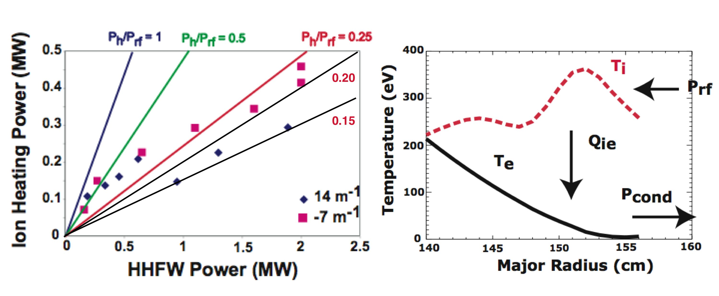
Figure 1. PDI losses for k|| = 7m⁻¹ and 14m⁻¹

the electrons is shown in Fig. 1 for the series of shots around 112699. Edge ion heating via parametric decay waves accounts for a substantial amount of RF power loss which increases somewhat with wavelength - 16%/23% loss for 14 m⁻¹/-7 m⁻¹. However, the very large reduction in RF heating efficiency observed at 7m⁻¹ relative to that for 14m⁻¹, as discussed earlier, requires large additional RF power loss of up to ~ 30% at the edge region of the plasma. This strong dependence of the RF power loss on parallel wave number and recalling that the loss was even more dramatic at k|| = 3m⁻¹ suggests that this additional loss at lower k|| may be due to the propagation properties of the launched fast waves themselves.

The propagation characteristics of the fast wave can also affect power losses in the edge region of the plasma. The wave propagation onsets at lower density for lower k|| since wave onset, k⊥ = 0, is proportional to B*k||². Perpendicular wave number versus density curves with k|| as a parameter are shown in Fig. 2 for B_{T} = 4.5 kG and f = 30 MHz. These curves are derived using the cold plasma dispersion relation for a two-component plasma in Eq. 1 and ignoring the pitch of the magnetic field:

D = n⊥⁴ + (Κ||/Κ⊥)*{n⊥² ∗[n||² (1+ K⊥/K||) – (K⊥+ K_{r}*K_{l}/K||)] + (-n||² + K_{r})*(-n||² + K_{l})} = 0 (1)

As indicated the onset density is ~ 2.6/0.6/0.1 in units of 10¹² cm⁻³ for k|| = 14/7/3 m⁻¹, respectively. Propagation is very close to the vessel wall at 7m⁻¹ and on the wall at 3m⁻¹. This should lead to higher power losses in the surface region of the plasma for lower k|| .
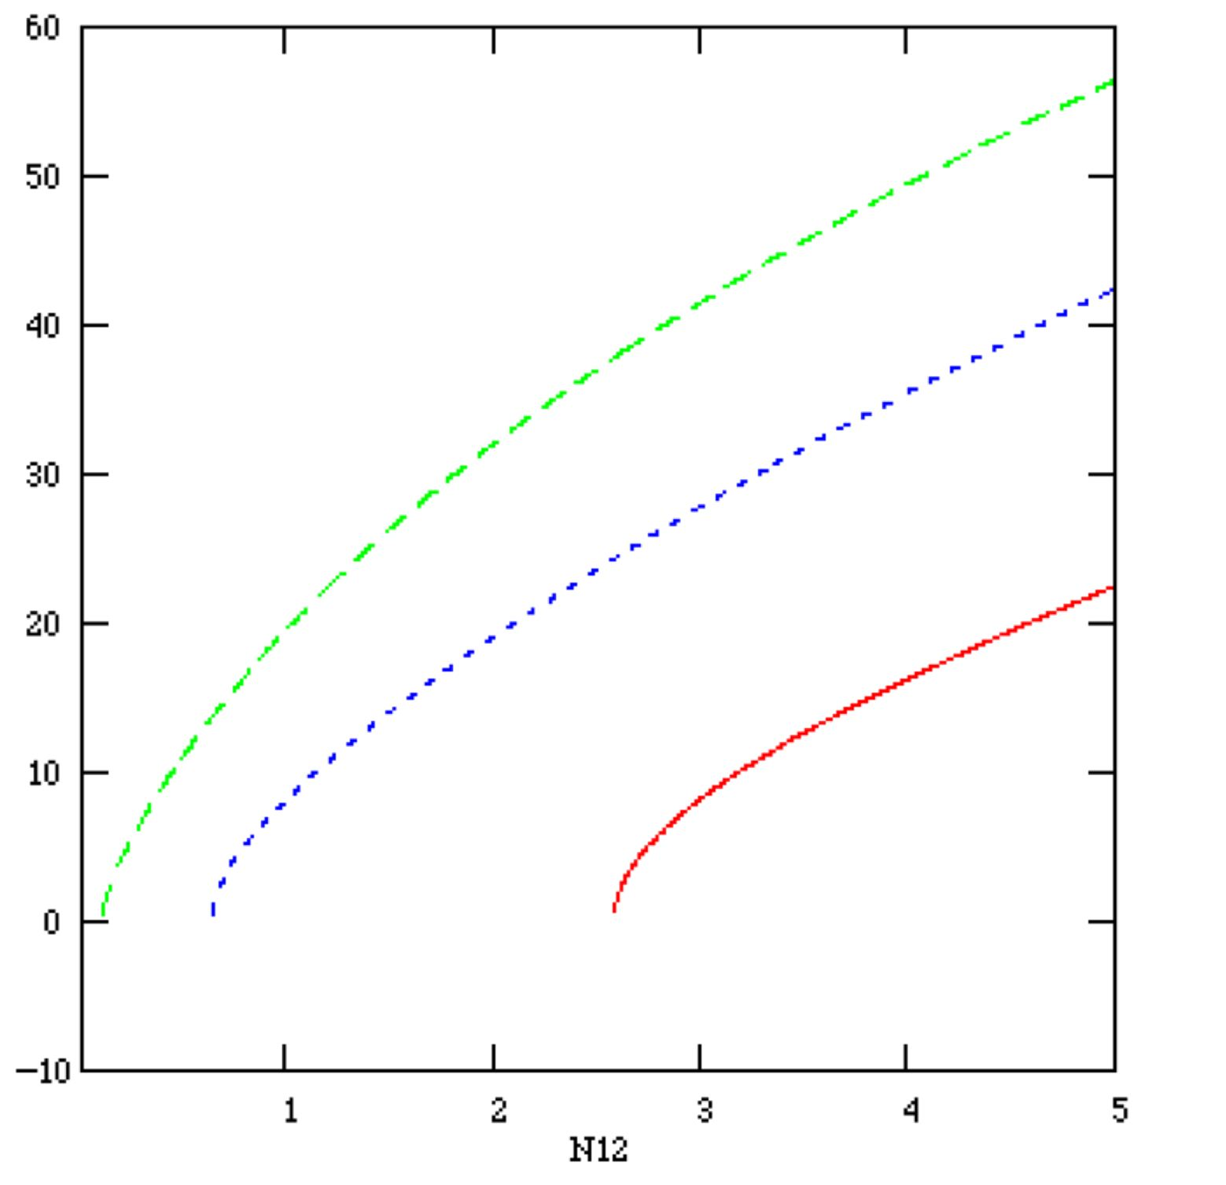
k⊥ (m⁻¹)
N12 (10¹² cm⁻³)
k|| = 3m⁻¹

7m⁻¹

14m⁻¹
Fig. 2. Perpendicular wave number vs density for 3 values of parallel wave number for B = 4.5 kG and f = 30 MHz.

The group velocity of the launched fast waves is also important with regard to the speed with which the waves enter the plasma and leave the edge plasma region. The group velocity is given by (partial derivatives):

v_{g} = dω/dk = - (dD/dk)/(dD/dω) (2)

The v_{g⊥} and v_{g||} values and their ratios for k|| = 14 m⁻¹ and 7 m⁻¹ for the conditions of Fig. 2 are given in Fig. 3. It is predicted that the perpendicular group velocity is lower in the mid 10¹² cm³
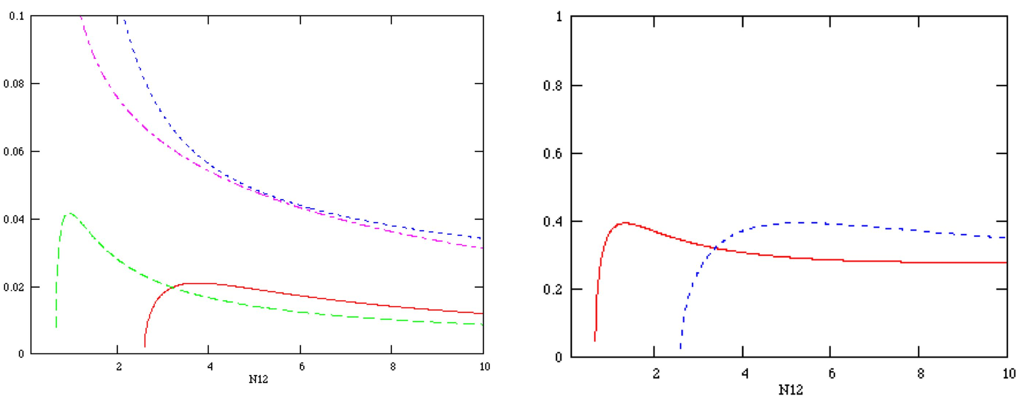
N12 (10¹² cm⁻³)
N12 (10¹² cm⁻³)

v_{g}/c
v_{g⊥}/v_{g||}
14 m⁻¹ v_{g||}
7 m⁻¹
7 m⁻¹
14 m⁻¹ v_{g⊥}
7 m⁻¹
14 m⁻¹

Fig. 3. Group velocity components and ratios for k|| = 14 m⁻¹ and 7 m⁻¹

for the lower k|| value. Furthermore, the perpendicular group velocity falls to a low value in the vicinity of the antenna for the lower k|| value. Both of these effects will tend to produce higher RF fields in front of the antenna that in turn increase the PDI, sheath and collisional power losses. Also, the direction of the wave energy flow is only ~ 20^{O} from the field direction after the perpendicular group velocity increases away from propagation onset. Thus the waves tend to propagate in the surface of the plasma away from the antenna and the interaction with the antenna and wall structures is considerably greater at lower k|| for which the wave propagation extends out to much lower density.

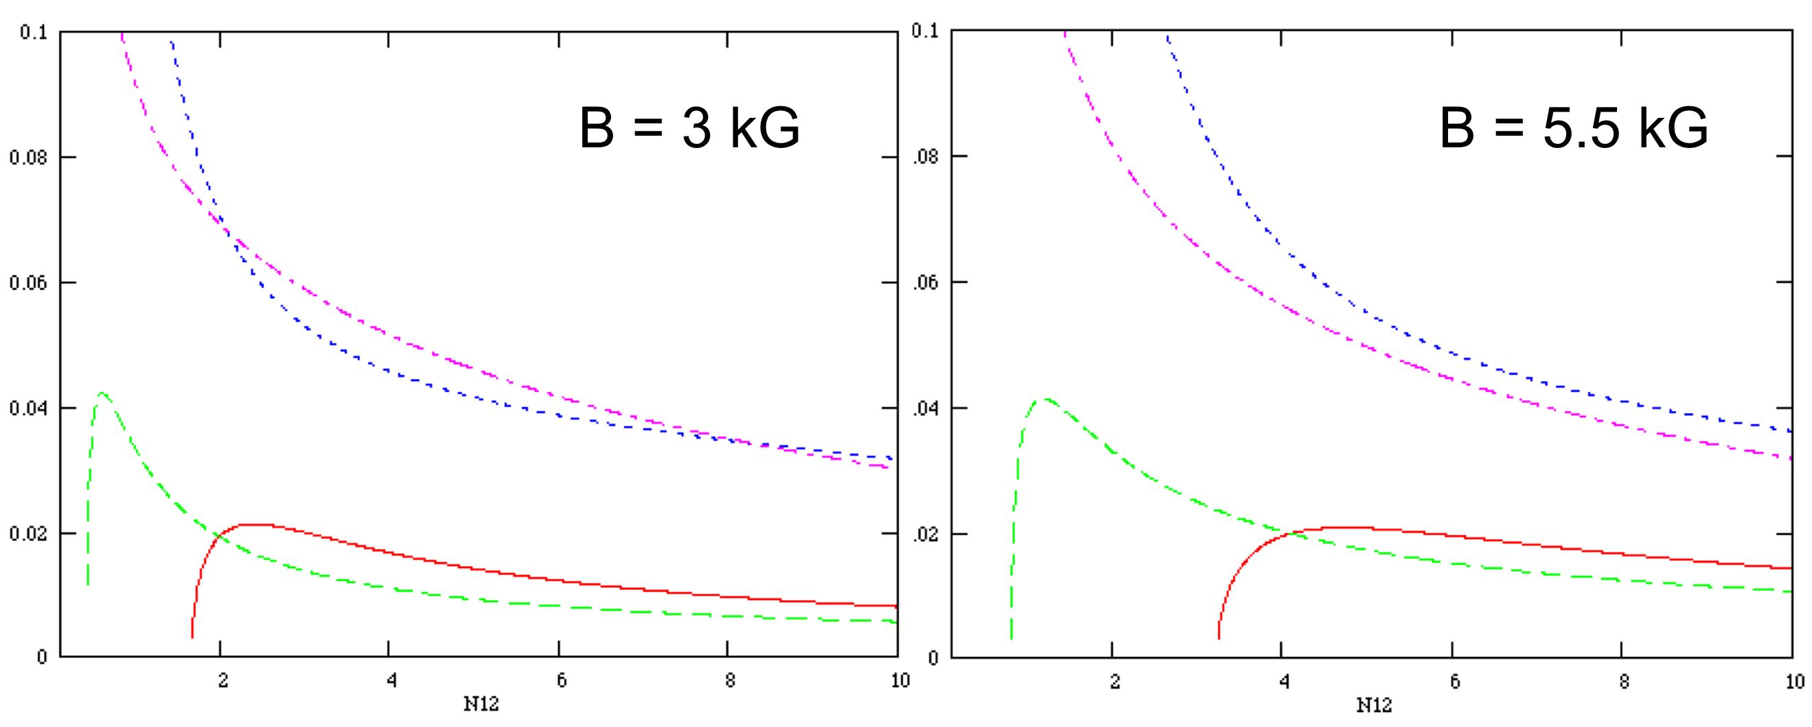
This proposal is to study heating efficiency/power loss over the widest magnetic field range possible. The two conditions desired are 3 kG @ 400 kA and 5.5 kG @ 730 kA where constant q is maintained to control instability. Figure 4 gives the calculated group velocity curves for these
v_{g}/c
7m⁻¹
14m⁻¹
7m⁻¹
14m⁻¹
Fig. 4. Perpendicular and parallel group velocities as a function of B

magnetic field values. Propagation onset density decreases a factor of two at the lower field for both 7m⁻¹ and 14m⁻¹. Surface losses should increase substantially at the lower field - even at
14m⁻¹. Perpendicular group velocity also decreases by a factor of ~ 2 at 3 kG in the mid 10¹² cm⁻³ density range so that wave fields should be enhanced even further at the lower field which should cause increased edge losses due to PDI, sheath and collisional effects.

3. Experimental run plan
- Setup stable shot at B = 4.5 kG, I_{P} = 600 kA similar to shot 112699 (or good shot now after Li injection)
  - Test point: Lower I_{P} somewhat if required to achieve acceptable stability
- LSN, helium L-mode, gap 4-5 cm
- Modulate P_{RF} as for shot 112699 with k|| = 14 m⁻¹
Bring P_{RF} up to ~ 2-3 MW (depending on conditions)
- 2 shots @ 14 m⁻¹
- 1 shot ohmic
- Test low field scaling
- Setup B = 3 kG, I_{P} = 400 kA discharge
- 2shots @ 14 m⁻¹
- 2 shots @ -7 m⁻¹ (co CD)
- 2 shots @ 7 m⁻¹ (π phasing)
- 1 shot ohmic
- Test point: Compare efficiency of 14 m⁻¹ case to that for 4.5 kG

- Test high field scaling
- Setup B = 5.5 kG, I_{P} = 730 kA discharge
- 2 shots @ 14 m⁻¹
- 2 shots @ -7 m⁻¹ (co CD)
- 2 shots @ 7 m⁻¹ (π phasing)
- 1 shot ohmic

4. Required machine, NBI, RF, CHI and diagnostic capabilities
Stable or at least reproducible plasma conditions are required for the quantitative comparisons of this XP. Critical diagnostics include:
- Soft x-ray and Mirnov loops for stability
- EFIT with high time resolution for W
- Thomson scattering for electrons
- Edge rotation diagnostic for edge heating
- NPA for edge and core ion heating
- Radiated power diagnostic
- Reflectometry for edge density and PDI
- Reflectometry for wave measurements for opposite side from antenna
- Edge probe for PDI
- Gap RF probes for leakage
- RF probe(s) for edge RF field (highly desirable but not essential)

5. Expected results and planned analysis
Expected results:
- Heating efficiencies vs B for 14 m⁻¹, -7 m⁻¹ (co CD) and 7 m⁻¹ (π phasing)
- Core heating from EFIT W
- Core electron heating from Thomson scattering
- Edge heating/power loss
- Edge ion heating from edge rotation diagnostic
- Edge electron heating from Thomson scattering
- Behavior of PDI characteristics and induced losses with field
- Plasma profiles , core and edge, for permitting predictions of wave propagation and damping characteristics and of PDI produced losses
- Relative surface wave amplitude for comparison to surface power loss for the explored conditions
- Ceramic gap RF emission for the explored conditions

Planned analysis:
- Calculation of τ and ΔW for EFIT W to obtain percent P_{RF} deposited
- Calculation of τ_{e} and ΔW_{e} for Thomson scattering W_{e} to obtain P_{RF} delivered to electrons
- Compare efficiencies for the two field cases
- Analysis of wave propagation and damping characteristics from onset density into the core of plasma - along field and perpendicular directions of the ray path, and including collisions - for predicting surface losses
- Development of predictions for PDI losses
- Projection of heating efficiency expected at 10 kG, with and without PDI present, to compare with DIII-D results and for higher field ST devices

6. Planned publication of results
The results will be submitted for publication in Physics of Plasmas by the end of this year.
PHYSICS OPERATIONS REQUEST
Title: HHFW Power Balance vs B at Constant q Error: Reference source not found
Machine conditions (specify ranges as appropriate)
B_{TF} (kG): 3 - 5.5 Flattop start/stop (s): 0.0 / 0.6 or as normal
I_{P} (MA): 0.4 – 0.73 Flattop start/stop (s): 0.1 /0.6 or as for 112699
Configuration: Lower Single Null as for 112699 or as newly developed this run
Outer gap (m): 4 – 5 cm, Inner gap (m): _____
Elongation κ: _____, Triangularity δ: _____
Z position (m): 0.00
Gas Species: He, Injector: Inner Wall
NBI - Species: D, Sources: A/B/C, Voltage (kV): _____, Duration (s): _____
ICRF – Power (MW): up to 3 MW Phasing: -7/7(π)/14 m⁻¹ Duration (s): 0.3 sec
(modulated) as for 112699
CHI: On / Off
Either: List previous shot numbers for setup: 112699
Or: Sketch the desired time profiles, including inner and outer gaps, κ, δ, heating, fuelling, etc. as appropriate. Accurately label the sketch with times and values.
DIAGNOSTIC CHECKLIST
Title: HHFW Power Balance vs B at Constant q Error: Reference source not found
Diagnostic | Need | Desire | Instructions
Bolometer - tangential array | X |  | Whatever is needed for measuring Prad
Bolometer array - divertor | X
CHERS
Divertor fast camera
Dust detector
EBW radiometers
Edge deposition monitor
Edge pressure gauges |  | X
Edge rotation spectroscopy | X |  | Essential
Fast lost ion probes – IFLIP
Fast lost ion probes – SFLIP
Filtered 1D cameras
Filterscopes
FIReTIP
Gas puff imaging
High-k scattering
Infrared cameras
Interferometer – 1 mm
Langmuir probes - PFC tiles |  | X
Langmuir probes - RF antenna | X
Magnetics – Diamagnetism | X
Magnetics – Flux loops | ✓
Magnetics – Locked modes
Magnetics – Pickup coils | ✓
Magnetics - Rogowski coils | ✓
Magnetics - RWM sensors
Mirnov coils – high frequency
Mirnov coils – poloidal array
Mirnov coils – toroidal array | X
MSE
Neutral particle analyzer
Neutron Rate (2 fission, 4 scint)
Neutron collimator
Plasma TV | X
Reciprocating probe |  | X
Reflectometer - FM/CW
Reflectometer - fixed frequency homodyne quadrature
Reflectometer - homodyne correlation |  | X
Reflectometer - HHFW/SOL | X
RF antenna camera |  | X
RF antenna probe | X
Solid State NPA
SPRED
Thomson scattering - 20 channel | ✓
Thomson scattering - 30 channel | X
Ultrasoft X-ray arrays | X
Ultrasoft X-ray arrays - 2 color
Visible bremsstrahlung det.
Visible spectrometers (VIPS)
X-ray crystal spectrometer - H
X-ray crystal spectrometer - V
X-ray pinhole camera
High time resolution EFIT | X
Gap RF probes | X
RF probes for edge RF field |  | X | Highly desirable

