Princeton Plasma Physics Laboratory
NSTX Experimental Proposal
Title: Long pulse double null development with lithium
OP-XP-603 | Revision: | Effective Date:  (Ref. OP-AD-97)  Expiration Date:  (2 yrs. unless otherwise stipulated)
PROPOSAL APPROVALS
Author: D. Gates |  |  | Date 1/31/2006
ATI – ET Group Leader: D. Gates/ S. Kaye |  |  | Date
RLM - Run Coordinator: R. Raman, S. Sabbagh (Deputy) |  |  | Date
Responsible Division: Experimental Research Operations
Chit Review Board (designated by Run Coordinator)
MINOR MODIFICATIONS (Approved by Experimental Research Operations)

NSTX EXPERIMENTAL PROPOSAL
Long pulse double null development at high κ and δ OP-XP-508

1. Overview of planned experiment
The goal is to develop and study long pulse plasmas at high elongation and triangularity, taking advantage of the upgraded PF1A coil. The plasma will be shaped as early as feasible and the plasma will be ramped as quickly as possible, so as to minimize internal inductance. The first phase goal is to achieve early H-mode in a double null plasma with a high initial ramp rate which will then be fixed at the optimum. Upon completion of the ramp-up phase of the XP, a toroidal field and plasma current scan will be performed, with only the secondary current ramp rate being varied.

2. Theoretical/ empirical justification
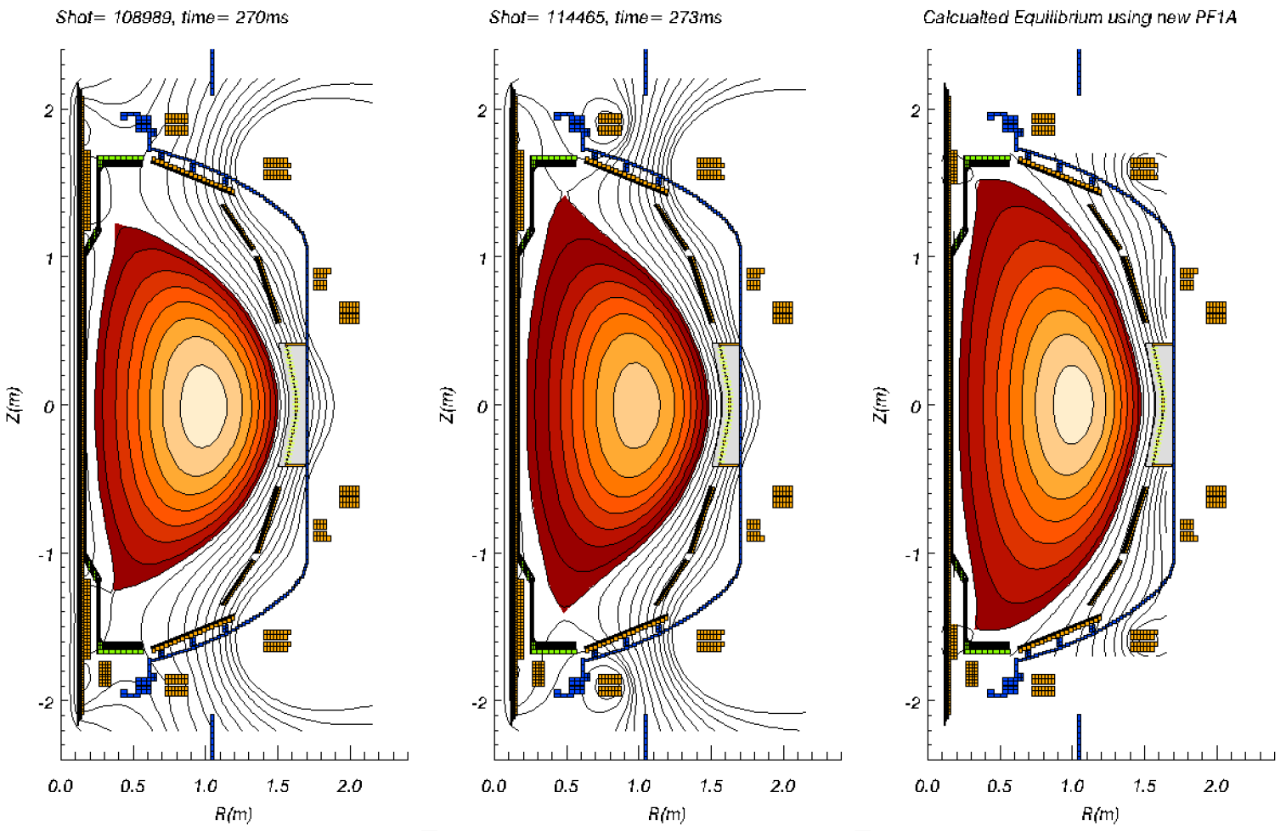
This experiment is designed to investigate the performance of long pulse highly shaped double null plasmas with density control using lithium. Experience from 2005 indicates that high elongation and high triangularity operation is capable of supporting interesting long pulse plasma performance regimes. This experiment directly addresses the goals of the NSTX five-year plan. Lithium will be investigated as a means for density control

3. Experimental run plan

1. Start from “best” shot of lithium boundary XP or 117814. (2 shots)
2. Use lithium scenario that leads to steady wall pumping conditions. (Requirement to have good pumping combined with reasonable shot rep rate). Vary glow time between 5 an 15 minutes to measure effect on density rise.
3. Adjust fueling to obtain steady state density n_{e} ~3x10¹⁹m⁻³ in flat-top. Requirement is to maintain H-mode and good confinement) Use shoulder, midplane puffers, lower dome and SGI.
Start with shoulder and vary start pressure form 1200-1500Torr maintaining early H-mode (at t~120ms). Add in shoulder during ramp if necessary. Try SGI as a steady fueling source. Start at full flow, and binary step down. Consider adding a second high field side plenum at lower pressure.
4. Time permitting do again at n_{e} ~ 5x10¹⁹m⁻³.

Comparison between shot 117111 and shot 117075 (before and after 30mg lithium pellet)

The goal should be to create a long pulse discharge with steady density that mimics the control shot (117814).

4. Required machine, NBI, RF, CHI and diagnostic capabilities
Reliable high power NBI is a prerequisite. Thomson is required. CHERS and MSE are highly desirable. A recent boronization is required. It would be best to have investigated the use of the movable glow probe ahead of time. LITER will be required for Scenario B.

5. Planned analysis
EFIT is required. TRANSP will be run on select shots according to data availability. TSC analysis is a possibility. Time dependent DCON analysis will be run on select shots.

6. Planned publication of results
These types of discharges have typically been the subject of our invited talks about long pulse and steady state (Physics of Plasmas, Nucl. Fusion). If performance is as expected, this should be the case again.

PHYSICS OPERATIONS REQUEST
Long pulse double null development at high κ and δ OP-XP-508
Machine conditions (specify ranges as appropriate)
I_{TF} (kA): 54kA Flattop start/stop (s): N/A
I_{P} (MA): 1.0MA Flattop start/stop (s): 200ms/as long as possible
Configuration: Double Null
Outer gap (m): 10cm, Inner gap (m): 2-4cm
Elongation κ: 2.3, Triangularity δ: 0.8
Z position (m): 0.00
Gas Species: D, Injector: Midplane CS gas valve/Shoulder/SGI
NBI - Species: D, Sources: A/B/C, Voltage (kV): 90kV, Duration (s): 400ms
ICRF – Power (MW): None, Phasing: N/A, Duration (s): N/A
CHI: Off
Either: List previous shot numbers for setup: See chart above.
Or: Sketch the desired time profiles, including inner and outer gaps, κ, δ, heating, fuelling, etc. as appropriate. Accurately label the sketch with times and values.
DIAGNOSTIC CHECKLIST
Stability limits vs. normalized current at high delta with new PF1A OP-XP-508
Diagnostic | Need | Desire | Instructions
Bolometer – tangential array |  | 
Bolometer array - divertor |  | 
CHERS |  | 
Divertor fast camera |  | 
Dust detector |  | 
EBW radiometers |  | 
Edge deposition monitor |  | 
Edge pressure gauges |  | 
Edge rotation spectroscopy |  | 
Fast lost ion probes - IFLIP |  | 
Fast lost ion probes - SFLIP |  | 
Filtered 1D cameras |  | 
Filterscopes | 
FIReTIP |  | 
Gas puff imaging
Infrared cameras |  | 
Interferometer - 1 mm |  | 
Langmuir probe array
Magnetics - Diamagnetism | 
Magnetics - Flux loops | 
Magnetics - Locked modes |  | 
Magnetics - Pickup coils | 
Magnetics - Rogowski coils | 
Magnetics - RWM sensors |  | 
Mirnov coils – high frequency |  | 
Mirnov coils – poloidal array |  | 
Mirnov coils – toroidal array |  | 
MSE |  | 
Neutral particle analyzer
Neutron measurements | 
Plasma TV | 
Reciprocating probe
Reflectometer – core
Reflectometer - SOL
RF antenna camera
RF antenna probe
SPRED |  | 
Thomson scattering | 
Ultrasoft X-ray arrays |  | 
Visible bremsstrahlung det. |  | 
Visible spectrometers (VIPS) |  | 
X-ray crystal spectrometer - H
X-ray crystal spectrometer - V
X-ray PIXCS (GEM) camera
X-ray pinhole camera
X-ray TG spectrometer

