Princeton Plasma Physics Laboratory
NSTX Experimental Proposal
Title: Comparative Study of the scattered spectra between L and H mode confinement regime on NSTX.
OP-XP-629 | Revision: 0 | Effective Date:  (Ref. OP-AD-97)  Expiration Date:  (2 yrs. unless otherwise stipulated)
PROPOSAL APPROVALS
Author: Hyeon Park, Dave Smith, E. Mazzucato. |  |  | Date
ATI – ET Group Leader: M. Bell, K. Kitz (T&T) |  |  | Date
RLM - Run Coordinator: R. Raman |  |  | Date
Responsible Division: Experimental Research Operations
Chit Review Board (designated by Run Coordinator)

MINOR MODIFICATIONS (Approved by Experimental Research Operations)

NSTX EXPERIMENTAL PROPOSAL
Error: Reference source not found: Comparative Study of the scattered spectra between L and H mode confinement regime on NSTX. OP-XP-629

1. Overview of planned experiment
During the initial operation of the high-k scattering system on NSTX, the observed scattered power spectra during the H-mode phase was significantly different from the L-mode phase at the edge of the plasma. Monotonically decreasing power spectra as function of wave-numbers during the L-mode phase is changed into a non-monotonic shape. A growth of the power spectrum at the highest k was noted as the power spectra of intermediate wave-numbers were remained clamped. The observed phenomenon is new and requires a systematic study near the edge region and the measurement will be compared with other fluctuation measurement and timing of the transition. The objective of this XP is to measure the scattered spectra at a few different edge radial positions (143 cm. 140 cm and 137 cm) so that the detailed comparison studies with fluctuation diagnostics and variations of the transition characteristics at different tangencies where the pressure gradient is changing rapidly.

2. Theoretical/ empirical justification
1) The newly observed variations in the scattered spectra from L-mode to the H-mode phase transition warrant the detailed experiment to improve understanding of the relationship between confinement and the behaviors of the turbulence at high wavenumbers.
2) The observed momentum bifurcation from one wave-number to another may require more experiments to build new theoretical model.
3) Understanding of the spatial delay time of the changes in the power spectra at different wave-numbers during L to H transition is critical to build a model. Therefore, comparison studies of the transition timing and variation in the scattered spectra as function of tangencies with other fast fluctuation diagnostics. The transition time changes can be compared with the D_{α} signals, Mirnov, etc.

3. Experimental run plan
Sample scattering raw signals from the edge of the OH and NBI heated are illustrated in Fig. 1 and Fig. 2, respectively. In an OH discharge, the scattered power is monotonically decreasing as function of wavenumbers within the present experimental error bars. The trend in L-mode discharge of the NBI heated plasmas is not much different from that of the OH discharges as shown in early and later stages of the discharge in Fig. 2. During H-mode phase, changes in the scattered spectra are significantly different from those of the L-mode phase as illustrated in this figure. As the transition is occurring, a sudden drop of the scattered power in lower wave-numbers is clear as it has been predicted in many other experiments. However, the recovery of the scattered power in the lowest wavenumber is noted while the power spectra in the intermediate wavenumbers are clamped for the duration of the H–mode. Notable growth of power spectra is observed at the highest wave-number. The new observation certainly warrants more experiment to clarify the physics of high-k spectra behavior during H-mode phase on NSTX. The model discharge is shot #119284, where L to H mode transition is clear and scattering system was tested and changes in scattered spectra during L to H mode phase was made.
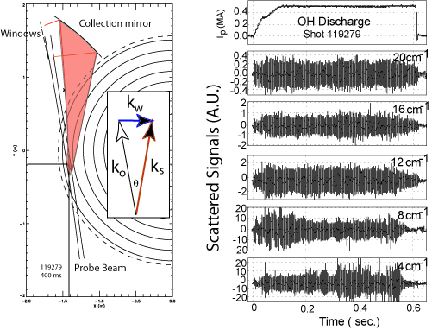
Fig. 1. Scattered geometry and raw scattered signals at five different wavenumbers of the OH discharge.
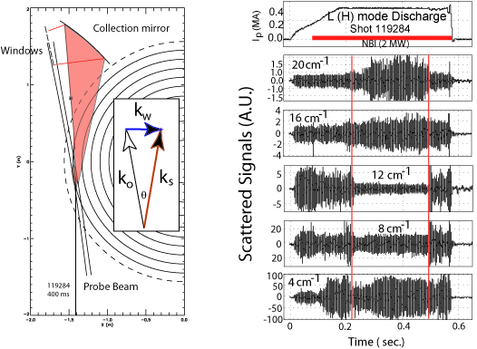
Fig. 2. Scattered raw signal at five different wavenumbers from NBI heated plasmas where L/H transition and corresponding changes in scattered power spectra are clear.
a) Stear the launching beam for the Rt =143 cm and adjust the five collection mirrors accordingly. Two discharges for this set are required.
b) Reteat step a) at Rt = 140 cm
c) Repeat step a) at Rt = 137 cm

4. Required machine, NBI, RF, CHI and diagnostic capabilities
NBI ~2 MW is required with the source combination for the Ti measurement (source A mandatory for Ti measurement). Reflectometry, probe, GPI and other fluctuation diagnostics systems are required, if possible.

5. Planned analysis
a) Scattered signals will be calibrated with the attenuators (optical and electrical) and theoretical numbers for the scattering geometry such as interaction length will be folded to plot scattered power as function of wave-numbers. FFT analysis will provide frequency spectra information.
b) EFIT and TRANSP will be required for the flux surface check and transport analysis (χ_{I}, χ_{e} and other transport related plasma parameters)

6. Planned publication of results
With the system calibration after the run and TRANSP analysis, the result will be aimed to be published in PRL.
PHYSICS OPERATIONS REQUEST
Error: Reference source not found: Comparative Study of the scattered spectra between L and H mode confinement regime on NSTX. OP-XP-629
Machine conditions (specify ranges as appropriate)
I_{TF} (kA): -55 kA Flattop start/stop (s): 0.0/0.8
I_{P} (MA): 800 kA Flattop start/stop (s): 0.15/0.6
Configuration: Inner Wall / Lower Single Null / Upper SN / Double Null
Outer gap (m): _____, Inner gap (m): _____
Elongation κ: _____, Triangularity δ: _____
Z position (m): 0.00 SAME CONFIGURATION with #119284
Gas Species: D, Injector: Midplane / Inner wall / Lower Dome
NBI - Species: D, Sources: A/C, Voltage (kV): 80kV, Duration (s): 01/0.55
ICRF – Power (MW): ____, Phasing: Heating / CD, Duration (s): _____
CHI: On / Off
Either: List previous shot numbers for setup: #119284
Or: Sketch the desired time profiles, including inner and outer gaps, κ, δ, heating, fuelling, etc. as appropriate. Accurately label the sketch with times and values.
DIAGNOSTIC CHECKLIST
Error: Reference source not found: Comp. Study of the scatt. spectra between L/H mode conf. regime on NSTX.
OP_XP-629
Diagnostic | Need | Desire | Instructions
Bolometer – tangential array | x
Bolometer array - divertor
CHERS | x
Divertor fast camera
EBW radiometer
Edge pressure gauges
Edge rotation spectroscopy | x
Fast lost ion probes
Filterscopes
FIReTIP | x
Gas puff imaging | x
H camera - 1D
Infrared cameras
Interferometer - 1 mm
Langmuir probe array | x
Magnetics - Diamagnetism | x
Magnetics - Flux loops | 
Magnetics - Locked modes
Magnetics - Pickup coils | 
Magnetics - Rogowski coils | 
Magnetics - RWM sensors
Mirnov coils – high frequency
MSE | x
Neutral particle analyzer
Neutron measurements
Plasma TV | 
Reciprocating probe | x
Reflectometer – core
Reflectometer - SOL | x
SPRED | x
Thomson scattering | x
Ultrasoft X-ray arrays | x
Visible bremsstrahlung det. | x
Visible spectrometer (VIPS) | x
X-ray crystal spectrometer - H | x
X-ray crystal spectrometer - V | x
X-ray GEM camera
X-ray pinhole camera

