Princeton Plasma Physics Laboratory
NSTX Experimental Proposal
Title: Comparison of Small ELM regimes on C-Mod, MAST, and NSTX
OP-XP-621 | Revision: | Effective Date: 03/08/06  (Ref. OP-AD-97)  Expiration Date:  (2 yrs. unless otherwise stipulated)
PROPOSAL APPROVALS
Author: A. Hubbard (MIT), R. Maingi, H. Meyer (UKAEA) |  |  | Date
ATI – ET Group Leader: R. Maingi |  |  | Date
RLM - Run Coordinator: R. Raman (S. Sabbagh) |  |  | Date
Responsible Division: Experimental Research Operations
Chit Review Board (designated by Run Coordinator)

MINOR MODIFICATIONS (Approved by Experimental Research Operations)

NSTX EXPERIMENTAL PROPOSAL
Error: Reference source not found OP-XP-621

1. Overview of planned experiment

The primary aim is to match, to the extent possible, the shape (except R/a) and key dimensionless parameters of small ELM regimes on Alcator C-Mod, MAST and NSTX. The Enhanced D_{α} H-mode and higher power ELMy H-mode in C-MOD will be compared with the Type V ELMy H-mode and mixed Type I/V ELMy H-modes in NSTX and MAST. We will compare access conditions and fluctuation properties of these ELM regimes in each device, to improve our understanding of the relationships between these regimes, including the possible role of aspect ratio.

2. Theoretical/ empirical justification

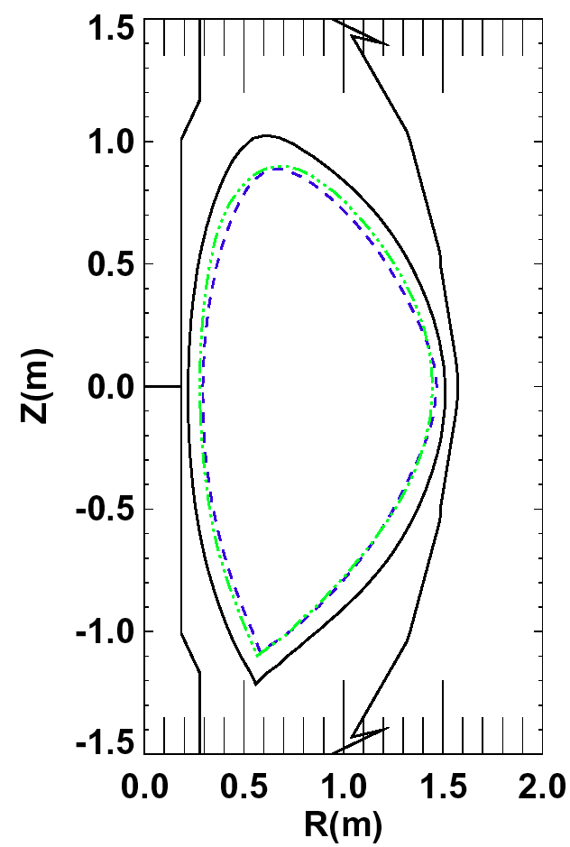
While the “Type I” ELMy H-mode regime is currently the baseline scenario for ITER, it is recognized that operation with large ELMs has serious disadvantages; extrapolation from present experiments indicates divertor erosion will be a serious issue. Development of regimes with high confinement but with smaller or no ELMs is thus a high priority on all tokamaks. A variety of small ELM regimes on various devices have been reported such as grassy ELMs (JT-60U, JET), type-II ELMs (JET, AUG, DIII-D, C-Mod), HRS-mode (JFT-2M, C-MOD), EDA (C-MOD), and type-V ELMs (NSTX) mostly at high collisionality ν_{e,ped}* > 0.5. The physics leading to these different regimes and, hence, the scalability towards ITER is not fully understood.
C-MOD: #1050608018,
t=800ms (2.7 scale)
MAST: #8859, t=280ms
NSTX: #111382, t=220ms
Fig. 1 – comparison of existing shapes in C-Mod, MAST, and NSTX

A recent ITPA-sponsored dimensionless comparison between C-MOD and the higher aspect ratio JFT-2M (PEP-12) showed much commonality between EDA H-mode and the HRS-mode. It is of interest to find out whether the new “type-V” ELM regime in NSTX, and possibly also observed in MAST, has the same physical mechanism as HRS/EDA or type-II; some properties appear similar, although the details seem to be different. A similar comparison between C-MOD, NSTX and MAST would help to understand the differences and commonalities of these regimes, and improve the reliability of extrapolations to ITER. They should also help establish such operation more routinely on MAST. The difference in field line pitch between small and large aspect ratio would highlight the role of q₉₅ for the instabilities. This experiment (PEP-16) was proposed as a high priority activity by the Pedestal ITPA group at its meeting in Lisbon (Nov 2004), and accepted by the representatives of MAST, NSTX and C-Mod at the IAE Program Leaders’ meeting in Culham, Dec 2004. A similar proposal has been submitted to MAST.

A common cross-sectional shape has been identified within the 3 machines: a lower-single null with elongation ~ 1.7 and triangularity ~ 0.45, as shown in Figure 1. Here the C-Mod shape is scaled to match the MAST shape, which is ~ 10% smaller than the NSTX shape. The target dimensional and dimensionless parameters for each machine are shown in Table I.
Table 1 – target parameter and ranges in C-Mod, MAST, and NSTX.

3. Experimental run plan (1 day in two 1/2 day increments)

We will focus on shape matching with C-Mod H-modes while achieving the target dimensionless parameters in Table I. The shape match is key since edge fluctuation characteristics are known to be highly sensitive to shape. It will not be possible to match aspect ratio, which is higher on C-Mod; the experiment will thus help to clarify the role of r/a on small ELM behaviour and the associated pedestal characteristics. Pedestal parameters will be measured and dimensionless parameters (ν*, ρ* and β) computed.

Because of the different r/a, it will not be possible to simultaneously match q₉₅ and ν*, ρ* and β at the pedestal. The target ranges for these quantities are: β_{ped}=0.6%-0.7% flux-surface averaged (1.3% at outer midplane in C-MOD, 2% in NSTX and MAST), ρ*_{ped}=0.004-0.007 flux-surface averaged (0.008-0.014 outer midplane), and ν*_{e,ped}=0.5-3 at the outer midplane. The C-Mod/JFT2M comparison revealed very similar access conditions for EDA/HRS and for small ELMs in terms of operation spaces in q₉₅ vs ν*_{ped}. We therefore anticipate that the second phase experiments will match these two parameters, and will separately attempt to match ρ* _{ped} and β_{ped} through variation of the density and heating power.

We propose to execute the run plan in two 1/2 experiments, with the break somewhere between the end of step 1 and step 2, depending on machine availability. This will allow us to compare the pedestal characteristics and finalize the target ranges in the second 1/2 day.

- Reproduce target shape with rtEFIT at higher I_{p} and B_{t} than in the old target discharge #111382. (5-10 discharges)
- Vary the β_{ped} value by doing an NBI scan from 1 to 3 NBI sources; we expect 1-2 sources will yield the target β_{ped} value. NBI modulation may be used here. (3-5 discharges)
- Match ρ* _{ped} and β_{ped} by simultaneously controlling the density ramp in NSTX, either by controlling the gas fueling and/or by using Lithium, since β_{ped} depends on density but ρ* _{ped} does not; NBI may need to be varied here as well. Adjust B_{t} to 0.5 T, 0.45 T if needed to change ratio of ρ* _{ped} to and β_{ped}. (5-10 discharges)

4. Required machine, NBI, RF, CHI and diagnostic capabilities
This XP requires an operational NBI system, as well as the capability of performing a detailed δ_{r}^{sep} scan with rtEFIT. We desire HeGDC between shots of ~ 6.5-7.5 minutes for a 12.5 minute repetition rate.

5. Planned analysis
Accurate EFIT reconstructions suitable for mapping pedestal diagnostics will be required. The pedestal profiles will be fitted with the widely accepted tanh function for comparison between machines. Edge stability calculations will be done with a number of codes, including PEST, DCON, and ELITE, and possibly MARS.

6. Planned publication of results

Results will first be presented and discussed at the next Pedestal ITPA meeting, and will then be published and/or presented at appropriate conferences. After this, data will be submitted to the ITPA pedestal profile database. Detailed analysis will be submitted to a refereed journal.

PHYSICS OPERATIONS REQUEST
Error: Reference source not found OP-XP-621
Machine conditions (specify ranges as appropriate)
I_{TF} (kA): 52-64 Flattop start/stop (s): _____/_____
I_{P} (MA): 0.8-1.0 Flattop start/stop (s): 0.15/1.5 (max)
Configuration: Lower Single Null
Outer gap (m): 5-15cm Inner gap (m): 5-10cm
Elongation κ: 1.7 Triangularity δ: 0.45
Z position (m): 0.00
Gas Species: D, Injector: Inner wall Midplane
NBI - Species: D, Sources: A/B/C, Voltage (kV): 90, Duration (s): <1.5 sec
ICRF – Power (MW): ____, Phasing: , Duration (s): _____
CHI: Off
Either: List previous shot numbers for setup: #111382 or more recent version
Or: Sketch the desired time profiles, including inner and outer gaps, κ, δ, heating, fuelling, etc. as appropriate. Accurately label the sketch with times and values.
DIAGNOSTIC CHECKLIST
Error: Reference source not found OP-XP-621

Diagnostic | Need | Desire | Instructions
Bolometer - tangential array | ✓
Bolometer array - divertor |  | ✓
CHERS | ✓
Divertor fast cameras |  | ✓
Dust detector
EBW radiometers
Edge deposition monitor |  | ✓
Edge pressure gauges |  | ✓
Edge rotation spectroscopy |  | ✓
Fast lost ion probes – IFLIP |  | ✓
Fast lost ion probes – SFLIP |  | ✓
Filtered 1D cameras |  | ✓
Filterscopes | ✓
FIReTIP | ✓
Gas puff imaging |  | ✓
High-k scattering |  | ✓
Infrared cameras | ✓
Interferometer – 1 mm
Langmuir probes - PFC tiles |  | ✓
Langmuir probes - RF antenna
Magnetics – Diamagnetism | ✓
Magnetics – Flux loops | ✓
Magnetics – Locked modes | ✓
Magnetics – Pickup coils | ✓
Magnetics - Rogowski coils | ✓
Magnetics - RWM sensors | ✓
Mirnov coils – high frequency | ✓
Mirnov coils – poloidal array | ✓
Mirnov coils – toroidal array | ✓
MSE | ✓
Neutral particle analyzer |  | ✓
Neutron Rate (2 fission, 4 scint)
Neutron collimator
Plasma TV | ✓
Reciprocating probe |  | ✓
Reflectometer - FM/CW |  | ✓
Reflectometer - fixed frequency homodyne quadrature |  | ✓
Reflectometer - homodyne correlation | ✓
Reflectometer - HHFW/SOL |  | ✓
RF antenna camera
RF antenna probe

Solid State NPA
SPRED |  | ✓
Thomson scattering - 20 channel | ✓
Thomson scattering - 30 channel | ✓
Ultrasoft X-ray arrays | ✓
Ultrasoft X-ray arrays - 2 color |  | ✓
Visible bremsstrahlung det. |  | ✓
Visible spectrometers (VIPS)
X-ray crystal spectrometer - H
X-ray crystal spectrometer - V
X-ray PIXCS (GEM) camera
X-ray pinhole camera

