Princeton Plasma Physics Laboratory
NSTX Experimental Proposal
Title: Plasma re-fueling with Supersonic Gas Jet
OP-XP-626 | Revision: | Effective Date:  (Ref. OP-AD-97)  Expiration Date:  (2 yrs. unless otherwise stipulated)
PROPOSAL APPROVALS
Author: V. A. Soukhanovskii |  |  | Date
ATI – ET Group Leader: R. Maingi |  |  | Date
RLM - Run Coordinator: R. Raman, S. Sabbagh (Deputy) |  |  | Date
Responsible Division: Experimental Research Operations
Chit Review Board (designated by Run Coordinator)
MINOR MODIFICATIONS (Approved by Experimental Research Operations)
NSTX EXPERIMENTAL PROPOSAL
Plasma re-fueling with Supersonic Gas Jet OP-XP-626

Overview of planned experiment
The goal of the experiment is to complete the evaluation of fueling properties of the supersonic gas injector (SGI) - essentially to complete XP 516 started last year. In FY05 progress has been made in parts 3.1 and 3.2 of XP 516 (the attached). This experiment will address and slightly expand on tasks from pars 3.2 and 3.3, as described below.

Experimental run plan

The experiment is comprised of three parts which can be executed separately and on different dates. Part one addresses the SGI fueling efficiency in the plasma start-up phase, part two addresses the SGI fueling efficiency in the flat-top phase and compares it directly to low field side conventional gas injectors, and H-mode access with SGI is studied in part three. Required diagnostics are the MPTS and FIReTIP. Desired diagnostics include fast cameras with a view of the supersonic gas jet at Bay I.

2.1 Use of SGI for initial density ramp in the front-end of discharge (up to 5 shots)
- Use a suitable 1-3 source NBI LSN target plasma. Use LFS Injector # 2 or 3 for initial density ramp-up (front-end) for a reference case. Replace the LFS injector with an identical SGI pulse. Note the density ramp rate. The SGI will be parked at the optimal (or closest possible to LCFS) major radius in all shots. SGI setup: plenum pressure P₀=2500 Torr.
- Repeat two times to assure reproducibility

2.2 SGI fueling efficiency in the flat-top phase (up to 5 shots)
- Use a suitable 1-3 source NBI LSN target plasma. Use LFS Injector # 2 or 3 for gas puffing. Add a 50 - 100 ms gas pulse at 70 Torr l / s from an LFS injector during an H-mode phase. Replace the LFS injector with an identical SGI pulse. Note the density development. The SGI will be parked at the optimal (or closest possible to LCFS) major radius in all shots. SGI setup: plenum pressure P₀=2000-2500 Torr.
- Repeat two times to assure reproducibility

2.3 H-mode access with SGI (up to 6 shots)
- Use a suitable 1-3 source NBI LSN target plasma with HFS fueling. Assure good wall conditioning and reproducible H-mode access. Obtain a reference H-mode discharge using HFS injector. Replace the HFS injector gas with an SGI gas pulse.
- Repeat a pair of the reference discharge followed by an SGI fueled discharge for three SGI rates: 30, 50, 70 Torr l /s.The SGI pulse start time is 0.100 - 0.150 s, duration 0.400 s

Princeton Plasma Physics Laboratory
NSTX Experimental Proposal
Title: Plasma re-fueling with Supersonic Gas Jet
OP-XP-516 | Revision: | Effective Date:  (Ref. OP-AD-97)  Expiration Date:  (2 yrs. unless otherwise stipulated)
PROPOSAL APPROVALS
Author: V. A. Soukhanovskii |  |  | Date
ATI – ET Group Leader: R. Kaita |  |  | Date
RLM - Run Coordinator: J. Menard, S. Sabbagh (Deputy) |  |  | Date
Responsible Division: Experimental Research Operations
Chit Review Board (designated by Run Coordinator)
MINOR MODIFICATIONS (Approved by Experimental Research Operations)

NSTX EXPERIMENTAL PROPOSAL
Plasma re-fueling with Supersonic Gas Jet OP-XP-516

1. Overview of planned experiment
Supersonic gas injector (SGI) has been developed and commissioned on NSTX in FY04. The aim of this experiment is to study
- fueling characteristics of the SGI
- edge and core plasma response to supersonic gas injection
- compatibility of the supersonic gas jet fueling with an H-mode plasma edge
- SGI diagnostic potential for cold-pulse transport experiments and helium edge spectroscopy
In the first part of the experiment, the SGI fueling efficiency and edge plasma characteristics will be evaluated for a reproducible injection of the supersonic deuterium jet in an ohmic and NBI-heated L-mode plasma, the LCFS – nozzle distance will be varied, and the SGI will be used for the plasma ramp-up phase development. In the second part of the experiment, supersonic D₂ injections will be performed in an H-mode plasma (ELM-free and/or ELMy). The latter part of the experiment may be done on a different day. It is planned to model the results of the experiment with the two-dimensional edge fluid code UEDGE and the neutral transport MC code DEGAS 2.

2. Theoretical/ empirical justification
A new method for re-fueling a high temperature fusion plasma with a supersonic gas jet has been developed on the HL-1M tokamak [1] and later implemented on several nuclear fusion plasma facilities [2, 3]. The method favorably compares to the conventionally used fueling methods: subsonic gas injection at the plasma edge, and high velocity cryogenic fuel pellet injection into the plasma core. Fueling experiments with supersonic gas jets have demonstrated a fueling efficiency of 0.3 - 0.6, reduced interaction of injected gas with in-vessel components, and therefore a higher wall saturation limit. Several models have been used to explain the enhanced penetration of the supersonic jet into the plasma: a cold channel model [4], an electrostatic double-layer shielding model [4], and a rapid plasma cooling leading to the increase in the ionization and dissociation length together with the polarization ExB drift [5]. High density and directionality of the supersonic gas jet enable a larger fraction of the injected gas to ionize and reduce the contact of neutrals with material surfaces. However, the benefits of this new fueling method may be downgraded by its incompatibility with the high performance plasma regimes, namely the H-mode plasmas, and common auxiliary heating methods, such as the radio-frequency waves.
The NSTX SGI is mounted on the vacuum vessel port slightly above the midplane. It is comprised of a graphite nozzle and a modified Veeco PV-10 piezoelectric valve. A graphite shroud protects the assembly from the plasma. Integrated in the shroud are a flush-mounted Langmuir probe and two small magnetic coils for Br and Bz measurements. The assembly is mounted on a Thermionics movable vacuum feedthrough controlled by a PC. The SGI operates at room temperature. The performance of the supersonic nozzle has been characterized in a laboratory setup. Highly collimated gas jet profiles were measured, and M=4 Mach number was obtained from the impact pressure measurements [6, 7] using the supersonic Releigh-Pitot law. Initial NSTX SGI results obtained in the end of FY04 campaign are encouraging: SGI demonstrated high gas jet collimation, good SOL penetration, and compatibility with plasma operations [8].
In the present experiment, the SGI fueling efficiency will be evaluated for a variety of plasma conditions. The fueling efficiency is defined as
$$h=\frac{{\text{dN}}/{\text{dt}}}{G_{\text{gas}}}$$
where N is the inventory of particles (ions or electrons), and Γ_{gas} is the gas injection rate. The proposed experiment should help in understanding the mechanism of the supersonic gas jet penetration into a magnetized plasmas.

Experimental run plan

Measurements and optimization of the SGI fueling efficiency in ohmic L-mode plasmas (10-13 shots)
- Setup an ohmic plasma, LSN with PF2L, both strike points on the floor, T_{f} = 4.5 kG, I_{p}=0.6-0.8 MA, no CS injector, R_{sep}=150-154 cm. Example shot: 112813. Setup: 2-3 shots
- Use 10-15 Min He GDC between shots. Helium shots may be necessary to run for every 7-10 deuterium shots to de-saturate the walls.
- Inject D₂ from SGI in the flat-top phase as follows: pulse duration 70-120 ms, injection rate 50-60 Torr l / s (plenum pressure P₀=2000 Torr). Start with SGI head parked at R=160 cm and scan the SGI position by 1-2 cm inward. Bring the SGI head to within 1 cm of separatrix location (from EFIT). An IDL routine is used to calculate SGI-LCFS distance for the given R_{SGI} and EFIT equilibrium (Figure 1). Shot count: 8-10 shots.

H-mode tolerance to SGI, H-mode flat-top fueling optimization and H-mode access with SGI (10-12 shots)
- Two main prerequisites: NBI is commissioned and H-modes are reproducibly obtained
- Setup an ELM-free or small ELM H-mode with CS gas injector fueling, B_{t}=0.45 T, I_{p}=0.8 MA, 2 NBI sources, LSN PF2L configuration. Shot example: 111543. (2 shots)
- Add SGI during an H-mode phase. SGI setup: plenum pressure P₀=2000 Torr, pulse duration 100-200 ms. Start at R_{SGI}=R_{LCFS}+2 cm. Perform an SGI drive scan by increasing R_{SGI} by 1-2 cm. Shot count: 4 shots
- Replace the CS injector gas form by the SGI injector gas form and repeat for three SGI plenum pressures: 1000 Torr, 1500 Torr and 2000 Torr. Shot count 4 shots.

Use of SGI for initial density ramp in the initial discharge phase (Optional, time permitting, up to 5 shots)
- Use the same ohmic shot scenario as in 3.1. Use Injector # 1 for initial density ramp-up. Add SGI during current ramp-up phase. Note the density ramp rate. The SGI will be parked at the optimal (or closest possible to LCFS) R. SGI setup: plenum pressure P₀=2000 Torr. Try two fueling scenarios:
  - Add an SGI pulse 100-200 ms duration, start at 30-80 ms
  - Use best results from above and continue fueling with CS injector (plenum pressure 1000 – 1200 Torr)
Note: Major radius of LCFS of example shot 112813 at 33 ms is at 139.8 cm, about 20 cm from the expected SGI position. The supersonic gas jet remains well collimated and penetrates well through a 20 cm wide SOL, as followed from the FY’04 SGI experiments.

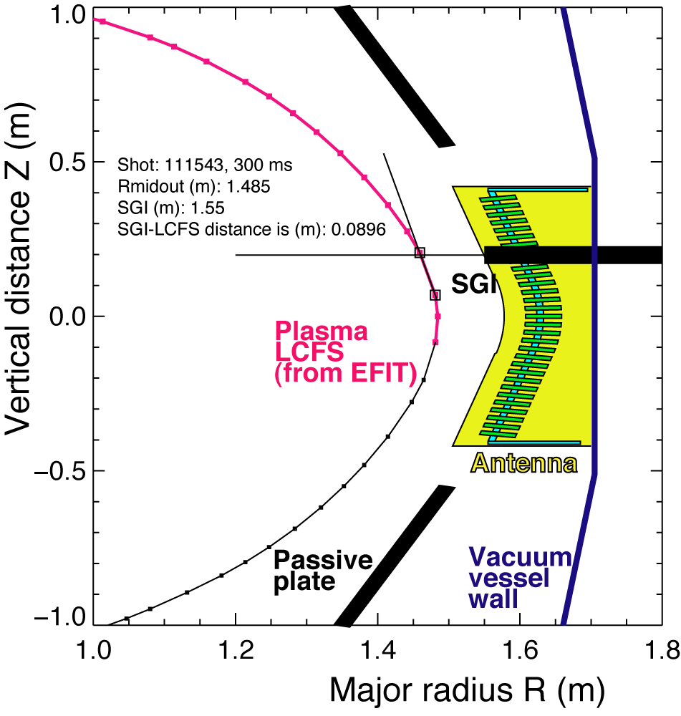
Figure 1. Example of SGI-LCFS distance calculation for shot 111543 at 300 ms

4. Required machine, NBI, RF, CHI and diagnostic capabilities
Completed Physics Operations Request and Diagnostic Checklist are attached.
Prerequisite conditions:
- Supersonic gas injector XMP-36 has been run and the SGI is commissioned
- Fast camera (Canadian Photonics, Kodak or Phantom) is available and mounted on Bay L port window
- NBI and H-mode access conditions are needed for part 3.3 of the experiment.

5. Planned analysis
We plan to use DEGAS 2, UEDGE and TRANSP for fueling efficiency and jet penetration analysis.

6. Planned publication of results
Results will be presented at conferences and / or refereed journals as appropriate.

References

[1] L. Yao et al., Nuc. Fusion 41, 817 (July 2001).
[2] B. Pegourie et al., J. Nuc. Mater. 313-316, 539 (2003).
[3] J. Miyazawa et al., Nucl. Fusion 44, 154 (2004).
[4] J. Yiming, Z. Yan, Y. Lianghua, and D. Jiaqi, Plasma Phys. Control. Fusion 45, 2001 (2003).
[5] J. Bucalossi et. al., in Proc. 29th Int Conf. on Fusion Energy, Lyon 2002 (IAEA, Vienna, 2002).
[6] V. A. Soukhanovskii, H. W. Kugel, R. Kaita, R. Majeski, A. L. Roquemore, Supersonic gas injector for fueling and diagnostic applications on the National Spherical Torus Experiment, Review of Scientific Instruments, October 2004, Volume 75, Issue 10, pp. 4320-4323
[7] V. A. Soukhanovskii, H. W. Kugel, R. Kaita, R. Majeski, A. L. Roquemore, D. P. Stotler, Supersonic gas jet for fueling experiments on NSTX, Paper P2.190, Proceedings of the 31st EPS Conference on Plasma Physics, 28 June - 2 July 2004, London, United Kingdom
[8] V. A. Soukhanovskii, H. W. Kugel, R. Kaita, A. L. Roquemore, First results from NSTX supersonic gas jet fueling experiments, NSTX FY 2004 Results Review, 20-21 September 2004, Princeton, New Jersey . http://nstx.pppl.gov/DragNDrop/Results_Review_04/Soukhanovskii-RR04/

PHYSICS OPERATIONS REQUEST
Plasma re-fueling with Supersonic Gas Jet OP-XP-516
Machine conditions for parts 3.1 and 3.3
I_{TF} (kA): -52.5 Flattop start/stop (s): -0.02 / 1.0
I_{P} (MA): 0.8 Flattop start/stop (s): 0.18 / 0.37
Configuration: Inner Wall / Lower Single Null / Upper SN / Double Null
Outer gap (m): 0.1, Inner gap (m): 0.055-0.070
Elongation κ: 1.85-1.95, Triangularity δ: 0.4-0.5
Z position (m): 0.00
Gas Species: D / He, Injector: Midplane and SGI
NBI - Species: D, Sources: None, Voltage (kV): _____, Duration (s): _____
ICRF – Power (MW): ____, Phasing: Heating / CD, Duration (s): _____
CHI: Off
Either: List previous shot numbers for setup: 112813
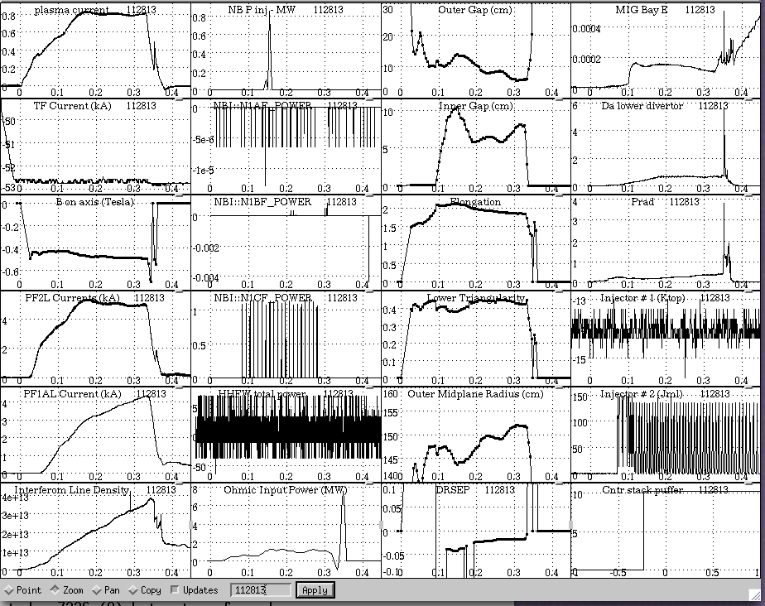
Machine conditions for part 3.2
I_{TF} (kA): -52.5 Flattop start/stop (s): -0.02/1.0
I_{P} (MA): 0.8 Flattop start/stop (s): 0.08/0.6
Configuration: Inner Wall / Lower Single Null / Upper SN / Double Null
Outer gap (m): 0.1, Inner gap (m): 0.05-0.10
Elongation κ: 2, Triangularity δ: 0.55
Z position (m): 0.00
Gas Species: D / He, Injector: Midplane / Inner wall /SGI
NBI - Species: D, Sources: A/B, Voltage (kV): 80, Duration (s): 0.6
ICRF – Power (MW): ____, Phasing: Heating / CD, Duration (s): _____
CHI: Off
Either: List previous shot numbers for setup: 111543

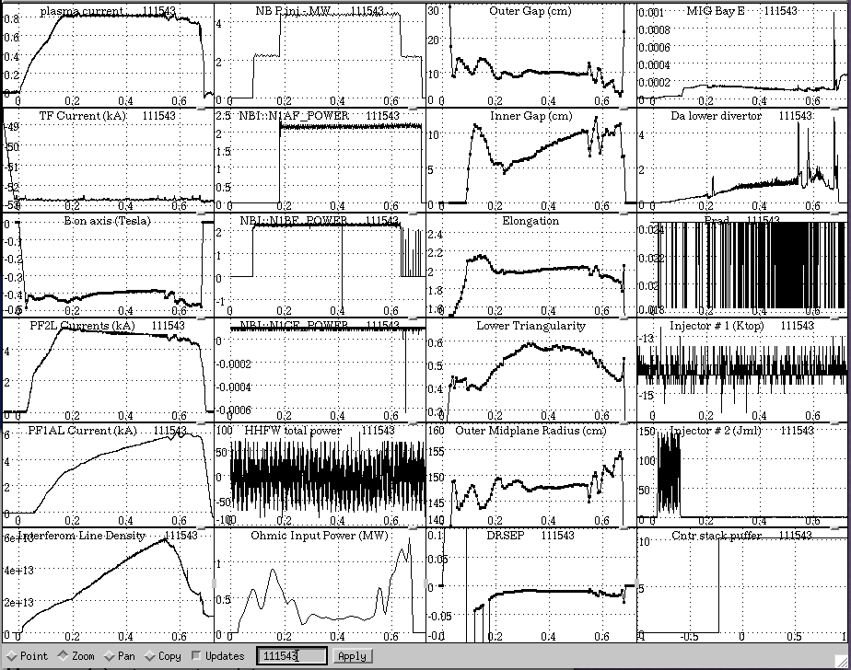
DIAGNOSTIC CHECKLIST
Plasma re-fueling with Supersonic Gas Jet OP-XP-516
Diagnostic | Need | Desire | Instructions
Bolometer - tangential array | ✓
Bolometer array - divertor | ✓
CHERS | ✓
Divertor fast camera | ✓
Dust detector |  | ✓
EBW radiometers
Edge deposition monitor
Edge pressure gauges | ✓
Edge rotation spectroscopy | ✓
Fast lost ion probes – IFLIP
Fast lost ion probes – SFLIP
Filtered 1D cameras | ✓
Filterscopes | ✓
FIReTIP | ✓
Gas puff imaging
High-k scattering
Infrared cameras | ✓
Interferometer – 1 mm
Langmuir probes - PFC tiles | ✓
Langmuir probes - RF antenna
Magnetics – Diamagnetism
Magnetics – Flux loops | ✓
Magnetics – Locked modes
Magnetics – Pickup coils | ✓
Magnetics - Rogowski coils | ✓
Magnetics - RWM sensors
Mirnov coils – high frequency | ✓
Mirnov coils – poloidal array
Mirnov coils – toroidal array
MSE
Neutral particle analyzer | ✓
Neutron Rate (2 fission, 4 scint)
Neutron collimator
Plasma TV | ✓
Reciprocating probe | ✓
Reflectometer - FM/CW
Reflectometer - fixed frequency homodyne quadrature
Reflectometer - homodyne correlation
Reflectometer - HHFW/SOL
RF antenna camera
RF antenna probe

Solid State NPA
SPRED | ✓
Thomson scattering - 20 channel | ✓
Thomson scattering - 30 channel | ✓
Ultrasoft X-ray arrays | ✓
Ultrasoft X-ray arrays - 2 color
Visible bremsstrahlung det. | ✓
Visible spectrometers (VIPS) | ✓
X-ray crystal spectrometer - H
X-ray crystal spectrometer - V
X-ray PIXCS (GEM) camera
X-ray pinhole camera
X-ray TG spectrometer

