Princeton Plasma Physics Laboratory
NSTX Experimental Proposal
Title: Stability limits with strong shaping at high I_{N}
OP-XP-727 | Revision: | Effective Date:  (Ref. OP-AD-97)  Expiration Date:  (2 yrs. unless otherwise stipulated)
PROPOSAL APPROVALS
Author: D. Gates |  |  | Date 5/2/07
ATI – ET Group Leader: S. Sabbagh/N. Gorelenkov |  |  | Date
RLM - Run Coordinator: D. Gates/ M. Bell (Deputy) |  |  | Date
Responsible Division: Experimental Research Operations
Chit Review Board (designated by Run Coordinator)
MINOR MODIFICATIONS (Approved by Experimental Research Operations)

NSTX EXPERIMENTAL PROPOSAL
OP-XP-727

1. Overview of planned experiment
The goal is to develop high current plasmas at low toroidal field and strong heating to investigate the β-limits as a function of shaping in the low q* regime. This continues work done in 2005 and is motivated by the modification to the PF1A coil.

2. Theoretical/ empirical justification
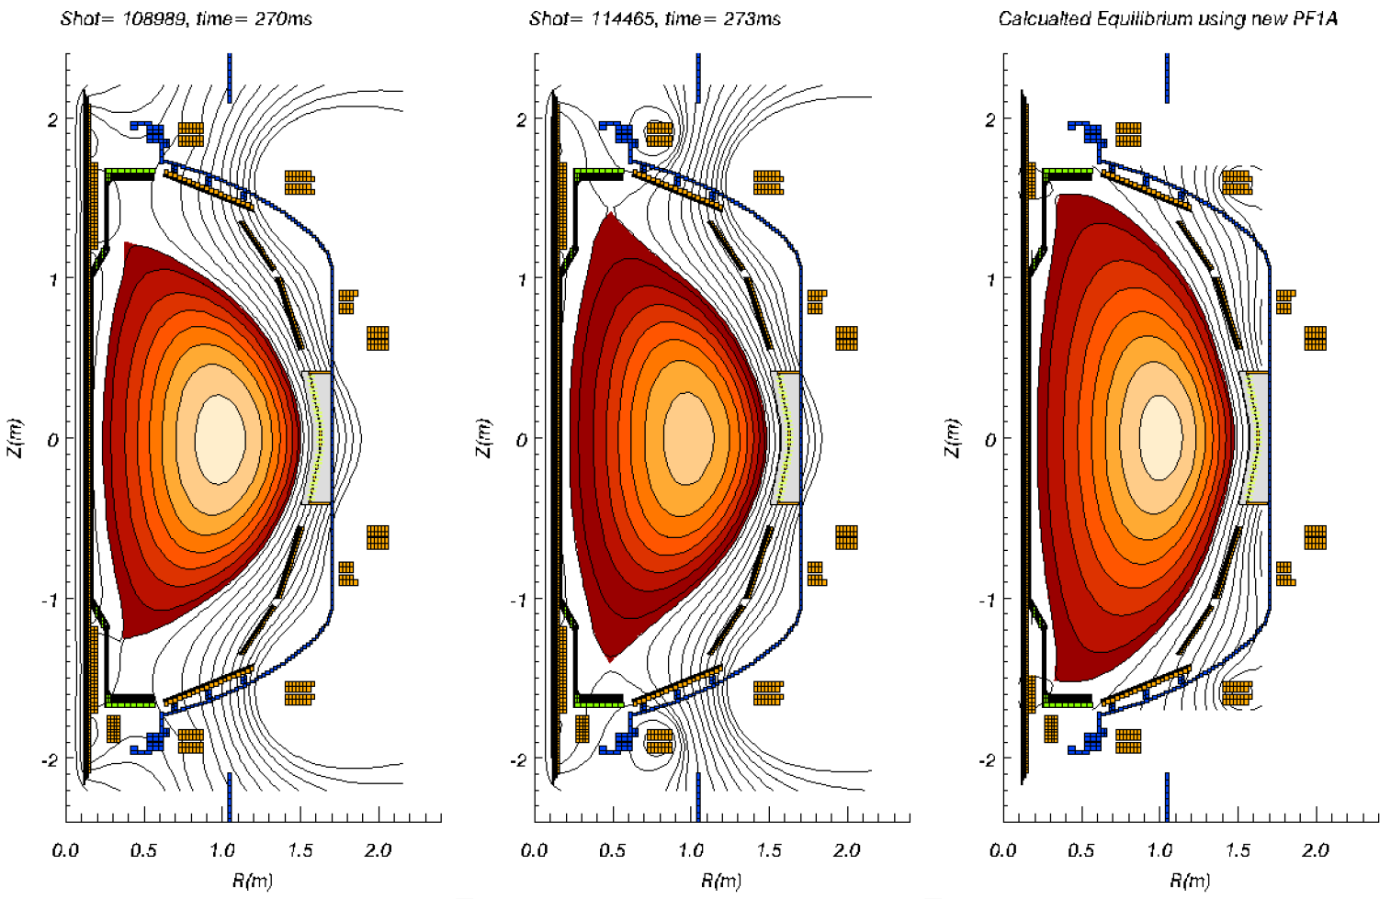
This experiment is the most recent in a series of experiments designed to investigate the performance of highly shaped double null plasmas. Experience from 2005 indicates that high elongation and high triangularity operation is capable of supporting interesting plasma performance regimes. Stability calculations made the NSTX 5-year plan indicate that plasmas with simultaneous high elongation and triangularity have higher β-limits, and simple geometric arguments also argue they should support higher plasma current due to increased q* for the same plasma current.

3. Experimental run plan

1. Reload fiducial, reduce TF to 3kGauss. Use lithium evaporator at nominal rate of 25mg/minute. Evaporate into 7 minute glow with ~15 minute rep rate.
2. Decrease PF1AU to 0.5*nominal value for fiducial in steps of 25%. Increase upper and lower outer squareness to achieve kappa = 2.5 with 1cm drsep. Require 12cm outer gap and 6cm inner gap.
If necessary adjust Ip ramp rate and PF1A time history, drsep time history, and beam timing to permit successful ramp-up. (5-15 shots)
3. Increase current in steps of 100kA maintaining ramp rate after knee in Ip ramp, maintaining best Ip ramp rate. If plasma appears power limited consider increasing voltage on source C to 95kV. (5-10 shots)
4. Repeat best shots at 3.5kGauss in attempt to create scenario with ~35% β_{t} for ~2τ_{E} (4-5shots)

4. Required machine, NBI, RF, CHI and diagnostic capabilities
Reliable high power NBI is a prerequisite. Thomson is required. CHERS and MSE are highly desirable. Lithium evaporation is required.

5. Planned analysis
EFIT is required. TRANSP will be run on select shots according to data availability. TSC analysis is a possibility. Time dependent DCON analysis will be run on select shots.

6. Planned publication of results
If successful in increasing β substantially, would publish the results in Physical Review Letters. Otherwise the material would be sent to Phys. Plasmas.

PHYSICS OPERATIONS REQUEST
OP-XP-727
Machine conditions (specify ranges as appropriate)
I_{TF} (kA): 36kA-54kA Flattop start/stop (s): N/A
I_{P} (MA): 1.0 - 1.5MA Flattop start/stop (s): N/A
Configuration: Double Null
Outer gap (m): 10cm, Inner gap (m): 2-4cm
Elongation κ: ~2.5, Triangularity δ: 0.8
Z position (m): 0.00
Gas Species: D, Injector: Midplane CS gas valve
NBI - Species: D, Sources: A/B/C, Voltage (kV): 90kV, Duration (s): 400ms
ICRF – Power (MW): None, Phasing: N/A, Duration (s): N/A
CHI: Off
Either: List previous shot numbers for setup: fiducial
Or: Sketch the desired time profiles, including inner and outer gaps, κ, δ, heating, fuelling, etc. as appropriate. Accurately label the sketch with times and values.
DIAGNOSTIC CHECKLIST
OP-XP-727
Diagnostic | Need | Desire | Instructions
Bolometer – tangential array |  | 
Bolometer array - divertor |  | 
CHERS | 
Divertor fast camera | 
Dust detector |  | 
EBW radiometers |  | 
Edge deposition monitor |  | 
Edge pressure gauges |  | 
Edge rotation spectroscopy |  | 
Fast lost ion probes - IFLIP |  | 
Fast lost ion probes - SFLIP |  | 
Filtered 1D cameras |  | 
Filterscopes | 
FIReTIP |  | 
Gas puff imaging
Infrared cameras |  | 
Interferometer - 1 mm |  | 
Langmuir probe array
Magnetics - Diamagnetism | 
Magnetics - Flux loops | 
Magnetics - Locked modes |  | 
Magnetics - Pickup coils | 
Magnetics - Rogowski coils | 
Magnetics - RWM sensors |  | 
Mirnov coils – high frequency |  | 
Mirnov coils – poloidal array |  | 
Mirnov coils – toroidal array |  | 
MSE | 
Neutral particle analyzer
Neutron measurements | 
Plasma TV | 
Reciprocating probe
Reflectometer – core
Reflectometer - SOL
RF antenna camera
RF antenna probe
SPRED |  | 
Thomson scattering | 
Ultrasoft X-ray arrays |  | 
Visible bremsstrahlung det. |  | 
Visible spectrometers (VIPS) |  | 
X-ray crystal spectrometer - H
X-ray crystal spectrometer - V
X-ray PIXCS (GEM) camera
X-ray pinhole camera
X-ray TG spectrometer

