Princeton Plasma Physics Laboratory
NSTX Experimental Proposal
Title: HHFW Current Drive at High B Field
OP-XP-717 | Revision: | Effective Date: Mar 22, 2007  (Ref. OP-AD-97)  Expiration Date: Mar 22, 2009  (2 yrs. unless otherwise stipulated)
PROPOSAL APPROVALS
Author: J. Hosea, R. Bell, S. Bernabei, L. Delgado-Aparicio, S. Kubota, B. LeBlanc, F. Levinton, C.K. Phillips, R. Pinsker, P. Ryan, S. Sabbagh, K. Tritz, J. Wilgen, J.R. Wilson, et al. |  |  | Date
ATI – ET Group Leader: Gary Taylor |  |  | Date
RLM - Run Coordinator: Dave Gates |  |  | Date
Responsible Division: Experimental Research Operations
Chit Review Board (designated by Run Coordinator)

MINOR MODIFICATIONS (Approved by Experimental Research Operations)
NSTX EXPERIMENTAL PROPOSAL
Title: HHFW Current Drive at High B Field OP-XP-717

J. Hosea, R. Bell, S. Bernabei, L. Delgado-Aparicio, S. Kubota, B. LeBlanc, F. Levinton, C.K. Phillips, R. Pinsker, P. Ryan, S. Sabbagh, K. Tritz, J. Wilgen, J.R. Wilson, et al.

ET – Wave Physics - HHFW

1. Overview of planned experiment
Goal: For optimum heating efficiency cases of OP-XP-1, measure current drive for RF into ohmic discharges and then with the addition of NB for enabling MSE measurement of current profiles (may need to do this experiment in deuterium to control Te adequately)

• RF current drive for RF only into ohmic discharge
- Compare +/- 7m⁻¹ , 14 m⁻¹ for current drive
- Monitor Vloop and heating/RF effects
  - Shots must be made stable for long pulses (100 ms or greater) by adjusting power to limit Te rise to less than ~ 3 keV
  - VLoop values are to be compared for similar Te/ne profiles to obtain ΔV to equate to current drive
  - Need to monitor other properties
    - RF probe signals – amplitude and spectra from edge turbulence/PDI
    - PDI signals – edge/core reflectometry, ERD
    - Thomson scattering, Chers, W_{EFIT}, MSE, etc.
• Add single NB source to permit MSE direct measurement of the current profile and Chers measurements of plasma velocities
- Establish efficient heating conditions with reasonable Vloop responses
- Measure current profiles for +/- 7m⁻¹, 14 m⁻¹

2. Theoretical/ empirical justification
A summary of the justification of this experiment is that heating at -7 m⁻¹ was shown to be much more efficient in the last run at the higher B field of 5.5 kG so that current drive should be enhanced as well and we may now be able to make a more quantified measurement of current drive. Also operation with NB was much improved - Te could be sustained at a high value while Vloop was driven down to ~ 0.3 V (for deuterium) – so that it should be possible to make MSE measurements of the current drive properties as well.

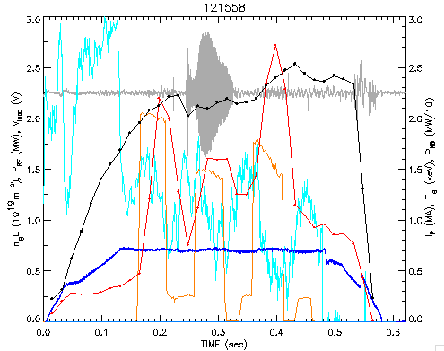
Fig. 1. Shot 121558 - 7 m⁻¹ for B = 5.5 kG and helium

Te response and Vloop response are quite strong for current drive phasing – 7m⁻¹ at B = 5.5 kG in helium (Fig. 1) and supports performing CD experiments by extending the length of the RF pulse. Note that the pulse length and power level must be set to avoid instability collapse as was observed for no modulation in helium at 2.2 MW in shot 121563. The temperature rise is less in deuterium and it could prove that CD experiments are best done in deuterium (Fig. 2).
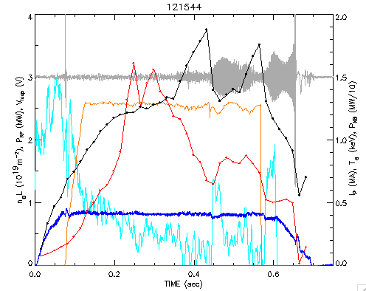
Fig. 2 Shot 121544 - 7m⁻¹ for B = 5.5 kG and deuterium

The best data at high field (5.5 kG) that supports the compatibility of using NB injection for MSE measurements were obtained with no modulation in deuterium (Fig. 3). MSE measurements should be possible over the range of ~ 0.2 to 0.4 sec for these conditions.

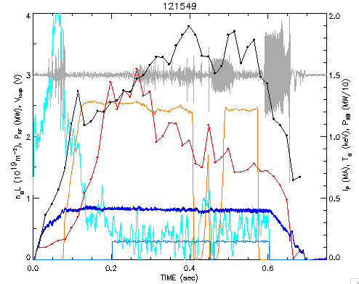
Fig. 3. Shot 121549 - 7m⁻¹ for B = 5.5 kG and deuteriium

Fig 4 shows that the beam adds stored energy to the RF produced stored energy and Fig 5 shows that V_{tor} should be measurable.
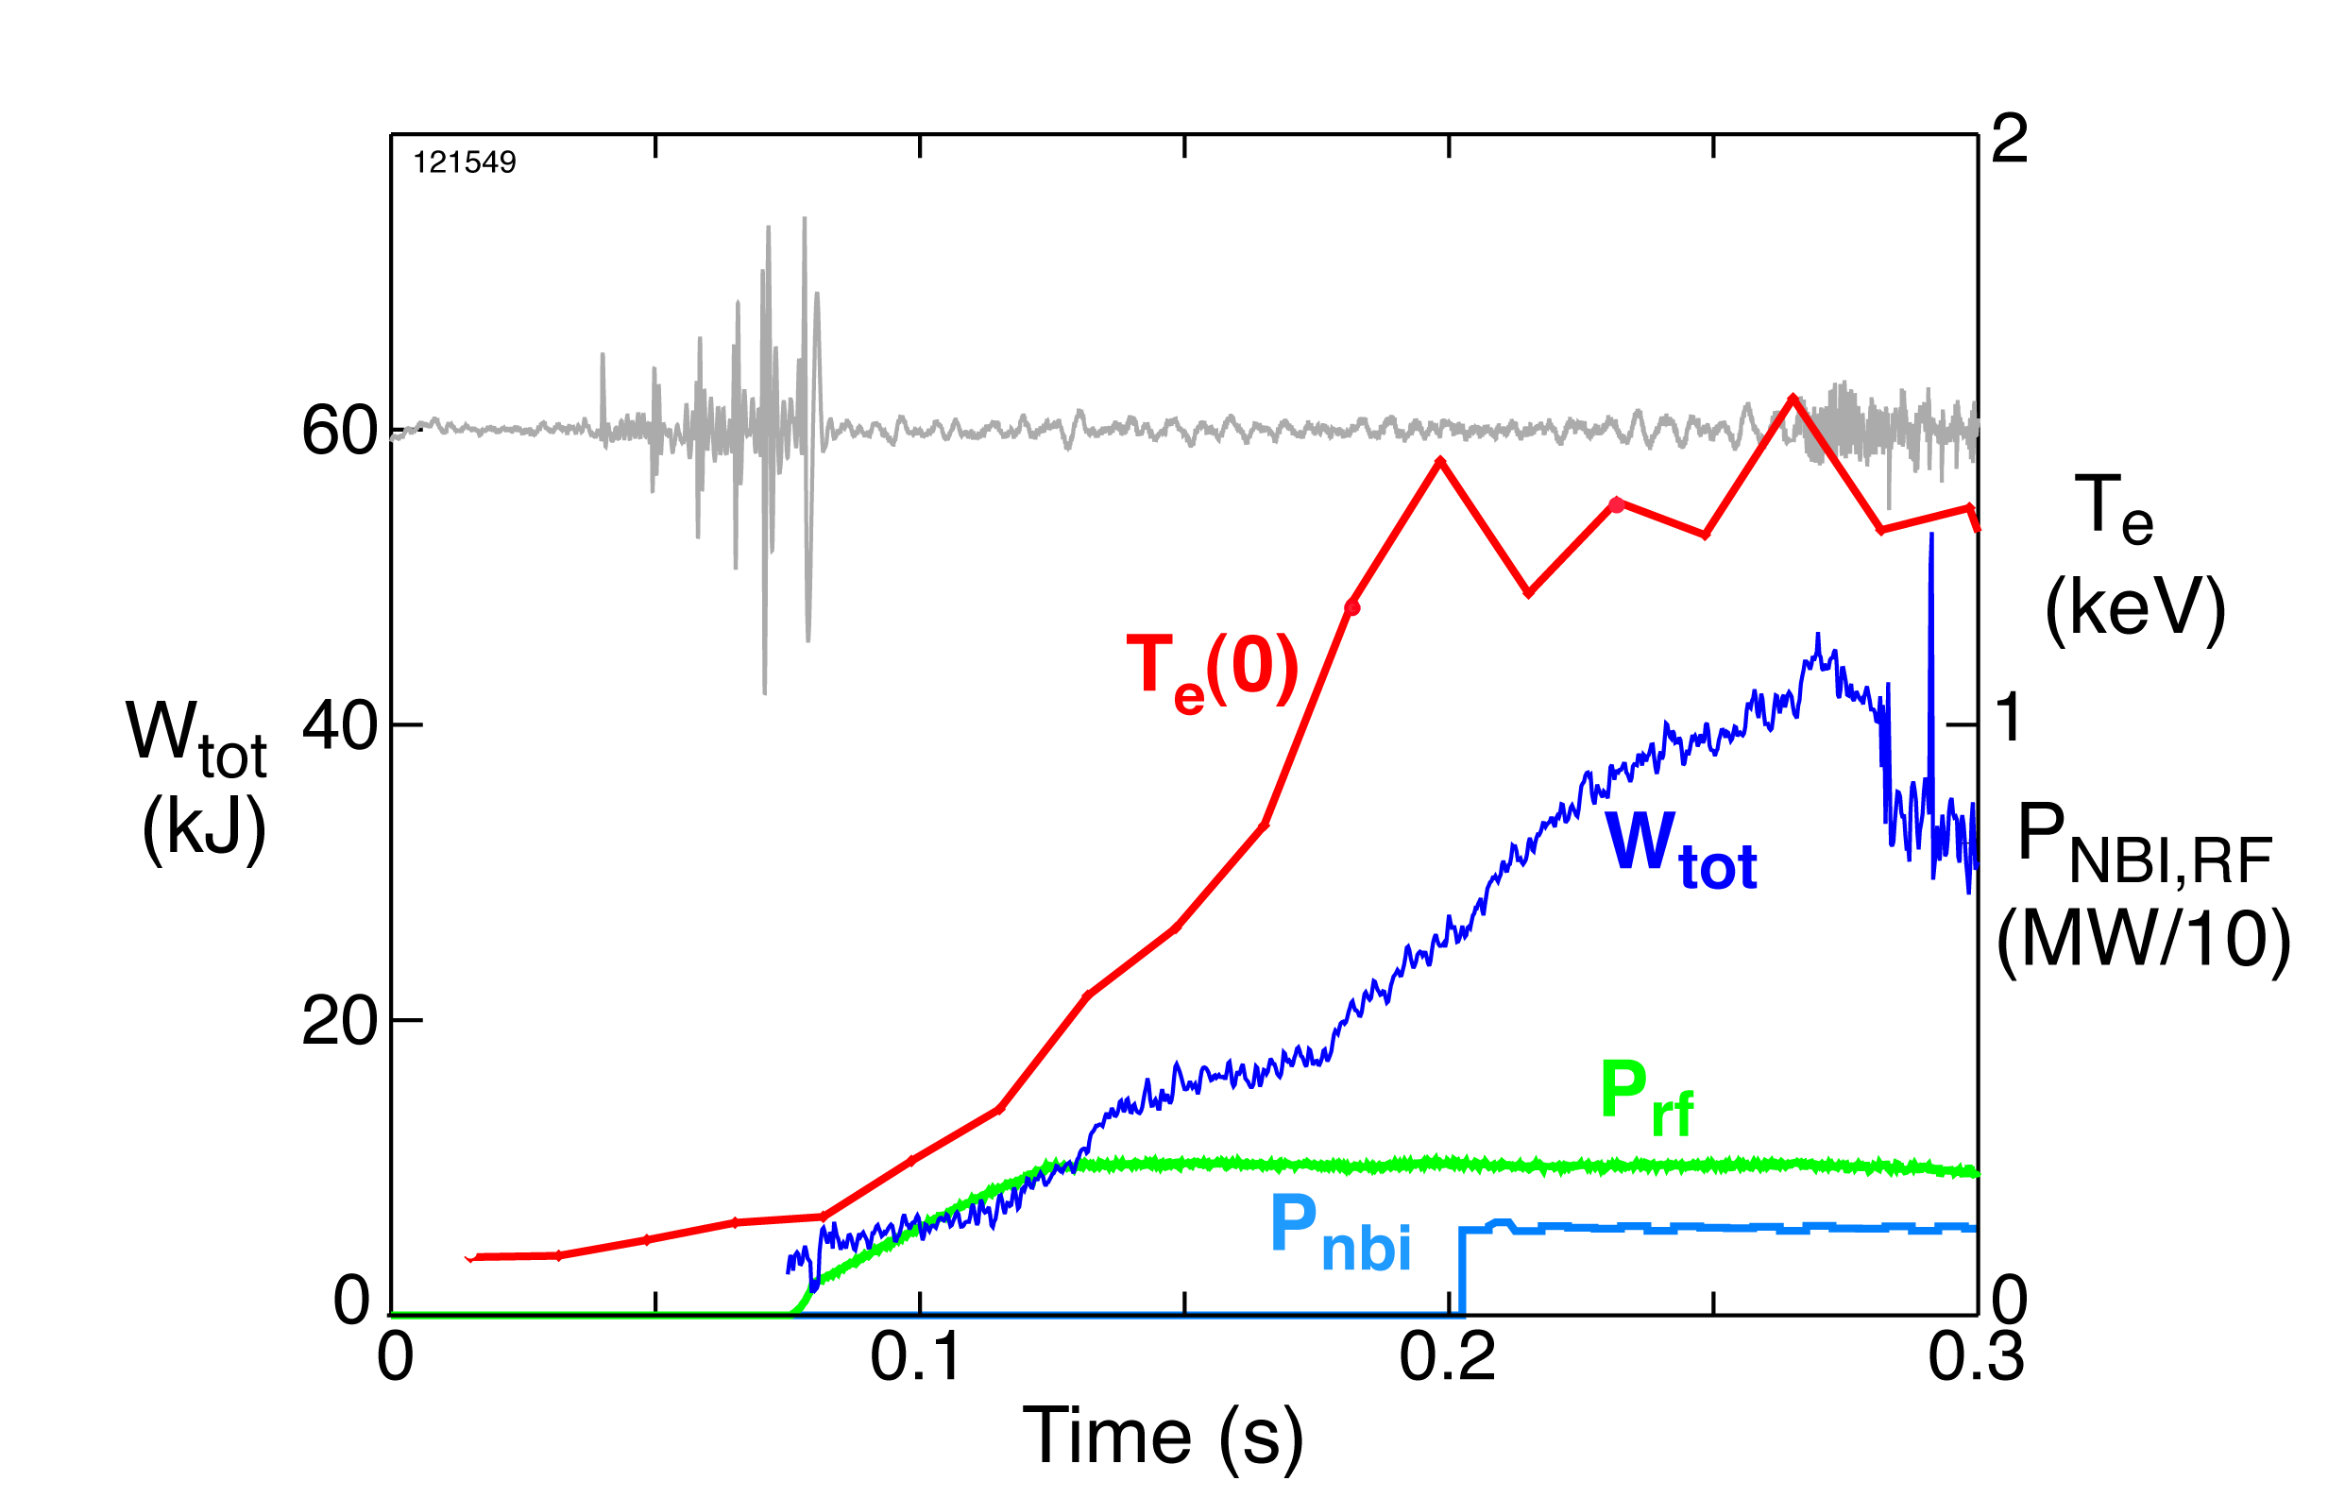
Fig4. Shot 121549 expanded - W_{tot}

Fig5. Shot 121549 expanded - V_{tor}

Relevant results from XMP runs will be applied to this XP to optimize conditions.

3. I. Experimental run plan -- 3 days of run time
Setup conditions as for XP617 at B = 5.5 kG:
- LSN, L-mode, gap 4-5 cm
- Start with helium
- Modulate P_{RF} as for shot 121558 with k|| = -7 m⁻¹ but with 100 ms pulses
- Bring power up to highest level that is stable
3 shots

- Decide if helium is OK or if switch to deuterium is called for
  - go to conditions for shot 121544 if deuterium is to be used

- Compare Vloop for RF/ohmic case – I day of run time
- 2 shots @ -7 m⁻¹ (co CD)
- 2 shots @ +7 m⁻¹ (counter CD)
- 2 shots @ 14 m⁻¹
- 2 no RF shots
- Other gaps/phases?

- Add NB and measure current profiles with MSE -- 2 days of run time
- Repeat shots in A
- Other phases?

3. II. Abbreviated experimental run plan – 1 day of run time
Setup conditions as for shot 122563 at B = 5.5 kG:
- LSN, L-mode, gap 3-5 cm
- Start with helium
- Apply P_{RF} as for shot 122563 with k|| = -7 m⁻¹ with 200 ms pulse
- Bring power up to highest level that is stable for optimum gap position
- Add NB at 90 kV for MSE during end of RF pulse
- Scan gap 3, 4, 5 cm and scan I_{P} 400, 600, 730 kA
8 shots
- CD in helium
- 2 shots @ -7 m⁻¹ (co CD)
- 2 shots @ +7 m⁻¹ (counter CD)
- 2 shots @ 14 m⁻¹
- 2 no RF shots
- Compare Vloop for RF/ohmic case and compare MSE measurements during NB

B CD in deuterium
Go to conditions for shot 121544 deuterium but with gap, I_{P}, and RF pulse of A
- Repeat shots in A
C Other phases?

4. Required machine, NBI, RF, CHI and diagnostic capabilities
Stable or at least reproducible plasma conditions are required for the quantitative comparisons of this XP. Critical diagnostics include:
- Soft x-ray and Mirnov loops for stability
- EFIT with high time resolution for W
- Thomson scattering for electrons
- Edge rotation diagnostic for edge heating
- NPA for edge and core ion heating
- Radiated power diagnostic
- Reflectometry for edge density and PDI
- Reflectometry for wave measurements for opposite side from antenna
- Edge probe for PDI
- Gap RF probes for leakage
- 4 RF probe(s) for edge RF field
- CHERS for some shots for T_{i} and velocities
- MSE for some shots for effects on current

Expected results and planned analysis
Expected results:
- Current drive differential between -7 m⁻¹ (co CD) and +7 m⁻¹ (counter CD) (and other phases?) for helium and deuterium
- CD properties from MSE, Vloop, l_{i}
- Core electron heating from Thomson scattering

- Heating properties/power loss vs gas
- Ion heating and core rotation from Chers
- Edge ion heating from edge rotation diagnostic
- Edge electron heating from Thomson scattering

- Behavior of PDI characteristics and induced losses vs gas

- Behavior of RF fields at plasma boundary vs gas

- Plasma profiles, core and edge, for permitting predictions of wave propagation and damping characteristics and of PDI produced losses

Planned analysis:
- Calculation of current driven vs phase

- Calculation of τ and ΔW for EFIT W to obtain percent P_{RF} deposited

- Calculation of τ_{e} and ΔW_{e} for Thomson scattering W_{e} to obtain P_{RF} delivered to electrons

- Compare current drive efficiencies for two gas cases with computations of expected efficiencies

- Analysis of wave propagation and damping characteristics from onset density into the core of plasma - along field and perpendicular directions of the ray path, and including collisions - for predicting core fields as part of CD analysis

6. Planned publication of results
The results will be submitted for publication.
PHYSICS OPERATIONS REQUEST
Title: HHFW Power Balance Optimization at High B Field
Machine conditions (specify ranges as appropriate)
B_{TF} (kG): 3 - 5.5 Flattop start/stop (s): 0.0 / 0.6 or as normal
I_{P} (MA): 0.4 – 0.73 Flattop start/stop (s): 0.1 /0.6 or as for 122563
Configuration: Lower Single Null as for 122563 or as newly developed this run.
Outer gap (m): 3 – 8 cm, Inner gap (m): ~ 4 cm
Elongation κ: _____, Triangularity δ: _____
Z position (m): 0.00
Gas Species: He or D Injector: Inner Wall or as best for stability and RF power
NBI - Species: D, Sources: A, Voltage (kV): 90, Duration (s): 0.04 -0.08
ICRF – Power (MW): up to 3 MW Phasing: -7/+7(π)/14 m⁻¹
Duration (s): 0.2 – 0.3 sec
CHI: On / Off
Either: List previous shot numbers for setup: 122563
Or: Sketch the desired time profiles, including inner and outer gaps, κ, δ, heating, fuelling, etc. as appropriate. Accurately label the sketch with times and values.
DIAGNOSTIC CHECKLIST
Title: HHFW Power Balance Optimization at High B Field
Diagnostic | Need | Desire | Instructions
Bolometer - tangential array | X |  | Whatever is needed for measuring Prad
Bolometer array - divertor | X
CHERS | X
Divertor fast camera
Dust detector
EBW radiometers
Edge deposition monitor
Edge pressure gauges |  | X
Edge rotation spectroscopy | X |  | Essential
Fast lost ion probes – IFLIP |  | X
Fast lost ion probes – SFLIP |  | X
Filtered 1D cameras |  | X
Filterscopes
FIReTIP
Gas puff imaging
High-k scattering |  | X
Infrared cameras |  | X
Interferometer – 1 mm
Langmuir probes - PFC tiles |  | X
Langmuir probes - RF antenna | X
Magnetics – Diamagnetism | X
Magnetics – Flux loops | ✓
Magnetics – Locked modes | X
Magnetics – Pickup coils | ✓
Magnetics - Rogowski coils | ✓
Magnetics - RWM sensors |  | X
Mirnov coils – high frequency |  | X
Mirnov coils – poloidal array |  | X
Mirnov coils – toroidal array | X
MSE | X |  | Essential for some shots
Neutral particle analyzer |  | X
Neutron Rate (2 fission, 4 scint)
Neutron collimator
Plasma TV | X
Reciprocating probe |  | X
Reflectometer - FM/CW |  | X
Reflectometer - fixed frequency homodyne quadrature
Reflectometer - homodyne correlation |  | X
Reflectometer - HHFW/SOL | X
RF antenna camera |  | X
RF antenna probe | X
Solid State NPA
SPRED |  | X
Thomson scattering - 20 channel | ✓
Thomson scattering - 30 channel | X
Ultrasoft X-ray arrays | X
Ultrasoft X-ray arrays - 2 color |  | X
Visible bremsstrahlung det.
Visible spectrometers (VIPS)
X-ray crystal spectrometer - H
X-ray crystal spectrometer - V
X-ray pinhole camera
High time resolution EFIT | X
Gap RF probes | X
RF probes for edge RF field | X

