Princeton Plasma Physics Laboratory
NSTX Experimental Proposal
Title: Momentum Transport Studies Using n=3 Non-Resonant Braking
OP-XP-813 | Revision: | Effective Date:  Expiration Date:  (2 yrs. unless otherwise stipulated)
PROPOSAL APPROVALS
Responsible Author: Wayne Solomon |  |  | Date
ATI – ET Group Leader: S. Kaye |  |  | Date
RLM - Run Coordinator: M. Bell |  |  | Date
Responsible Division: Experimental Research Operations
Chit Review Board (designated by Run Coordinator)

MINOR MODIFICATIONS (Approved by Experimental Research Operations)

NSTX EXPERIMENTAL PROPOSAL
TITLE: Momentum Transport Studies Using n=3 Non-Resonant Braking | No. OP-XP-813
AUTHORS: Wayne Solomon | DATE: 2/6/08

1. Overview of planned experiment
This XP aims to continue the characterization of momentum transport on NSTX, by using n=3 non-resonant magnetic perturbations to distort the rotation profile, allowing for separation of the roles of momentum diffusion vs convection (pinch).

2. Theoretical/ empirical justification
Measurements obtained from XP 723 demonstrated the applicability of the perturbation technique using n=3 non-resonant perturbations, and obtained first evidence of an inward momentum pinch on NSTX. The inferred pinches showed semi-quantitative agreement with theoretical predictions based on low-k turbulence, but due to the limited success in obtaining long MHD quiescent phases in the previous attempt, it was not possible to determine how robust this agreement was, or how to distinguish between two competing but similar theoretical expressions for the pinch velocity
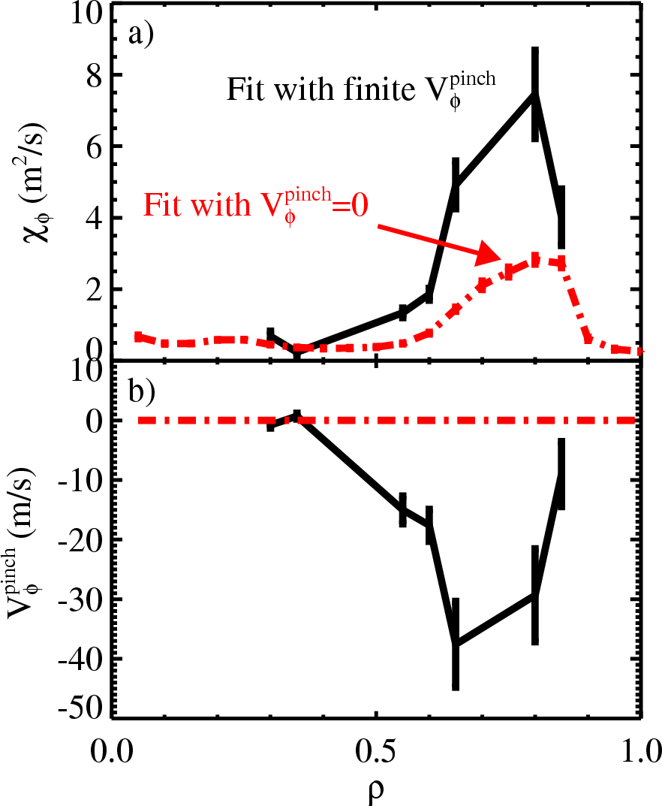

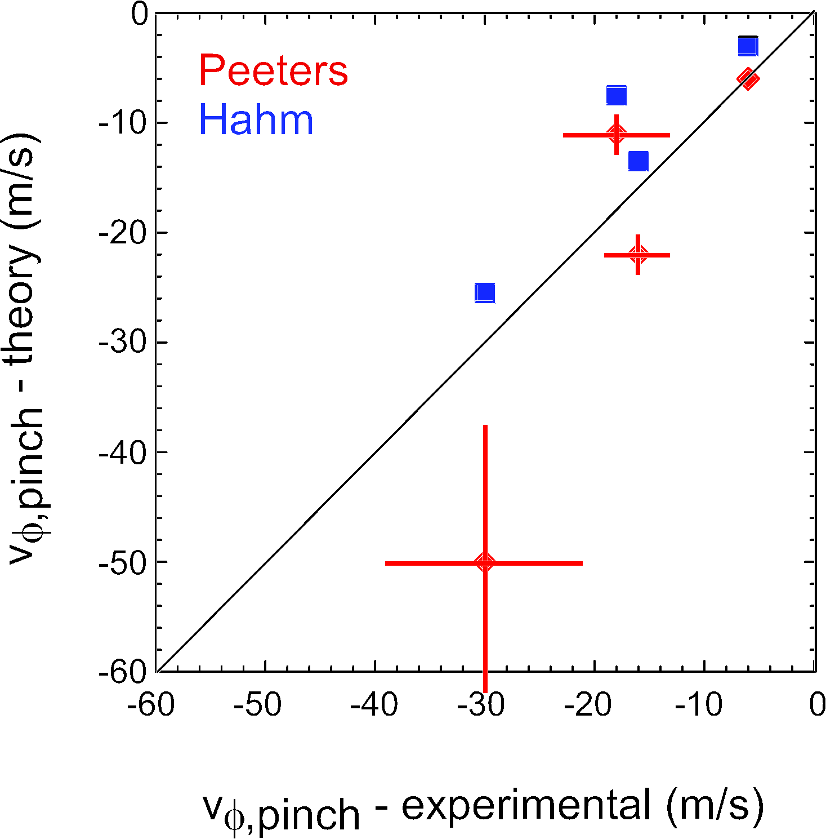
Figure 1 - a) Momentum diffusivity and (b) momentum pinch velocity inferred using n=3 non-resonant magnetic perturbations to the plasma. For comparison, the inferred diffusivity neglecting any momentum pinch is also shown (dashed).
Figure 2 - Comparison of the theoretically predicted momentum pinch velocities from Hahm vs Peeters et al to the experimentally determined quantity.
The present experiment will attempt to extend the database considerably, by considering different baseline rotation conditions, and different densities (more particularly scale lengths) to distinguish between the Hahm and Peeters models.
The data obtained will also be important for further characterizing the relationship between the momentum and thermal diffusivities. Our analysis so far has shown that there is essentially no relationship between the momentum and ion thermal diffusivities in H-mode, unlike at higher aspect ratio.

3. Experimental run plan
The key requirement for success of this XP is to obtain reproducible long MHD quiescent phases of the discharge. We only had limited success at achieving this in XP 723, although it was certainly adequate for a first attempt. Since that XP, there was a successful MHD quiescent plasma run as part of XP740 (eg #123848), and also some older shots (eg #121154) may be suitable candidates. We should aim to run at the highest possible toroidal magnetic field to try to minimize MHD. If a quality target plasma cannot be achieved, then seriously consider deferring experiment until Li run period if the conclusion is that this significantly improves the MHD stability and shot reproducibility. The baseline target plasma may already have been developed in the XP on the “Effect of Rotation on Energy/Impurity Confinement”. If so, reproduce a target from that XP, and start at step #3.
Once a suitable reference discharge is established in the absence of n=3 braking, we can proceed with the main part of the experiment. Since we wish to distinguish between competing theories of the momentum pinch, we wish to conduct a scan in L_{n}. As a proxy for this, we will first try a simple density scan. If time permits, we will try repeating some measurements in L-mode, although it is less clear whether a suitable target can be found there. We will also measure the momentum transport under different base line rotation conditions using different beam mixes, and n=3 NTV to change the background plasma.

- Reproduce #123848 1 shots
  - Repeat at highest possible Bt and use as baseline reference 1 shot
Subtotal: 2 + 2 contingency

Decision: If successful, skip to step #3, otherwise, consider if failure due to lack of Li, if so, try #121154
- Reproduce #121154 1 shots
  - Repeat at highest possible Bt and use as baseline reference 1 shot
Subtotal: 2 + 2 contingency
Decision: If still have not achieved long quiescent plasma, consider aborting and reassess experiment (eg conduct during Li campaign?)
- Two point density scan (as proxy for L_{n} scan), to distinguish turbulent pinch theories of Hahm vs. Peeters et al. Apply n=3 braking (50 ms pulse at approx 1000 A) at different times in discharge to get maximal (natural) variation in density. Want repeat shot at each condition.
  - nRMP at approx 350 ms (earlier if possible) 2 shots
  - nRMP after 500 ms (as late as reference shot indicates feasible) 2 shots
Subtotal: 4 shots
- Three point Bt scan. Want to vary momentum transport, and previous scalings show this is a more sensitive knob than Ip. Will attempt two nRMP blips per discharge, however, due to NSTX long momentum confinement time, need to wait approx 200 ms before applying second (identical) pulse.
  - Bt ~ 0.45 T 2 shots
  - Bt ~ 0.35 T 2 shots
Subtotal: 4 shots
Decision: If lowering Bt produces MHD problems in 3a, then skip 3b.
- Three point Ip scan. Expect larger variation in ion thermal diffusivity than momentum, but need to make sure that changes in pinch velocity aren’t confusing our steady state comparisons
  - Ip ~ 1.1 MA 2 shots
  - Ip ~ 0.7 MA 2 shots
Subtotal: 4 shots
- Vary background rotation, since studies on DIII-D have shown momentum transport strongly affected by rotation
  - NB input torque “scan” by switching from sources A+B vs A+C.
Expect only moderate change to rotation profile (hopefully 20%).
Use highest field . 1 shots
  - Use n=3 braking to modify background plasma. Apply 200 ms of braking to allow plasma to reach new steady state, then apply 50 ms perturbation. If discharge remains quiescent, apply a second train approx 200 ms after first sequence.
    - 700 A for 200 ms, then 1400 A for 50 ms. 1 shots
    - 700 A for 200 ms, then off for 50 ms (check symmetry) 1 shot
    - 1000 A for 200 ms, then 1400 A for 50 ms. 1 shots
    - 1000 A for 200 ms, then switch off (NTV fiducial) 1 shot
Subtotal 5 shots
Decision: If did not invest significant time in steps #1+2 (either due to luck or because development was done in previous XP as expected), then attempt to develop high density L-mode target, to get better variation in density scale length, Also expect larger diffusivities and subsequently larger pinch velocities. Can also look for increased correlation of momentum and ion thermal transport.
- Compare L and H-mode one source plasma
  - Run H-mode as above, but drop to one source after
transition (~ 200 ms) 2 shots
  - Develop high density one source L-mode (no nRMP) 3 shots
  - L-mode w/ nRMP 2 shots
Subtotal 7 shots
TOTAL: 17 shots + (possibly 8 development up front, or 3 development + 4 physics at end)

4. Required machine, NBI, RF, CHI and diagnostic capabilities
Shot development needed to attain MHD quiescent H-mode and L-mode conditions.

5. Planned analysis
This data will be analyzed using EFIT/LRDFIT, with follow up analysis in TRANSP for computation of the torque sources and transport quantities. The TRANSP output will be processed using codes developed in XP 723 to extract perturbed diffusivity and pinch velocities. For the cases using NTV to get different baseline rotation conditions, NTV calculations will be required. Alternatively, the NTV torque may be estimated by looking at the change in angular momentum following the application of braking (requires assumptions about the underlying momentum transport).

6. Planned publication of results
The data obtained from this XP will be required to write a more extensive paper (eg PoP) of the presently submitted PRL on the topic of momentum transport.. Also supports Joule milestone, TTF, IAEA and EPS.
PHYSICS OPERATIONS REQUEST
TITLE: Momentum Transport Studies Using n=3 Non-Resonant Braking | No. OP-XP-813
AUTHORS: Wayne Solomon | DATE: 2/6/08
Machine conditions (specify ranges as appropriate)
I_{TF} (kA): 64 kA (5.5 kG) Flattop start/stop (s):
I_{P} (MA): 0.9 MA Flattop start/stop (s):
Configuration: LSN
Outer gap (m): Inner gap (m):
Elongation κ: 2.3 Upper/lower triangularity δ: 0.8
Z position (m): 0
Gas Species: D Injector(s): SGI + conventional
NBI Species: D Sources: 3 Voltage (kV): 80, 90 Duration (s): full shot
ICRF Power (MW): 0 Phasing: Duration (s):
CHI: Off Bank capacitance (mF):
LITER: Off (during initial attempt at XP)
Either: List previous shot numbers for setup: 123848, 121154
Or: Sketch the desired time profiles, including inner and outer gaps, κ, δ, heating, fuelling, etc. as appropriate. Accurately label the sketch with times and values.
DIAGNOSTIC CHECKLIST
TITLE: Effect of rotation on energy and impurity confinement | No. OP-XP-
AUTHORS: Kaye and Delgado-Aparicio | DATE: 2/1/08

Diagnostic | Need | Want | Conditions
Bolometer – tangential array | x
Bolometer – divertor |  | x
CHERS – toroidal | x
CHERS – poloidal | x
Divertor fast camera
Dust detector
EBW radiometers
Edge deposition monitors
Edge neutral density diag.
Edge pressure gauges
Edge rotation diagnostic | x
Fast ion D_alpha - FIDA | x
Fast lost ion probes - IFLIP |  | x
Fast lost ion probes - SFLIP |  | x
Filterscopes | x
FIReTIP |  | x
Gas puff imaging |  | x
Hα camera - 1D
High-k scattering |  | x
Infrared cameras
Interferometer - 1 mm |  | x
Langmuir probes - divertor
Langmuir probes – RF ant.
Magnetics – Diamagnetism | x
Magnetics - Flux loops | x
Magnetics - Locked modes | x
Magnetics - Pickup coils | x
Magnetics - Rogowski coils | x
Magnetics - RWM sensors | x

Diagnostic | Need | Want | Conditions
Mirnov coils – high f. | x
Mirnov coils – poloidal array | x
Mirnov coils – toroidal array | x
MSE | x
NPA – ExB scanning
NPA – solid state |  | x
Neutron measurements | x
Plasma TV
Reciprocating probe
Reflectometer – 65GHz
Reflectometer – correlation
Reflectometer – FM/CW
Reflectometer – fixed f |  | x
Reflectometer – SOL
RF edge probes
Spectrometer – SPRED | x
Spectrometer – VIPS
SWIFT – 2D flow
Thomson scattering | x
Ultrasoft X-ray arrays | x
Ultrasoft X-rays – bicolor | x
Ultrasoft X-rays – TG spectr.
Visible bremsstrahlung det. |  | x
X-ray crystal spectrom’r - H |  | x
X-ray crystal spectrom’r - V |  | x
X-ray fast pinhole camera
X-ray spectrometer - XEUS |  | x

