Princeton Plasma Physics Laboratory
NSTX Experimental Proposal
Title: ELM mitigation with midplane control coils
OP-XP-818 | Revision: 1.0 | Effective Date: 2/12/08  Expiration Date:  (2 yrs. unless otherwise stipulated)
PROPOSAL APPROVALS
Responsible Author: S.A. Sabbagh |  |  | Date:
ATI – ET Group Leader: S.A. Sabbagh |  |  | Date
RLM - Run Coordinator: M.G. Bell |  |  | Date
Responsible Division: Experimental Research Operations
Chit Review Board (designated by Run Coordinator)

MINOR MODIFICATIONS (Approved by Experimental Research Operations)

NSTX EXPERIMENTAL PROPOSAL
TITLE: ELM mitigation with midplane control coils | No. OP-XP-818
AUTHORS: S.A. Sabbagh, J-K. Park, T. Evans, S. Gerhardt, R. Maingi, J.E. Menard | DATE: 2/12/08

1. Overview of planned experiment
The general goal of the experiment is to take up the challenge of the USBPO to demonstrate ELM mitigation with midplane magnetic control coils. This demonstration could greatly simplify control needs for ELM mitigation in ITER and other devices.
In addition to this overall goal, the science of ELM mitigation will be investigated by expanding upon work already performed in NSTX and DIII-D. Because the physics of ELM mitigation by non-axisymmetric fields is not established, this experiment is somewhat exploratory in nature. For instance, plasma targets with various edge q will be exposed to different forms on non-axisymmetric fields, making touch with existing data to some extent, but focusing on changes that are believed to be more favorable for ELM mitigation, or to expose new possibilities for mitigation and provide insight into the key physics.

2. Theoretical/ empirical justification
While hypotheses exist to attempt to explain ELM mitigation by magnetic means, the physics of this mitigation is not completely clear. Analysis of experiments to date focuses on reduction of edge pressure gradients and currents by field ergodization. The Chirikov parameter (ratio of the magnetic island width to the distance between resonant surfaces) is typically used to judge the most effective non-axisymmetric field configurations (Chirikov parameter > 1 is desired). Another consideration is not having the 3-D field perturbation penetrate too far into the plasma core, possibly leading to significant plasma rotation damping by resonant or non-resonant means and subsequent mode formation and locking. One approach of the present experiment is to examine new non-axisymmetric field spectra based on new NSTX hardware capabilities for 2008. One example of this proposed and analyzed by J-K. Park (Fig. 1) is a superposition of n = 2 and n = 3 fields. This configuration appears to yield favorable Chirikov parameter with appropriate radial field penetration, relatively low n = 1 component to best avoid resonant field amplification and mode generation/subsequent locking, all with reasonable levels of currents applied to the midplane RWM control coils on the device. Several DC applied field configurations will be considered. In addition, past experience on NSTX in RWM control and NTV braking experiments have showed that changes in plasma rotation can lead to changes in MHD mode stability (RWMs and NTMs, for example). This could be due to the direct influence of the rotation profile, or the effect that the rotation profile changes (including rotation shear) have on edge pressure and currents. These in turn could affect ELMs, with the large potential benefit that an AC field has been shown to be less perturbative to the plasma, to create less non-resonant braking, and might require less RMS power than a DC applied field. Also, the buildup toward giant ELMs (ΔW_{tot} ~ 10%) causes a sufficiently large n = 1 perturbation detected by the RWM radial field sensors well before a stored energy collapse due to the ELM. Therefore, n = 1 feedback on the RWM B_{r} sensors may also allow mitigation of giant ELMs using midplane control coils.

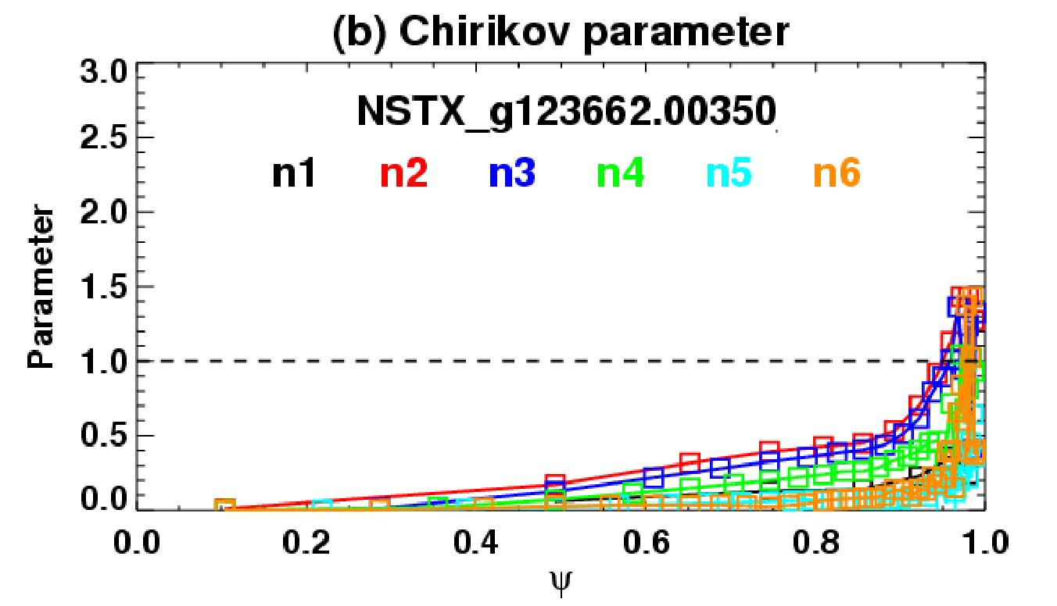

Figure 1: Chirikov parameter vs. normalized psi for proposed n = 2 + 3 applied field configuration for RWM coil currents 0.5 kA in coils 1,4; 0.5 kA in coils 2,6; 1.5 kA in coils 3,5 (from J-K. Park).

Note that ergodization of the field near the plasma edge is not the sole consideration for ELM mitigation. The effect appears to be sensitive to edge q (possibly a resonant effect – the present conclusion from DIII-D experiments (Fig. 2)) as well as edge recycling conditions. Therefore, target plasmas with low and high edge q will be created, along with a scan in q used as a diagnostic analogous to that shown in Fig. 2. These targets will then be exposed to various non-axisymmetric field configurations mentioned above. A target plasma with lower q₉₅ less than or about 6 is required. High edge q targets are available, but will be rerun and re-evaluated regarding the H-mode and ELMs produced. Also, this experiment is best run both before and after lithium is introduced to the machine to determine the effect of edge recycling on ELM mitigation. Based on present experimental experience, it is possible that the higher recycling conditions may preclude ELM mitigation. Even if this is the conclusion, the initial experimental results will establish the target plasmas, and provide information on how the DC and AC non-axisymmetric field perturbations affect the plasma equilibrium and profiles.

Figure 2: Dependence of ELM mitigation effectiveness on q in DIII-D.

3. Experimental run plan
There are three major components of the present experiment:
A) Target development: As expected, create target plasmas with conditions sufficient to establish ELMs for consequent mitigation. Two q₉₅ targets will be developed along with a discharge with varying q₉₅ to eliminate the possibility of missing ELM mitigation due to a tight resonance window that would be missed by a high/low target set, or a simpler q₉₅ step scan.
B) Apply non-axisymmetric fields in normal recycling conditions: After discussion at several group meetings, the fields considered for this experiment fall into four classes:
(i) DC odd parity fields (n = 1, 3) used in a similar fashion to past results, now operating on lower q₉₅ targets. Field ergodization analysis indicates that lower q₉₅ plasmas should be more amenable to ELM mitigation.
(ii) DC fields in new configurations based on upgraded NSTX capabilities in 2008. This includes even parity fields (e.g. n = 2, which carries a significant n = 4 component and negligible n = 1 component) and the composition of even and odd parity fields (e.g. n = 2 + 3) which are thought to be favorable for ELM mitigation.
(iii) Pre-programmed AC fields – using either/both odd and even parity. ELM mitigation would be through effects on edge plasma profiles by the AC field, rather than DC field ergodization.
(iv) Feedback n = 1 AC fields – useful for larger ELMs as the approach to the crash of these ELMs is detected significantly before it happens by the n = 1 signal of the radial RWM sensors. Feeding back on this signal may prevent these ELMs.
C) Apply non-axisymmetric fields in low recycling conditions:
Repeat portions of step (B) above showing most promise, now in low recycling conditions.
The specific shot list is shown below in two forms. First, the shot list is shown arranged as described above. Second, a shot list representing the envisioned first ½ run day of this experiment is given. Shot lists and logic for runs on subsequent run days to complete the experiment will be defined for best run efficiency based on accumulated results.

Run plan:

Task Number of Shots
1) Create target plasmas
A) Create q₉₅ < 6 target: (generate at least 10 ELMs with approximately even spacing)
(q₉₅ ~ 5.5 is adequate)
- Use shot 124349 as setup shot, (I_{p} = 0.8 MA, B_{t} = 0.5 T), change NBI source C to 1 MW unmodulated 2
- Raise I_{p} to 0.9 MA; change B_{t} to 0.45T, then 0.40T 3
- If q₉₅ > 6 and insufficient ELMs, perform startup optimizations as per J. Menard
to raise q_{min}. (8)
B) Create q₉₅ ramp target
- Start from low q₉₅ target created in step (1A), I_{p} flat-top to 0.7 MA, ramping up
to 1.0 MA; adjust eventual I_{p} flat-top if needed to create steady ELMs. 4
- if plasma drops out of H-mode, start I_{p} ramp from 1.0 MA ramping to 0.7 MA (2)
- vary B_{t} to change range of q ramp (optional) (2)
C) Create q₉₅ > 8 target
- Use shot 124349 as setup shot, (I_{p} = 0.8 MA, B_{t} = 0.5 T), change NBI source C to 1 MW unmodulated
- Drop I_{p} to 0.7 MA; tweak to 0.75 MA if desired 2
2) Attempt ELM mitigation with non-axisymmetric fields under normal recycling conditions
- DC fields:
A) Apply n = 3 field configuration; vary amplitude from 1.5 kA 4
B) Apply n = 3 + 1 field configuration; vary amplitude from 1.0 kA, 0.5 kA 4
C) Apply n = 2 + 3 field configuration
(start from RWM (1-4) 0.5kA, RWM (2,6) 0.5kA, RWM (3,5) 1.5 kA) 4
D) Apply n = 2 field configuration; vary amplitude from 1.5 kA 4
E) Apply n = 6 field configuration (primary field is n = 0); vary amplitude from 2.5 kA 3
- AC fields (pre-programmed):
F) Apply n = 3; vary f above/below ELM frequency; vary amplitude from 2.0 kA 4
G) Apply n = 1 (co-propagating); vary f above/below ELM frequency; vary amplitude 4
H) Apply n = 1 (ctr-propagating); vary f above/below ELM frequency; vary amplitude 4
- AC fields (n = 1 feedback):
I) n = 1 B_{r} feedback: giant ELM target (e.g. 125271), vary (i) gain (ii) phase 6

3) Attempt ELM mitigation with non-axisymmetric fields under reduced recycling conditions 16
__________________________________________________________________________________
Total (optional): 64 (12)

Note that the non-axisymmetric field configurations considered in the shot plan above are presently considered as favorable for ELM mitigation, however, the enhanced flexibility of the new NSTX RWM coil patch panel allows a greater range of field combinations. As we learn more about ELM mitigation physics via magnetic means, different field configurations from the specific ones mentioned above may be considered in future runs. The configurations would be defined in revised shot lists.
Specific run plan envisioned for first ½ day of run:

This specific shot list applies to a proposed ½ day run for this experiment. The run will explore several methods of ELM mitigation in low q₉₅ and/or swept q₉₅ targets if these targets can be developed quickly. If they cannot, the run time will be solely devoted to developing these targets.

Note that the run plan is shown in priority order.

Run plan:

Task Number of Shots
1) Create target plasmas
A) Create q₉₅ < 6 target: (generate at least 10 ELMs with approximately even spacing)
(q₉₅ ~ 5.5 is adequate)
- Use shot 124349 as setup shot, (I_{p} = 0.8 MA, B_{t} = 0.5 T), change NBI source C to 1 MW unmodulated 2
- Raise I_{p} to 0.9 MA; vary B_{t} to 0.45T, then 0.40T 3
- If q₉₅ > 6 and insufficient ELMs, perform startup optimization as per J. Menard
to raise q_{min}. (8)
B) Create q₉₅ ramp target
- Start from low q₉₅ target created in step (1A), I_{p} flat-top to 0.7 MA, ramping up
to 1.0 MA; adjust eventual I_{p} flat-top if needed to create steady ELMs. 4
- If plasma drops out of H-mode, start I_{p} ramp from 1.0 MA ramping to 0.7 MA (2)
- Vary B_{t} to change range of q ramp (optional) (2)

2) Attempt ELM mitigation with non-axisymmetric fields under normal recycling conditions
- DC and AC fields:
i) Apply DC n = 3 field configuration; vary amplitude from 1.5kA 2
ii) Apply AC n = 3; vary f above/below ELM frequency; vary amplitude 2
iii) Apply DC n = 3 + 1 field configuration; vary amplitude from 1.5kA 2
iv) Apply AC n = 1 (co-propagating); vary f above/below ELM frequency; vary ampl. 2
(optionally include n = 3 based on results from (iii) above)
_________________________________________________________________________________
Total (optional): 17 (12)

4. Required machine, NBI, RF, CHI and diagnostic capabilities
Special setup for RWM coil system and SPA connections
There are three categories of connections between the switching power amplifiers (SPAs) and the RWM control coils on NSTX that are planned for this experiment:
1) Odd parity, anti-series connection: This is the “standard” existing circuitry, allowing primary n = 1 and n = 3 configurations.
2) Even parity, series connection: This is a new configuration, connecting diametrically opposed coils in series. This is a configuration allowed by PPPL engineering for the 2008 run.
3) Connection of coils that include non-diametrically-opposed pairs: There is one such connection proposed in the present XP that appears to be favorable for ELM mitigation – the n = 2+3 configuration. The required coil connections are given below. These connections are possible given the patch panel upgrade made for the 2008 run. The coil pairs can be connected to any of the three SPA units.
1
4

Figure 3: RWM coil connections for n = 2+3 field configuration.

5. Planned analysis
SURFMN and IPEC will be used to examine field ergodicity. EFIT and LRDFIT will be used for equilibrium reconstructions as input to these analyses, for NTV calculations to analyze the braking torque on these plasmas if they are significant, and MHD stability calculations computed during ELM evolution.

6. Planned publication of results
If ELM mitigation using the midplane coil set could be conclusively shown with associated analysis to explain the effect, the results would justify publication in PRL. Partial evidence of ELM mitigation might appear as part of a Phys. Plasmas or Nuclear Fusion paper of larger scope. NTV analysis associated with DC fields in these plasmas could be published alongside ELM mitigation successes or to supplement results from other dedicated NTV experiments planned to be run on NSTX in 2008. Most likely, these results would be appropriate for Phys. Plasmas or Nuclear Fusion.
PHYSICS OPERATIONS REQUEST
TITLE: ELM mitigation with midplane control coils | No. OP-XP-818
AUTHORS: S.A. Sabbagh, J-K. Park, T. Evans, S. Gerhardt, R. Maingi, J.E. Menard | DATE: 2/12/08
Machine conditions (specify ranges as appropriate)
I_{TF}: 0.35 – 0.55T Flattop start/stop (s):
I_{P} (MA): 0.7 – 1.1 Flattop start/stop (s):
Configuration: Limiter / DN / LSN / USN
Outer gap (m): 0.06 – 0.09 Inner gap (m): 0.04
Elongation κ: 1.7 – 2.3 Upper/lower triangularity δ: 0.45 – 0.75
Z position (m): -0.013
Gas Species: D Injector(s):
NBI Species: D Sources: Voltage (kV): 65 - 100 Duration (s): 0.8
ICRF Power (MW): Phasing: Duration (s):
CHI: On / Off Bank capacitance (mF):
LITER: On / Off (XP starts without LITER, ends with LITER on separate days
Shot numbers for setup: 124349, 127571 (giant ELMs)
DIAGNOSTIC CHECKLIST
TITLE: ELM mitigation with midplane control coils | No. OP-XP-818
AUTHORS: S.A. Sabbagh, J-K. Park, T. Evans, S. Gerhardt, R. Maingi, J.E. Menard | DATE: 2/12/08

Diagnostic | Need | Want
Bolometer – tangential array |  | X
Bolometer – divertor |  | X
CHERS – toroidal | X
CHERS – poloidal |  | X
Divertor fast camera | X
Dust detector |  | X
EBW radiometers |  | X
Edge deposition monitors |  | X
Edge neutral density diag. |  | X
Edge pressure gauges |  | X
Edge rotation diagnostic |  | X
Fast ion D_alpha - FIDA |  | X
Fast lost ion probes - IFLIP |  | X
Fast lost ion probes - SFLIP |  | X
Filterscopes |  | X
FIReTIP | X
Gas puff imaging |  | X
Hα camera - 1D | X
High-k scattering |  | X
Infrared cameras |  | X
Interferometer - 1 mm |  | X
Langmuir probes - divertor |  | X
Langmuir probes – RF ant.
Magnetics – Diamagnetism | X
Magnetics - Flux loops | X
Magnetics - Locked modes | X
Magnetics - Pickup coils | X
Magnetics - Rogowski coils | X
Magnetics - RWM sensors | X

Diagnostic | Need | Want
Mirnov coils – high f. |  | X
Mirnov coils – poloidal array | X
Mirnov coils – toroidal array | X
MSE |  | X
NPA – ExB scanning |  | X
NPA – solid state |  | X
Neutron measurements | X
Plasma TV |  | X
Reciprocating probe
Reflectometer – 65GHz |  | X
Reflectometer – correlation |  | X
Reflectometer – FM/CW |  | X
Reflectometer – fixed f |  | X
Reflectometer – SOL |  | X
RF edge probes
Spectrometer – SPRED |  | X
Spectrometer – VIPS |  | X
SWIFT – 2D flow
Thomson scattering | X
Ultrasoft X-ray arrays | X
Ultrasoft X-rays – bicolor |  | X
Ultrasoft X-rays – TG spectr. |  | X
Visible bremsstrahlung det. |  | X
X-ray crystal spectrom’r - H |  | X
X-ray crystal spectrom’r - V |  | X
X-ray fast pinhole camera |  | X
X-ray spectrometer - XEUS |  | X

