Princeton Plasma Physics Laboratory
NSTX Experimental Proposal
Title: Resistive Wall Mode Stabilization Physics – Comparison to Theory
OP-XP-830 | Revision: 2.0 | Effective Date: 4/21/08  (Approval date unless otherwise stipulated)  Expiration Date:  (2 yrs. unless otherwise stipulated)
PROPOSAL APPROVALS
Responsible Author: J.W. Berkery |  |  | Date
ATI – ET Group Leader: S.A. Sabbagh |  |  | Date
RLM - Run Coordinator: M.G. Bell |  |  | Date
Responsible Division: Experimental Research Operations
Chit Review Board (designated by Run Coordinator)

MINOR MODIFICATIONS (Approved by Experimental Research Operations)

NSTX EXPERIMENTAL PROPOSAL
TITLE: Resistive Wall Mode Stabilization Physics | No. OP-XP-830
AUTHORS: J.W. Berkery, S.A. Sabbagh, H. Reimerdes | DATE: 4/21/2008

1. Overview of planned experiment
The resistive wall mode (RWM) is thought to be stabilized by energy dissipation mechanisms that depend on plasma rotation and other parameters, including ion collisionality. Recent results from NSTX have shown that the use of a scalar critical rotation frequency for RWM stabilization is not justified, while recent theoretical work emphasizes the importance of kinetic dissipation effects. The goal of this experiment is to test the effectiveness of kinetic dissipation in stabilizing the RWM in NSTX by varying the ion collisionality and rotation profile. The kinetic effects will subsequently be calculated using a PEST post-processor developed at the University of Rochester, and possibly with the new MARS-K kinetic code as well. The collisionality and rotation values compliment those from DIII-D, so that direct comparisons to a similar experiment in DIII-D can be made. NSTX results utilizing non-resonant magnetic braking will be compared to DIII-D plasmas with balanced NBI.

2. Theoretical/ empirical justification
The passive stabilization of the RWM is still not well understood. The combination of plasma rotation and dissipation mechanisms, such as kinetic effects, is thought to stabilize the RWM. DIII-D results indicate that past RWM critical rotation thresholds determined by resonant n=1, may be determined by error fields and that Ω_{crit} = ω₀/2 at the q=2 surface, where ω₀ is the steady state rotation frequency. Results from NSTX using non-resonant n=3 braking produce RWM critical rotation profiles that are inconsistent with this model, possibly due to kinetic effects, which may stabilize the RWM at low rotation.
The fluid RWM growth rate can be written in terms of the ratio of the no-wall and with-wall δWs. Kinetic effects add a complex component, δW_{K}, to each of these terms. Hu, Betti, and Manickam have developed a PEST post-processor that determines this kinetic contribution, and the MARS code has been updated to include a self-consistent stabilization model with a full kinetic prescription (MARS-K). Preliminary results from analysis of NSTX shots with the Hu/Betti code indicate that the strongest kinetic contribution to RWM stabilization is from the trapped ion precession drift resonance. This effect depends, roughly, linearly on the ion diamagnetic frequency and inversely on the collision frequency. It is also influenced in a somewhat more complicated way by the plasma rotation profile. The following equation shows the dependencies of the kinetic δW:
where ν_{eff} is the effective ion collisionality, and ω_{E} is the E×B frequency, which is directly related to the rotation frequency.
Figure 1 shows the contribution to δW_{K} as a function of Ψ, as calculated by the Hu/Betti/Manickam code (the contributions from rational surfaces have been removed). These preliminary results indicate that significant stabilization can originate from interior to the q=2 surface. This is consistent with previous experimental results from NSTX, and differs significantly from simplified RWM theoretical models in which the dynamics are limited to the edge inertial layer (e.g. the Fitzpatrick “simple” RWM model). Therefore it is interesting to study the effect of different plasma rotation profiles on the kinetic stabilization and compare these to several theories – ranging from the simple models to the more complex code solutions. Figure 2 shows some examples of rotation profiles that can be achieved in NSTX, from one that is very broad to one that is peaked to the extent of having zero rotation near the q=2 surface.
XP 619 demonstrated the feasibility of varying the ion collisionality while maintaining a constant q profile in NSTX. This is achieved by varying the plasma density. Figure 3 shows some examples of the different collisionality levels that can be obtained.
Active MHD spectroscopy will also be employed in this experiment to compute the theoretical growth rate and rotation frequency of a weakly damped, stable RWM, assuming a single, rigid-mode model. This entails applying an AC signal to the RWM coils, and comparison of the plasma response to the vacuum field. These measurements will be correlated with other analyses to determine the no-wall stability limit and to best compare results to DIII-D.

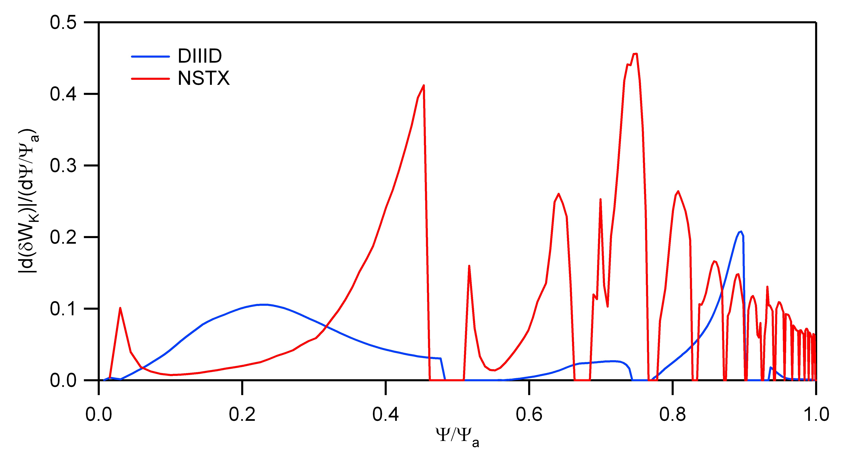

Figure 1: Contributions to the kinetic δW as a function of Ψ for an NSTX shot

compared to a DIIID shot, as calculated by the Hu/Betti/Manickam code.

Figure 2: Comparison of rotation profile for three different shots.

Figure 3: Comparison of ion collisionality for three different shots just before RWM instability.

3. Experimental run plan
We will first establish a target plasma that has a long time period free of rotating modes, especially strong n=1 modes. Next the AC active MHD spectroscopy field will be added and adjusted to make sure that it does not significantly perturb the plasma. After this, the DC n=3 correction/braking field will be applied (in addition to the AC field). By varying the ramp rate of the DC field, we will establish different rotation profiles and destabilize the RWM. We also may use the n = 1 Bp and Br feedback system to correct the n=1 dynamic error field and/or to delay the RWM destabilization. Finally, for each of these rotation profiles, the ion collisionality will be varied over the widest possible range.

Run plan:

Task Number of Shots

1) Establish target
A) Use 128470 as setup shot (relatively high elongation ~ 2.3 to avoid rotating
modes). Increase I_{p} from 0.8 to 0.9 MA (B_{t} = -0.45T), start n=3 correcting field
at 0.250 s, ramping to full amplitude at 0.300 s. 3

2) Add the AC active MHD spectroscopy field
A) Vary the frequency and n=1 applied field amplitude (will provide full
waveform details for PCS). 5

f (Hz) | Propagation | Peak to peak amplitude (kA)
50 | counter | 1.9
30 | counter | 1.55
40 | co- | 1.7
70 | co- | 2.0
100 | co- | 2.7

3) Vary the n=3 DC field timing and magnitude
A) Correct n=1 error filed using feedback system, Bp sensor filter time = 50 ms. 3
B) During the period devoid of n=1 rotating mode activity, vary the DC field
from correcting phase to braking phase, and vary the SPA current ramp rate. 6
C) Vary SPA current timing to further alter rotation by moving the n=3 correcting
pulse later in time for a more peaked profile. Vary the braking time as needed. 4

4) Ion collisionality variation
A) Vary ν_{i} by operating at Ip = 1.1 MA, B_{t} = -0.55T (constant q).
Drop B_{t} if bN < 4. Change ramp rate on the braking field to get 3 different
rotation profiles (based on step 3). 6
B) Vary ν_{i} by operating at Ip = 0.7 MA, B_{t} = -0.35T (constant q). Change ramp
rate on the braking field to get 3 different rotation profiles (based on step 3). 6

5) Comparison to DIII-D
A) With above steps completed, determine if closer matches to DIII-D can be made
and alter plasma conditions and SPA currents to allow this. 6
__________________________________________________________________________________
Total: 39

4. Required machine, NBI, RF, CHI and diagnostic capabilities
See attached Physics Operations Request and Diagnostic Checklist. RWM coil patch panel needs to be configured for standard odd-parity operation to allow n = 1 AC fields plus n = 3 DC braking fields.

5. Planned analysis

Equilibrium reconstructions will be performed with EFIT, with MSE and the flux iso-surface constraint, for reduced error on the q profile. These equilibria will then be analyzed with PEST to obtain the fluid stabilization and the Hu/Betti/Manickam code to obtain the kinetic stabilization. Kinetic stability will be compared for shots with varying collisionality and rotation profiles. These equilibria will also be sent to Yueqiang Liu at the UKAEA Culham Science Centre for analysis with MARS-K. The results of the two codes will be compared.
Additional analysis will be required for the active MHD spectroscopy. Present coding will be upgraded to allow computation of the time evolution of the resonant field amplification and phase shift dynamics, using existing codes to calculate the vacuum field and standard FFT routines.

6. Planned publication of results
The results of this experiment will be the first analysis of the kinetic stabilization effects on the resistive wall mode in NSTX and will contribute to the first comparison of those effects between various kinetic codes and various machines. This experiment is a critical step towards reaching the FY09 milestone on understanding RWM stabilization physics as a function of plasma rotation. If results and subsequent comparison to theory yields a significant new understanding of the RWM critical rotation profile, the results will be suitable for publication in Physical Review Letters. Results that are not at the level of novelty for a PRL publication will be sent to Physics of Plasmas. Any clear conclusions from this experiment are expected to be presented at the APS conference in November 2008.

PHYSICS OPERATIONS REQUEST
TITLE: Resistive Wall Mode Kinetic Stabilization Physics | No. OP-XP-830
AUTHORS: J.W. Berkery, S.A. Sabbagh, H. Reimerdes | DATE: 4/21/2008
Machine conditions (specify ranges as appropriate)
I_{TF} (kA): 0.3 – 0.55 T Flattop start/stop (s):
I_{P} (MA): 0.6 – 1.1 MA Flattop start/stop (s):
Configuration: Limiter / DN / LSN / USN
Outer gap (m): 0.06-0.10 Inner gap (m): 0.04
Elongation κ: 2.1-2.5 Upper/lower triangularity δ: 0.45-0.75
Z position (m):
Gas Species: D Injector(s):
NBI Species: D Sources: Voltage (kV): 80-100 Duration (s): 0.8
(Source A at 90kV for MSE)
ICRF Power (MW): Phasing: Duration (s):
CHI: On / Off Bank capacitance (mF):
LITER: On / Off

Shot numbers for setup:
128470 (for plasma)
128470 (for n = 3 phasing for error field correction; start n=3 pulse at 0.250 s)
128491 (n=3 phasing for correction, then braking; turn n=1 feedback off or set filter time to 50 ms).

Similar 2008 shots taken at various plasma current and toroidal field:
128042: Ip = 0.8 MA, Bt = -0.40 T
128052: Ip = 1.1 MA, Bt = -0.45 T

DIAGNOSTIC CHECKLIST
TITLE: Resistive Wall Mode Kinetic Stabilization Physics | No. OP-XP-830
AUTHORS: J.W. Berkery, S.A. Sabbagh, H. Reimerdes | DATE: 4/21/2008

Note special diagnostic requirements in Sec. 4
Diagnostic | Need | Want
Bolometer – tangential array |  | X
Bolometer – divertor |  | X
CHERS – toroidal | X
CHERS – poloidal |  | X
Divertor fast camera | X
Dust detector |  | X
EBW radiometers |  | X
Edge deposition monitors |  | X
Edge neutral density diag. |  | X
Edge pressure gauges |  | X
Edge rotation diagnostic |  | X
Fast ion D_alpha - FIDA |  | X
Fast lost ion probes - IFLIP |  | X
Fast lost ion probes - SFLIP |  | X
Filterscopes |  | X
FIReTIP |  | X
Gas puff imaging |  | X
Hα camera - 1D |  | X
High-k scattering |  | X
Infrared cameras |  | X
Interferometer - 1 mm |  | X
Langmuir probes – divertor |  | X
Langmuir probes – BEaP
Langmuir probes – RF ant.
Magnetics – Diamagnetism | X
Magnetics – Flux loops | X
Magnetics – Locked modes | X
Magnetics – Pickup coils | X
Magnetics – Rogowski coils | X
Magnetics – Halo currents |  | X
Magnetics – RWM sensors | X
Mirnov coils – high f. |  | X
Mirnov coils – poloidal array | X
Mirnov coils – toroidal array | X
Mirnov coils – 3-axis proto.
Note special diagnostic requirements in Sec. 4
Diagnostic | Need | Want
MSE | X
NPA – ExB scanning |  | X
NPA – solid state |  | X
Neutron measurements | X
Plasma TV |  | X
Reciprocating probe
Reflectometer – 65GHz |  | X
Reflectometer – correlation |  | X
Reflectometer – FM/CW |  | X
Reflectometer – fixed f |  | X
Reflectometer – SOL |  | X
RF edge probes
Spectrometer – SPRED |  | X
Spectrometer – VIPS |  | X
SWIFT – 2D flow
Thomson scattering | X
Ultrasoft X-ray arrays | X
Ultrasoft X-rays – bicolor |  | X
Ultrasoft X-rays – TG spectr. |  | X
Visible bremsstrahlung det. |  | X
X-ray crystal spectrom. - H |  | X
X-ray crystal spectrom. - V |  | X
X-ray fast pinhole camera |  | X
X-ray spectrometer - XEUS |  | X

A.C. Sontag, S.A. Sabbagh, W. Zhu, et al., Nucl. Fusion 47 (2007) 1005.
B. Hu, R. Betti, and J. Manickam, Phys. Plasmas 12 (2005) 057301.
H. Reimerdes, M.S. Chu, A.M. Garofalo, et al., Phys. Rev. Lett. 93 (2004) 135002.

