XP-900
Finish Bakeout

Magnetic Calibrations

Standard reference shots from start-up XMP

Boronization

Standard reference shots from start-up XMP

Other supporting discharges

Mario Podesta:
I'd like to propose the following discharge setup -- having some data with this scenario in the first two/three days of operations would be very useful to identify the right parameters for XP-916 (fast-ion transport by TAEs):
Deuterium as working gas
Center-stack limited plasma
Btor=5.5kG
Ip=900kA
Outer gap = 5 cm
Central density ~3 x 10-19 m-3
Low-field-side gas injection
NB waveform:
- source A on from 90ms to 400ms, then
- source A on with 50% duty cycle modulation, 10ms/10ms from 400ms to 600ms
NB sources B & C off
A possible reference shot is sh#128455, but with all the modifications indicated above.
Vlad: I would like to request / propose the following for the initial development
period:

1) SGI XMP - just a few tests of SGI injection into the plasma discharge
tail end to check out SGI operation

2) We could consider developing the SGI-only fueling scenario (no HFS) -
there is considerable interest from many XPs

3) I would like to test a few initial ideas for the "snowflake" divertor
configuration. This would involve running a plasma test shot, and then
changing divertor coil currents slightly in subsequent shots to see if this
reproduces my ISOLVER modeling.

Maingi: As you will hear from others, preparing a low delta shot that we
haven't run in 6 years is a high priority, e.g. #107714. That has
delta_l ~ 0.4 and delta_u of 0.25, with a 10cm strike point sweep
from 75-85cm. Lowest stable delta that I recall, but we moved away
from it after 2002. Needed for some LLD development, as well as for
my T & T XP, and for Skinner's particle balance.

See attached file for 3 different radii desired for X-point/delta scan.

An rtEFIT version of 107714 does exist - thanks to Stefan and Vlad
for setting me on the right trail. The target shot is from Vlad's XP:
shot 119840.

Attached are some comparisons on p.2 of the pdf. This should make
development/testing easier.
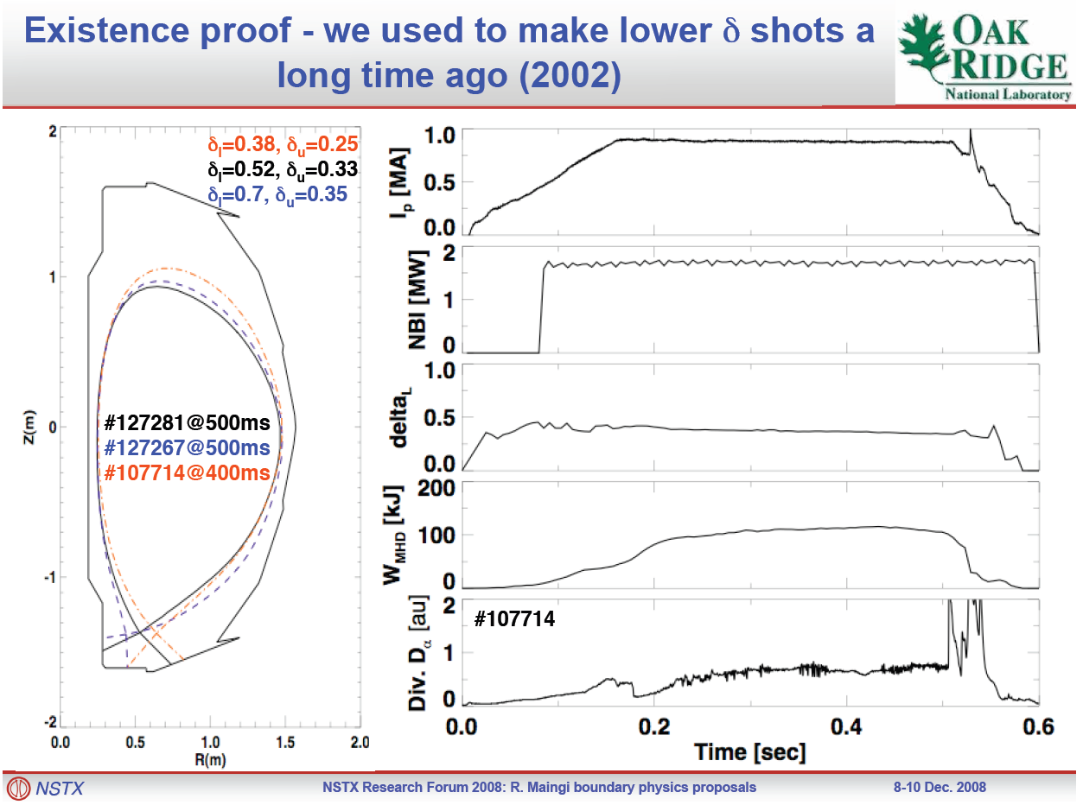

Charles: Further to my message below, Rajesh has identified some excellent candidate shots.
107714 890 kA, -53kA TF, LSN, 1.7 MW NB, type 5 ELMS, 0.35 s flattop (12 April 2002)
107317 up to 4.9 MW NBI same shape
107314 up to 4.8 MW NBI same shape
107714 with 650 kA and no beams as ohmic candidate.
I think these are also of interest to Rajesh and Stephan and maybe others.
It would be great to have these developed for XP911 on retention.

Doug Darrow:
The shot number I plan to use as a reference shot for XP 905 is
127397. Alternate shots (I think they are the same set up) are 127393
and 127389.

[Stan] It turns out that Rajesh did not specifically ask for the shot I am interested in (he asked for it if necessary). It is 127267.
The high triangularity lower single null shot that Rajesh requested is probably the one I would use as a baseline for my L-H threshold experiments.

Stefan: For XP-901: CHI For Rapid Discharge Shutdown (S. Gerhardt and R. Raman Primary Authors)
This XP could benefit from, if available, a low-triangularity H-mode discharge which does not use the CS gas injector; use of such a discharge for the target would allow different gasses to be injected using the LDGIS while keeping D2 as the main gas species. If H-mode is impossible, than a good L-mode scenario is desirable. Hence the request:

700-800 kA, 0.45 T, low triangularity (see 129015), no-CS gas injection. H-mode preferable, but L-mode acceptable. >=200 msec flat top, 2-6 MW NBI.

Results of DDB searching.

119136 is a low-triangularity, kappa~2, PF2L only shot, strongly biased down. It looks like an RTEFIT shot, unlike the 2002 candidate we have been discussing. This might help with re-development

I attach two files, that should open in excell, with shots with drsep<-0.015, 0.4<tribot<0.2. Don't know if they would have the desired strike-point evolution. Nothing in 2007 or 2008 seemed to meet the criterion (for drsep, pulse length, kappa, tribot).

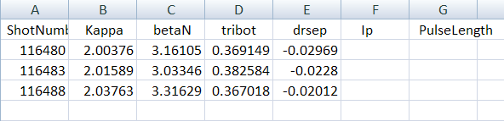

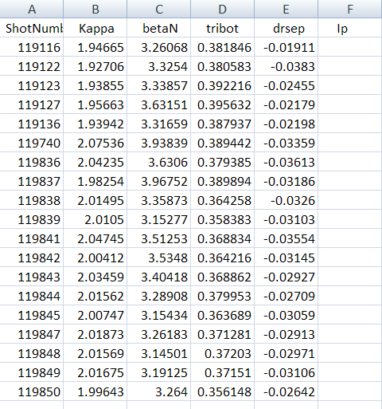
[from Stefan] Steve, Rajesh, John, Aaron, Jong-Kyu, Jon, (Hi Roger, again)

So you guys are the prime trouble-makers with respect to funky EFC coil configurations...

Can you guys comment about whether you are likely to desire any RWM coil configurations beyond the standard odd and even connections. This could impact what calibration shots I ask for.
Is the mixed 2+3 configuration in anybodies plans? I didn't see it anywhere in the ELM related research forum proposals, but I could have missed it.

I recognize that both Jon and Steve have proposals for the TBM study, that this will require something special, and that this probably hasn't been fully scoped out yet...so we can leave that in the air for the moment.

[Steve’s response to Stefan]
I’ll want n = 2, and as you say at the end, some more exotic configurations (one coil powered, one coil out, end the like).
One thing I'd like to do is to add the Br sensors to supplement the Bp sensors in the RWM
feedback system - using the "optimal" seeting we found by the end of the run last year.

I can supply shot numbers for this. I suggest we start with the "strandard" Bp-only situation
for the first day, then switch to Bp+Br some time over these first few days. Of course, we'd
monitor the success, and take out the Br sensors if there's any issue.

[Stefan’s response to Steve] I understand where Steve is coming from, but let me caution that we may not be in a position to to any feedback in the first few DAYS of the run.

We need to get the calibration shots in, check the compensations off-line, rebuild operations trees, check compensations on-line, and only then can we do feedback. I would not turn RWM feedback on until all these steps were checked, as any problems would only further confuse any startup issues. And note that while trying to do this, I'll also be having to troubleshoot all the equilibrium magnetics, which will take priority if/when any problems arise.

Getting feedback going early is an obvious priority; getting it going that early, however, may be a stretch.

[Dennis’s response to Steve and Stefan] OTOH, near the end of this start-up period, checking out that the feedback system works, in the sense that it does what is requested, is a good idea.
[Stefan’s response to Dennis] I generally agree with Dennis' comment...this is a good goal. Indeed, if we are willing to run with old compensations just to test that the PCS requests get turned into the correct SPA currents, then it surely can be done in the first few days.

FYI: A large number of the BP sensors (and one BR sensor) were removed from their mounting locations for the BES and HHFW upgrades. They were of course put back, but one can reasonably anticipate that the compensations will have changed.

[Dave’s response to all] Stefan is making a plea that you allow him to do his work in a timely and appropriate manner.
I support this.
It is important that plasma control be done with accurately calibrated sensors. There is a great deal of work to be done, all non-axisymmetric control sensor calibrations will invariably be second priority to the equilibrium sensor calibrations. Without the calibrations for the equilibrium sensors we cannot run, so this is first priority.
Dennis set a goal of having the previously used non-axisymmetric control system (n=3 correction, with n=1 feedback using the sensor set-up from last year) for the end of the start-up period, which in my mind is roughly the first 2 weeks after the ISTP (what fraction of this we call run-time and what fraction is start-up commissioning is TBD). This seems reasonable. As Stefan points out, there may be issues with this given the relatively major perturbations to the sensors. We should incorporate the resultant uncertainty in our planning process.
Any further work which incorporates additional sensors would be done after this, as part of RWM feedback development for this run. This work should be done in priority order according to the priorities set during the research forum. Other control developments currently ongoing would have to be taken into account during the run planning exercise which Roger will oversee. In particular, there are activities associated with the beta feedback control and strike point control that are ongoing and are also high priority.
[Another reply from Stefan] - The issues about under what circumstances the BR sensors should be added to "standard" feedback should probably be discussed by the interested folks, at a meeting OTHER than Roger's meeting for day 1-3 experiments, since the capability won't be available anyway.

Clarification: I realize that part of the confusion is because Roger indicated that the "RWM system" would be available when the run began. More accurately, the ability to pre-program the RWM coils should be available very early in the run. The ability to do RWM feedback will be delayed by the time required for the compensations and such. I should have made that distinction more clear to Roger and others a few weeks ago. Sorry.

--------------------------OTHER SHOTS --------------------------------
From Vlad: Charles,

FYI, the D2 glow shots are as follows:

1) 26 March 2008 - 127952-127957 (after that, He conditioning shots)

2) 25 April 2008 - 128749, 128750, 128751

