Princeton Plasma Physics Laboratory
NSTX Experimental Proposal
Title: Error Field Threshold Study in High-beta Plasmas
OP-XP-903 | Revision: | Effective Date:  (Approval date unless otherwise stipulated)  Expiration Date:  (2 yrs. unless otherwise stipulated)
PROPOSAL APPROVALS
Responsible Author: Jong-kyu Park |  |  | Date:
ATI – ET Group Leader: Steve A. Sabbagh |  |  | Date:
RLM - Run Coordinator: Michael G. Bell |  |  | Date
Responsible Division: Experimental Research Operations
Chit Review Board (designated by Run Coordinator)

MINOR MODIFICATIONS (Approved by Experimental Research Operations)

NSTX EXPERIMENTAL PROPOSAL
TITLE: Error Field Threshold Study in High-beta Plasmas | No. OP-XP-903
AUTHORS: Jong-kyu Park, Jonathan E. Menard, et al. | DATE:

1. Overview of planned experiment
Briefly describe the scientific goals of the experiment.
The goal of the experiment is to study locking phenomena driven by external non-axisymmetric field (error field) in high-beta NSTX plasmas. This study will extend the parametric space of the present error field threshold database, which is concentrated mostly on low-beta cases, and thus will increase the applicability of the database to the wider range of plasmas.
Another important point of physics in this experiment is the role of the plasma amplification in high-beta plasmas. The locking is known to be dangerous in low-beta plasmas due to the linear correlation of the critical field with plasma density, but the field itself can be amplified in high-beta plasmas and thus can become also destructive. In addition, more detailed locking dynamics can be studied by taking advantages of diagnostics available only in the high-beta operations. For example, the evolution of the rotation or the opening of magnetic islands can be measured by facilitating CHERS and MPTS measurements.

2. Theoretical/ empirical justification
Brief justification of activity, including supporting calculations as appropriate. Describe briefly any previous or related experiments.
The locking is believed to be the sudden opening of magnetic islands at the rational surfaces, when an external non-axisymmetric field is beyond a threshold and so plasma rotation can not shield the perturbation any more. The substantial degradation can be followed by enhanced transport across magnetic islands and rotational damping, and then islands can grow further until a plasma disruption. Since an external magnetic perturbation almost always exists, it is important to estimate the field threshold and to correct the field below the threshold during operation.
The method estimating the actual driving field at the rational surfaces has been significantly improved by Ideal Perturbed Equilibrium Code (IPEC), which calculates ideal plasma response, shielding currents and the total resonant field () at the rational surfaces q=m/n. The previous vacuum approximation used the external resonant field (), which is very often inappropriate to measure the actual drive of magnetic islands. As Figure 1 shows for both NSTX and DIII-D, the known correlation between the resonant field and the locking density can be restored when the total resonant field is evaluated by IPEC even for the cases when the external resonant field does not show any relevant correlation. Note that DIII-D data in Figure 1 include a recent high beta locking experiment (~1.5 ) as seen at the high density.
As the recently attempted in DIII-D, our experiments will focus on the high beta locking in NSTX. If it is assumed that the linear correlation in the NSTX low-beta locking experiments holds up to the high-beta, the resonant field 5~7 Gauss is required to lock the high beta plasmas, which roughly have the line-averaged density . IPEC calculations show that the required resonant field is achievable through the plasma amplifications with n=1 SPA ~ 1kA in high beta plasmas.
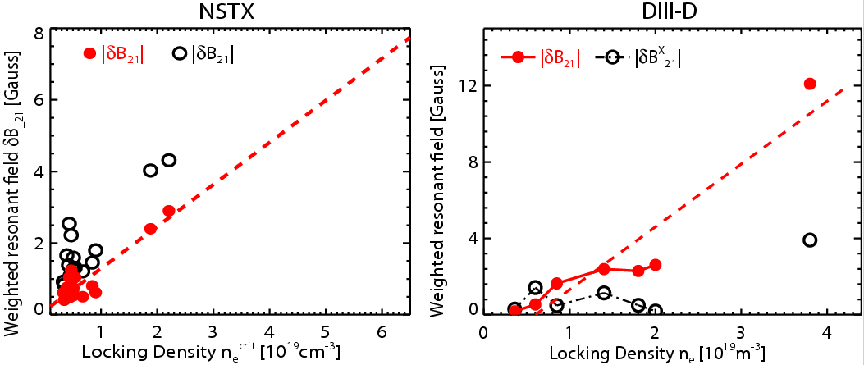
The empirical feasibility can be also found, for instance, with the previous XP810 #130217~130221, where a mixed n=1+3 field was applied and SPA ~ 1kA actually locked the plasmas. The dataset can provide at least 4 data for high-beta locking experiments, but this new experiment will use a pure n=1 rather than the field n=1+3, in order to avoid the additional degrading effects of n=3 field.
Figure1. The correlation between the critical resonant field (red) at q=2 surface and locking density for NSTX and DIII-D. The external resonant field (black) is shown for comparison, and often shows very poor correlation as can be seen. As the high density experiment on the rightmost data in DIII-D, this experiment will focus on the locking of the high density (>
) NSTX plasmas.

3. Experimental run plan
Describe experiment in detail, including decision points and processes.
1. The first part of this experiment will be straightforward if
1) the target plasma has at least 250ms flat-top period without rotating tearing modes, and
2) starts slightly below or with ~3.0 and evolves up to the no-wall limit 4.0~4.5
The previous XP810 shot #130217 satisfies these two conditions, so is relevant for the target shot. NBI 4MW may be relevant to start with, but the source C modulation may be required depending on the beta evolution and also depending on until when rotating tearing modes last. 4 shots

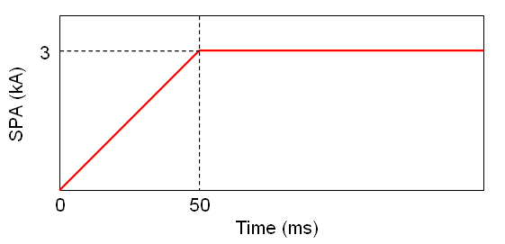
When the relevant target is developed, an n=1 SPA waveform (Figure 2) will be applied at different times during the beta evolution, and thus effectively to different beta plasmas. The appropriate times and intervals have to be determined after the target is fixed. 6 shots
Figure 2. The desired SPA current waveform. For n=1 perturbation, one of three SPA currents will be uncharged and the other two will have the above proposed wave form.
2. The second part of the experiment will be attempted only when time permitting. The goal of this part is to eliminate the evolutional effects existing in the first part of the experiment. The relatively low-beta range () in the first part of the experiment will be achieved during the early period of the plasma evolution, and so is more likely to suffer from the unsettled kinetic equilibrium. So, the relatively low-beta range of the experiment will be revisited by decreasing and by maintaining in the later time. A suggested method is to use NBI 1MW modulation at the relevant timing. The same SPA waveform will be used. This part of the experiment may require more than 6 shots, so appropriate decision must be made during the first part of the experiment.

4. Required machine, NBI, RF, CHI and diagnostic capabilities
Describe any prerequisite conditions, development, XPs or XMPs needed.
Attach completed Physics Operations Request and Diagnostic Checklist.

5. Planned analysis
What analysis of the data will be required: EFIT, TRANSP, etc.?
EFIT and LRDFIT will be used to reconstruct the 2D MHD equilibrium, and IPEC will be used to reconstruct the 3D MHD equilibrium. The non-resonant braking by n=1 NTV will be also analyzed to study the non-resonant field effects on locking.

6. Planned publication of results
What will be the final disposition of the results; where will results be published and when?
The results will be added to the locking database for tokamaks. Depending on the level of physics that the total dataset indicates, the results will be published in Nuclear Fusion or Physics of Plasmas during 2009.
PHYSICS OPERATIONS REQUEST
TITLE: Error Field Threshold Study in High Beta Plasmas | No. OP-XP-903
AUTHORS: Jong-kyu Park, Jonathan E. Menard, et al. | DATE:

Describe briefly the most important plasma conditions required for the XP:
- ~250ms tearing-free flat-top period
- Plasma = 3.0~4.5 during the period

List any pre-existing shots: 130217, 130220

Equilibrium Control: Gap Control / rtEFIT(isoflux control):
Machine conditions (specify ranges as appropriate, use more than one sheet if necessary)
I_{TF} (kA): 0.45~0.55T Flattop start/stop (s):
I_{P} (MA): 0.8~1.1MA Flattop start/stop (s):
Configuration: Limiter / DN / LSN / USN (strike out inapplicable cases)
Outer gap (m): 0.06~0.09 Inner gap (m): 0.04
Z position (m): ~0
Elongation κ: 2.0~2.2 Upper/lower triangularity δ: 0.45~0.75
Gas Species: D Injector(s):
NBI Species: D Voltages (kV or off) A: B: C: Duration (s):
ICRF Power (MW): Phasing: Duration (s):
CHI: Off / On Bank capacitance (mF):
LITERs: Off / On Total deposition rate (mg/min):
EFC coils: Off/On Configuration: Odd / Even / Other (attach detailed sheet)
DIAGNOSTIC CHECKLIST
TITLE: Error Field Threshold Study in High-beta Plasmas | No. OP-XP-903
AUTHORS: Jong-kyu Park, Jonathan E. Menard, et al. | DATE:

Note special diagnostic requirements in Sec. 4
Diagnostic | Need | Want
Bolometer – tangential array |  | √
Bolometer – divertor |  | √
CHERS – toroidal | √
CHERS – poloidal | √
Divertor fast camera |  | √
Dust detector |  | √
EBW radiometers |  | √
Edge deposition monitors |  | √
Edge neutral density diag. |  | √
Edge pressure gauges |  | √
Edge rotation diagnostic |  | √
Fast ion D_alpha - FIDA |  | √
Fast lost ion probes - IFLIP |  | √
Fast lost ion probes - SFLIP |  | √
Filterscopes | √
FIReTIP |  | √
Gas puff imaging |  | √
Hα camera - 1D |  | √
High-k scattering |  | √
Infrared cameras |  | √
Interferometer - 1 mm |  | √
Langmuir probes – divertor |  | √
Langmuir probes – BEaP |  | √
Langmuir probes – RF ant. |  | √
Magnetics – Diamagnetism |  | √
Magnetics – Flux loops | √
Magnetics – Locked modes | √
Magnetics – Pickup coils | √
Magnetics – Rogowski coils | √
Magnetics – Halo currents |  | √
Magnetics – RWM sensors | √
Mirnov coils – high f. | √
Mirnov coils – poloidal array | √
Mirnov coils – toroidal array | √
Mirnov coils – 3-axis proto. | √

Note special diagnostic requirements in Sec. 4
Diagnostic | Need | Want
MSE | √
NPA – ExB scanning |  | √
NPA – solid state |  | √
Neutron measurements |  | √
Plasma TV |  | √
Reciprocating probe |  | √
Reflectometer – 65GHz |  | √
Reflectometer – correlation |  | √
Reflectometer – FM/CW |  | √
Reflectometer – fixed f |  | √
Reflectometer – SOL |  | √
RF edge probes |  | √
Spectrometer – SPRED |  | √
Spectrometer – VIPS |  | √
SWIFT – 2D flow |  | √
Thomson scattering | √
Ultrasoft X-ray arrays | √
Ultrasoft X-rays – bicolor |  | √
Ultrasoft X-rays – TG spectr. |  | √
Visible bremsstrahlung det. |  | √
X-ray crystal spectrom. - H |  | √
X-ray crystal spectrom. - V |  | √
X-ray fast pinhole camera |  | √
X-ray spectrometer - XEUS |  | √

