Princeton Plasma Physics Laboratory
NSTX Experimental Proposal
Title: Error Field Threshold Study in High-beta Plasmas
OP-XP-903 | Revision: 1 | Effective Date:  (Approval date unless otherwise stipulated)  Expiration Date:  (2 yrs. unless otherwise stipulated)
PROPOSAL APPROVALS
Responsible Author: Jong-kyu Park |  |  | Date:
ATI – ET Group Leader: Steve A. Sabbagh |  |  | Date:
RLM - Run Coordinator: Michael G. Bell |  |  | Date
Responsible Division: Experimental Research Operations
Chit Review Board (designated by Run Coordinator)

MINOR MODIFICATIONS (Approved by Experimental Research Operations)

NSTX EXPERIMENTAL PROPOSAL
TITLE: Error Field Threshold Study in High-beta Plasmas | No. OP-XP-903
AUTHORS: Jong-kyu Park, Jonathan E. Menard, et al. | DATE:

1. Overview of planned experiment
Briefly describe the scientific goals of the experiment.
The goal of the experiment is to study static locking (error field penetration) phenomena driven by external non-axisymmetric field in high- NSTX plasmas. This study will extend the parametric space of the present error field threshold database, which is concentrated mostly on low- cases, and thus will increase the applicability of the database to the wider range of plasmas.
Another important point of physics in this experiment is the role of the plasma amplification in high- plasmas. The static locking is known to be dangerous in low- plasmas due to the linear correlation of the critical field with plasma density, but the field itself can be amplified in high- plasmas and thus can become also destructive. In addition, more detailed dynamics can be studied by taking advantages of diagnostics available only in the high- operations. For example, the evolution of the rotation or the opening of magnetic islands can be measured by facilitating CHERS and MPTS measurements.

2. Theoretical/ empirical justification
Brief justification of activity, including supporting calculations as appropriate. Describe briefly any previous or related experiments.
The static locking is believed to be the sudden opening of magnetic islands at the rational surfaces, when an external non-axisymmetric field is beyond a threshold and so plasma rotation can not shield the perturbation any more. The substantial degradation can be followed by enhanced transport across magnetic islands and rotational damping, and then islands can grow further until a plasma disruption. Since an external magnetic perturbation almost always exists, it is important to estimate the field threshold and to correct the field below the threshold during operation.
The method estimating the actual driving field at the rational surfaces has been significantly improved by Ideal Perturbed Equilibrium Code (IPEC), which calculates ideal plasma response, shielding currents and the total resonant field () at the rational surfaces q=m/n. The previous vacuum approximation used the external resonant field (), which is very often inappropriate to measure the actual drive of magnetic islands. As Figure 1 shows for both NSTX and DIII-D, the known correlation between the resonant field and the locking density can be restored when the total resonant field is evaluated by IPEC even for the cases when the external resonant field does not show any relevant correlation. Note that DIII-D data in Figure 1 include a recent high- locking experiment (~1.5 ) as seen at the high density.
As the recently attempted in DIII-D, our experiment will test the high- locking in NSTX. If it is assumed that the linear correlation in low- locking experiments from XP703 holds up to the high-, the resonant field 5~7 Gauss is required to lock the high- plasmas, which roughly have the line-averaged density . IPEC calculations show that the required resonant field is achievable through the plasma amplifications with n=1 SPA ~ 1kA in high- plasmas.
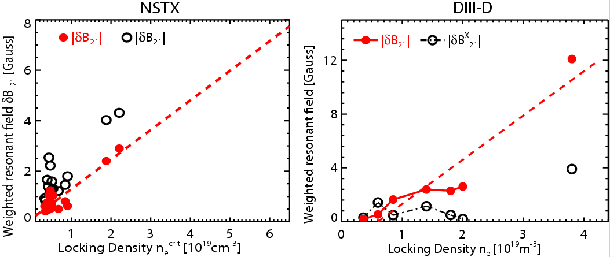
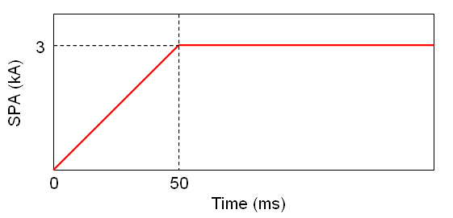
The empirical feasibility for this part of experiment can be also found, for instance, with the previous XP810 #130217~130221, where a mixed n=1+3 field was applied to NBI 4MW H-mode plasmas and SPA ~ 1kA actually locked the plasmas. The dataset can provide at least 4 data for high- locking experiments, but this new experiment will use a pure n=1 rather than the field n=1+3, in order to avoid the additional degrading effects of n=3 field.
Figure1. The correlation between the critical resonant field (red) at q=2 surface and locking density for NSTX and DIII-D. The external resonant field (black) is shown for comparison, and often shows very poor correlation as can be seen. As the high density experiment on the rightmost data in DIII-D, this experiment will focus on the locking of the high density (>
) NSTX plasmas.

Figure 2. The desired SPA current waveform. For n=1 perturbation, one of three SPA currents will be uncharged and the other two will have the above proposed wave form.
The high- locking in XP810 is straightforward and is likely to be reproducible, but there are significant transitions from Ohmic L-mode plasmas to NBI H-mode plasmas in terms of various plasma parameters. So, the other part of the experiment will explore the intermediate- regime starting from Ohmic L-mode in XP703 and adding only one source of NBI to keep L-mode, but increase the density and thus the plasma. This intermediate- experiment is desired to be ahead of the high- part of the experiment.
The density is the primary parameter to determine the error field threshold, but also the plasma can become very important through the plasma response. The density and the plasma are not well separable parameters in experiments, but the appropriate control of gas puffing and NBI timing can provide the interesting parametric dependency of the error field threshold.

3. Experimental run plan
Describe experiment in detail, including decision points and processes.
There are two major components in this experiment. The estimated number of shots is indicated by {}.
- The error field threshold study in intermediate- plasmas
  - Reproduce the static locking in Ohmic L mode plasmas in XP703
    - Use the reference Ohmic shot #122458 (I_{P} = 600kA~700kA, B_{T} = 0.45T), change gas puff (PZV2 flow rate > 100 TorrL/s) to achieve the density > 10¹⁹m⁻³. {4}
(If this target is not achievable in 4 shots, go to the step 1.b.)
    - Apply SPA’s at 150ms and increase the currents up to (3,-3,0) kA at 200ms. Note Figure 2. {2}
  - Test the static locking in NBI-heated L mode plasmas
    - Start with the developed Ohmic target and use NBI source A at 120~150ms to achieve higher density and plasma. Make sure the evolution of density and, and no rotating mode. {4}
(If this target is not achievable in 4 shots, go to the step 2.b.)
    - Apply the same SPA waveforms at 150ms ~ 300ms with an interval ~50ms. {4}
    - Change gas puffing to vary the density, and apply the same SPA waveforms. {4}
- The error field threshold study in high- plasmas (2.a and 2.b are alternative)
  - (Time permitting) Study the static locking in NBI-heated H mode plasmas from 1.b.
    - Start with the developed NBI-heated L-mode target and increase NBI up to 4MW to achieve higher density and plasma. Check no rotating mode. {2}
(If this target is not achievable in 2 shots, go to the step 2.b.)
    - Apply the same SPA waveform at 300ms ~ 500ms with an interval ~50ms. {4}
  - (IF 1.b failed) Study the static locking in NBI-heated H-mode plasmas from XP810
    - Use the reference shot #130217 (I_{P} = 900kA, B_{T} = 0.45T) and make sure no rotating mode. {2}
    - Apply the same SPA waveform at 300ms~500ms with an interval ~50ms. {4}

The estimated number of shots is 24 in total. If 1.a and 1.b are sufficiently successful during the experiment, the further exploration of locking in the intermediate- regime can be considered.

4. Required machine, NBI, RF, CHI and diagnostic capabilities
Describe any prerequisite conditions, development, XPs or XMPs needed.
Attach completed Physics Operations Request and Diagnostic Checklist.
The full magnetics/profile diagnostics are needed.

5. Planned analysis
What analysis of the data will be required: EFIT, TRANSP, etc.?
EFIT and LRDFIT will be used to reconstruct the 2D MHD equilibrium, and IPEC will be used to reconstruct the 3D MHD equilibrium. The non-resonant braking by n=1 NTV will be also analyzed to study the non-resonant field effects on locking.

6. Planned publication of results
What will be the final disposition of the results; where will results be published and when?
The results will be added to the locking database for tokamaks. Depending on the level of physics that the total dataset indicates, the results will be published in Nuclear Fusion or Physics of Plasmas during 2009.
PHYSICS OPERATIONS REQUEST
TITLE: Error Field Threshold Study in High Beta Plasmas | No. OP-XP-903
AUTHORS: Jong-kyu Park, Jonathan E. Menard, et al. | DATE:

Describe briefly the most important plasma conditions required for the XP:
- Intermediate-β_{N} plasma : = 1.0~3.0 and NBI-heated L-mode
- High-β_{N} plasma : = 3.0~4.5 H-mode
Both are desired to have the flat-top period > 250ms without a rotating tearing mode

List any pre-existing shots: 122458, 130217

Equilibrium Control: Gap Control / rtEFIT(isoflux control):
Machine conditions (specify ranges as appropriate, use more than one sheet if necessary)
I_{TF} (kA): 0.45T Flattop start/stop (s):
I_{P} (MA): 0.6~0.9MA Flattop start/stop (s):
Configuration: Limiter / DN / LSN / USN (strike out inapplicable cases)
Outer gap (m): 0.06~0.09 Inner gap (m): 0~0.04
Z position (m): ~0
Elongation κ: 2.0~2.2 Upper/lower triangularity δ: 0.45~0.75
Gas Species: D Injector(s):
NBI Species: D Voltages (kV or off) A: 90 B: 90 C: 0 Duration (s):
ICRF Power (MW): Phasing: Duration (s):
CHI: Off / On Bank capacitance (mF):
LITERs: Off / On Total deposition rate (mg/min):
EFC coils: Off/On Configuration: Odd / Even / Other (attach detailed sheet)
DIAGNOSTIC CHECKLIST
TITLE: Error Field Threshold Study in High-beta Plasmas | No. OP-XP-903
AUTHORS: Jong-kyu Park, Jonathan E. Menard, et al. | DATE:

Note special diagnostic requirements in Sec. 4
Diagnostic | Need | Want
Bolometer – tangential array | √
Bolometer – divertor |  | √
CHERS – toroidal | √
CHERS – poloidal | √
Divertor fast camera |  | √
Dust detector |  | √
EBW radiometers |  | √
Edge deposition monitors |  | √
Edge neutral density diag. |  | √
Edge pressure gauges |  | √
Edge rotation diagnostic |  | √
Fast ion D_alpha - FIDA |  | √
Fast lost ion probes - IFLIP |  | √
Fast lost ion probes - SFLIP |  | √
Filterscopes | √
FIReTIP |  | √
Gas puff imaging |  | √
Hα camera - 1D |  | √
High-k scattering |  | √
Infrared cameras |  | √
Interferometer - 1 mm |  | √
Langmuir probes – divertor |  | √
Langmuir probes – BEaP |  | √
Langmuir probes – RF ant. |  | √
Magnetics – Diamagnetism | √
Magnetics – Flux loops | √
Magnetics – Locked modes | √
Magnetics – Pickup coils | √
Magnetics – Rogowski coils | √
Magnetics – Halo currents |  | √
Magnetics – RWM sensors | √
Mirnov coils – high f. | √
Mirnov coils – poloidal array | √
Mirnov coils – toroidal array | √
Mirnov coils – 3-axis proto. | √

Note special diagnostic requirements in Sec. 4
Diagnostic | Need | Want
MSE | √
NPA – ExB scanning |  | √
NPA – solid state |  | √
Neutron measurements | √
Plasma TV | √
Reciprocating probe |  | √
Reflectometer – 65GHz |  | √
Reflectometer – correlation |  | √
Reflectometer – FM/CW |  | √
Reflectometer – fixed f |  | √
Reflectometer – SOL |  | √
RF edge probes |  | √
Spectrometer – SPRED |  | √
Spectrometer – VIPS |  | √
SWIFT – 2D flow |  | √
Thomson scattering | √
Ultrasoft X-ray arrays | √
Ultrasoft X-rays – bicolor |  | √
Ultrasoft X-rays – TG spectr. |  | √
Visible bremsstrahlung det. |  | √
X-ray crystal spectrom. - H |  | √
X-ray crystal spectrom. - V |  | √
X-ray fast pinhole camera |  | √
X-ray spectrometer - XEUS |  | √

