Princeton Plasma Physics Laboratory
NSTX Experimental Proposal
Title: Dependence of momentum and particle pinch on collisionality
OP-XP-908 | Revision: | Effective Date:  Expiration Date:  (2 yrs. unless otherwise stipulated)
PROPOSAL APPROVALS
Responsible Author: Wayne Solomon |  |  | Date 4/8/09
ATI – ET Group Leader: K. Tritz |  |  | Date
RLM - Run Coordinator: M. Bell |  |  | Date
Responsible Division: Experimental Research Operations
Chit Review Board (designated by Run Coordinator)

MINOR MODIFICATIONS (Approved by Experimental Research Operations)

NSTX EXPERIMENTAL PROPOSAL
TITLE: Dependence of momentum and particle pinch on collisionality | No. OP-XP-908
AUTHORS: Wayne Solomon | DATE: 4/8/09

1. Overview of planned experiment
The goal of the experiment is to look at the dependence of the momentum pinch velocity as a function of collisionality, and compare with analytic theory and/or gyrokinetic predictions. In addition, we will attempt to compare the momentum pinch velocity with the particle pinch velocity (which should be related), using separate density perturbation techniques.

2. Theoretical/ empirical justification
Measurements obtained from XP 723 demonstrated the applicability of the perturbation technique using n=3 non-resonant perturbations, and obtained first evidence of an inward momentum pinch on NSTX. Further studies in XP 813 showed good agreement between the experimentally determined momentum pinch velocity with theoretical predictions based on low-k turbulence.
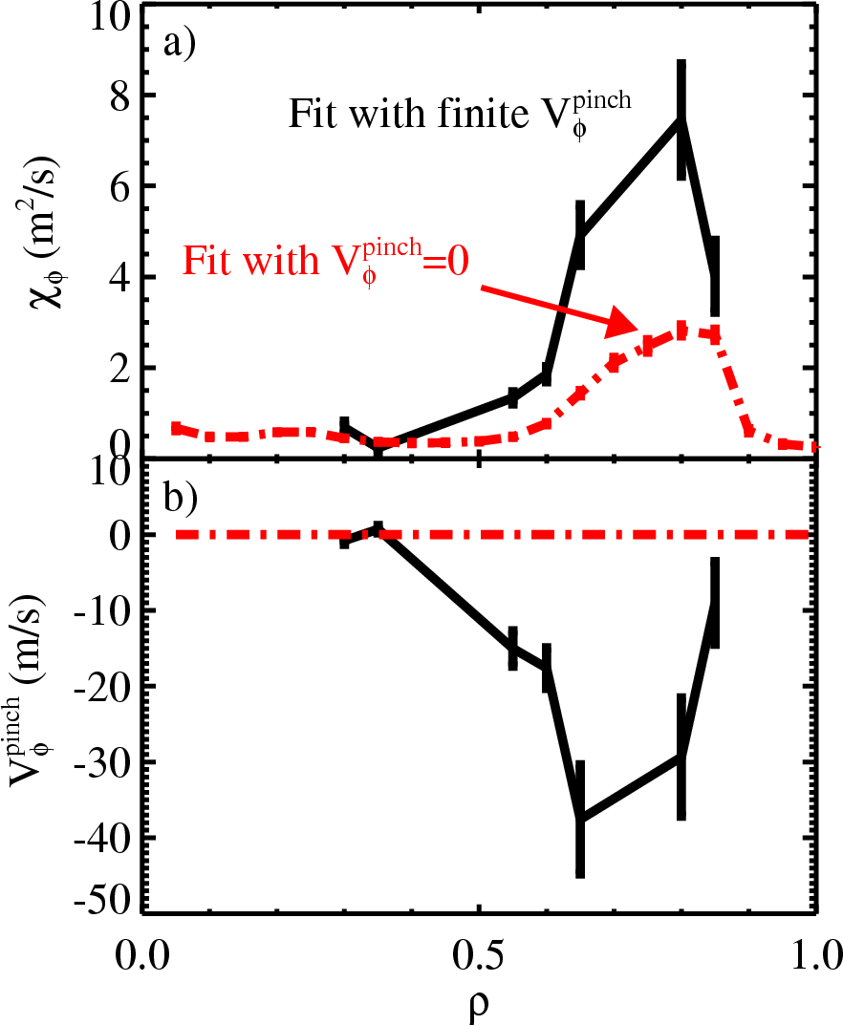
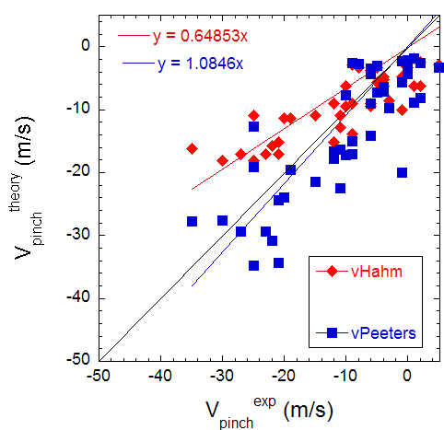
Figure 1 - a) Momentum diffusivity and (b) momentum pinch velocity inferred using n=3 non-resonant magnetic perturbations to the plasma. For comparison, the inferred diffusivity neglecting any momentum pinch is also shown (dashed).
Figure 2 - Comparison of the theoretically predicted momentum pinch velocities from Hahm vs Peeters et al to the experimentally determined quantity.
The present experiment will attempt to further test theory by examining the role of collisionality on the momentum pinch, which is expected to be a sensitive parameter affecting the pinch.

3. Experimental run plan
The key requirement for success of this XP is to obtain reproducible long MHD quiescent phases of the discharge. We had reasonable success at achieving this in XP 813, using Li evaporation, coupled with optimal EF correction and n=1 mode control, whereas previous attempts were much more problematic. As such, this experiment requires Li evaporation and static and dynamic control. The baseline discharge will be comparable to #129922.
Once a suitable reference discharge is re-established in the absence of n=3 braking, we can proceed with the main part of the experiment. Since we wish to isolate the role of collisionality on the momentum pinch velocity, we obviously need to perform a collisionality scan. Results from Kaye et al IAEA 2006 showed that this can effectively be achieved on NSTX by varying Ip/Bt at fixed q, so this experiment will follow this technique.
A secondary goal of the experiment is to investigate the relationship between the momentum and particle pinch velocities. Therefore, in addition to the collisionality scan, we will use Ne puffing (and/or use the supersonic gas injectors) to perturb the edge density and watch the inflow of density up the density gradient to infer the core particle pinch. Use of the SGI will require close spacing of the MPTs lasers after the gas perturbation to assess the change in density profile and infer the particle diffusivity and pinch. If the discharge is sufficiently MHD quiescent, we may attempt to economize the number of shots by doing the Ne (or SGI) puffing as part of a second perturbation in the same discharge with n=3 braking. However, if we do this, we must be wary of the fact that the plasma conditions at the second pulse may have evolved.
If time permits, we will try repeating the measurements in L-mode (both to extend the collisionality variation, as well as changing the underlying low-k turbulence properties of the plasma). Repeating the collisionality scan at a different q is another option to explore if things work well (q is the next most sensitive parameter affecting the momentum pinch). Performing this in L-mode will allow use of the UCLA reflectometer system to infer particle diffusivity and pinch.

- Reproduce #129922 (no n=3 braking), Bt=0.55 T, Ip=1.1 MA 1 shots
  - Repeat with n=3 braking (two pulses of 50 ms duration @ t=350 ms and 550 ms, with ~1000 A in the coils 2 shots
# shots: 3 + 4 contingency

Decision: If unsuccessful at producing suitable MHD quiescent discharge, reevaluate and consider deferring. If plasma is very quiescent and second pulse is robustly usable, consider combining steps #2 and #3 together, with the density perturbations made during the second nRMP pulse.
- Complete 3-point “collisionality” scan by varying Bt, Ip at fixed q (4+2 shots)
  - (Bt, Ip) = (0.45, 0.9) 2 shots
  - (Bt, Ip) = (0.35, 0.7) 2 shots
# shots: 4 + 2 contingency
Decision: If lowest Bt produces MHD, try (0.4, 0.8), or skip
- Repeat 3-point collisionality scan, using edge density perturbations + NRMP
# shots: 6 + 4 contingency
- Repeat 3-point collisionality scan with edge density perturbation but without nRMP (compare edge particle transport with/without NRMP) – do not take repeat discharges.
# shots: 3 + 1 contingency
Decision: Adjust dt of MPTS to optimize for SNR if necessary.
Establish suitable quiescent L-mode target 1 shots
  - Perform 3-point collisionality scan (same Ip/Bt combinations) 6 shots
# shots: 7 + 5 contingency

TOTAL: Approx 23 good shots
If we are so fortunate that we get through the run plan with time to spare, then we can also add in a q-scan, which is another sensitive parameter expected to affect the momentum pinch velocity.

4. Required machine, NBI, RF, CHI and diagnostic capabilities
Shot development may be needed to attain MHD quiescent H-mode depending on conditions (nominally want to repeat #129922) and (especially) L-mode conditions.
Use of SGI dependent on results of testing method for such in early Boundary Physics XP. Will require closely spaced MPTs laser pulses (Δt~4 ms, tweak as necessary) after SGI pulse. High time resolution profile reflectometry (1 ms) is also requested for particle pinch. Soft X-ray data for the particle pinch is also required with Ne puff.

5. Planned analysis
This data will be analyzed using EFIT/LRDFIT, with follow up analysis in TRANSP for computation of the torque sources and transport quantities. The TRANSP output will be processed using codes developed in XP 723/813 to extract perturbed diffusivity and pinch velocities. Similar analysis will be utilized for the particle pinch velocity, and/or following analysis of Delgado-Aparicio et al.

6. Planned publication of results
The data obtained from this XP will be required to write a more extensive paper (eg PoP) continuing from our PRL and IAEA/NF papers in 2008, and contribute to possible APS invited.
PHYSICS OPERATIONS REQUEST
TITLE: Dependence of momentum and particle pinch on collisionality | No. OP-XP-908
AUTHORS: Wayne Solomon | DATE: 4/8/09
Machine conditions (specify ranges as appropriate)
I_{TF} (kA): 41 – 64 (3.5 – 5.5 kG) Flattop start/stop (s):
I_{P} (MA): 0.7 – 1.1 Flattop start/stop (s):
Configuration: LSN
Outer gap (m): Inner gap (m):
Elongation κ: 2.3 Upper/lower triangularity δ: 0.8
Z position (m): 0
Gas Species: D, Ne Injector(s): SGI + conventional
NBI Species: D Sources: 3 Voltage (kV): 80, 90 Duration (s): full shot
ICRF Power (MW): 0 Phasing: Duration (s):
CHI: Off Bank capacitance (mF):
LITER: ON 15 mg/min
Either: List previous shot numbers for setup: 129922 (use EF correction and n=1 feedback)
Or: Sketch the desired time profiles, including inner and outer gaps, κ, δ, heating, fueling, etc. as appropriate. Accurately label the sketch with times and values.
350 400 550 600
nRMP / Ne-puff / SGI
MPTS timing
Time 400 404
Laser # 1 2

DIAGNOSTIC CHECKLIST
TITLE: Dependence of momentum and particle pinch on collisionality | No. OP-XP-908
- AUTHORS: W.M. Solomon, S.M. Kaye, L.F. Delgado-Aparicio, V. Soukhanovskii, … | DATE: 4/8/09

Note special diagnostic requirements in Sec. 4
Diagnostic | Need | Want
Bolometer – tangential array | √
Bolometer – divertor |  | √
CHERS – toroidal | √
CHERS – poloidal | √
Divertor fast camera
Dust detector
EBW radiometers
Edge deposition monitors
Edge neutral density diag. |  | √
Edge pressure gauges |  | √
Edge rotation diagnostic | √
Fast ion D_alpha - FIDA | √
Fast lost ion probes - IFLIP |  | √
Fast lost ion probes - SFLIP |  | √
Filterscopes | √
FIReTIP |  | √
Gas puff imaging |  | √
Hα camera - 1D |  | √
High-k scattering |  | √
Infrared cameras
Interferometer - 1 mm |  | √
Langmuir probes – divertor
Langmuir probes – BEaP
Langmuir probes – RF ant.
Magnetics – Diamagnetism | √
Magnetics – Flux loops | √
Magnetics – Locked modes | √
Magnetics – Pickup coils | √
Magnetics – Rogowski coils | √
Magnetics – Halo currents | √
Magnetics – RWM sensors | √
Mirnov coils – high f. | √
Mirnov coils – poloidal array | √
Mirnov coils – toroidal array | √
Mirnov coils – 3-axis proto.

Note special diagnostic requirements in Sec. 4
Diagnostic | Need | Want
MSE | √
NPA – ExB scanning
NPA – solid state |  | √
Neutron measurements | √
Plasma TV |  | √
Reciprocating probe
Reflectometer – 65GHz |  | √
Reflectometer – correlation
Reflectometer – FM/CW | √
Reflectometer – fixed f |  | √
Reflectometer – SOL
RF edge probes
Spectrometer – SPRED | √
Spectrometer – VIPS | √
SWIFT – 2D flow
Thomson scattering | √
Ultrasoft X-ray arrays | √
Ultrasoft X-rays – bicolor | √
Ultrasoft X-rays – TG spectr. |  | √
Visible bremsstrahlung det. |  | √
X-ray crystal spectrom. - H |  | √
X-ray crystal spectrom. - V |  | √
X-ray fast pinhole camera
X-ray spectrometer - XEUS |  | √

