Princeton Plasma Physics Laboratory
NSTX Experimental Proposal
Title: Beta Scaling of Confinement in Weakly Shaped Plasmas
OP-XP-910 | Revision: | Effective Date:  (Approval date unless otherwise stipulated)  Expiration Date:  (2 yrs. unless otherwise stipulated)
PROPOSAL APPROVALS
Responsible Author: S. Kaye |  |  | Date 4/7/09
ATI – ET Group Leader: K. Tritz |  |  | Date
RLM - Run Coordinator: R. Raman |  |  | Date
Responsible Division: Experimental Research Operations
Chit Review Board (designated by Run Coordinator)

MINOR MODIFICATIONS (Approved by Experimental Research Operations)

NSTX EXPERIMENTAL PROPOSAL
TITLE: Beta Scaling of Confinement in Weakly Shaped Plasmas | No. OP-XP-910
AUTHORS: S. Kaye | DATE: 4/7/09

1. Overview of planned experiment
This XP follows up on last year’s confinement scaling XP in which the degradation of energy confinement with beta was found to be negligible. That scan was done in a strongly shaped plasma (κ~2.1, δ~0.8). This result supported results found in other strongly shaped tokamak devices, while experiments in more weakly shaped plasmas indicated a strong degradation of confinement with beta. This XP will address the shape issue by redoing the power scan but in an ITER-shaped plasma, and using Li to suppress ELMs.

2. Theoretical/ empirical justification
The results from last year’s XP showed very little degradation of confinement with beta. This conclusion was obtained from a scan in which B_{T}, I_{p} and line-averaged density were the same, and in which the beam power was varied from one to three sources. Over this beam power range, the effective collisionality and electron gyroradius were constant to within 20%, while beta varied by a factor of 2.5 to 3. The results are shown below.

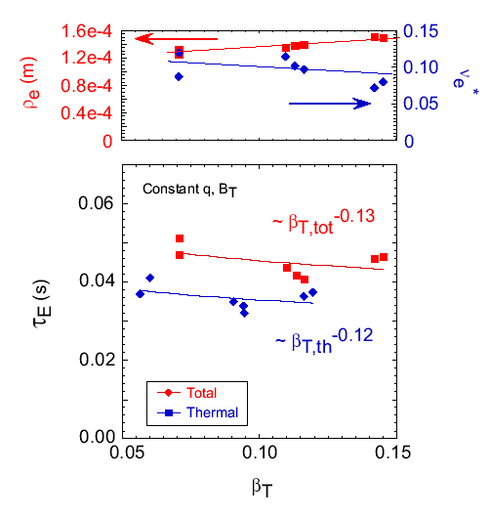
These results supported the lack of beta scaling on other devices (DIII-D and JET) with strongly shaped plasmas, but differed from those on AUG and JT60-U, which showed a strong degradation of confinement with beta. In these latter two experiments, the plasma shaping was weaker. It has been hypothesized that the difference in the beta degradation results is due to the differences in plasma shaping. NSTX will test this hypothesis by redoing the beta scan in an ITER-shaped plasma with κ~1.7 and δ~0.4

3. Experimental run plan
Redo beta scan with κ~1.7 and δ~0.45. Shot 127301, developed for the small ELM experiment, but with B_{T} increased to 5.5 T will be used as a baseline. In addition, 15-20 mg/min of Li injection will be used to suppress large ELMs. This is a ½ day experiment, and the shot list is given below.

Case | Power
Low-β | Source A
Med-β | Source A,B
High-β | All sources
If there is time, the medium β case will be rerun with sources A&C. Two shots per condition will be taken, with 2 to 3 setup shots anticipated.
If the high-β case disrupts with all three sources, the voltage on source C will be lowered. Start off with full energy on each beam, but then might have to lower voltage to get wide enough range in beta without hitting beta limit. Will also consider modulating beam instead of, or in addition to, lowering voltage.

4. Required machine, NBI, RF, CHI and diagnostic capabilities
Optimum EF, low-n mode stabilization feedback on.

5. Planned analysis
EFIT, TRANSP, etc.

6. Planned publication of results
APS, journal article, ITPA
PHYSICS OPERATIONS REQUEST
TITLE: Beta Scaling of Confinement in Weakly Shaped Plasmas | No. OP-XP-910
AUTHORS: S. Kaye | DATE: 4/7/09

Describe briefly the most important plasma conditions required for the XP:
Quiescent, ELM-free discharges that are capable of attaining high-betan at the highest beam power.

List any pre-existing shots: 127301

Equilibrium Control: Gap Control / rtEFIT(isoflux control):
Machine conditions (specify ranges as appropriate, use more than one sheet if necessary)
I_{TF} (kA): 66 kA (0.55 T) Flattop start/stop (s):
I_{P} (MA): 0.8 MA Flattop start/stop (s):
Configuration: LSN
Outer gap (m): Inner gap (m): Z position (m):
Elongation κ: 1.7 Upper/lower triangularity δ: 0.45 (lower)
Gas Species: D Injector(s):
NBI Species: D Voltages (kV or off) A: max B: max C: max Duration (s): ~1 s
ICRF Power (MW): 0 Phasing: Duration (s):
CHI: Off Bank capacitance (mF):
LITERs: On Total deposition rate (mg/min): ~15
EFC coils: On Configuration: Other (optimal EF correction with low-n feedback)
DIAGNOSTIC CHECKLIST
TITLE: Beta Scaling of Confinement in Weakly Shaped Plasmas | No. OP-XP-910
AUTHORS: S. Kaye | DATE: 4/7/09

Note special diagnostic requirements in Sec. 4
Diagnostic | Need | Want
Bolometer – tangential array | √
Bolometer – divertor
CHERS – toroidal | √
CHERS – poloidal |  | √
Divertor fast camera
Dust detector
EBW radiometers
Edge deposition monitors
Edge neutral density diag.
Edge pressure gauges
Edge rotation diagnostic
Fast ion D_alpha - FIDA |  | √
Fast lost ion probes - IFLIP
Fast lost ion probes - SFLIP
Filterscopes | √
FIReTIP
Gas puff imaging
Hα camera - 1D
High-k scattering |  | √
Infrared cameras
Interferometer - 1 mm
Langmuir probes – divertor
Langmuir probes – BEaP
Langmuir probes – RF ant.
Magnetics – Diamagnetism | √
Magnetics – Flux loops | √
Magnetics – Locked modes | √
Magnetics – Pickup coils | √
Magnetics – Rogowski coils | √
Magnetics – Halo currents
Magnetics – RWM sensors | √
Mirnov coils – high f.
Mirnov coils – poloidal array
Mirnov coils – toroidal array
Mirnov coils – 3-axis proto.

Note special diagnostic requirements in Sec. 4
Diagnostic | Need | Want
MSE | √
NPA – ExB scanning
NPA – solid state
Neutron measurements | √
Plasma TV |  | √
Reciprocating probe
Reflectometer – 65GHz
Reflectometer – correlation
Reflectometer – FM/CW
Reflectometer – fixed f
Reflectometer – SOL
RF edge probes
Spectrometer – SPRED |  | √
Spectrometer – VIPS
SWIFT – 2D flow
Thomson scattering | √
Ultrasoft X-ray arrays |  | √
Ultrasoft X-rays – bicolor
Ultrasoft X-rays – TG spectr.
Visible bremsstrahlung det.
X-ray crystal spectrom. - H
X-ray crystal spectrom. - V
X-ray fast pinhole camera
X-ray spectrometer - XEUS

