Princeton Plasma Physics Laboratory
NSTX Experimental Proposal
Title: Li pumping and retention in NSTX neutral beam heated plasmas.
OP-XP-911 | Revision: | Effective Date:  (Approval date unless otherwise stipulated)  Expiration Date:  (2 yrs. unless otherwise stipulated)
PROPOSAL APPROVALS
Responsible Author: C. H. Skinner, et al |  |  | Date 2/23/09
ATI – ET Group Leader: Vlad Soukhanovskii |  |  | Date
RLM - Run Coordinator: Roger Raman |  |  | Date
Responsible Division: Experimental Research Operations
Chit Review Board (designated by Run Coordinator)

MINOR MODIFICATIONS (Approved by Experimental Research Operations)

NSTX EXPERIMENTAL PROPOSAL
TITLE: Li pumping and retention in NSTX neutral beam heated plasmas. | No. OP-XP-911
AUTHORS: C. H. Skinner, H Kugel, L Roquemore,  R. Maingi, V. Soukhanovskii, W. Blanchard, J.P. Allain, C. Taylor | DATE: 2/23/09

1. Overview of planned experiment
Briefly describe the scientific goals of the experiment.
- Measure the fraction of the injected deuterium that is retained in the NSTX vessel after neutral beam heated plasmas. The measurement will compare the dynamic pressure rise in the vessel after NB heated plasmas with the pressure rise in the vessel in a gas-only shot. The XP will be run before-Li and with-Li to compare retention in PFCs uncoated and coated with fresh (active) lithium. Results will be compared to XP824 on ohmic/RF plasmas run separately.
- Obtain ‘physics-based’ retention fraction (D flux/D retained ) via Langmuir probe estimates of the D flux to the divertor.
- Address the fundamental processes governing retention via prompt surface analysis of ATJ graphite, Pd, and Si samples exposed to these plasmas on the Bay J sample probe. The samples will be analysed by ex-vessel TDS and at Purdue U.

2. Theoretical/ empirical justification
Brief justification of activity, including supporting calculations as appropriate. Describe briefly any previous or related experiments.
XP911 is part of the Joint US tokamak FY 2009 milestone on pumping and retention. It is also important for the NSTX lithium program which aims at density control using lithium pellet injection and lithium evaporation to reduce recycling of hydrogenic species. In 2008 we obtained preliminary data (XP824) on static retention (D pressure rise) in ohmic plasmas before and with-Li. We plan to repeat XP824 in 2009 using the new Bay J sample probe, Langmuir probe data, D-alpha array data, new high accuracy baratron, and improved RGA data. A companion XMP is aimed at measuring (i) the baseline leak/outgassing rate, (ii) pressure gauge/RGA calibrations and (iii) the pumping speed of the NB cryopumps to known gas-only pulses.
This XP911 is focussed on dynamic retention measurement of NB heated plasmas and will be run in a total of three ½ day parts: ½ Friday before Li injection, ½ Tuesday after sample probe is installed before Li, and ½ Friday after Li injection. The Friday XPs will allow the measurement of outgassing through Saturday PM. The XP will provide well defined plasma exposure of the new sample probe. This XP will also compare dynamic and static measurements of ohmic retention to identify and evaluate systematic errors in the dynamic measurements. Some prior discharge development is required.

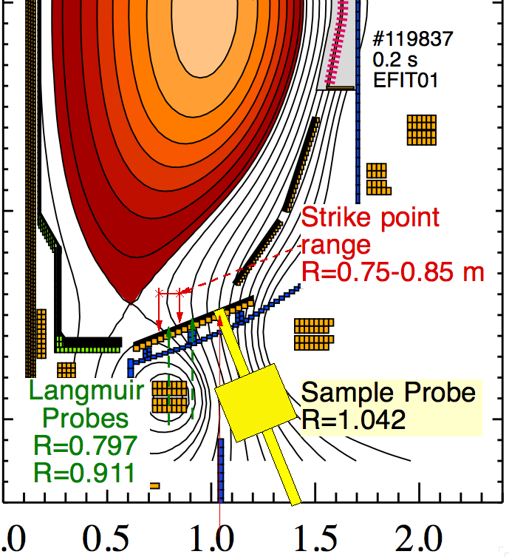
3. Experimental run plan
Describe experiment in detail, including decision points and processes.
Anticipate ½ day ~ 10 shots Friday afternoon and outgassing measurements through Saturday plus ½ day after the maintenance break for sample probe exposure (after sample probe installation) but before any introduction of lithium. A third ½ day will measure retention with two LiTERs operating.
A. Discharge Development prior to running XP and before Lithium
- NBI Fiducials 000001, 000002. Discharge development aimed at 1 and 2 NB sources modelled on 119827, long pulse, H-mode, no minor disruptions on rampdown, low triangularity, strike point as close as possible to sample probe, strike point scan over Langmuir probes. NB cryopump operating normally. GDC @ discretion of operators.
- Ohmic Fiducial 000000 (derived from 119827 with lower Ip, with reference to 128957 from 2May08 pre-Li is high triangularity LSN)
Optimize: no minor disruptions on rampdown, low triangularity, strike point as close as possible to sample probe, strike point sweep over Langmuir probes. NB cryopump operating normally.
B. First ½ day: Compare static and dynamic gas balance measurements.
- Gas-only shot all valves closed (e.g. 129708 from 5Jun08 5-puffs)
- Ohmic shot all valves closed 000000.
- Gas only shot NB TIV open (but no NB injection) same gas pulse as 000002
- Repeat gas only shot NB TIV open (but no NB injection) with more gas to check no gas-only retention.
- Ohmic shot NB TIV open (but no NB injection) 000000
C. Dynamic retention measurements,
- 1 source NB long pulse H-mode discharge #000001 but with 1 NB source. Close NB TIV ~ 10 sec after discharge to measure outgassing for ~ 5 mins after shot. Repeat 3 times to optimize discharge
- 2 source NB long pulse H-mode discharge #000002. Close NB TIV ~ 10 sec after discharge to measure outgassing for ~ 5 mins after shot. Repeat 3 times to optimize discharge.
- Repeat 2 source NB long pulse H-mode. Close NB TIV ~ 10 sec after discharge to measure long term outgassing through Saturday 5:00 PM.
D. Second ½ day after sample probe installed: expose sample probe
- Controlled access to open sample probe TIV and raise sample probe into vessel
- Run step 9 above, accumulate 5 discharges on sample probe
- Withdraw sample probe, close sample probe TIV.
- Perform ex-vessel thermal desorption spectroscopy of one ATJ sample.
- Remove 2nd ATJ + Si and Pd samples under argon for shipment to Purdue
E. Third ½ day: Repeat above sequence (steps 8-15) with two LiTERs operating 10 mg/min . Simultaneously expose sample probe and measure retention and Saturday outgassing as in steps 8-15.
GDC with LiTER ? Recommend operators review 5Jun08 experience with LiTER mg/min rate, GDC or no GDC and successful shot # 129723 to optimize density control.

4. Required machine, NBI, RF, CHI and diagnostic capabilities
Describe any prerequisite conditions, development, XPs or XMPs needed.
Attach completed Physics Operations Request and Diagnostic Checklist.
PREQUISITES:
- Measurement of (i) the baseline leak/outgassing rate, (ii) pressure gauge/RGA calibrations and (iii) the pumping response of the NB cryopumps to known gas-only pulses is needed before or after XP911.
- XP911 will follow XMP ?? to develop NBI and ohmic fiducials (p.3).
- Spectroscopic H/D should be < few% to avoid confusion with H retention.
- Set the IOC time for channel archiver by hand(~ 1 sec) to match the NTP.
- Check LiTER interlock removed from ig110 operation.
- Check ig110 set to ‘MV’
- Disarm PF, TF, IP supplies for gas-only shots.
- Sample probe is required for the sample probe part 2x ATJ, Pd, Si samples installed..
- LiTER is required for the with-Li part.
DIAGNOSTICS:
- New 0.1 torr baratron, IG1, IG3A and IG110 ionization gauges, 1 torr baratron,
- In-vessel micro ion gauges
- Trend and Shot RGA EM=-800 volts emission 0.1 mA on both RGAs. Trend RGA 30 ms dwell time 8 points / amu, (12 sec/scan). Trend RGA scans continuously. Trend data files should be saved on the PC. The fast RGA will be run in ‘calibration shot mode’ with calibration shot software from Dana M. Fast RGA ‘Scan’ will be OFF to improve time resolution from 12 s to 0.25 s. This will generate a series of data files with calibration shot numbers.
- VIPS2 to measure H/D ratio
- D-alpha array (Vlad) to estimate D flux to wall/divertor. Extend to R=0.9m if possible
- Divertor Langmuir probes (Kaita / Josh Kallman) (Whole tile probe ? Gerhardt)
- Scanning Langmuir probe (for Brooks modeling) .
- Quartz Microbalances
- IR camera to measure tile temperatures (important for comparing NB to ohmic results)
- Usual plasma diagnostics (see checklist p.6)

5. Planned analysis
What analysis of the data will be required: EFIT, TRANSP, etc.?
- Send exposed samples to Allain’s group at Purdue for surface analysis.
- Compare TDS spectra to IMPACT lab results from Purdue. Aim to identify Li/C/D bond energy and ‘fundamental processes governing particle balance’ (milestone language).
- Use mds scopes to calculate time dependent retention. NB pumping speed needed to track D on cryopanels
- Use idl codes gas_balance_new to calculate retention
- Plot retention vs. time (seconds) from mds downloaded data – get speed of outgassing.
- Use Bens code (IDL> ue,129709,times,netotin=netotin,netotou=netotou )
to calculate total electrons in plasma.
- Calculate D flux to divertor/wall from Langmuir probe data (Kallman).
- Calculate D flux to divertor/wall from D-alpha array (Vlad).
- Send data to Pigarov so he can use Wall PSI code to model the retention.
- Send data to Jeff Brooks so he can apply the REDEP code.
- Compare to results from DIII-D and C-mod.

6. Planned publication of results
What will be the final disposition of the results; where will results be published and when?
- Quarterly reports to DoE for Joule milestone.
- Preliminary presentation (including 2008 results) at Div/SOL ITPA mtg in Amsterdam 5-8 May 09 and 12th International Workshop on Plasma Facing Materials and Components for Fusion Applications Juelich on 11-14th May 2009.
PHYSICS OPERATIONS REQUEST
TITLE: Li pumping and retention in NSTX neutral beam heated plasmas. | No. OP-XP-911
AUTHORS: C. H. Skinner et al., | DATE: 2/23/09
Machine conditions to be developed…
(specify ranges as appropriate, use more than one sheet if necessary)
I_{TF} (kA): Flattop start/stop (s):
I_{P} (MA): Flattop start/stop (s):
Configuration: Limiter / DN / LSN / USN (strike out inapplicable cases)
Outer gap (m): Inner gap (m): Z position (m):
Elongation κ: Upper/lower triangularity δ:
Gas Species: Injector(s):
NBI Species: D Voltages (kV or off) A: B: C: Duration (s):
ICRF Power (MW): Phasing: Duration (s):
CHI: Off / On Bank capacitance (mF):
LITERs: Off / On Total deposition rate (mg/min):
EFC coils: Off/On Configuration: Odd / Even / Other (attach detailed sheet)
Either: List previous shot numbers for setup:
Or: Sketch the desired time profiles, including inner and outer gaps, κ, δ, heating, fuelling, etc. as appropriate. Accurately label the sketch with times and values.
DIAGNOSTIC CHECKLIST
TITLE: Li pumping and retention in NSTX neutral beam heated plasmas. | No. OP-XP-911
AUTHORS: C. H. Skinner et al., | DATE: 2/23/09

Note special diagnostic requirements in Sec. 4
Diagnostic | Need | Want
Bolometer – tangential array |  | √
Bolometer – divertor |  | √
CHERS – toroidal |  | √
CHERS – poloidal |  | √
Divertor fast camera |  | √
Dust detector |  | √
EBW radiometers |  | √
Edge deposition monitors |  | √
Edge neutral density diag. |  | √
Edge pressure gauges |  | √
Edge rotation diagnostic |  | √
Fast ion D_alpha - FIDA |  | √
Fast lost ion probes - IFLIP |  | √
Fast lost ion probes - SFLIP |  | √
Filterscopes |  | √
FIReTIP |  | √
Gas puff imaging
Hα camera - 1D | √
High-k scattering
Infrared cameras | √
Interferometer - 1 mm
Langmuir probes – divertor | √
Langmuir probes – BEaP
Langmuir probes – RF ant.
Magnetics – Diamagnetism
Magnetics – Flux loops | √
Magnetics – Locked modes
Magnetics – Pickup coils | √
Magnetics – Rogowski coils | √
Magnetics – Halo currents
Magnetics – RWM sensors
Mirnov coils – high f.
Mirnov coils – poloidal array
Mirnov coils – toroidal array
Mirnov coils – 3-axis proto.

Note special diagnostic requirements in Sec. 4
Diagnostic | Need | Want
MSE
NPA – E||B scanning
NPA – solid state
Neutron measurements
Plasma TV |  | √
Reciprocating probe | √
Reflectometer – 65GHz
Reflectometer – correlation
Reflectometer – FM/CW
Reflectometer – fixed f
Reflectometer – SOL
RF edge probes
Spectrometer – SPRED |  | √
Spectrometer – VIPS |  | √
SWIFT – 2D flow
Thomson scattering |  | √
Ultrasoft X-ray arrays
Ultrasoft X-rays – bicolor
Ultrasoft X-rays – TG spectr.
Visible bremsstrahlung det.
X-ray crystal spectrom. - H
X-ray crystal spectrom. - V
X-ray fast pinhole camera
X-ray spectrometer - XEUS |  | √

