Princeton Plasma Physics Laboratory
NSTX Experimental Proposal
Title: CHI use of absorber coils
OP-XP-927 | Revision: | Effective Date:  (Approval date unless otherwise stipulated)  Expiration Date:  (2 yrs. unless otherwise stipulated)
PROPOSAL APPROVALS
Responsible Author: Mueller |  |  | Date
ATI – ET Group Leader: Mueller/Raman |  |  | Date
RLM - Run Coordinator: Raman |  |  | Date
Responsible Division: Experimental Research Operations
Chit Review Board (designated by Run Coordinator)

MINOR MODIFICATIONS (Approved by Experimental Research Operations)

NSTX EXPERIMENTAL PROPOSAL
TITLE: CHI use of absorber coils | No. OP-XP-927
AUTHORS: Mueller | DATE: 3/24/2009

1. Overview of planned experiment
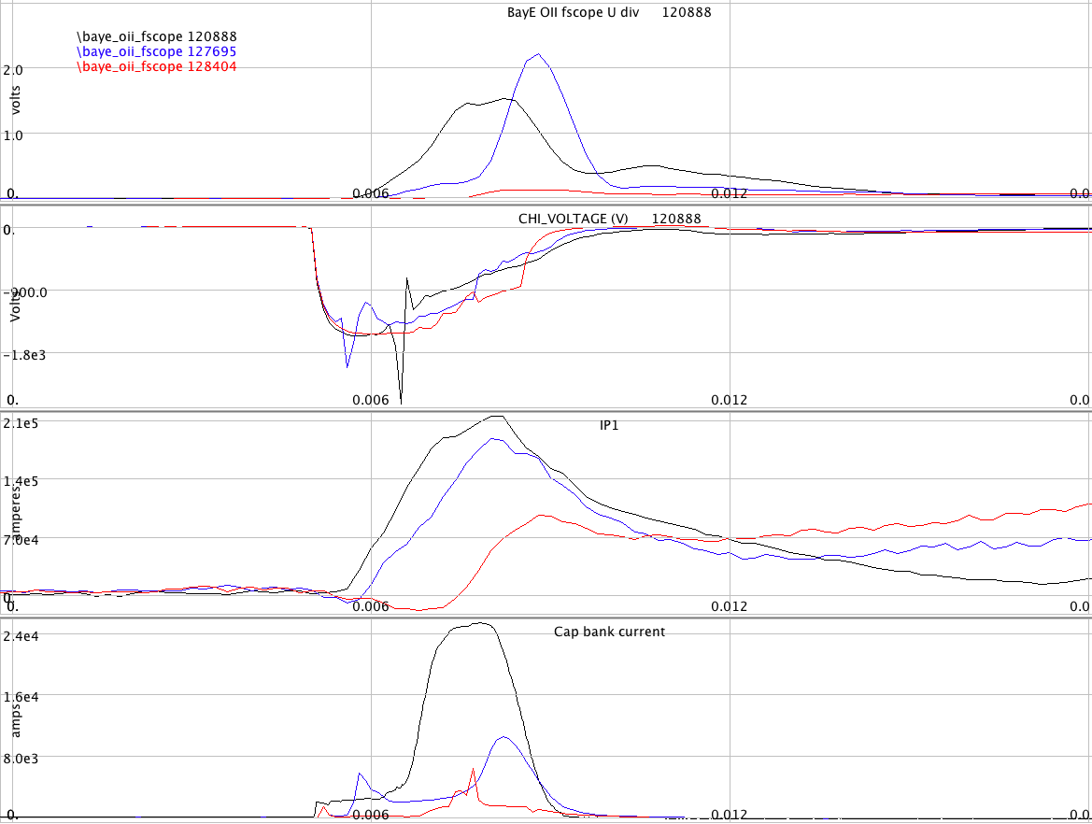
CHI experiments have suffered from absorber arcs at the top of NSTX. These arcs, while they do not result incomplete elimination of the desired injector current, do discharge the capacitor and rob voltage and current the injector, furthermore, the absorber arcs are a likely source of the low Z impurities seen in CHI initiated discharges. See Fig. 1. The SPAs will be used to power the two absorber coils in order to lower the poloidal field connecting the inner and outer vessel, thus raising the impedance to reduce the incidence of absorber arcs and/or reduce the current in such arcs.
Fig. 1 Capacitor bank current for a variety of CHI discharges.

Theoretical/ empirical justification
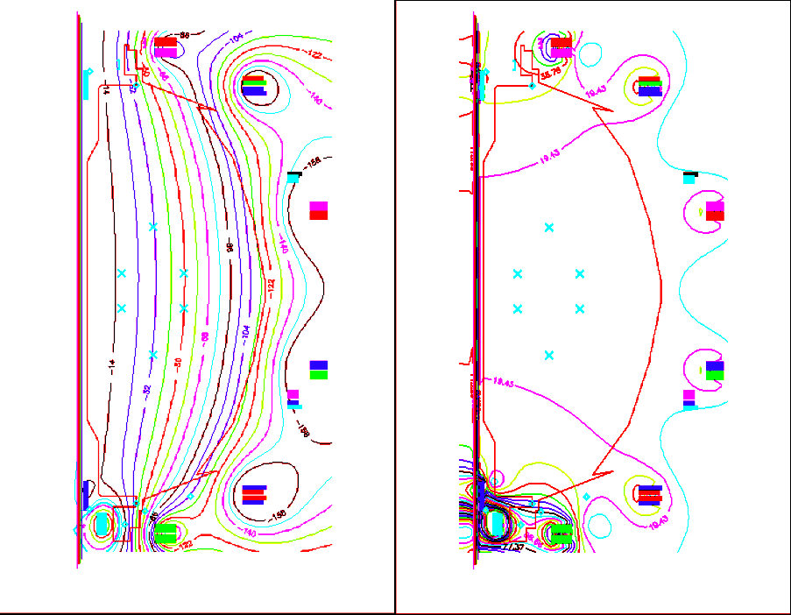
Fig. 2. Flux and ModB at 7.5 ms in 128401, a CHI initiated discharge.
The calculated modB and flux for CHI start-up is shown in Fig. 2. Fig. 3 shows the results with -600 and 600A in absorber coils PFAB1 and PFAB2. It is clear that the poloidal field in the absorber region shown in Fig. 3 is lower than for the case without the absorber coils energized. Because the geometry of the coils and of the absorber insulator is complex, it is not possible to completely eliminate poloidal fields connecting the two electrodes. Broadly speaking the location of the minimum in modB moves out with more negative PFAB1 and down with more positive PFAB2. Fig. 4 shows the results for FPAB1 = -800 A and PFAB2 = 600 A. Since the inner and outer vessel surfaces locations of closest approach is the region below the large vertical insulator, it is there that the field should be minimized. (-800, 600) is a good starting point.

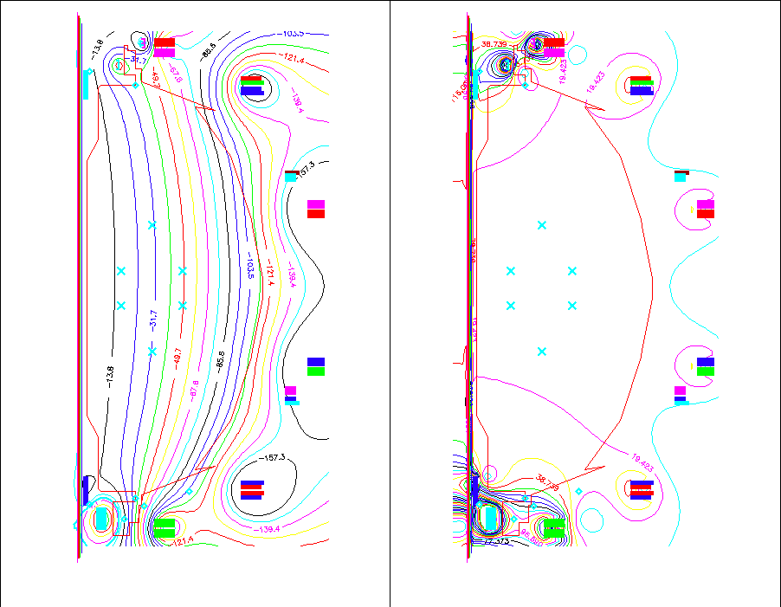

Fig. 3. Flux and ModB for 128401 with -600 A in PFAB1 and 600 A in PFAB2.

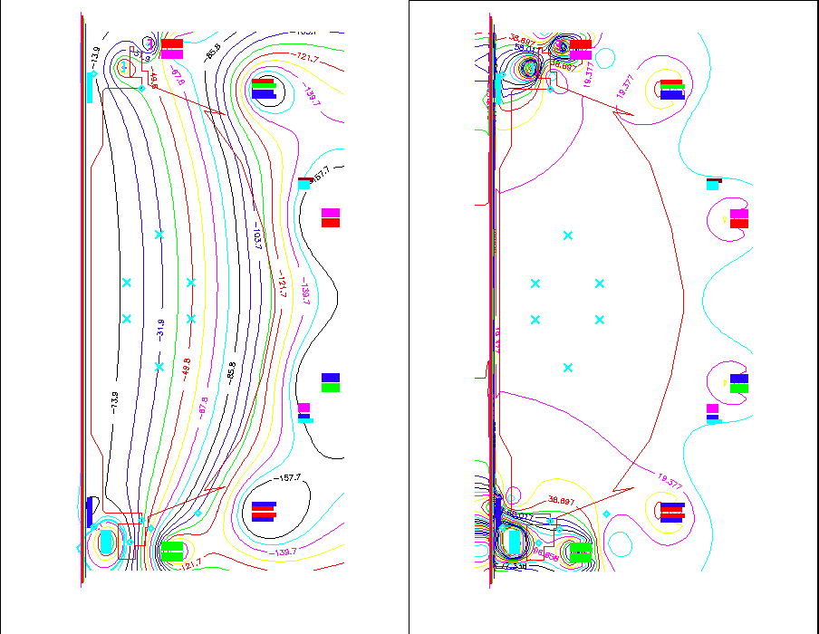

Fig. 4. Flux and ModB for 128401 with -800 A in PFAB1 and 600 A in PFAB2.

3. Experimental run plan
Start with the CHI setup for shot 128401 (or a more recent CHI discharge).
Examine the shot for signs of an absorber arc (sudden increase in CHI current, drop in CHI voltage, and low Z impurity influx from upper divertor)
Perform a shot-to shot scan in PFAB1 and PFAB2, select best estimate of PFAB1 and PFAB2 and make small variations about that.
SHOT | PFAB1 | PFAB2 | I CHI | UD Oii
 | 0 | 0
 | -800 | 600
 | -800 | 800
 | -600 | 600
 | -600 | 500
 | -600 | 700
 | -500 | 600

4. Required machine, NBI, RF, CHI and diagnostic capabilities
The Absorber coils must be connected to the SPAs and the ISTP for their use must be completed.
The usual conditions for CHI operation must be satisfied (Capacitor banks configured, V_{OH} < 6 kV, PF2U/L reversed, etc.).

5. Planned analysis
EFIT analysis

6. Planned publication of results
SOFE conference in June 2009 and other reports of CHI results on NSTX.
PHYSICS OPERATIONS REQUEST
TITLE: CHI use of absorber coils | No. OP-XP-927
AUTHORS: Mueller | DATE: 3/24/2009
(use additional sheets and attach waveform diagrams if necessary)
Describe briefly the most important plasma conditions required for the experiment:
CHI configuration with absorber coils connected to SPAs.
Previous shot(s) which can be repeated: 128401
Previous shot(s) which can be modified:
Machine conditions (specify ranges as appropriate, strike out inapplicable cases)
I_{TF} (kA): -58.5 Flattop start/stop (s): -0.020/0.5
I_{P} (MA): Flattop start/stop (s):
Configuration: LSN
Equilibrium Control: Outer gap / Isoflux (rtEFIT)
Outer gap (m): .01 Inner gap (m): .01 Z position (m): 0
Elongation κ: 2 Upper/lower triangularity δ: .4
Gas Species: D Injector(s): Lower Dome, inj 2
NBI Species: D Voltage (kV) A: 90 B: 90 C: 90 Duration (s): .5
ICRF Power (MW): 2 Phase between straps (°): Duration (s): .5
CHI: On Bank capacitance (mF): 5, 10, 15
LITERs: Off Total deposition rate (mg/min):
EFC coils: Off Configuration: Other SPAs connected to PFAB1 and PFAB2

DIAGNOSTIC CHECKLIST
TITLE: CHI use of absorber coils | No. OP-XP-927
AUTHORS: Mueller | DATE: 3/24/2009

Note special diagnostic requirements in Sec. 4
Diagnostic | Need | Want
Bolometer – tangential array |  | √
Bolometer – divertor | √
CHERS – toroidal
CHERS – poloidal
Divertor fast camera | √
Dust detector
EBW radiometers
Edge deposition monitors
Edge neutral density diag.
Edge pressure gauges | √
Edge rotation diagnostic
Fast ion D_alpha - FIDA
Fast lost ion probes - IFLIP
Fast lost ion probes - SFLIP
Filterscopes | √
FIReTIP
Gas puff imaging
Hα camera - 1D
High-k scattering
Infrared cameras
Interferometer - 1 mm
Langmuir probes – divertor
Langmuir probes – BEaP
Langmuir probes – RF ant.
Magnetics – Diamagnetism
Magnetics – Flux loops | √
Magnetics – Locked modes
Magnetics – Pickup coils | √
Magnetics – Rogowski coils | √
Magnetics – Halo currents
Magnetics – RWM sensors
Mirnov coils – high f.
Mirnov coils – poloidal array
Mirnov coils – toroidal array
Mirnov coils – 3-axis proto.

Note special diagnostic requirements in Sec. 4
Diagnostic | Need | Want
MSE
NPA – E||B scanning
NPA – solid state
Neutron measurements
Plasma TV | √
Reciprocating probe
Reflectometer – 65GHz
Reflectometer – correlation
Reflectometer – FM/CW
Reflectometer – fixed f
Reflectometer – SOL
RF edge probes
Spectrometer – SPRED
Spectrometer – VIPS
SWIFT – 2D flow
Thomson scattering | √
Ultrasoft X-ray arrays
Ultrasoft X-rays – bicolor
Ultrasoft X-rays – TG spectr.
Visible bremsstrahlung det. | √
X-ray crystal spectrom. - H
X-ray crystal spectrom. - V
X-ray fast pinhole camera
X-ray spectrometer - XEUS

