Princeton Plasma Physics Laboratory
NSTX Experimental Proposal
Title: Influence of Hot Ions on Resistive Wall Mode Stability
OP-XP-932 | Revision: 2.1 | Effective Date: 5/5/09  (Approval date unless otherwise stipulated)  Expiration Date:  (2 yrs. unless otherwise stipulated)
PROPOSAL APPROVALS
Responsible Author: J.W. Berkery, S.A. Sabbagh, H. Reimerdes |  |  | Date
ATI – ET Group Leader: |  |  | Date
RLM - Run Coordinator: |  |  | Date
Responsible Division: Experimental Research Operations
Chit Review Board (designated by Run Coordinator)

MINOR MODIFICATIONS (Approved by Experimental Research Operations)

NSTX EXPERIMENTAL PROPOSAL
TITLE: Influence of Hot Ions on Resistive Wall Mode Stability | No. OP-XP-932
AUTHORS: J.W. Berkery, S.A. Sabbagh, H. Reimerdes | DATE: 5/5/2009

1. Overview of planned experiment
The resistive wall mode (RWM) is thought to be stabilized by energy dissipation mechanisms that depend on plasma rotation and other parameters. Recently, a theory of kinetic resonances as passive RWM stabilization mechanisms has been explored. The kinetic theory includes trapped and circulating thermal ions, trapped electrons, Alfven resonances at the rational surfaces, and most recently, fast particles. Also, recently, JT-60U showed that energetic particle modes can act as triggers for resistive wall modes (see Figure 1). The proposed experiment is to determine the influence of hot ions on the kinetic stability of resistive wall modes by varying the hot ion fraction. Experimental results will be compared to calculations from the MISK code. A similar experiment is also being run in DIII-D this year.

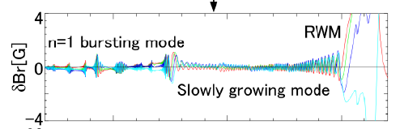

Figure 1: JT-60U results, showing an energetic particle mode triggering the resistive wall mode.

(From Matsunaga, et al., IAEA 2009).

2. Theoretical/ empirical justification
The Modification to Ideal Stability by Kinetic effects (MISK) code calculates the contributions to the kinetic δW. In conjunction with PEST, which calculates the fluid and vacuum components, the RWM growth rate may be determined. The following equation shows the dependencies of the kinetic δW for thermal particles:
where ν_{eff} is the effective ion collisionality, and ω_{E} is the E×B frequency, which is directly related to the rotation frequency. We can immediately see that the plasma rotation enters the stability calculation in a somewhat complicated manner.
For energetic particles the calculation is different, since they have a different distribution. We use a slowing-down distribution function, and the result is the following dependence.

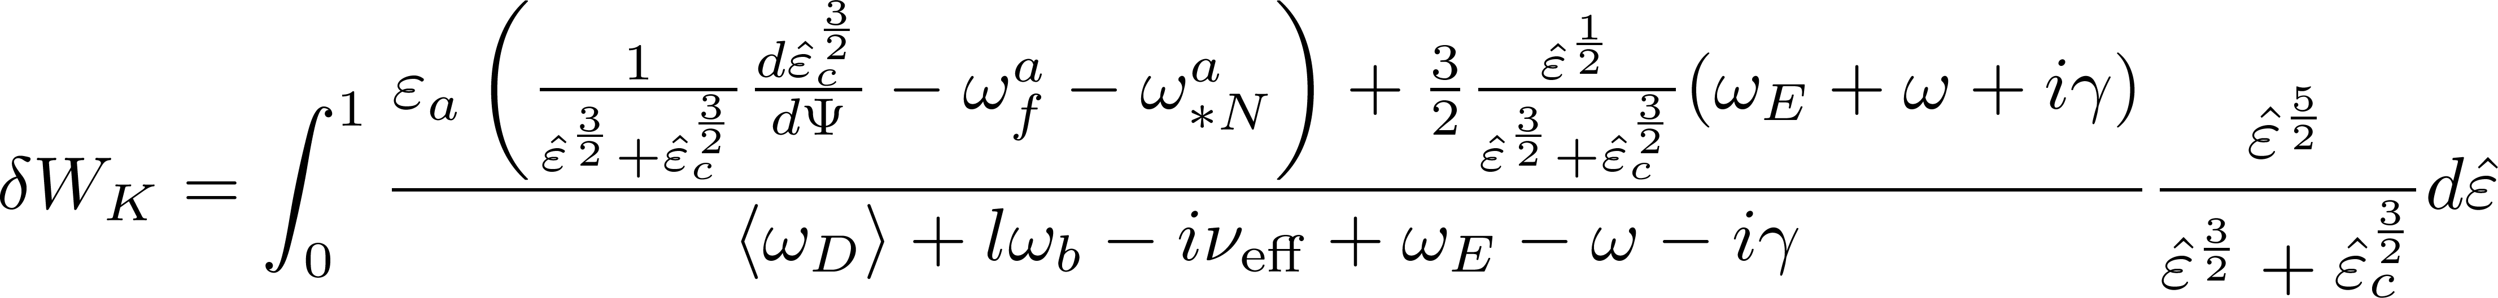

Although this expression is somewhat more complicated, we can see that many of the same frequency resonances are present, such as the resonances with precession and bounce frequencies.
Figure 2 shows a stability diagram for NSTX shot 121083 @ 0.475s, just before the RWM was observed to experimentally go unstable. The solid line and markers are for the calculation without including hot ions. Values of the imaginary vs. the real components of δW_{K} are plotted for various levels of rotation, scaled from the experimental rotation profile. The value at “1.0” is quite close to the predicted marginal stability point (zero growth rate), in agreement with experimental observation. When hot ions are added to the calculation, the prediction is that the RWM is more stable over every rotation profile tested. Although this prediction is farther from the experimental observation, it makes the important effect of hot ions clear. Theoretically, hot ions tend to add to the real part of the δW_{K}, increasing stability. Since the effect is significant, decreasing the hot ion fraction in experiments should lead to an observable change in the stability of the plasma.

Figure 2: Stability diagram for NSTX shot 121083 @ 0.475s. The markers are for calculations with the plasma rotation profile scaled as indicated. The solid line and markers are without hot ions, while the dashed line and open markers are with hot ions.

Figure 3: Core fast ion density vs. time for multiple shots with varying plasma current and magnetic field, as calculated by TRANSP.

There are three main methods we can use to control the hot ion fraction. First, the hot ion density has been seen to correlate with the toroidal magnetic field. Figure 3 shows the core hot ion density, calculated by TRANSP, vs. time for seven shots from XP619 (Sontag, 2006). These shots span a variety of plasma
currents and toroidal fields. A correlation between field and hot ion density can be seen, with the difference between the minimum and maximum being about a factor of three. Changing the field (at constant q) will be the main control over hot ion fraction in this experiment.
The second method of controlling the fast ion density is through the beam voltages. In XP840 (Stutman, 2008), beam source B was changed between two shots from 80kV to 70kV (which does change the neutral beam injected power slightly). TRANSP analysis shows that this change resulted in a ~20% reduction in fast particle density (Fig. 4, after 0.45s). In the same XP there was also a pair of shots in which the same total beam power was maintained, while the beam voltages were changed from 95kV on B to 65kV each on B and C (Fig. 5). In this case, the core fast particle density also dropped about 20%.
The third way to control hot ion fraction is through the slowing down time. The fast ion slowing down time is inversely dependent on the plasma density. By increasing the density, the slowing down time is decreased and therefore the hot ion fraction is decreased. This control will be principally employed in a similar experiment this year on DIII-D. In NSTX we can employ lithium to change the plasma density profile. So far, TRANSP analysis does not show a large effect of lithium on the hot ion profile. Similarly, the FIDA diagnostic failed to see a large effect of lithium on fast ion profiles from shots this year. Also, XP905 (Darrow, 2009) recently attempted to change the plasma density from shot to shot by changing the gas injection, but was unsuccessful. This strategy will therefore be reserved as an additional possible method of control over the hot ion fraction in this experiment, if further run time is allocated and more analysis, or shot development, is performed that shows the promise of this method.

Figure 4: Core fast ion density vs. time for two shots from XP840, which have different source B beam voltages starting at 0.45s, as calculated by TRANSP.

Figure 5: Core fast ion density vs. time for two shots from XP840, which have different beam voltages at the same total beam power, as calculated by TRANSP.

3. Experimental run plan

Task Number of Shots

- Establish target
A) Start lithium deposition
B) Use 130232 as setup shot (relatively high elongation ~ 2.3 to avoid rotating
modes, I_{p} = 0.9 MA, B_{t} = 0.45T), start n=3 correcting field at 0.250 s, ramping
to full amplitude at 0.300 s. Use 90kV on sources A, B, and C, and change
timing on C if necessary. 3

2) Vary the n=3 DC field timing and magnitude
A) Correct n=1 error field using feedback system, B_{p} sensor filter time = 100 ms. 3
B) During the period devoid of n=1 rotating mode activity, vary the n=3 DC field
from correcting phase to braking phase, and vary the SPA current ramp rate and
timing to optimally change plasma rotation, to find the marginal point. 6

3) Vary the plasma current and toroidal field to change the fast particle density
Repeat the above procedure for the next two conditions, still with lithium.
Condition | I_{p} (MA) | B_{t} (T) | Shots
1 | 0.9 | 0.45 | (already done above)
2 | 0.7 | 0.35 | 6
3 | 1.1 | 0.55 | 6

If the conditions can be completed quickly, we could add two more: I_{p} = 0.8 MA, B_{t} = 0.40T,
and I_{p} = 1.0 MA, B_{t} = 0.50T, or we could move on to step four.

4) Vary the neutral beam voltage for one of the above conditions
A) Choose the above current/field condition that is working best and change the
beam voltages at constant power. First, using either source B or C only changes
the deposition profile. Then reducing the voltage on both B and C changes the
fast ion density. 3
B) Reduce source C from 90kV to 80kV, 70kV and 60kV
(This will change the total beam power). 3

Beam A (kV) | Beam B (kV) | Beam C (kV) | Beam Power (MW) | Shots
90 | 95 | 0 | 4 | 1
90 | 0 | 95 | 4 | 1
90 | 65 | 65 | 4 | 1
90 | 90 | 90 | 6 | (already done above)
90 | 90 | 80 | ? | 1
90 | 90 | 70 | ? | 1
90 | 90 | 60 | ? | 1

__________________________________________________________________________________
Total: 30

4. Required machine, NBI, RF, CHI and diagnostic capabilities
See attached Physics Operations Request and Diagnostic Checklist.
The FIDA diagnostic will be used to monitor the fast ion population for each shot. Unfortunately, FIDA requires a low plasma density (<5x10¹⁹ m⁻³) in order to achieve good signal to noise. This means that we will probably only be able to get measurements with low error bars for the edge fast ion population. However, we will use this information to determine whether we are making a difference in hot ion fraction from shot to shot. Mario Podesta has provided a comparison of the shots shown in Fig. 5. The results, shown in Fig. 6, although in arbitrary units, show a large effect of beam voltage on the fast ion distribution.

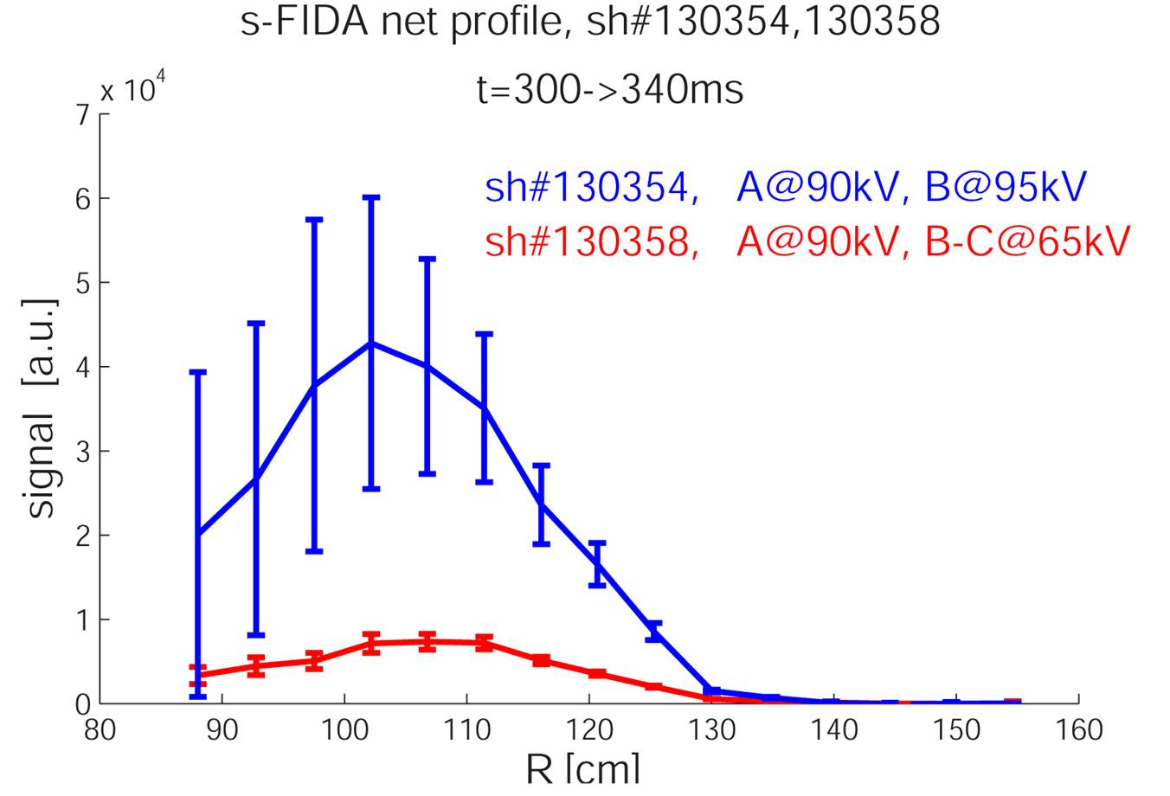
Figure 6: FIDA analysis for two shots from XP840, which have different beam voltages at the same total beam power.

5. Planned analysis

Equilibrium reconstructions will be performed with EFIT, with MSE and the flux iso-surface constraint, for reduced error on the q profile. These equilibria will then be analyzed with PEST to obtain the fluid stabilization and MISK to obtain the kinetic stabilization.

6. Planned publication of results
This experiment is a critical step towards reaching the FY09 milestone on understanding RWM stabilization physics as a function of plasma rotation, and delves into the role of fast ions for the first time. If results and subsequent comparison to theory yields a significant new understanding of RWM kinetic stabilization, the results will be suitable for publication in Physical Review Letters. Results that are not at the level of novelty for a PRL publication will be sent to Physics of Plasmas. Any clear conclusions from this experiment are expected to be presented at the APS conference in Atlanta, November 2009.
PHYSICS OPERATIONS REQUEST
TITLE: Influence of Hot Ions on Resistive Wall Mode Stability | No. OP-XP-932
AUTHORS: J.W. Berkery, S.A. Sabbagh, H. Reimerdes | DATE: 5/52009

Describe briefly the most important plasma conditions required for the XP:

High beta plasma with a long MHD free phase. Will be changing plasma current and field, RWM coils currents and timing, and beam voltages.

List any pre-existing shots: 132723 (I_{p} = 1.1 MA, B_{t} = -0.55 T)

Equilibrium Control: Gap Control / rtEFIT(isoflux control):
Machine conditions (specify ranges as appropriate, use more than one sheet if necessary)
I_{TF} (kA): 0.3 – 0.55 T Flattop start/stop (s):
I_{P} (MA): 0.6 – 1.1 MA Flattop start/stop (s):
Configuration: Limiter / DN / LSN / USN (strike out inapplicable cases)
Outer gap (m): 0.06 – 0.10 Inner gap (m): 0.04 Z position (m):
Elongation κ: 2.1 – 2.5 Upper/lower triangularity δ: 0.45 – 0.75
Gas Species: D Injector(s):
NBI Species: D Voltages (kV or off) A: 90 B: 60-100 C: 60-100 Duration (s):
ICRF Power (MW): Phasing: Duration (s):
CHI: Off / On Bank capacitance (mF):
LITERs: Off / On Total deposition rate (mg/min): 15
EFC coils: Off/On Configuration: Odd / Even / Other (attach detailed sheet)
DIAGNOSTIC CHECKLIST
TITLE: | No. OP-XP-
AUTHORS: | DATE:

Note special diagnostic requirements in Sec. 4
Diagnostic | Need | Want
Bolometer – tangential array |  | √
Bolometer – divertor |  | √
CHERS – toroidal | √
CHERS – poloidal |  | √
Divertor fast camera |  | √
Dust detector |  | √
EBW radiometers |  | √
Edge deposition monitors |  | √
Edge neutral density diag. |  | √
Edge pressure gauges |  | √
Edge rotation diagnostic |  | √
Fast ion D_alpha - FIDA | √
Fast lost ion probes - IFLIP |  | √
Fast lost ion probes - SFLIP |  | √
Filterscopes |  | √
FIReTIP |  | √
Gas puff imaging |  | √
Hα camera - 1D |  | √
High-k scattering |  | √
Infrared cameras |  | √
Interferometer - 1 mm |  | √
Langmuir probes – divertor |  | √
Langmuir probes – BEaP
Langmuir probes – RF ant.
Magnetics – Diamagnetism | √
Magnetics – Flux loops | √
Magnetics – Locked modes | √
Magnetics – Pickup coils | √
Magnetics – Rogowski coils | √
Magnetics – Halo currents |  | √
Magnetics – RWM sensors | √
Mirnov coils – high f. |  | √
Mirnov coils – poloidal array | √
Mirnov coils – toroidal array | √
Mirnov coils – 3-axis proto.

Note special diagnostic requirements in Sec. 4
Diagnostic | Need | Want
MSE | √
NPA – ExB scanning |  | √
NPA – solid state |  | √
Neutron measurements | √
Plasma TV |  | √
Reciprocating probe
Reflectometer – 65GHz |  | √
Reflectometer – correlation |  | √
Reflectometer – FM/CW |  | √
Reflectometer – fixed f |  | √
Reflectometer – SOL |  | √
RF edge probes
Spectrometer – SPRED |  | √
Spectrometer – VIPS |  | √
SWIFT – 2D flow
Thomson scattering | √
Ultrasoft X-ray arrays | √
Ultrasoft X-rays – bicolor |  | √
Ultrasoft X-rays – TG spectr. |  | √
Visible bremsstrahlung det. |  | √
X-ray crystal spectrom. - H |  | √
X-ray crystal spectrom. - V |  | √
X-ray fast pinhole camera |  | √
X-ray spectrometer - XEUS |  | √

B. Hu, R. Betti, and J. Manickam, Phys. Plasmas 12 (2005) 057301.
G. Matsunaga et al., IAEA, 2009
Personal communication with Mario Podesta.

