Princeton Plasma Physics Laboratory
NSTX Experimental Proposal
Title: Diffusive Lithium Injection
OP-XP- | Revision: | Effective Date:  (Approval date unless otherwise stipulated)  Expiration Date:  (2 yrs. unless otherwise stipulated)
PROPOSAL APPROVALS
Responsible Author: Charles H. Skinner |  |  | Date
ATI – ET Group Leader: |  |  | Date
RLM - Run Coordinator: |  |  | Date
Responsible Division: Experimental Research Operations
Chit Review Board (designated by Run Coordinator)

MINOR MODIFICATIONS (Approved by Experimental Research Operations)

NSTX EXPERIMENTAL PROPOSAL
TITLE: Diffusive Lithium Injection | No. OP-XP-
AUTHORS: Charles H. Skinner et al., | DATE: 6/1/09

1. Overview of planned experiment
Briefly describe the scientific goals of the experiment.
The goal of XP is to increase Li coverage of NSTX vessel wall by using LiTER to inject Li into low pressure helium. The mean free path of Li in He will be adjusted by varying the helium pressure to produce a diffusive coating of the upper vessel and any regions not in line-of-sight to LiTER. It’s possible that this may circumvent the current problem with the Bay K LiTER.

2. Theoretical/ empirical justification
Brief justification of activity, including supporting calculations as appropriate. Describe briefly any previous or related experiments.
Density and impurity control is goal of multi-year Li program on NSTX but so far elimination of ELMs by Li has caused impurity accumulation late in discharge. Core carbon levels actually increase with Li. (R. Bell). Asdex experience showed that carbon impurities were not reduced without complete W coating of C [A. Kallenbach Nucl. Fus. 49 (2009) 045007]. Complete Li wall coverage in NSTX may be essential to reap full benefits of Li.
Previous quartz microbalance (QMB) measurements [C. H. Skinner, J. Nucl. Mater., 390-391 (2009) 1005] showed that a 1.3 mtorr puff of D₂ caused deposition on the upper QMB that was out of sight of LiTER and that had not shown deposition earlier. The D₂ puff also interrupted deposition on the lower QMB that was in line-of-sight of LiTER. The behavior was consistent with the D₂ mean free path from a sophisticated atomic physics calculation by P. Krstic reported in the same paper.

3. Experimental run plan
Describe experiment in detail, including decision points and processes.
Plan on ½ day XP.
1) Establish baseline LSN, Li conditioned, ELM-free H-mode with impurity accumulation.
2) Perform staged Li deposition, both LiTERs 10 mg/min (note XP can also be run with 1 LiTER):
Fill to 2.5 mtorr He with GDC system (no plasma), close TMPs, then partial pump out to:
- 0.225 mtorr He (0.30 m mfp), 3 minutes then partial pump out,
- 0.096 mtorr He (0.70 m mfp), 3 minutes then partial pump out,
- 0.045 mtorr He (1.50 m mfp), 3 minutes then full pump out,
- base vacuum, 3 minutes.
Wait 5 mins for any helium pump out (note no HeGDC and low pressure He will reduce chance of helium entrapment in Li)
3) Repeat ELM free H-mode and check on impurity accumulation and core carbon levels.
4) Repeat step 2 and 3
6) Repeat step 2 and 3
8) Try 3 discharges at shorter mfp (0.1, 0.2, 0.3 m)
9) Try 3 discharges at longer mfp (1, 1.5, 2 m) to coat sides of centerstack.
Increase 5 min wait to 10 mins if helium 304Å line becomes prominent on SPRED.
LITER (1)
LITER (2)
Figure 1. Calculation of lithium deposition in NSTX lower vessel. Note Li poor coverage of sides of centerstack and some areas on passive plates. [L. Zakharov].

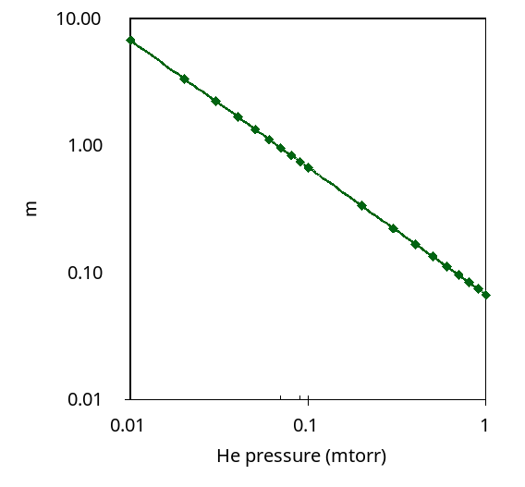
Figure 2. Mean free path of neutral lithium at 627°C in helium gas at 27 °C (from J. Nucl. Mater., 390-391 (2009) 1005].
Deposition at Bay H bottom
Deposition at Bay H top x10, offset
Rate of deposition at Bay H bottom
Rate of deposition at Bay H top
Gas only D₂ pulse
Figure 3. QMB data. Curve (a) shows the rise in mass on lower QMB during lithium evaporation interrupted by a deuterium gas-only pulse 123521. In contrast the upper QMB (b) that is shadowed from the evaporator shows a small rise during the gas pulse. The data for (b) has been multiplied x10 and offset by -155 µg/cm² to bring the curves to the same frame. Curves (c) and (d) show the respective deposition rates. The LiTER temperature cooled from 671 °C at 17.1h to 657 °C at 17.35 h.
(a)
(b)
(c)
(d)

4. Required machine, NBI, RF, CHI and diagnostic capabilities
Describe any prerequisite conditions, development, XPs or XMPs needed.
This XP could follow a XP that used high performance LSN, Li conditioned ELM-free H-mode discharges. It would be based on a current high performance discharge.
Key diagnostics are bolometer for radiated power, visible bremstrahlung Zeff, CHERS core carbon density and carbon Zeff, and SPRED & XEUS.
Attach completed Physics Operations Request and Diagnostic Checklist.

5. Planned analysis
What analysis of the data will be required: EFIT, TRANSP, etc.?
Analysis will be based on comparisons of the radiated power, core carbon density, Z-effective, and SPRED spectra in discharges with the use of helium and without helium for diffusive Li injection.

6. Planned publication of results
What will be the final disposition of the results; where will results be published and when?
The results will be presented at the DPP APS 2009.
PHYSICS OPERATIONS REQUEST
TITLE: Diffusive Lithium Injection | No. OP-XP-
AUTHORS: Charles H. Skinner et al., | DATE:
(use additional sheets and attach waveform diagrams if necessary)
Describe briefly the most important plasma conditions required for the experiment:
Baseline LSN, Li conditioned, ELM-free H-mode with impurity accumulation
Previous shot(s) which can be repeated:
Previous shot(s) which can be modified:
Machine conditions (specify ranges as appropriate, strike out inapplicable cases)
I_{TF} (kA): Flattop start/stop (s):
I_{P} (MA): Flattop start/stop (s):
Configuration: Limiter / DN / LSN / USN
Equilibrium Control: Outer gap / Isoflux (rtEFIT)
Outer gap (m): Inner gap (m): Z position (m):
Elongation κ: Upper/lower triangularity δ:
Gas Species: Injector(s):
NBI Species: D Voltage (kV) A: B: C: Duration (s):
ICRF Power (MW): Phase between straps (°): Duration (s):
CHI: Off / On Bank capacitance (mF):
LITERs: Off / On Total deposition rate (mg/min):
EFC coils: Off/On Configuration: Odd / Even / Other (attach detailed sheet

DIAGNOSTIC CHECKLIST
TITLE: Diffusive Lithium Injection | No. OP-XP-
AUTHORS: Charles H. Skinner et al., | DATE:

Note special diagnostic requirements in Sec. 4
Diagnostic | Need | Want
Bolometer – tangential array | √
Bolometer – divertor | √
CHERS – toroidal | √
CHERS – poloidal | √
Divertor fast camera
Dust detector
EBW radiometers
Edge deposition monitors
Edge neutral density diag.
Edge pressure gauges
Edge rotation diagnostic
Fast ion D_alpha - FIDA
Fast lost ion probes - IFLIP
Fast lost ion probes - SFLIP
Filterscopes
FIReTIP
Gas puff imaging
Hα camera - 1D
High-k scattering
Infrared cameras
Interferometer - 1 mm
Langmuir probes – divertor
Langmuir probes – BEaP
Langmuir probes – RF ant.
Magnetics – Diamagnetism
Magnetics – Flux loops | √
Magnetics – Locked modes
Magnetics – Pickup coils | √
Magnetics – Rogowski coils | √
Magnetics – Halo currents
Magnetics – RWM sensors
Mirnov coils – high f.
Mirnov coils – poloidal array
Mirnov coils – toroidal array
Mirnov coils – 3-axis proto.

Note special diagnostic requirements in Sec. 4
Diagnostic | Need | Want
MSE
NPA – E||B scanning
NPA – solid state
Neutron measurements
Plasma TV
Reciprocating probe
Reflectometer – 65GHz
Reflectometer – correlation
Reflectometer – FM/CW
Reflectometer – fixed f
Reflectometer – SOL
RF edge probes
Spectrometer – SPRED | √
Spectrometer – VIPS
SWIFT – 2D flow
Thomson scattering
Ultrasoft X-ray arrays
Ultrasoft X-rays – bicolor
Ultrasoft X-rays – TG spectr.
Visible bremsstrahlung det. | √
X-ray crystal spectrom. - H
X-ray crystal spectrom. - V
X-ray fast pinhole camera
X-ray spectrometer - XEUS | √

