Princeton Plasma Physics Laboratory
NSTX Experimental Proposal
Title: Dust mobilization from ITER-scale castellations
OP-XP-938 | Revision:0 | Effective Date: 7/21/09  (Approval date unless otherwise stipulated)  Expiration Date: 7/21/11  (2 yrs. unless otherwise stipulated)
PROPOSAL APPROVALS
Responsible Author: C H Skinner, S Gerhardt and L Roquemore |  |  | Date
ATI – ET Group Leader: V Soukhanovskii |  |  | Date
RLM - Run Coordinator: Roger Raman |  |  | Date
Responsible Division: Experimental Research Operations
Chit Review Board (designated by Run Coordinator)

MINOR MODIFICATIONS (Approved by Experimental Research Operations)

NSTX EXPERIMENTAL PROPOSAL
TITLE: Dust mobilization from ITER-scale castellations | No. OP-XP-
AUTHORS: C H Skinner, S Gerhardt and L Roquemore | DATE: 7/23/09

1. Overview of planned experiment
Dust is likely to accumulate in gaps between tile castellations in ITER. The ability of dust to be ejected from these castellations by off-normal events is unknown. This XP plans to obtain the first experimental data on the mobilization of dust from ITER-scale castellations.
A boron nitride mockup with the exact geometry of the ITER castellation gaps (Fig. 1) will be loaded with a pre-weighed quantity of carbon or tungsten dust and mounted on the sample probe. The probe will be inserted into NSTX and subject to discharges that end with planned vertical displacement events that land close to the probe. Afterwards the probe will be withdrawn and the amount of dust left in the gaps will be weighed. Fast camera and spectroscopic measurements of dust will also be made.

2. Theoretical/ empirical justification
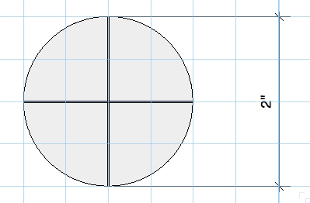
Dust will be generated by plasma-wall interactions on ITER. The total quantity of dust in ITER is limited for safety reasons. The quantity of dust on hot surfaces is also limited to assure the integrity of the vacuum vessel in accident conditions. Dust may also transport impurities into the core plasma limiting the performance. Finally dust may coat diagnostic mirrors. Thus it is important to obtain data on the mobilization of dust from castellation gaps. There is also interest in obtaining ITER-relevant tungsten spectra with the XEUS and LOWEUS spectrometers (P. Beiersdorfer).
View of top of sample probe with 0.5 mm wide gaps in ‘castellations’ at depth of gap 15 mm ‘carbon’ and 8 mm tungsten

3. Experimental run plan
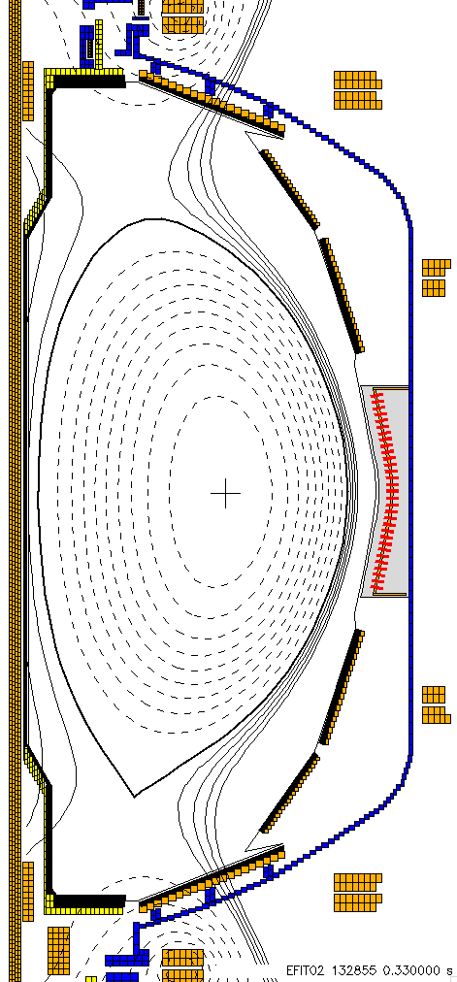
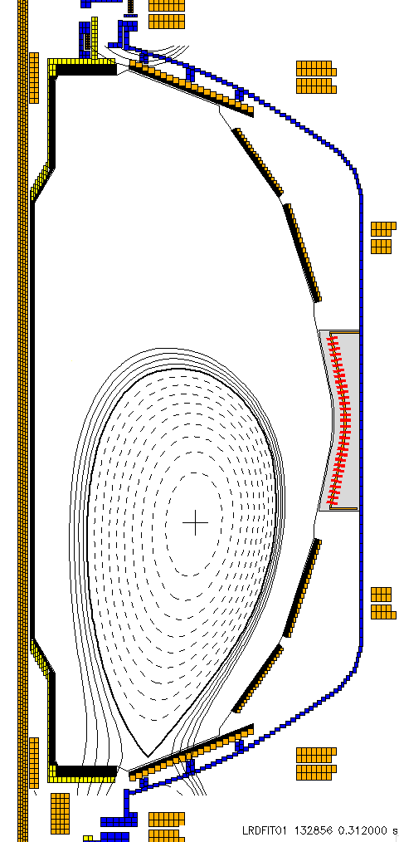
Step 1: Reload shot 132855. This is a combined PF-2/PF-1a shot. Convert from He to D₂, and inject Scr. A from 100 msec till 1 sec. Example LFS D2 waveform can be found in shot 129512, though be careful that this is from 2008.
132855 during the flat top
Repeat of 132856
At the end of the VDE
Step 2: Repeat, with vertical control freeze. Freeze the PF-3 voltage from 260-360, and apply a 40 V offset. The discharge should develop a downward VDE.
Step 3: Repeat with Src. B at 0.14 sec, for a total of 4MW
Step 4: Repeat once the best shot from Steps 2 or 3.
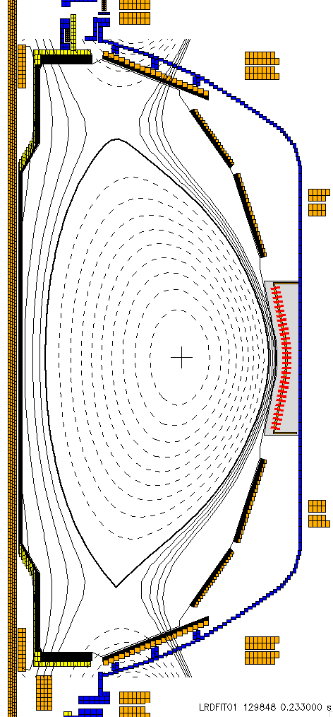
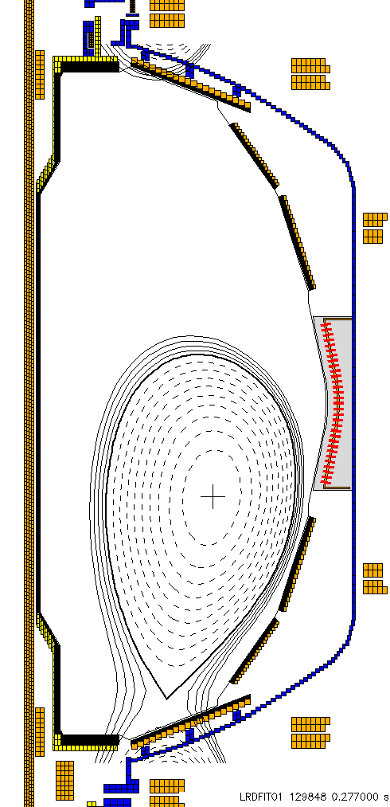
Step 5: Reload shape category from shot 129848. This is a similar L-mode shot to what is used above, but with more current in the PF-2 coils, so that the triangularity is reduced. This tends to move the VDE impact point to larger radius. Keep the voltage freeze and offset.
129848 during
the flat top
129848 just before vessel contact
If this discharge has issues, try once to fix it.
Step 6: Repeat twice more the best discharge taken from those above.
We plan to do a dry run to establish no dust is lost by probe motion. This would entail loading the probe with a pre-weighed quantity of dust, inserting it into the machine, withdrawing it and reweighing the dust. Also if He-GDC is used a separate trial to determine if GDC mobilizes dust will be done.
Experiments are planned with carbon and then with tungsten dust (if time permits). In the case of tungsten the dust influx into the plasma could be identified spectoscopically.
The probe head will be fabricated from boron nitride (an insulator) to avoid issues with induced JXB forces.

4. Required machine, NBI, RF, CHI and diagnostic capabilities
Shots have already been developed (for normal TF).
A fast camera will view the probe to detect dust ejected.
The IR camera will be used to assess the temperature excursion.
Langmuir probe data will be taken without bias scan to improve time resolution.
Attach completed Physics Operations Request and Diagnostic Checklist.

5. Planned analysis
Depending on the results we will compare the dust mobilization to that expected from ITER off-normal events.

6. Planned publication of results
A potential venue is the International Conference on Plasma Surface Interactions PSI19 next May in San Diego.
PHYSICS OPERATIONS REQUEST
TITLE: Dust mobilization from ITER-scale castellations | No. OP-XP-
AUTHORS: C H Skinner, S Gerhardt and L Roquemore | DATE:
(use additional sheets and attach waveform diagrams if necessary)
Describe briefly the most important plasma conditions required for the experiment:
See sect. 3.

Previous shot(s) which can be repeated:
Previous shot(s) which can be modified:
Machine conditions (specify ranges as appropriate, strike out inapplicable cases)
I_{TF} (kA): Flattop start/stop (s):
I_{P} (MA): Flattop start/stop (s):
Configuration: Limiter / DN / LSN / USN
Equilibrium Control: Outer gap / Isoflux (rtEFIT)
Outer gap (m): Inner gap (m): Z position (m):
Elongation κ: Upper/lower triangularity δ:
Gas Species: Injector(s):
NBI Species: D Voltage (kV) A: B: C: Duration (s):
ICRF Power (MW): Phase between straps (°): Duration (s):
CHI: Off / On Bank capacitance (mF):
LITERs: Off / On Total deposition rate (mg/min):
EFC coils: Off/On Configuration: Odd / Even / Other (attach detailed sheet

DIAGNOSTIC CHECKLIST
TITLE: Dust mobilization from ITER-scale castellations | No. OP-XP-
AUTHORS: C H Skinner, S Gerhardt and L Roquemore | DATE:

Note special diagnostic requirements in Sec. 4
Diagnostic | Need | Want
Bolometer – tangential array
Bolometer – divertor
CHERS – toroidal
CHERS – poloidal
Divertor fast camera
Dust detector
EBW radiometers
Edge deposition monitors
Edge neutral density diag.
Edge pressure gauges
Edge rotation diagnostic
Fast ion D_alpha - FIDA
Fast lost ion probes - IFLIP
Fast lost ion probes - SFLIP
Filterscopes
FIReTIP
Gas puff imaging
Hα camera - 1D
High-k scattering
Infrared cameras | √
Interferometer - 1 mm
Langmuir probes – divertor | √
Langmuir probes – BEaP
Langmuir probes – RF ant.
Magnetics – Diamagnetism
Magnetics – Flux loops | √
Magnetics – Locked modes
Magnetics – Pickup coils | √
Magnetics – Rogowski coils | √
Magnetics – Halo currents
Magnetics – RWM sensors
Mirnov coils – high f.
Mirnov coils – poloidal array
Mirnov coils – toroidal array
Mirnov coils – 3-axis proto.

Note special diagnostic requirements in Sec. 4
Diagnostic | Need | Want
MSE
NPA – E||B scanning
NPA – solid state
Neutron measurements
Plasma TV
Reciprocating probe
Reflectometer – 65GHz
Reflectometer – correlation
Reflectometer – FM/CW
Reflectometer – fixed f
Reflectometer – SOL
RF edge probes
Spectrometer – SPRED
Spectrometer – VIPS
SWIFT – 2D flow
Thomson scattering
Ultrasoft X-ray arrays
Ultrasoft X-rays – bicolor
Ultrasoft X-rays – TG spectr.
Visible bremsstrahlung det.
X-ray crystal spectrom. - H
X-ray crystal spectrom. - V
X-ray fast pinhole camera
X-ray spectrometer - XEUS | √

