Princeton Plasma Physics Laboratory
NSTX Experimental Proposal
Title: Optimization of long-pulse high-β_{T} discharges
OP-XP-938 | Revision: | Effective Date:  (Approval date unless otherwise stipulated)  Expiration Date:  (2 yrs. unless otherwise stipulated)
PROPOSAL APPROVALS
Responsible Author: S.P. Gerhardt, D.A. Gates |  |  | Date
ATI – ET Group Leader: D. A. Gates |  |  | Date
RLM - Run Coordinator: R. Raman |  |  | Date
Responsible Division: Experimental Research Operations
Chit Review Board (designated by Run Coordinator)

MINOR MODIFICATIONS (Approved by Experimental Research Operations)

NSTX EXPERIMENTAL PROPOSAL
TITLE: Optimization of long-pulse high-β_{T} discharges | No. OP-XP-948
AUTHORS: S.P. Gerhardt, D.A. Gates | DATE:

1. Overview of planned experiment
The goal of this experiment is to expand the high-β_{T} operational space achieved in NSTX. This experiment will follow the traditional method for achieving high-β: the plasma current will be raised as the toroidal field is reduced, and high elongation will be used to keep q*>~2.2. More specifically, the recent high-β_{P} shot 133964, which operated at 700 kA and 0.47T, will be used as an initial target, though at 900 kA and 0.45 T. The toroidal field will then be dropped to 0.4 T and discharges made with I_{P} values of 700, 900,1000, 1100, and 1200 kA, all at the maximum NB power. This should result in a series of discharges at increasing values of β_{T}, but decreasing pulse duration; the scaling of confinement and NI fraction with plasma current could will be determined. If time permits one or two of these I_{P} values will be repeated at both lower (0.375 or 0.35 T) and higher (0.475 or 0.55 T) toroidal fields, in order to study the scaling of transport and NI fraction with B_{T} in these high-κ, low-l_{i} plasmas.

2. Theoretical/ empirical justification
Most designs that make use of the ST concept to make something useful (say, a CTF or a reactor) operate at substantially higher toroidal β than is common in NSTX: CTFs may operate at β_{T} in the rage of 18-28, while an ST reactor may need β_{T}=50%! Furthermore, the elongation in these studies typically is 3 or higher. It is the purpose of the present XP to push the present NSTX operating space to the longest available pulses at high-β_{T} and low-q*, using a high-κ discharge that should be optimal for increasing the NI fraction.
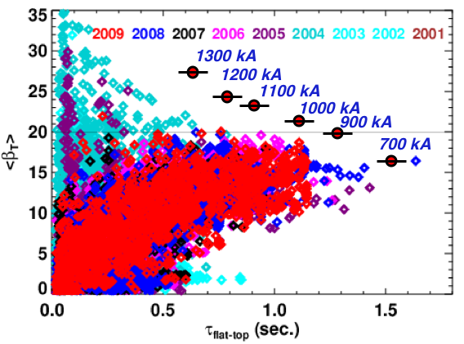
Fig 1: The NSTX database of flat-top average β_{T} values, sorted by year. Also shown in red circles are the target points for this XP at B_{T}=0.4T, assuming good confinement.
A further important topic for these equilibria is to understand how the transport and non-inductive current fraction scale with I_{P} and B_{T} in these high-κ, low-l_{i} discharges. Though these studies are not the primary goal of the XP, the subject will be addressed in the scans to be conducted.
In preparation for this XP, a series of target equilibrium were studied with the isolver code. The profiles and shape were taken from 133964, the value of β_{N} was fixed at 5.5, and I_{P} and B_{T} were scanned. The resulting equilibrium characteristics are shown in table 1. The lines in red indicate the equilibrium at B_{T}=0.4 T that are of primary interest for this XP.

Case | Ip (MA) | BT (T) | betaN | betaT (%) | q* | q95 | WMHD (kJ)
1 | 0.7 | 0.5 | 5.5 | 13.6 | 4.78 | 14 | 260
2 | 0.7 | 0.45 | 5.5 | 14.8 | 4.4 | 12.5 | 234
3 | 0.7 | 0.4 | 5.5 | 16.4 | 4 | 11.1 | 208
4 | 0.7 | 0.375 | 5.5 | 17.4 | 3.8 | 10.4 | 195
5 | 0.7 | 0.35 | 5.5 | 18.5 | 3.57 | 9.7 | 183
6 | 0.9 | 0.5 | 5.5 | 17 | 3.9 | 10.7 | 330
7 | 0.9 | 0.45 | 5.5 | 18.5 | 3.57 | 9.7 | 300
8 | 0.9 | 0.4 | 5.5 | 20.5 | 3.23 | 8.6 | 270
9 | 0.9 | 0.375 | 5.5 | 21.8 | 3.05 | 8.1 | 252
10 | 0.9 | 0.35 | 5.5 | 23 | 2.87 | 7.5 | 235
11 | 1 | 0.55 | 5.5 | 17 | 3.9 | 10.7 | 410
12 | 1 | 0.5 | 5.5 | 18.5 | 3.6 | 9.7 | 373
13 | 1 | 0.45 | 5.5 | 20.3 | 3.3 | 8.7 | 337
14 | 1 | 0.4 | 5.5 | 22.5 | 2.9 | 7.7 | 300
15 | 1 | 0.375 | 5.5 | 23.9 | 2.7 | 7.3 | 281
16 | 1 | 0.35 | 5.5 | 25.3 | 2.6 | 6.8 | 263
17 | 1.1 | 0.55 | 5.5 | 18.5 | 3.6 | 9.7 | 452
18 | 1.1 | 0.5 | 5.5 | 20 | 3.3 | 8.8 | 411
19 | 1.1 | 0.45 | 5.5 | 22 | 3 | 7.9 | 371
20 | 1.1 | 0.4 | 5.5 | 24.6 | 2.7 | 7.1 | 330
21 | 1.1 | 0.375 | 5.5 | 26.2 | 2.6 | 6.63 | 310
22 | 1.1 | 0.35 | 5.5 | 28 | 2.4 | 6.2 | 289
23 | 1.2 | 0.55 | 5.5 | 19.5 | 3.3 | 8.88 | 493
24 | 1.2 | 0.5 | 5.5 | 21 | 3.1 | 8.1 | 449
25 | 1.2 | 0.45 | 5.5 | 24 | 2.8 | 7.3 | 405
26 | 1.2 | 0.4 | 5.5 | 26.7 | 2.5 | 6.5 | 361
27 | 0.2 | 0.375 | 5.5 | 28.4 | 2.4 | 6.1 | 339
28 | 1.2 | 0.35 | 5.5 | 30 | 2.2 | 5.7 | 317
29 | 1.3 | 0.5 | 5.5 | 21.4 | -3.1 | 8.2 | 537
30 | 1.3 | 0.5 | 5.5 | 23.4 | 2.8 | 7.5 | 487
31 | 1.3 | 0.45 | 5.5 | 25.8 | 2.6 | 6.7 | 439
32 | 1.3 | 0.4 | 5.5 | 28.8 | 2.3 | 6 | 391
33 | 1.3 | 0.375 | 5.5 | 30.6 | 2.2 | 5.6 | 367
34 | 1.3 | 0.35 | 5.5 | 32 | 2.05 | 5.2 | 343
Table #1: Characteristics of the high-κ discharge at different I_{P} and B_{T}.

3. Experimental run plan
For reference, here is a table of possible B_{T} waveforms and a figure showing their durations:
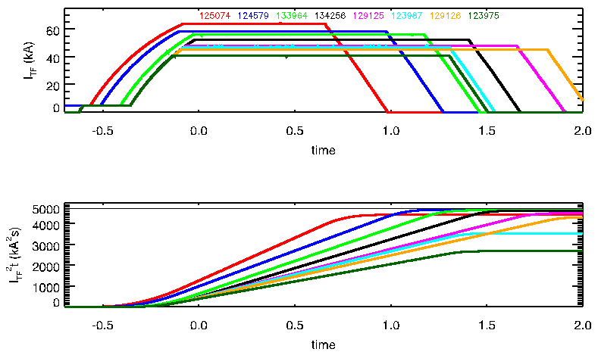
Figure #2: Example TF waveforms, along with their approach to the I²t limit of the coil.

Shot | I_{TF} (kA) | B_{T} (T) | I²t (kA²s) | SOFT (msec)
125074 | -64.2 | -0.534 | 4437 | -92
124579 | -58.5 | -0.49 | 5684 | -116
133964 | -56.2 | -0.47 | 4657 | -39
134256 | -52.7 | -0.44 | 4639 | -29
129125 | -48.3 | -0.4 | 4513 | -71
123987 | -47.3 | -0.395 | 3548 | -81
129126 | -45.3 | -0.38 | 4331 | -98
123975 | -40.9 | -0.34 | 2683 | -138
Table #2: Selected TF waveforms to reload; some will require modification. The I²t limit on the OH coil is 4750 kA²s. SOFT is the start of flat top, and should be about -40 msec. In a few cases (125074,124579), the TF waveform should be delayed in order to maximize the flat-top after t=0.

Regarding Fueling: LITER rate appropriate for 300 mg/shot, using two evaporators. Use 12.5 minute shot cycle, no GDC. For the LFS gas, can use waveforms from 133964 (700kA), 132592 (1MA), or 132912 (1.3 MA). For the HFS gas, the approximate scaling of plenum fill pressure in torr, with I_{P} (MA) is 1050+400*I_{P}. However, this is for guidance only, and the actual required amount may vary depending on conditions at the time.
3.1) Reload shot 133964. Reduce the outer gap to ~13 cm, from 16 cm. Reduce B_{T} to 0.45 Tesla and increase I_{P} to 900 kA (can simply use the waveforms for the fiducial). May need a few shots to get the fuelling right.
3.2) Reduce B_{T} to 0.4 Tesla (TF waveform from 129125) and extend the I_{P} flat-top duration such that the current is ramped all the way down by 1.6 seconds. Fill in the following table of shots at this toroidal field.
The plasma current ramp rate is to be left unchanged as I_{P} is raised; shots with higher I_{P} will simply reach flat-top that much later.
To first order, the center-stack gas should be increased/decreased in a proportion to I_{P}, as noted above. Care should be taken to track changing fuelling requirements through the day.
It may be desirable to increase the NB power to 95kV on sources B and C.
Once the desired condition is reached, the shot should be repeated at least once.

I_{P} | B_{T} | Shots
900 | 0.4
1000 | 0.4
1100 | 0.4
1200 | 0.4
1300 | 0.4
700 | 0.4

3.3) Pick a value of plasma current from table #1 and scan the toroidal field.
I_{P} | B_{T} | Shots
 | 0.55
 | 0.475
 | 0.375
 | 0.35

3.4) Pick a value of plasma current from table #1 and scan the toroidal field
I_{P} | B_{T} | Shots
 | 0.55
 | 0.475
 | 0.375
 | 0.35

4. Required machine, NBI, RF, CHI and diagnostic capabilities
May request sources B & C to be run at 95 kV. Would use β-feedback if it is available, but it is not a requirement. However, all three NB sources are required. RWM feedback is a requirement. Dual LITER operations and 30mg/min total rate is a requirement.

5. Planned analysis
EFIT/LRDFIT equilibrium analysis, TRANSP for non-inductive current and transport analysis, DCON for ideal stability limit calculations

6. Planned publication of results
These results will be part of the report for the ASC milestone for 2009. They will be presented at the 2009 APS meeting, and likely go into a NF paper.
PHYSICS OPERATIONS REQUEST
TITLE: Optimization of long-pulse high-β_{T} discharges | No. OP-XP-948
AUTHORS: S.P. Gerhardt, D.A. Gates | DATE:
(use additional sheets and attach waveform diagrams if necessary)
Describe briefly the most important plasma conditions required for the experiment:
This XP does not require any special conditions. Need 2 LITER units to be functional, all three NB sources working, and RWM feedback on-line.
Previous shot(s) which can be repeated:
Previous shot(s) which can be modified: 133964
Machine conditions (specify ranges as appropriate, strike out inapplicable cases)
I_{TF} (kA): 40-65 Flattop start/stop (s): See table #2
I_{P} (MA): 700-1.3 Flattop start/stop (s): Variable
Configuration: LSN, though dr_{sep} is so small that it is almost DN
Equilibrium Control: Isoflux (rtEFIT)
Outer gap (m): 12 Inner gap (m): 6 Z position (m): -0.02
Elongation κ: 2.5 Upper/lower triangularity δ: PF1A shot
Gas Species: D₂ Injector(s): 1& 2
NBI Species: D Voltage (kV) A: 90 B: 90 (95?) C: 90 (95?) Duration (s): 1.6
ICRF Power (MW): 0 Phase between straps (°): Duration (s):
CHI: Off Bank capacitance (mF):
LITERs: On Total deposition rate (mg/min): 30
EFC coils: On Configuration: Odd

DIAGNOSTIC CHECKLIST
TITLE: Optimization of long-pulse high-β_{T} discharges | No. OP-XP-948
AUTHORS: S.P. Gerhardt, D.A. Gates | DATE:

Note special diagnostic requirements in Sec. 4
Diagnostic | Need | Want
Bolometer – tangential array | √
Bolometer – divertor
CHERS – toroidal | √
CHERS – poloidal
Divertor fast camera
Dust detector
EBW radiometers
Edge deposition monitors
Edge neutral density diag. | √
Edge pressure gauges | √
Edge rotation diagnostic
Fast ion D_alpha - FIDA
Fast lost ion probes - IFLIP
Fast lost ion probes - SFLIP
Filterscopes | √
FIReTIP
Gas puff imaging
Hα camera - 1D | √
High-k scattering
Infrared cameras | √
Interferometer - 1 mm
Langmuir probes – divertor
Langmuir probes – BEaP
Langmuir probes – RF ant.
Magnetics – Diamagnetism | √
Magnetics – Flux loops | √
Magnetics – Locked modes | √
Magnetics – Pickup coils | √
Magnetics – Rogowski coils | √
Magnetics – Halo currents | √
Magnetics – RWM sensors | √
Mirnov coils – high f. | √
Mirnov coils – poloidal array
Mirnov coils – toroidal array | √
Mirnov coils – 3-axis proto.

Note special diagnostic requirements in Sec. 4
Diagnostic | Need | Want
MSE | √
NPA – E||B scanning
NPA – solid state
Neutron measurements | √
Plasma TV | √
Reciprocating probe
Reflectometer – 65GHz
Reflectometer – correlation
Reflectometer – FM/CW
Reflectometer – fixed f
Reflectometer – SOL
RF edge probes
Spectrometer – SPRED | √
Spectrometer – VIPS
SWIFT – 2D flow
Thomson scattering | √
Ultrasoft X-ray arrays | √
Ultrasoft X-rays – bicolor | √
Ultrasoft X-rays – TG spectr.
Visible bremsstrahlung det.
X-ray crystal spectrom. - H
X-ray crystal spectrom. - V
X-ray fast pinhole camera
X-ray spectrometer - XEUS | √

