Princeton Plasma Physics Laboratory
NSTX Machine Proposal
Title: Neon (gas-puff) injection within the lithium deposition framework
OP-XMP- |  | Revision: 0 |  |  | Effective Date:  (Ref. OP-AD-97)  Expiration Date:  (2 yrs. unless otherwise stipulated)
Procedure Approvals
Responsible author: Luis F. Delgado-Aparicio |  |  |  |  |  | Date 04/29/2009
ATI (NSTX Physics Ops): |  |  |  |  |  | Date
RLM (NSTX Expt. Research Ops): |  |  |  |  |  | Date
Responsible Division: Experimental Research Operations
Procedure Requirements
designated by RLM
 | NSTX Work Permit |  |  | T-MOD (OP-AD-03)
 | Independent Review |  |  | ES&H Review
MINOR MODIFICATIONS
Approved by RLM

REVIEWERS (designated by RLM)
Organization/Position | Name | Signature
ATI | D. Mueller
Test Director
Independent Reviewer
NB
RF
Diagnostics

TRAINING (designated by RLM)
Training required: No  Yes  Instructor _____________________

Personnel (group, job title or individual name) | Read Only | Instruction | Hands-On
Training Rep. _______________________________
RLM ____________________________________
NSTX MACHINE PROPOSAL
TITLE: Neon (gas-puff) injection within the lithium deposition framework | No. OP-XMP-
AUTHORS: L. Delgado-Aparicio, K. Tritz, B. Blanchard, M. Cropper, R. Bell, M. Finkenthal, B. LeBlanc, S. Kaye, S. Sabbagh, W. Solomon and D. Stutman. | DATE: 04/29/2009

1. Overview:
Before the application of Lithium to the PFCs, a brief neon puff (~10-50 ms) has been used as a perturbative transport tool in NSTX in order to asses impurity diffusivity as well convective (pinch) velocity. However, the application of Lithium deposition may have lowered the neutral density at the edge resulting in an increased neon mean free path (much stronger penetration as previously experienced), thus the standard H-modes collapsed rapidly. Now we have the expertise and the tools needed to control the gas puffs (e.g. operational knobs such as t_{injection}, Δt_{injection}, P_{Plenum} and Neon gas flow rates) in order to avoid the plasma collapse allowing the use of this perturbative tool in both MHD and T&T experimental proposals.

2. Justification:
Three experimental proposals have indicated the use of Neon injection to asses particle transport and the effect of RWM in the background plasma: a) XP931 on the Effect of the active stabilization of RWMs on the background plasma (Macroscopic Stability TSG), b) XP-921 on the Characterization of GAE modes & their effect on electron thermal transport (Transport and Turbulence & Wave and Particles TSGs) and c) XP 908 on the Dependence of momentum and particle pinch on collisionality (Transport and Turbulence TSG). The development of this perturbative tool is necessary for the success of these three experimental proposals mentioned above, since Lithium deposition is required in between plasma shots.

3. Plan:
Add 121162 NBI prescriptions to the morning fiducial shot. Lithium deposition will be added in subsequent shots (at rates of 15 and 30 mg/min for 10 minutes) with neon injection timed at t~350-400 ms for a time window of 10 ms; the flow rate chosen will be of 1.5 Torr⋅l/sec for different plenum pressures in the range of 100-600 T. Two shots for dialing the background conditions and four shots per Lithium deposition rate make a total of ten (10) plasma shots.
__121162 and/or morning fiducial__
Total shot number: 10 (including contingency)
4. Required machine, beam, ICRF and diagnostic capabilities:
Normal operations (e.g. as for fiducial morning shots). The neon bottle will be arranged by vacuum techs as described in the schematic drawing shown below.

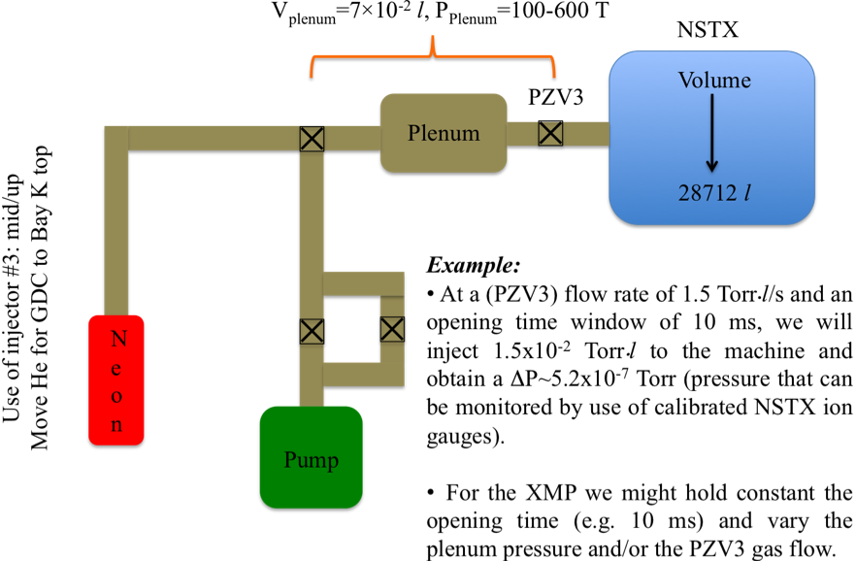

Fig 1.- Basic gas/pump diagram for neon tests during XMP

5. Sign off at run time:
5.1 Permission to Proceed:
Physics Operations Head
5.2 Documentation of results:
Documentation of the results completed, attached to proposal and sent to Ops. Center with copies to Cognizant Physicist and Head of Physics Operations.

Cognizant Physicist/Test Director

PHYSICS OPERATIONS REQUEST
TITLE: Neon (gas-puff) injection within the lithium deposition framework | No. OP-XMP-
AUTHORS: L. Delgado-Aparicio, et al. | DATE: 04/29/2009
Machine conditions (specify ranges as appropriate, use more than one sheet if necessary)
I_{TF} (kA): Flattop start/stop (s):
I_{P} (MA): 1.0 MA Flattop start/stop (s):
Configuration: Limiter / DN / LSN / USN (strike out inapplicable cases)
Outer gap (m): Inner gap (m): Z position (m):
Elongation κ: Upper/lower triangularity δ:
Gas Species: Injector(s):
NBI Species: D Voltages (kV or off) A: 90 B: 90 C: 90 Duration (s):
ICRF Power (MW): Phasing: Duration (s):
CHI: Off Bank capacitance (mF):
LITERs: Off and On Total deposition rate (mg/min): Between 10 and 40 mg/min
EFC coils: Off and On Configuration: Odd (n=1)
Either: List previous shot numbers for setup:
Or: Sketch the desired time profiles, including inner and outer gaps, κ, δ, heating, fuelling, etc. as appropriate. Accurately label the sketch with times and values.
DIAGNOSTIC CHECKLIST
TITLE: Neon (gas-puff) injection within the lithium deposition framework | No. OP-XMP-
AUTHORS: L. Delgado-Aparicio, et al. | DATE: 04/29/2009

Note special diagnostic requirements in Sec. 4
Diagnostic | Need | Want
Bolometer – tangential array | √
Bolometer – divertor
CHERS – toroidal | √
CHERS – poloidal | √
Divertor fast camera
Dust detector
EBW radiometers
Edge deposition monitors
Edge neutral density diag.
Edge pressure gauges | √
Edge rotation diagnostic
Fast ion D_alpha - FIDA
Fast lost ion probes - IFLIP
Fast lost ion probes - SFLIP
Filterscopes |  | √
FIReTIP | √
Gas puff imaging
Hα camera - 1D
High-k scattering
Infrared cameras
Interferometer - 1 mm
Langmuir probes – divertor
Langmuir probes – BEaP
Langmuir probes – RF ant.
Magnetics – Diamagnetism
Magnetics – Flux loops | √
Magnetics – Locked modes | √
Magnetics – Pickup coils | √
Magnetics – Rogowski coils | √
Magnetics – Halo currents
Magnetics – RWM sensors | √
Mirnov coils – high f. | √
Mirnov coils – poloidal array | √
Mirnov coils – toroidal array | √
Mirnov coils – 3-axis proto. | √

Note special diagnostic requirements in Sec. 4
Diagnostic | Need | Want
MSE | √
NPA – E||B scanning
NPA – solid state
Neutron measurements | √
Plasma TV
Reciprocating probe
Reflectometer – 65GHz
Reflectometer – correlation
Reflectometer – FM/CW
Reflectometer – fixed f
Reflectometer – SOL
RF edge probes
Spectrometer – SPRED |  | √
Spectrometer – VIPS |  | √
SWIFT – 2D flow
Thomson scattering | √
Ultrasoft X-ray arrays | √
Ultrasoft X-rays – bicolor | √
Ultrasoft X-rays – TG spectr.
Visible bremsstrahlung det.
X-ray crystal spectrom. - H
X-ray crystal spectrom. - V
X-ray fast pinhole camera
X-ray spectrometer - XEUS

