Princeton Plasma Physics Laboratory
NSTX Experimental Proposal
Title: Effect of the active stabilization of RWMs on the background plasma
OP-XP-931 | Revision: | Effective Date:  (Approval date unless otherwise stipulated)  Expiration Date:  (2 yrs. unless otherwise stipulated)
PROPOSAL APPROVALS
Responsible Author: Luis F. Delgado-Aparicio et al. |  |  | Date
ATI – ET Group Leader: S. Sabbagh |  |  | Date
RLM - Run Coordinator: Roger Raman |  |  | Date
Responsible Division: Experimental Research Operations
Chit Review Board (designated by Run Coordinator)

MINOR MODIFICATIONS (Approved by Experimental Research Operations)

NSTX EXPERIMENTAL PROPOSAL
TITLE: Effect of the active stabilization of RWMs on the background plasma | No. OP-XP-931
AUTHORS: L. Delgado-Aparicio, S. A. Sabbagh, K. Tritz, D. Stutman, R. Bell, J. Berkery, M. Finkenthal, S. P. Gerhardt, B. LeBlanc, J. Levesque, J. Manickam and J-K. Park | DATE: 05/04/2009

1. Overview of planned experiment
The main motivation of the present experimental proposal is to contribute on addressing the 2009 research milestone of understanding the physics of RWM stabilization and control, especially on the effects of the actively stabilized RWMs on the background plasma. The two research targets to study are a) the modification of the kinetic plasma profiles by the use of the (n=3 braking and the n=1 active feedback) external fields and, b) the role of the resonant field amplification and its kinetic response near the marginal stability.

2. Theoretical/ empirical justification
A fast and compact multi-energy soft X-ray (ME-SXR) array has been used for the determination of time and space-resolved SXR emissivity in different energy ranges during active stabilization of resistive wall modes (RWM) in NSTX. The insensitivity of ME-SXR to stray fields helps to discriminate between the RWM and parasitic perturbations. At high $β_{N}>β_{N}^{\text{No}−\text{wall}}$, n=1 perturbations with a characteristic frequency of ~20-30 Hz appear in the ME-SXR emissivity profiles that have been correlated with density and temperature fluctuations in both the edge and core regions (see Figure 1). Fast T_{e} measurements are obtained from ratios of the emissivity profiles by modeling the slope of the continuum radiation. The amplitude of the core and mid-radius T_{e} modulations associated with actively-stabilized resistive RWMs is of the order of 50-100 eV (~10%). Their time history is also in good agreement with the slow evolution of the n=1 magnetic perturbation measured by the poloidal and radial RWM coils. The ME-SXR data shows that during RWM active stabilization there is a strong coupling between the edge and core activity. Similar observations have also been made during experimental campaigns both at DIII-D and JT-60U [e.g. a) Investigation of Resistive Wall Mode internal structure (I. N. Bogatu, APS-DPP-2006) and b) Dynamics and Stability of Resistive Wall Mode in the JT-60U High-β Plasmas (Matsunaga, 22nd IAEA-2008)]. This result suggests the presence of a stable resistive wall mode (RWM) near the natural resonant field amplification (RFA) resonance. The implications of the latter are important because we should be able to conclude whether an unstable RWM grows from the stable RFA, or indeed from another n = 1 mode denoting multi-mode behavior.

3. Experimental run plan
The first part of this experimental proposal attempts to study the effects of the applied external fields (n=3 magnetic braking + n=1 active feedback) on the plasma profiles. As is shown in Figure 1, it appears that either the braking or the active feedback can modified the kinetic profiles at early times, possibly affecting both the dynamics associated to the H-mode density ears (R~140 cm) and the impurity accumulation during active stabilization. The edge and core carbon densities, together with the neutrons and D_{α} (not shown here), also show the same ~20-30 Hz n=1 activity. Two discharges per condition (with and without n=1, 3 external fields) will be attempted, with and without neon injection. We will inject neon at a rate of 1.5 Torr⋅l/s (or less) for a short (e.g 5-10 ms) time window within [350-400] ms (see Figure 2 for details on neon injection). The external n=3 braking and n=1 active stabilization fields will begin at ~450 ms like in previous discharges (e.g. 120041-44-47, 120717). A matrix of shots is indicated in Figure 3. Total time: ½ day

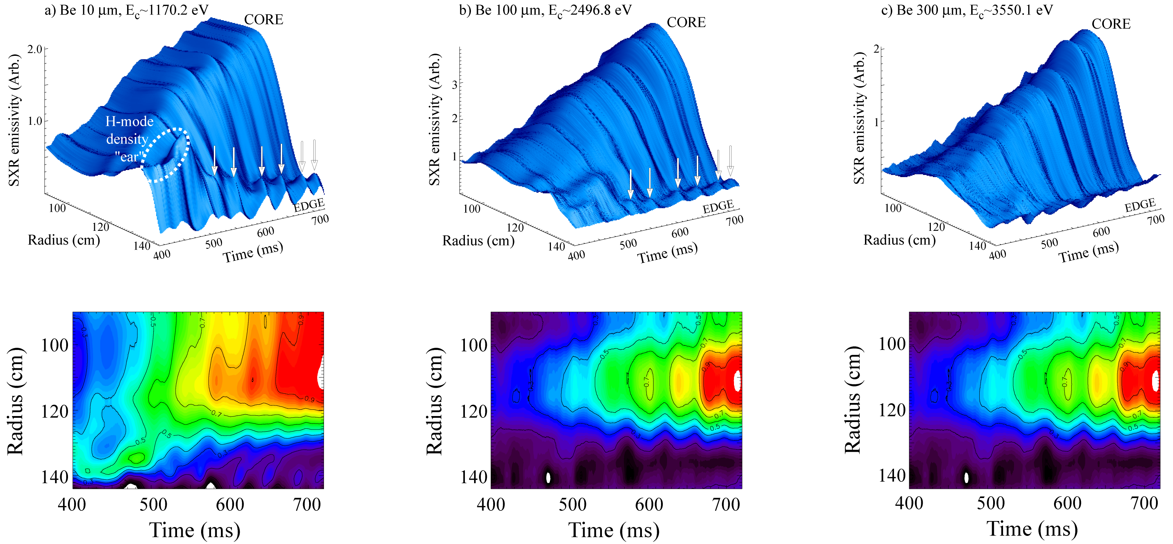
Fig. 1. ME-SXR characterization of actively stabilized RWM plasmas.

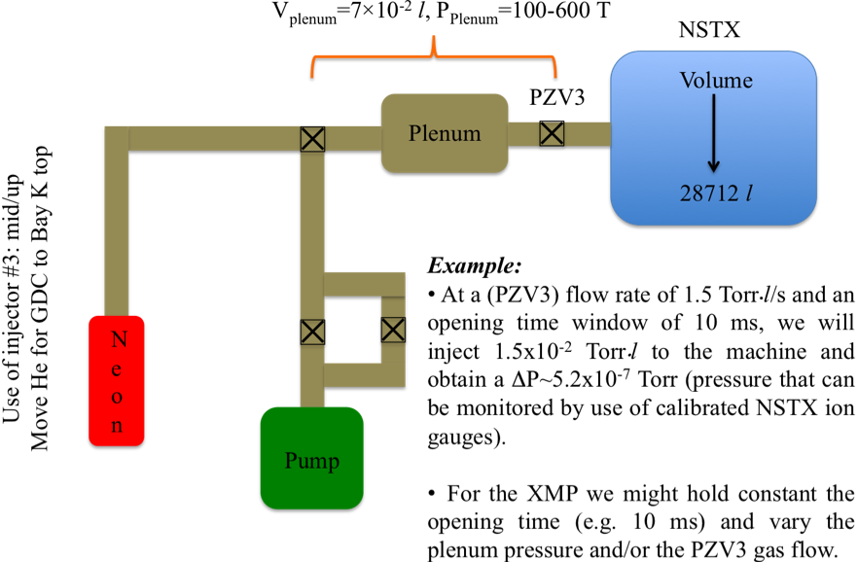

Fig 2.- Basic gas/pump diagram for neon tests during neon injection XMP and XP931.

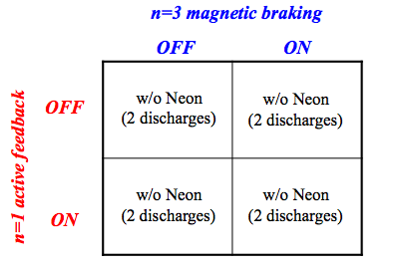
Fig 3.- Shot matrix for first part of XP931.

The goal of the second part of this XP is to study the role of the resonant field amplification near marginal stability (see details in Figure 4). Both the n=1 active feedback and the n=3 error field correction will increase the β_{n} close to marginal stability on the early part of the discharges; the error filed correction and the active feedback will turn onto an n=3 magnetic braking and a single frequency (20-30 Hz) n=1 waveform at approximately t₁~600 ms. We will then scan the Pk-Pk n=1 amplitude to look for the kinetic response of the RFA; neon injection will also be used to test this dependence. Total time: ½ day (maximum of 12 shots).

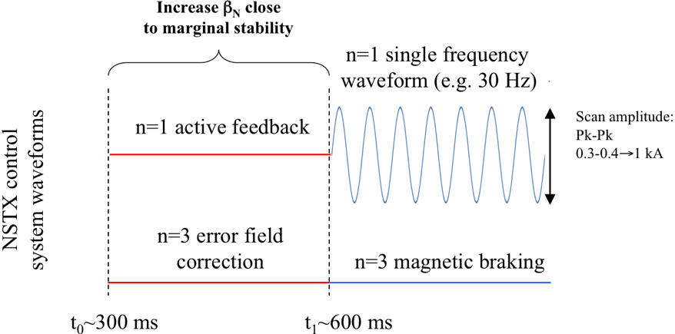

Figure 4. Waveforms for n=1, 3 active feedback, error field correction, magnetic braking and single frequency Pk-Pk scan.

4. Required machine, NBI, RF, CHI and diagnostic capabilities
An important prerequisite for the development of our experimental proposal is XMP-???, on the neon (gass-puff) injection within the lithium deposition framework. The tangential multi-energy OSXR array will operate in its 10, 100 and 300 μm capability meanwhile the USXR horizontal arrays should image the boundary plasma using the 5 μm Be foil.

5. Planned analysis
Data analysis planned: LRDFIT, MIST, TRANSP and NCLASS. Results from PEST, DCON and VALEN will be also required.

6. Planned publication of results
Presentations at the APS, EPS and IAEA meetings together with publications in major scientific journals (e.g. PRL, Nuclear Fusion, PoP, PPCF)
PHYSICS OPERATIONS REQUEST
TITLE: Effect of the active stabilization of RWMs on the background plasma | No. OP-XP-931
AUTHORS: L. Delgado-Aparicio, et al. | DATE: 05/04/2009
(use additional sheets and attach waveform diagrams if necessary)
Describe briefly the most important plasma conditions required for the experiment:
- Reproducibility of H-modes
- MHD free period from 350-400 ms onward
- Availability of neon injection
- n=1, 3 external fields
Previous shot(s) which can be repeated:
Previous shot(s) which can be modified:
Machine conditions (specify ranges as appropriate, strike out inapplicable cases)
I_{TF} (kA): Flattop start/stop (s):
I_{P} (MA): 0.9 MA Flattop start/stop (s):
Configuration: Limiter / DN / LSN / USN
Equilibrium Control: Outer gap / Isoflux (rtEFIT)
Outer gap (m): Inner gap (m): Z position (m):
Elongation κ: Upper/lower triangularity δ:
Gas Species: Injector(s):
NBI Species: D Voltage (kV) A: 90 B: 90 C: 90 Duration (s):
ICRF Power (MW): Phase between straps (°): Duration (s):
CHI: Off / On Bank capacitance (mF):
LITERs: Off and On Total deposition rate (mg/min): 10 mg/min
EFC coils: Off and On Configuration: As planned (see Figure 3 and 4)

DIAGNOSTIC CHECKLIST
TITLE: Effect of the active stabilization of RWMs on the background plasma | No. OP-XP-931
AUTHORS: L. Delgado-Aparicio, et al. | DATE:05/04/2009

Note special diagnostic requirements in Sec. 4
Diagnostic | Need | Want
Bolometer – tangential array | √
Bolometer – divertor
CHERS – toroidal | √
CHERS – poloidal | √
Divertor fast camera
Dust detector
EBW radiometers
Edge deposition monitors
Edge neutral density diag.
Edge pressure gauges | √
Edge rotation diagnostic
Fast ion D_alpha - FIDA
Fast lost ion probes - IFLIP
Fast lost ion probes - SFLIP
Filterscopes |  | √
FIReTIP | √
Gas puff imaging
Hα camera - 1D
High-k scattering
Infrared cameras
Interferometer - 1 mm
Langmuir probes – divertor
Langmuir probes – BEaP
Langmuir probes – RF ant.
Magnetics – Diamagnetism
Magnetics – Flux loops | √
Magnetics – Locked modes
Magnetics – Pickup coils | √
Magnetics – Rogowski coils | √
Magnetics – Halo currents
Magnetics – RWM sensors | √
Mirnov coils – high f. | √
Mirnov coils – poloidal array | √
Mirnov coils – toroidal array | √
Mirnov coils – 3-axis proto. | √

Note special diagnostic requirements in Sec. 4
Diagnostic | Need | Want
MSE | √
NPA – E||B scanning
NPA – solid state
Neutron measurements | √
Plasma TV
Reciprocating probe
Reflectometer – 65GHz
Reflectometer – correlation
Reflectometer – FM/CW
Reflectometer – fixed f
Reflectometer – SOL
RF edge probes
Spectrometer – SPRED |  | √
Spectrometer – VIPS |  | √
SWIFT – 2D flow
Thomson scattering | √
Ultrasoft X-ray arrays | √
Ultrasoft X-rays – bicolor | √
Ultrasoft X-rays – TG spectr.
Visible bremsstrahlung det.
X-ray crystal spectrom. - H
X-ray crystal spectrom. - V
X-ray fast pinhole camera
X-ray spectrometer - XEUS |  | √

