Princeton Plasma Physics Laboratory
NSTX Experimental Proposal
Title: RMP Threshold of ELM Modifications vs. q₉₅
OP-XP-1048 | Revision: 0 | Effective Date:  (Approval date unless otherwise stipulated)  Expiration Date:  (2 yrs. unless otherwise stipulated)
PROPOSAL APPROVALS
Responsible Author: J.-K. Park, J. E. Menard, J.-W. Ahn, J. M. Canik, R. Maingi |  |  | Date
ATI – ET Group Leader: V. Soukhanovskii |  |  | Date
RLM - Run Coordinator: E. Fredrickson |  |  | Date
Responsible Division: Experimental Research Operations
RESTRICTIONS or MINOR MODIFICATIONS
(Approved by Experimental Research Operations)

NSTX EXPERIMENTAL PROPOSAL
TITLE: RMP Threshold of ELM Modifications vs. q₉₅ | No. OP-XP-1048
AUTHORS: Park, et al. | DATE:

1. Overview of planned experiment
The purpose of this XP is to characterize NSTX Resonant Magnetic Perturbations (RMPs, or 3D fields in general) with respect to Edge Localized Mode (ELM) modifications by changing important parameters in target plasmas. The RMPs can trigger ELMs as found in NSTX and are presently being used for ELM modifications based on empirical experiences. Their quantifications in this XP will be performed by changing essentially the two most important parameters in tokamak 3D equilibria, the field strength and spectrum. The n=3 SPA currents will be increased until the field strength reaches to a threshold for ELM triggering. The n=3 spectrum will be modified indirectly by changing q₉₅ of target plasmas instead of changing RMP coil configurations. This XP will support useful references and data for two other related XPs in this year, XP1046 (J.-W. Ahn) and XP1030 (D. Battaglia).

2. Theoretical/ empirical justification
The Resonant Magnetic Perturbations (RMPs) have been rapidly appreciated and recognized as one of the most important techniques for Edge Localized Mode (ELM) controls. However, RMPs work very differently on ELMs depending on tokamak devices and parameters. Reliable results can be summarized based on DIII-D and NSTX data as follows.

 | DIII-D | NSTX
RMP functions | Stabilization | Destabilization
Field strength | Vacuum Chirikov Δ > 0.15 | Relatively unknown
(Empirical parameter) | I-coil > 3~4kAt | RWM coil > 0.75~1kAt
Field spectrum | Sufficient pitch-alignment | Relatively unknown
(Empirical parameter #1) | I-coil n=3 even or one-row only | RWM n=3
(Empirical parameter #2) | q₉₅ = 3.3~3.7 | q₉₅ = 9~11
Collisionality | ν_{e}*<0.5 | ν_{e}*>0.5

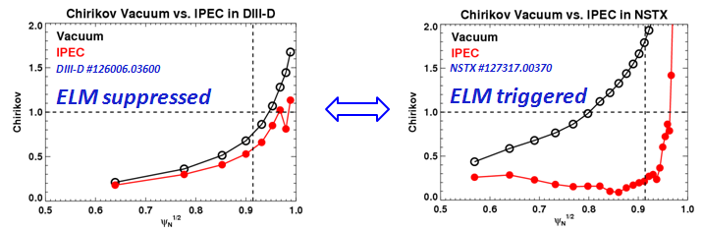
The relatively unknown parts in NSTX will be investigated in this XP, by the needs at least for reliable empirical database as DIII-D empirical quantifications. The field strength can be quantified by investigating the threshold of RWM coil currents and the following vacuum analysis, and the effect of the field spectrum can be investigated by changing q₉₅ instead of changing the applied field spectrum that is not possible with present one-row NSTX RWM coils. Another possible approach to change the applied field spectrum is to shift the target plasmas vertically as proposed by XP1030. The collisionality is also believed as a critical parameter for RMP functions on ELMs. Although the collisionality is not focused in this XP, the effect can be briefly explored using the natural density evolution in NSTX if the relatively long flat-top of target plasmas is guaranteed.
Figure 1. Comparisons of Vacuum and IPEC Chirikov parameter profiles for ELM stabilizing RMPs in DIII-D and ELM destabilizing RMPs in NSTX. One can see IPEC shows strong shielding may occur by ideal plasma responses in NSTX.

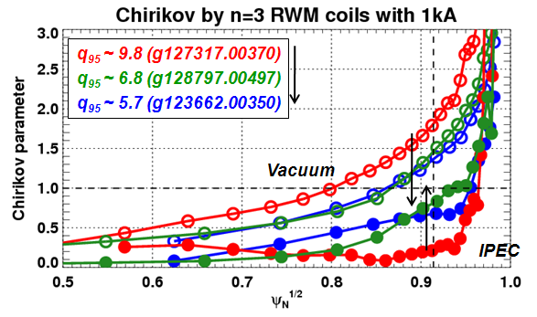
The physics behind RMPs on ELMs is not yet fully understood. It may or may not require the calculations of more self-consistent tokamak 3D equilibria including non-ideal effects, such as non-ambipolar transport or island dynamics. Before the full understanding of non-ideal 3D tokamak equilibria, Ideal Perturbed Equilibrium Code (IPEC) can be used to include at least ideal plasma response effects. Observations indicate that the actual field penetration may be very different from what is expected from Vacuum Chirikov analysis, due to ideal plasma response currents. The example is shown in Fig 1. One can see the field is strongly shielded by plasmas in NSTX although the field penetrations are not altered very much by plasmas in DIII-D. Note that the field penetration effects are represented by Chirikov parameters using expected island sizes in Vacuum and in IPEC by assuming eventual island opening. IPEC results may represent the combined effects of the field strength and the field spectrum as one can reconcile that the sufficient pitch-alignment can make stronger field penetrations due to resonant amplifications, as can be seen in DIII-D.
Figure 2. Comparisons of Vacuum and IPEC Chirikov parameter profile in NSTX, for different low q₉₅s. One can see that field penetration may be stronger in low q₉₅ targets.

The pitch-alignment conditions can be improved in NSTX by changing q₉₅. The applied RWM fields in NSTX are basically non-resonant partially due to large aperture of present coils and partially due to very high q₉₅. That is, the resonant components can be increased by reducing q₉₅. IPEC found that the field penetration can be indeed improved for low q₉₅ target plasmas, as shown in Fig 2. This XP is originally motivated by these IPEC observations, but also empirically XP818 found somewhat different behaviors for RMPs on ELMs for low q95 target plasmas. If one assumes that typical NSTX plasmas with high q₉₅~10 is optimized for ELM triggering and that typical DIII-D plasmas with low q₉₅ is optimized for ELM stabilization, one may be able to expect through this XP the transition between the two different ELM modifications by RMPs. The threshold of q₉₅ for ELM triggering may exist, or q₉₅ window for ELM stabilization may also exist, as a search is planned in this XP when time permitting.
This XP is planning to support other related physics experiments. One of important measurements is that the strike point splitting (3D footprints) on divertor by 3D heat and particle fluxes can be different depending on collisionality, indicating that transport mechanism can be changed also by collisionality. The goal of XP1046 is to investigate the footprints versus collisionality, and this XP will produce data for the footprints versus q₉₅, and thus help XP1046 investigate the footprint patterns versus the two main parameters.
The characterizations planned in this XP are essential to increase credibility of various new RMP coil designs. Presently RMP coils are being designed for JET and ITER only based on DIII-D database. Although target plasmas in JET and ITER are much similar to DIII-D than NSTX, the extension of RMP techniques to very different parametric regimes obviously require thorough investigations for quantifications and understanding.

3. Experimental run plan
3.1 Baseline case for ELM triggering (q95~11)
3.1.1 The reference is #135185 or #138560 discharges for q₉₅~11, which had I_{P}=800 kA, with high-κ and high-δ shape. Target plasmas can be changed if recent shots are found more stable. The LITER is required and LLD is not desired. (1 shots)
Shot Numbers ______ ______ ______ ______
3.1.2 Apply RWM/EF n=3 currents, initially with 1.5kA/200ms ramp rates (Fig. 3) to find rough thresholds. (1 shots)
Shot Numbers ______ ______ ______ ______
3.1.3 Apply RWM/EF n=3 currents, with adjusted ramp rates and waveforms based on 3.1.2 (Fig. 3) to measure thresholds in accuracy and possibly to explore different collisionality regimes. (2 shots)
Shot Numbers ______ ______ ______ ______

3.2 The q95~9 case for ELM triggering
3.2.1: Increase I_{P} up to 1MA to obtain low q₉₅~9 target shots. (1 shots)
Shot Numbers ______ ______ ______ ______
3.2.2: Repeat the previous 3.1.2 on 3.2.1 targets. (1 shots)
Shot Numbers ______ ______ ______ ______
3.2.3: Repeat the previous 3.1.3 on 3.2.1 targets. (2 shots)
Shot Numbers ______ ______ ______ ______

3.3 The q95~7 case for ELM triggering
3.3.1: Increase I_{P} up to 1.2MA to obtain lower q₉₅~7 target shots. (1 shots)
Shot Numbers ______ ______ ______ ______
3.3.2: Repeat the previous 3.1.2 on 3.3.1 targets. (1 shots)
Shot Numbers ______ ______ ______ ______
3.3.3: Repeat the previous 3.1.3 on 3.3.1 targets. (2 shots)
Shot Numbers ______ ______ ______ ______

3.4 The lower q95 case for ELM stabilization
3.4.1: Turn off LITER and develop targets for natural ELMs with lower q₉₅<7 (Recent reference shot is #138228). Try this only if 3.1~3.3 steps show any positive trend for this part, such as any evidence for a low q₉₅ limit for ELM triggering and reliable target plasmas with high I_{P}>1.2MA. (3 shots)
Shot Numbers ______ ______ ______ ______

3.3.2: Apply RWM/EF n=3 currents, initially with 1.5kA/200ms ramp rates (Fig. 3) to find any indication for ELM suppression. (3 shots)
Shot Numbers ______ ______ ______ ______

Shot # | NBI | SPA | I_{P}, q₉₅, β_{N}, etc | Comment

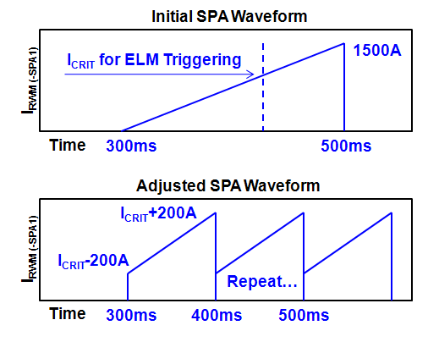
Figure 1. Desired SPA waveforms.

4. Required machine, NBI, RF, CHI and diagnostic capabilities
NBI (A,B) or (A,C) up to 2MW, HHFW up to a maximum power, but CHI is not required. The relevant HHFW power including a maximum needs to be predetermined.
All magnetic, profile diagnostics are required: MSE, CHERS, MPTS.
Fast camera is also strongly recommended

5. Planned analysis
Equilibrium reconstruction with EFIT and LRDFIT, and error field analysis using VAC3D and IPEC. All other kinetic parameters will be mapped on magnetic surfaces.

6. Planned publication of results
Successful results would make a nice Nuclear Fusion paper.
PHYSICS OPERATIONS REQUEST
TITLE: RMP Threshold of ELM Modifications vs. q₉₅ | No. OP-XP-1048
AUTHORS: Park, et al. | DATE:

Brief description of the most important operational plasma conditions required:

Previous shot(s) which can be repeated: This XP will likely use #135185
Machine conditions (specify ranges as appropriate, strike out inapplicable cases)
I_{TF} (kA): 0.4-0.45 T Flattop start/stop (s): 0.2s/0.6s.
I_{P} (MA): 800-1200 kA Flattop start/stop (s):
Configuration: SN (maybe slightly biased down)
Equilibrium Control: Isoflux (rtEFIT)
Outer gap (m): ~10 cm Inner gap (m): Z position (m):
Elongation: Triangularity (U/L): OSP radius (m):
Gas Species: Injector(s):
NBI Species: D Voltage (kV) A: 90 B: 90 C: 90 Duration (s): ~1.3
ICRF Power (MW): 3MW Phase between straps (°): N. A. Duration (s): 0
CHI: Off Bank capacitance (mF):
LITERs: On Total deposition rate (mg/min): TBD, likely 100 mg/shot
LLD: Probably no. Temperature (°C):
EFC coils: On Configuration: Odd

DIAGNOSTIC CHECKLIST
TITLE: RMP Threshold of ELM Modifications vs. q₉₅ | No. OP-XP-1048
AUTHORS: Park, et al. | DATE:

Note special diagnostic requirements in Sec. 4
Diagnostic | Need | Want
Beam Emission Spectroscopy
Bolometer – divertor
Bolometer – midplane array
CHERS – poloidal | √
CHERS – toroidal | √
Dust detector
Edge deposition monitors
Edge neutral density diag.
Edge pressure gauges
Edge rotation diagnostic | √
Fast cameras – divertor/LLD | √
Fast ion D_alpha - FIDA | √
Fast lost ion probes - IFLIP
Fast lost ion probes - SFLIP
Filterscopes
FIReTIP | √
Gas puff imaging – divertor
Gas puff imaging – midplane
Hα camera - 1D
High-k scattering
Infrared cameras | √
Interferometer - 1 mm | √
Langmuir probes – divertor
Langmuir probes – LLD
Langmuir probes – bias tile
Langmuir probes – RF ant. | √
Magnetics – B coils | √
Magnetics – Diamagnetism | √
Magnetics – Flux loops | √
Magnetics – Locked modes | √
Magnetics – Rogowski coils | √
Magnetics – Halo currents
Magnetics – RWM sensors | √
Mirnov coils – high f. | √
Mirnov coils – poloidal array
Mirnov coils – toroidal array
Mirnov coils – 3-axis proto.

Note special diagnostic requirements in Sec. 4
Diagnostic | Need | Want
MSE | √
NPA – E||B scanning
NPA – solid state
Neutron detectors
Plasma TV | √
Reflectometer – 65GHz
Reflectometer – correlation
Reflectometer – FM/CW
Reflectometer – fixed f
Reflectometer – SOL
RF edge probes | √
Spectrometer – divertor
Spectrometer – SPRED
Spectrometer – VIPS
Spectrometer – LOWEUS
Spectrometer – XEUS
SWIFT – 2D flow
Thomson scattering | √
Ultrasoft X-ray – pol. arrays
Ultrasoft X-rays – bicolor
Ultrasoft X-rays – TG spectr.
Visible bremsstrahlung det.
X-ray crystal spectrom. - H
X-ray crystal spectrom. - V
X-ray tang. pinhole camera

