|  |  |  |  |
| --- | --- | --- | --- |
| **Princeton Plasma Physics Laboratory**  **NSTX Experimental Proposal** | | | |
| Title:Core impurity density and radiated power reduction using variations in divertor conditions | | | |
| **OP-XP-1002** | Revision: | Effective Date:  *(Approval date unless otherwise stipulated)*  Expiration Date:  *(2 yrs. unless otherwise stipulated)* | |
| **PROPOSAL APPROVALS** | | | |
| **Responsible Author: V. A. Soukhanovskii** | | | Date |
| **ATI – ET Group Leader: C. H. Skinner** | | | Date |
| **RLM - Run Coordinator: E. Fredrickson** | | | Date |
| **Responsible Division: Experimental Research Operations** | | | |
| **RESTRICTIONS or MINOR MODIFICATIONS**  (Approved by Experimental Research Operations) | | | |
|  | | | |

NSTX EXPERIMENTAL PROPOSAL

|  |  |
| --- | --- |
| TITLE:Core impurity density and radiated power reduction using variations in LLD divertor conditions | No. **OP-XP-1002** |
| AUTHORS: **V. A. Soukhanovskii et al.** | DATE: |

# 1. Overview of planned experiment

This experiment aims at reducing carbon and metal impurity accumulation typically observed in lithium-enabled ELM-free H-mode discharges, by means of divertor D2 injection. An operational objective is to develop a long ELM-free H-mode discharge scenario with optimized rate and timing of the divertor gas puff. The physics objective is to clarify the mechanism of the core impurity reduction by diverotr gas injection. This would be accomplished by detailed spectroscopic measurements of impurity (Li, C, O, Fe, Mo) sources at several poloidal locations (CS, outer midplane, lower and upper divertors), as well as impurity density profile measurements in the core, and impurity transport modeling.

# 2. Theoretical/ empirical justification

Previous NSTX divertor experiments that demonstrated divertor peak heat flux reduction by means of either the radiative divertor with D2 injection [1,2] or the divertor geometry in the “snowflake” divertor configuration [3,4] showed significant core impurity density and radiated power reductions. The experiments were conducted in ELMy H-modes without any lithium conditioning. The reduction of core impurities was attributed to a reduction of the divertor impurity source at very low *Te* attained in the detached divertor. However, no systematic studies were performed, and a number of other effects, e.g., neoclassical convection at the edge of confined plasmas due to increased neutral pressure, changes in the SOL transport and flows, improved impurity compression, and other effects, could play a role. This experiment will attempt to clarify the physics of the observed effect.

# 3. Experimental run plan

1. Obtain a reference discharge, 3-5 MW NBI, high triangularity shape w/ PF1A, LITER rate 10-20 mg/min (100-200 mg), *ROSP*=0.40-0.55 m, nearly ELM-free H-mode, long pulse (~ 1s), HFS fueling
   * 1 MA, similar to discharges 138178, 138180
   * Optional, time permitting - 0.8 MA, similar to discharges 138239-1380241
   * If available, use PCS strike point control
   * Use LITER rate 100-200 mg per shot to obtain ELM-free H-mode
2. Use Bay E divertor gas injector at 5000 Torr (up to 200 Torr l /s) for divertor gas injections. Gas delay in respect to the valve opening time is about 100 ms.

* Injection in the flattop phase of discharge

|  |  |  |  |
| --- | --- | --- | --- |
| Number | Plenum pressure | Injection time wrt t0  in PCS (s) | Gas pulse duration (ms) |
| 1 | 500 | 0.300 | 100 |
| 2 | 5000 | 0.300 | 50-100 |
| 3 | 1000 | 0.300 | 100 |
| 4 | 4000 | 0.300 | 100 |
| 5 | 1500 | 0.300 | 100 |

* Injection in the initial phase of discharge – use best injector rate and start at t=0.100-0.150 ms

1. Optional, time permitting – obtain data for lower-end NBI power (2-3 MW) and higher-end NBI power (4-5 MW)
2. Optional, time permitting, pending administrative approval – use a medium-d discharge target with OSP at *R*=1.75 m to take advantage of the Langmuir probe array
3. Optional, time-permitting – use CD4 injection instead of D2

# 4. Required machine, NBI, RF, CHI and diagnostic capabilities

# 5. Planned analysis

EFIT, LRDFIT, TRANSP, MIST, UEDGE

# 6. Planned publication of results

Results will be presented in upcoming fusion meetings and major refereed publications.

**References**

[1] V. A. Soukhanovskii *et al.,* Phys. Plasmas 16 (2009) 022501

[2] V. A. Soukhanovskii *et al.,* Nucl. Fusion 49 (2009) 095025

[3] V. A. Soukhanovskii *et al.,* Taming the Plasma Material Interface with the “Snowflake” divertor in NSTX, U.S. Burning Plasma Organization eNews , March 17, 2010 (Issue 42),<http://burningplasma.org/enews031710.html>

[4] V. A. Soukhanovskii *et al.,* “Snowflake” divertor in NSTX, submitted to J. Nucl. Mater., May 2010

PHYSICS OPERATIONS REQUEST

|  |  |
| --- | --- |
| TITLE:Core impurity density and radiated power reduction using variations in LLD divertor conditions | No. **OP-XP-1002** |
| AUTHORS: **V. A. Soukhanovskii et al.** | DATE: |

|  |
| --- |
| **Brief description of the most important operational plasma conditions required:** |
| **Previous shot(s) which can be repeated: 1 MA: 138178, 138180; 0.8 MA: 138235-138241**  **Previous shot(s) which can be modified:** |
| **Machine conditions** *(specify ranges as appropriate, strike out inapplicable cases)*  ITF (kA): Flattop start/stop (s):  IP (MA): Flattop start/stop (s):  Configuration: **LSN**  Equilibrium Control: **Outer gap / Isoflux** (rtEFIT) **/ Strike-point control** (rtEFIT)  Outer gap (m):Inner gap (m):Z position (m):  **0.00**  Elongation:Triangularity (U/L):OSP radius (m): **0.4-0.55**  Gas Species: **D2** Injector(s): **HFS, 2, 3, Bay E divertor**  **NBI** Species: **D** Voltage (kV) **A: B: C:** Duration (s):  **ICRF** Power (MW): Phase between straps (°): Duration (s):  **CHI**: **Off / On** Bank capacitance (mF):  **LITERs: Off / On** Total deposition rate (mg/min):  **LLD:** Temperature (°C):  **EFC coils: Off/On** Configuration: **Odd / Even / Other** |

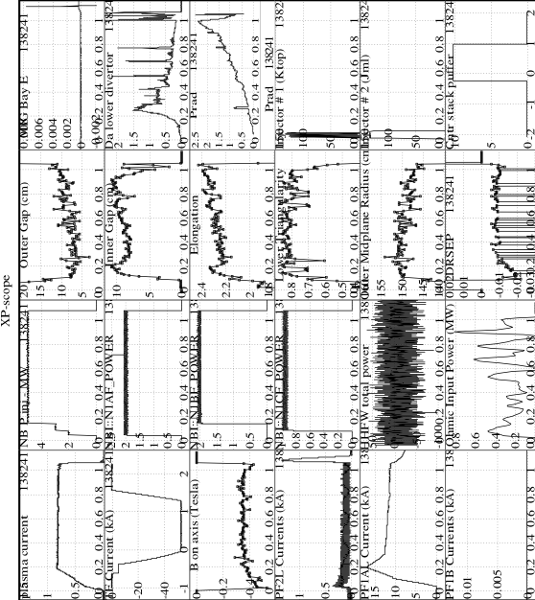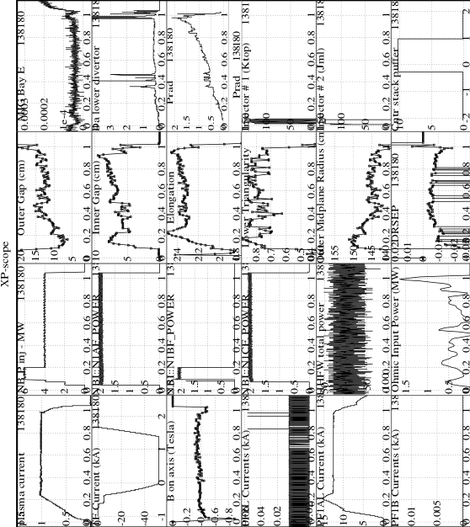

DIAGNOSTIC CHECKLIST

|  |  |
| --- | --- |
| TITLE:Core impurity density and radiated power reduction using variations in LLD divertor conditions | No. **OP-XP-1002** |
| AUTHORS: **V. A. Soukhanovskii et al.** | DATE: |

*Note special diagnostic requirements in Sec. 4*

| **Diagnostic** | **Need** | **Want** |
| --- | --- | --- |
| Beam Emission Spectroscopy |  |  |
| Bolometer – divertor |  | **√** |
| Bolometer – midplane array | **√** |  |
| CHERS – poloidal |  |  |
| CHERS – toroidal | **√** |  |
| Dust detector |  |  |
| Edge deposition monitors |  |  |
| Edge neutral density diag. |  | **√** |
| Edge pressure gauges | **√** |  |
| Edge rotation diagnostic |  | **√** |
| Fast cameras – divertor/LLD |  | **√** |
| Fast ion D_alpha - FIDA |  |  |
| Fast lost ion probes - IFLIP |  |  |
| Fast lost ion probes - SFLIP |  |  |
| Filterscopes | **√** |  |
| FIReTIP |  | **√** |
| Gas puff imaging – divertor |  | **√** |
| Gas puff imaging – midplane |  | **√** |
| H camera - 1D |  | **√** |
| High-k scattering |  |  |
| Infrared cameras |  | **√** |
| Interferometer - 1 mm |  |  |
| Langmuir probes – divertor |  | **√** |
| Langmuir probes – LLD |  | **√** |
| Langmuir probes – bias tile |  | **√** |
| Langmuir probes – RF ant. |  |  |
| Magnetics – B coils | **√** |  |
| Magnetics – Diamagnetism |  |  |
| Magnetics – Flux loops | **√** |  |
| Magnetics – Locked modes |  |  |
| Magnetics – Rogowski coils | **√** |  |
| Magnetics – Halo currents |  |  |
| Magnetics – RWM sensors |  |  |
| Mirnov coils – high f. |  |  |
| Mirnov coils – poloidal array |  |  |
| Mirnov coils – toroidal array |  |  |
| Mirnov coils – 3-axis proto. |  |  |

*Note special diagnostic requirements in Sec. 4*

|  |  |  |
| --- | --- | --- |
| **Diagnostic** | **Need** | **Want** |
| MSE |  |  |
| NPA – E||B scanning |  |  |
| NPA – solid state |  |  |
| Neutron detectors |  |  |
| Plasma TV | **√** |  |
| Reflectometer – 65GHz |  |  |
| Reflectometer – correlation |  |  |
| Reflectometer – FM/CW |  |  |
| Reflectometer – fixed f |  |  |
| Reflectometer – SOL |  | **√** |
| RF edge probes |  |  |
| Spectrometer – divertor |  | **√** |
| Spectrometer – SPRED |  | **√** |
| Spectrometer – VIPS |  | **√** |
| Spectrometer – LOWEUS |  | **√** |
| Spectrometer – XEUS |  | **√** |
| SWIFT – 2D flow |  |  |
| Thomson scattering | **√** |  |
| Ultrasoft X-ray – pol. arrays |  | **√** |
| Ultrasoft X-rays – bicolor |  |  |
| Ultrasoft X-rays – TG spectr. |  | **√** |
| Visible bremsstrahlung det. |  | **√** |
| X-ray crystal spectrom. - H |  |  |
| X-ray crystal spectrom. - V |  |  |
| X-ray tang. pinhole camera |  |  |