Princeton Plasma Physics Laboratory
NSTX Experimental Proposal
Title: HHFW Heating of Low T_{e}(0), I_{p} Plasmas
OP-XP-1009 | Revision: 1 | Effective Date:  (Approval date unless otherwise stipulated)  Expiration Date:  (2 yrs. unless otherwise stipulated)
PROPOSAL APPROVALS
Responsible Author: G. Taylor & D. Mueller |  |  | Date
ATI – ET Group Leader: G. Taylor/D. Mueller |  |  | Date
RLM - Run Coordinator: E. Fredrickson |  |  | Date
Responsible Division: Experimental Research Operations
RESTRICTIONS or MINOR MODIFICATIONS
(Approved by Experimental Research Operations)

NSTX EXPERIMENTAL PROPOSAL
TITLE: HHFW Heating of Low T_{e}(0), I_{p} Plasmas | No. OP-XP-1009
AUTHORS: G. Taylor, D. Mueller, J.C. Hosea, S. Gerhardt,  C. Kessel, B.P. LeBlanc, C.K. Phillips, S. Zweben,  R. Raman, P.M. Ryan, R. Maingi | DATE:  January 28, 2010

1. Overview of planned experiment
This experiment tests HHFW heating of low I_{p} plasmas as a precursor to studying HHFW-assisted I_{p} ramp-up in the Solenoid-Free Start-up Topical Science Group. The experiment will use the new HHFW double-feed antenna and the increased lithium conditioning coverage available in 2010 to improve on previous HHFW electron heating results obtained with low I_{p} and T_{e}(0) plasmas. The goal of the experiment is to couple ~ 3 MW of -14 + -18 m⁻¹ (180º) antenna phasing) and k_{φ} = ±8 m⁻¹ (±90º antenna phasing) HHFW power into a deuterium plasma with I_{p} ≤ 200 kA. Although the primary goal is to study heating of low current plasmas, a secondary goal is to look for current drive. This is a revised version of XP-920, which was approved but not run in 2009. This experiment contributes to the NSTX research milestone R10-2.

2. Theoretical/ empirical justification
A major goal of the 30 MHz HHFW program on NSTX is to generate bootstrap current overdrive during non-inductive I_{p} ramp-up. TSC I_{p} ramp-up simulations predict that coupling 6 MW of HHFW power into the I_{p} ramp-up can result in bootstrap current overdrive. 85% bootstrap current fraction was achieved in XP-521 by coupling 2.5 MW of -14 + -18 m⁻¹ (180º) HHFW power into an I_{p} = 250 kA deuterium plasma. The goal of this experiment is to couple HHFW power into plasmas with I_{p} ≤ 200 kA. HHFW-assisted I_{p} ramp-up experiments have recently benefited from lithium wall conditioning, which reduces the edge density, improving HHFW heating efficiency. In 2008 XP-817 successfully coupled HHFW power, with k_{φ} = - 8 m⁻¹ current drive phasing, into lithium-conditioned deuterium plasmas. 550 kW of RF power coupled after the initiation of a CHI start-up plasma increased T_{e}(0) from 3 to 15 eV when
n_{e}(0) ~ 4 x 10¹⁸m⁻³ and I_{p} ~ 100 kA. Also, 1.1 MW was coupled into the early phase of an ohmically-heated I_{p} ramp-up, when I_{p} was ramping from 100 kA to 300 kA, increasing T_{e}(0) from 140 to 700 eV, when n_{e}(0) ~ 6-9 x10¹⁸m⁻³. HHFW low I_{p} experiments in 2010 will benefit from the recent HHFW antenna upgrade from single-end fed straps to double-end fed straps, which should provide higher power than was previously achieved, as well as allowing coupling of HHFW power during a wider range of plasma edge conditions.

3. Experimental run plan
This experiment is expected to take about 1.5-2 run days to complete. Considerable effort may be needed to develop a discharge with I_{p} ≤ 200 kA.
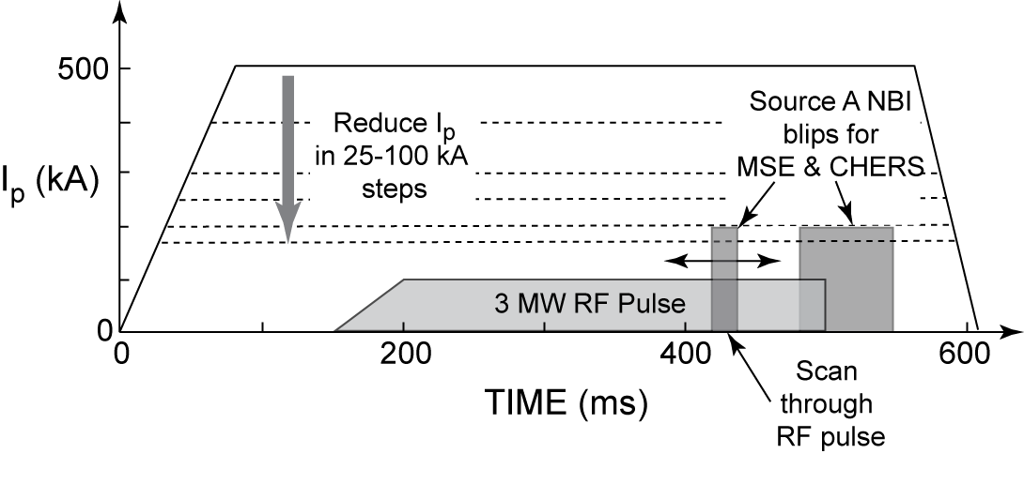
Normally the rtEFIT isoflux control is set to operate when I_{p} ≥ 250 kA. For this experiment the rtEFIT isoflux control will be set for I_{p} ≥ 150 kA. The experiment requires clamping the OH coil current, instead of feeding back on I_{p}. Shots without HHFW power will therefore have decaying I_{p} and when RF power is applied I_{p} will be sustained or decay more slowly depending on the amount of RF current drive and bootstrap current resulting from RF heating. It may be necessary to run some ohmic discharges with I_{p} feedback on to gain an estimate of the OH current needed to minimize plasma motion at low I_{p}.
The run plan is as follows:
1. Setup a 600 ms I_{p} flattop plasma, similar to RF conditioning shot 135260 (I_{p} = 650 kA, B_{T} = 5.5 kG, helium), but run in deuterium and initially operate at I_{p} = 500 kA. Add k_{φ} = 14 + 18 m⁻¹ (180º) HHFW power, coupled from 150 – 500 ms, with a 50 ms ramp-up in power at the start of the RF pulse. Increase RF power to 3 MW, while adjusting lithium evaporation rate, gas injection rate and outer gap to optimize HHFW heating efficiency. (5-10 shots)
2. Run a sequence of shots, reducing I_{p} in 100 kA increments from 500 kA to 300 kA, while coupling
3 MW of k_{φ} = 14 + 18 m⁻¹ (180º) HHFW power. Adjust lithium evaporation rate, gas injection rate and outer gap to optimize HHFW heating efficiency. Take no RF shot at the lowest I_{p} achieved with good RF coupling (10 shots)
3. Repeat (1) and (2) with -8 m⁻¹ (-90º) heating. (10 shots)
4. Reduce I_{p} from 300 kA to ≤ 200 kA in 25-50 kA steps, while maintaining plasma position control so that the outer gap is 5-10 cm. (5-10 shots)
5. At the lowest I_{p} achieved with good plasma control, add k_{φ} = 14 + 18 m⁻¹ (180º) power, coupled from 150 – 500 ms, with a 50 ms ramp-up in power at the start of the RF pulse. Increase RF power to ~ 3 MW. (5 shots)
6. Repeat (5) with -8 m⁻¹ (-90º) heating. (5 shots)
7. Repeat (5) with k_{φ} = +8 m⁻¹ (+90º) heating. (5 shots)
8. Perform a density scan with k_{φ} = -8 m⁻¹ (-90º) heating. (5-10 shots)
9. Adjust RF pulse to start as soon as I_{p} reaches the flattop value. Then use open loop OH programming to provide no ohmic drive after plasma current reaches the minimum value, (< 200 kA at approximately 25 ms). (5 shots to get start time, 5-10 shots to perform CD with ohmic current flat)

4. Required machine, NBI, RF, CHI and diagnostic capabilities
This experiment should follow the first two days of the HHFW plasma conditioning XMP, and requires P_{RF} ~ 3 MW at 14 + 18 m⁻¹and ±8 m⁻¹. This experiment needs rtEFIT isoflux control for the outer gap. LITERs are required, but the LLD should be maintained in “cold”, solid lithium state. An NBI blip from source A at 90 keV should be added for MSE and CHERS data acquisition from 480 to 550 ms. In addition a 20 ms NBI blip from source A at 90 keV will be scanned through the RF pulse once good, reproducible, ~ 3 MW RF heating has been established. Thomson scattering data are required for core and edge electron heating data. For analysis of edge power loss and coupling efficiency the experiment also requires SOL reflectometry and edge ion heating data from edge rotation diagnostic.

5. Planned analysis
Planned analysis includes analysis of heating efficiency at k_{φ} = ±8 m⁻¹ and 14 + 18 m⁻¹, TRANSP and GENRAY/CQL3D modeling.

6. Planned publication of results
The results will be submitted for publication in Nuclear Fusion or Physics of Plasmas, and may contribute to an HHFW IAEA paper.

PHYSICS OPERATIONS REQUEST
TITLE: HHFW Heating of Low T_{e}(0), I_{p} Plasmas | No. OP-XP-1009
AUTHORS: G. Taylor, D. Mueller, J.C. Hosea, S. Gerhardt,  C. Kessel, B.P. LeBlanc, C.K. Phillips, S. Zweben,  R. Raman, P.M. Ryan, R. Maingi | DATE:  January 28, 2010

Brief description of the most important operational plasma conditions required:
I_{p} as low as possible, preferable I_{p} < 200 kA. Stable, reproducible plasma with outer gap = 0.05 – 0.1 m.
Request D. Mueller as operator.
Previous shot(s) which can be repeated:
Previous shot(s) which can be modified: RF plasma conditioning shot 135260
Machine conditions (specify ranges as appropriate, strike out inapplicable cases)
I_{TF} (kA): 66 Flattop start/stop (s): 0/0.7
I_{P} (MA): 0.15-0.5 Flattop start/stop (s): 0.08/0.6
Configuration: LSN
Equilibrium Control: Outer gap / Isoflux (rtEFIT) / Strike-point control (rtEFIT)
Outer gap (m): 0.05-0.1 Inner gap (m): Z position (m): 0.0
Elongation: Triangularity (U/L): OSP radius (m):
Gas Species: D Injector(s):
NBI Species: D Voltage (kV) A: 90 B: C: Duration (s): 480-550 ms, and
20 ms blip stepped between 250 to 450 ms from shot to shot
ICRF Power (MW): 3 Phase between straps (°): ±90, 180 Duration (s): 0.35
CHI: Off Bank capacitance (mF):
LITERs: On Total deposition rate (mg/min): 20 mg/min to start, adjust as needed
LLD: Cold Temperature (°C):
EFC coils: Off Configuration: Odd / Even / Other
DIAGNOSTIC CHECKLIST
TITLE: HHFW Heating of Low T_{e}(0), I_{p} Plasmas | No. OP-XP-1009
AUTHORS: G. Taylor, D. Mueller, J.C. Hosea, S. Gerhardt,  C. Kessel, B.P. LeBlanc, C.K. Phillips, S. Zweben,  R. Raman, P.M. Ryan, R. Maingi | DATE:  January 28, 2010

Note special diagnostic requirements in Sec. 4
Diagnostic | Need | Want
Beam Emission Spectroscopy
Bolometer – divertor | √
Bolometer – midplane array | √
CHERS – poloidal | √
CHERS – toroidal | √
Dust detector
Edge deposition monitors
Edge neutral density diag. |  | √
Edge pressure gauges |  | √
Edge rotation diagnostic | √
Fast cameras – divertor/LLD
Fast ion D_alpha - FIDA
Fast lost ion probes - IFLIP
Fast lost ion probes - SFLIP
Filterscopes | √
FIReTIP |  | √
Gas puff imaging – divertor
Gas puff imaging – midplane |  | √
Hα camera - 1D |  | √
High-k scattering
Infrared cameras | √
Interferometer - 1 mm |  | √
Langmuir probes – divertor |  | √
Langmuir probes – LLD
Langmuir probes – bias tile
Langmuir probes – RF ant. |  | √
Magnetics – B coils | √
Magnetics – Diamagnetism | √
Magnetics – Flux loops | √
Magnetics – Locked modes | √
Magnetics – Rogowski coils | √
Magnetics – Halo currents | √
Magnetics – RWM sensors | √
Mirnov coils – high f. | √
Mirnov coils – poloidal array | √
Mirnov coils – toroidal array | √
Mirnov coils – 3-axis proto. | √

Note special diagnostic requirements in Sec. 4
Diagnostic | Need | Want
MSE | √
NPA – E||B scanning |  | √
NPA – solid state |  | √
Neutron detectors |  | √
Plasma TV | √
Reflectometer – 65GHz
Reflectometer – correlation
Reflectometer – FM/CW
Reflectometer – fixed f
Reflectometer – SOL | √
RF edge probes | √
Spectrometer – divertor | √
Spectrometer – SPRED | √
Spectrometer – VIPS | √
Spectrometer – LOWEUS
Spectrometer – XEUS |  | √
SWIFT – 2D flow
Thomson scattering | √
Ultrasoft X-ray – pol. arrays | √
Ultrasoft X-rays – bicolor | √
Ultrasoft X-rays – TG spectr.
Visible bremsstrahlung det. | √
X-ray crystal spectrom. - H |  | √
X-ray crystal spectrom. - V |  | √
X-ray tang. pinhole camera |  | √

